Physics PAG 2: Forces

Combined Science PAG P2: Forces

Suggested Activity 2: Investigating the effects of forces on the compression of a sample

Instructions and answers for teachers & technicians
These instructions cover the learner activity section which can be found on page 7. This Practical activity supports OCR GCSE Physics.
When distributing the activity section to the learners either as a printed copy or as a Word file you will need to remove the teacher instructions section.
This is a suggested practical activity that can be used as part of teaching the GCSE (9-1) Gateway Science (A) and Twenty First Century Science (B) specifications.
These are not controlled assessment tasks, and there is no requirement to use these particular activities.
You may modify these activities to suit your learners and centre. Alternative activities are available from, for example, Royal Society of Biology, Royal Society of Chemistry, Institute of Physics, CLEAPSS and publishing companies, or of your own devising.
Further details are available in the specifications (Practical Skills Topics), and in these videos.
OCR recommendations:
Before carrying out any experiment or demonstration based on this guidance, it is the responsibility of teachers to ensure that they have undertaken a risk assessment in accordance with their employer’s requirements, making use of up-to-date information and taking account of their own particular circumstances. Any local rules or restrictions issued by the employer must always be followed.
CLEAPSS resources are useful for carrying out risk-assessments: (http://science.cleapss.org.uk).
Centres should trial experiments in advance of giving them to learners. Centres may choose to make adaptations to this practical activity, but should be aware that this may affect the Apparatus and Techniques covered by the learner.

Introduction
In this experiment students will be investigating the compression (negative extension) of a foam block or marshmallow when masses are placed on it.

DfE Apparatus and Techniques covered
The codes used below match the OCR Practical Activity Learner Record Sheet (Physics / Combined Science) and Trackers (Physics / Combined Science) available online. There is no requirement to use these resources.
1a [1]: Use of appropriate apparatus to make and record a range of measurements accurately, including: i [i]) length; iii [iii]) mass
5 [17]): Safe use of appropriate apparatus in a range of contexts to measure: i [i] energy changes/transfers, ii [ii] associated values such as work done.

Aims
To use appropriate apparatus to measure force and height.
To plot a graph of force against extension
To calculate the spring constant of a foam block/marshmallow
To calculate the work done in compressing a foam block/marshmallow

Intended class time
50-60 minutes

Links to Specifications:

Gateway Science (Suite A) including Working Scientifically (WS)
P2.3c describe the relationship between force and extension for a spring and other simple systems
P2.3d describe the difference between linear and non-linear relationships between force and extension
P2.3e calculate a spring constant in linear cases
PM2.3i recall and apply: force exerted by a spring (N) = extension (m) x spring constant (N/m)
PM2.3ii apply: energy transferred in stretching (J) = 0.5 x spring constant (N/m) x (extension (m))²
WS1.2e Evaluate methods and suggest possible improvements and further investigations
WS1.3a Presenting observations and other data using appropriate methods
WS1.3b Translating data from one form to another
WS1.3e Interpreting observations and other data
WS1.4a Use scientific vocabulary, terminology and definitions
WS1.4b Recognise the importance of scientific quantities and understand how they are determined
WS1.4c Use SI units and IUPAC chemical nomenclature unless inappropriate
WS2a Carry out experiments
WS2c Presenting observations using appropriate methods

Twenty First Century Science (Suite B) including Ideas about Science (IaS)
P6.3.3a describe the relationship between force and extension for a spring and other simple systems
P6.3.3b describe how to measure and observe the effect of forces on the extension of a spring
P6.3.4 describe the difference between the force-extension relationship for linear systems and for non-linear systems
P6.3.5 recall and apply the relationship between force, extension and spring constant for systems where the force-extension relationship is linear:
force exerted by a spring (N) = extension (m) x spring constant (N/m)
P6.3.6a) calculate the work done in stretching a spring or other simple system, by calculating the appropriate area on the force-extension graph
P6.3.7 select and apply the relationship between energy stored, spring constant and extension for a linear system:
energy stored in a stretched spring (J) = ½ x spring constant (N/m) x (extension (m))²

IaS1.2 Suggest appropriate apparatus, materials and techniques, justifying choice with reference to the precision, accuracy and validity of the data that will be collected
IaS1.4 Identify factors that need to be controlled, and the ways in which they could be controlled
IaS2.1 Present observations and other data using appropriate formats
IaS2.2 When processing data use SI units where appropriate (e.g. kg, g, mg, km, m, mm, kJ, J)
IaS2.4 Be able to translate data from one form to another
IaS2.7 When displaying data graphically select an appropriate graphical form, use appropriate axes and scales, plot data points correctly, draw an appropriate line of best fit, and indicate uncertainty (e.g. range bars)
IaS2.11 In a given context interpret observations and other data (presented in diagrammatic, graphical, symbolic or numerical form) to make inferences and to draw conclusions, using appropriate scientific vocabulary and terminology to communicate the scientific rationale for findings and conclusions

Mathematical Skills covered
M3b Change the subject of an equation
M3c Substitute numerical values into algebraic equations using appropriate units for physical quantities
M3d Solve simple algebraic equations
M4a Translate information between graphical and numerical form
M4b Understand that y=mx+c represents a linear relationship
M4c Plot two variables from experimental or other data
M4d Determine the slope and intercept of a linear graph
M4f Understand the physical significance of area between a curve and the x-axis and measure it by counting squares as appropriate

Health and Safety
This is a very safe experiment when performed sensibly; masses may be heavy so care must be taken to not drop them. Studentss should also take care when adding masses that the equipment does not topple over.

Method
Studentss to apply masses to a sample, such as a foam block or alternatively a marshmallow, that is stabilised by the use a ruler (see diagram on learner sheet). Studentss measure the height of the sample, and hence the extension (a negative value) for each mass added and record their results in a table. Students then plot a graph of their results and describe the pattern in the results. Students calculate the spring constant for the sample both through numerical calculation and through calculation of the gradient of the graph.

Notes
Discussing compression of materials prior to the investigation may be useful in explaining the results recorded. Students s who have considered the extension of springs previously, should appreciate that this is an inverse relationship, and the linear region can be used to find a spring constant for the sample. Students will need to convert between units and deal with small numbers, a standard level requirement.
Studentss should be able compare the spring constants calculated via both methods. Encourage students to consider where the inaccuracies in their measurements may be. This is an opportunity to look at the accuracy of the measuring equipment they are using as well as systematic errors. It is also good for studentss to consider how they could improve on their experimental technique.

Technician Notes

For this practical the teacher will require for a class of 30:
- 15x foam blocks or marshmallow
- 15x metre ruler
- 15x mass hanger and slotted masses (10g and 100g masses should be available)
- 30x graph paper
- 30x 30cm ruler
- Sticky tape/masking tape

Answers for quiz questions
1ai [3 marks]
1N 1.23
2N 2.50
3N 3.73
1aii [2 marks] Ideas covered should include;
To check for anomalous results
Gives information about the reliability of the results
A mean can be calculated from repeat readings, which reduces the impact of random errors or AW
1bi [4 marks]
force exerted by a spring = extension x spring constant
spring constant = force ÷ extension
7.5 cm = 0.075 m
6 N ÷ 0.075 m = 80 N/m
1bii [3 marks]
force exerted by a spring = extension x spring constant
= 0.1 x 80
= 8N
2a [1 mark]
A line of double the gradient (by eye)
2b [2 marks] Any two reasonable answers that may include;
Sofas and other upholstery
Car or bicycle suspension
Trampolines
Jewellery
Toasters
Baby bouncers
We’d like to know your view on the resources we produce. By clicking on ‘Like’ or ‘Dislike’ you can help us to ensure that our resources work for you. When the email template pops up please add additional comments if you wish and then just click ‘Send’. Thank you.
If you do not currently offer this OCR qualification but would like to do so, please complete the Expression of Interest Form which can be found here: www.ocr.org.uk/expression-of-interest
Looking for a resource? There is now a quick and easy search tool to help find free resources for your qualification:
www.ocr.org.uk/i-want-to/find-resources/
OCR Resources: the small print
This formative assessment resource has been produced as part of our free GCSE teaching and learning support package. All the GCSE teaching and learning resources, including delivery guides, topic exploration packs, lesson elements and more are available on the qualification webpages.
If you are looking for examination practice materials, you can find Sample Assessment Materials (SAMs) on the qualification webpages: here

OCR’s resources are provided to support the teaching of OCR qualifications, but in no way constitute an endorsed teaching method that is required by the Board, and the decision to use them lies with the individual teacher. Whilst every effort is made to ensure the accuracy of the content, OCR cannot be held responsible for any errors or omissions within these resources.
© OCR 2017 - This resource may be freely copied and distributed, as long as the OCR logo and this message remain intact and OCR is acknowledged as the originator of this work.
OCR acknowledges the use of the following content: n/a
Please get in touch if you want to discuss the accessibility of resources we offer to support delivery of our qualifications: resources.feedback@ocr.org.uk

Physics PAG 2: Forces

Combined Science PAG P2: Forces

Suggested Activity 2: Investigating the effects of forces on the compression of a sample

Learner Activity

Introduction
In this experiment you will be investigating the compression (a negative extension) of a foam block or marshmallow when masses are placed on it.

Aims
To use appropriate apparatus to measure force and height.
To plot a graph of force against extension
To calculate the spring constant of a foam block/marshmallow
To calculate the work done in compressing a foam block/marshmallow

Intended class time
50-60 minutes

Equipment (per group)
- Foam block/marshmallow
- metre ruler
- mass hanger and slotted masses
- graph paper
- 30 cm ruler
- Sticky tape/masking tape

Health and Safety
This is a very safe experiment when performed sensibly; masses may be heavy so care must be taken to not drop them. You should also take care when adding masses that the equipment doesn’t topple over.

Method
- Set up apparatus as shown below but do not place the mass hanger or masses on the sample yet.
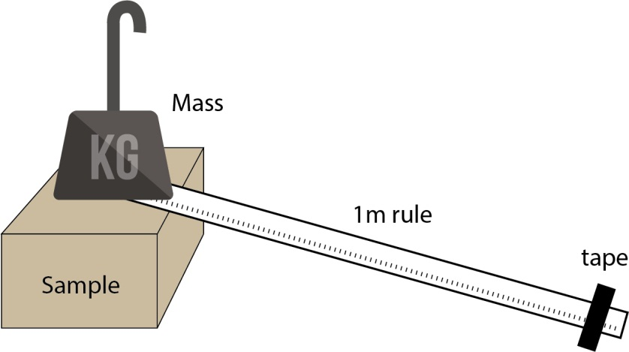
- Measure the original height of the sample measuring from the desk to the stabilising ruler, and record it in your results below.
- Now start adding the mass hanger and masses. After each mass is added read off the new height of the sample.
- Calculate the extension of the sample after each mass is added by using the equation:
Extension = new height (cm) – original height (cm)
- Record results in the table below
- Convert the mass (kg) into weight (Force, N) by using the equation:
Weight (N) = mass (kg) x gravitational field strength (N/kg) where g = 10 N/kg
- Keep adding masses until you have 10 results
- Repeat the above 3 times and calculate a mean value
- Plot a graph of force (N) against extension (m)
- Calculate the spring constant of the sample by rearranging the equation:
force exerted by a sample (N) = extension (m) x spring constant (N/m)
- Calculate the spring constant of the sample by calculating the gradient of your graph
- Calculate the work done in compressing the sample by working out the area under the graph
- Calculate the energy transferred in compression by using the equation:
energy transferred in compression (J) = 0.5 x spring constant (N/m) x (extension (m))²

Results

Original sample height = (mm)

 |  | New height of sample (mm) |  |  | Original height of sample (mm) |  |  | Extension of sample (mm) |  |  | Mean extension of sample (mm) | Mean extension of sample (m)
Mass added (kg) | Force (N) | 1 | 2 | 3 | 1 | 2 | 3 | 1 | 2 | 3

Calculated spring constant =

(N/m)
Spring constant from graph =

(N/m)

Work done from graph

(J)
Energy transferred in compressing

(J)

Evaluation
What does the graph show?
What type of mathematical relationship does this graph suggest exists between force and extension?

Can you think of any sources of uncertainty and systematic error in this investigation?
How could you improve the procedure to reduce the uncertainty?

Quiz - test your knowledge and understanding
1. |  | A student is investigating springs and forces. They measure how much a spring extends when different weights are hung on it.  These are the results collected  Force (N) Extension (cm) Mean extension (cm)  1 2 3  1 1.2 1.3 1.2  2 2.5 2.6 2.4  3 3.6 3.7 3.9  - (i) Calculate the mean extension for the first 3 results. Use the space below to show your working. [3 marks]  - (ii) Why is it important to carry out repeat readings? [2 marks]

- (i) Calculate the spring constant of a spring if it extends by 7.5 cm when 6N are applied
[4 marks]

(N/m)

- (ii) Work out the force required to extend the same spring by 10 cm. [3 marks]

(m)

2. | The extension of a spring is shown in the graph below.
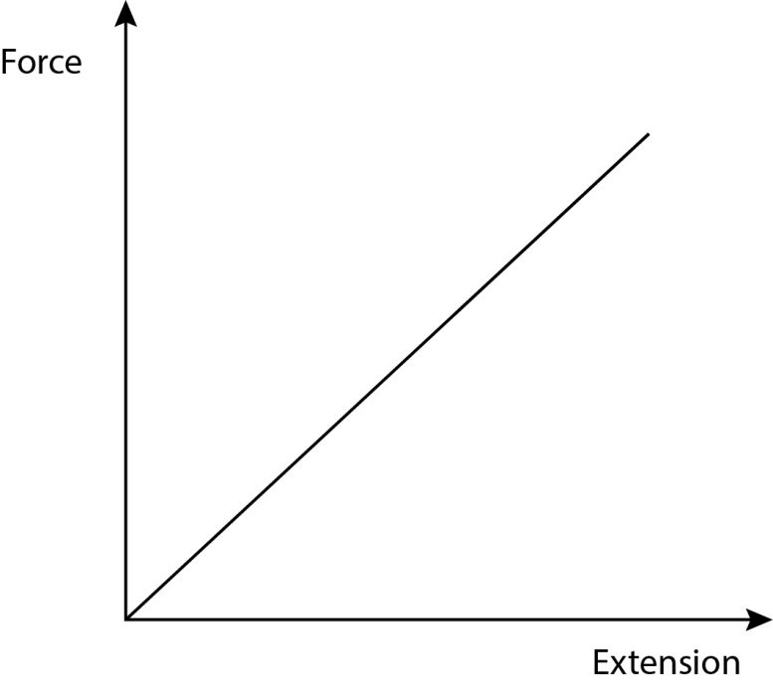
- (i) Another spring has double the spring constant. Add a line above to show the relationship of this new spring. [1 mark]

(b) | List two ways that springs are used [2 marks]

DfE Apparatus and Techniques covered
If you are using the OCR Practical Activity Learner Record Sheet (Physics / Combined Science) you may be able to tick off the following skills:

Physics |  |  |  |  | Combined Science
1a–i | 1a-iii | 5–i | 5–ii |  | 1–i | 1–iii | 17–i | 17–ii

