# Foundation Check In - 9.04 Similarity

1. The triangles below are similar. Work out *x*.

2 cm

5 cm

*x*

6 cm

*p*

*q*

*p*

*q*

**Not to scale**

1. Shape **B** is an enlargement of shape **A**. Find the scale factor and centre of enlargement.

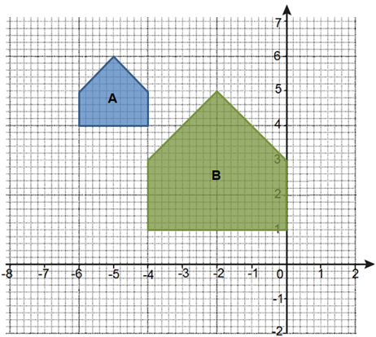

1. Shapes ABCD and A’B’C’D’ are similar. Find length A’B’.

B’

**Not to scale**

B

C

C’

16 cm

A’

D’

D

A

7.5 cm

10 cm

1. Triangle ABC is similar to triangle ADE. Work out length BC.

B

6 cm

E

3 cm

C

6 cm

A

D

**Not to scale**

1. Calculate the missing lengths in these similar shapes.

**Not to scale**

12 cm

3 cm

10 cm

9 cm

A

B

C

D

C’

B’

A’

D’

18 cm

1. Plot the following points on the coordinate grid to create triangle ABC.

* A (4, 2)
* B (8, 2)
* C (6, 8)

Enlarge the triangle using a scale factor of  about the point (-2, 0).

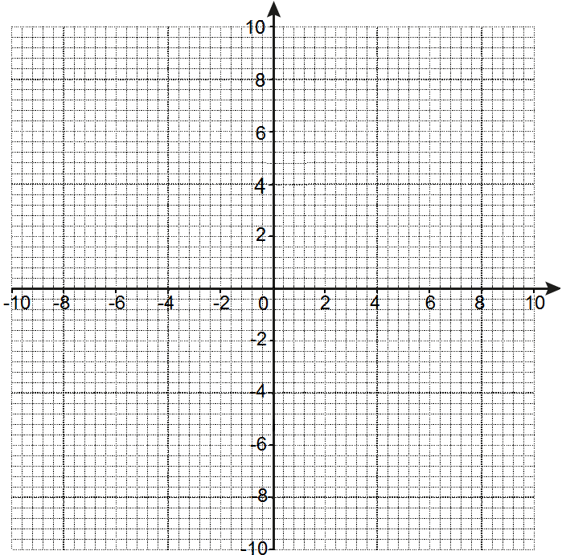

1. The side lengths of triangle A are 12 cm, 15 cm and 18 cm. The side lengths of triangle B are 8 cm, 10 cm and 12 cm. Show that these two triangles are similar.
2. Prove that these two triangles are similar.

12 cm

75°

7.5 cm

75°

8 cm

5 cm

**Not to scale**

1. The sides of a triangle are 5 cm, 6 cm and 10 cm. Find the length of the shortest side of a similar triangle whose longest side is 35 cm.
2. This diagram shows part of a pattern of increasing triangles.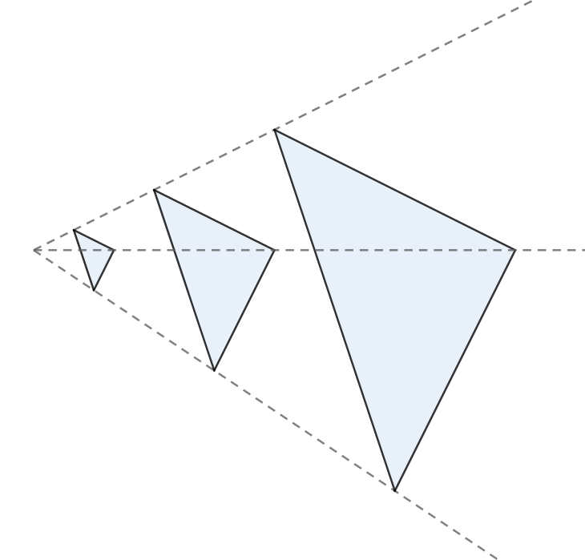

3.2 cm

**Not to scale**

11 cm

11 cm

*x*

*y*

9.6 cm

2.2 cm

What are the values of *x* and *y*?

**Extension**

The diagram below shows two similar triangles and two similar rectangles.

Work out the lengths B’C’ and F’G’.

Work out the area for each shape and then comment on the relationship between scale factors for the lengths and areas.

A’

A

2 cm

6 cm

C

B

**Not to scale**

5 cm

C’

B’

E

E’

D’

D

2 cm

G

F

8 cm

4 cm

G’

F’

Answers

1. Scale factor is  so cm.
2. Centre of enlargement (-8, 7), scale factor 2.
3. Scale factor is  so A’B’ cm.
4. Scale factor is  so BC cm.
5. Scale factor is  so A’B’ cm, B’C’ cm and

C’D’ cm.

1. Enlarged triangle is at A’(1, 1), B’(3, 1), C’(2, 4).
2.  oe
3. The sides in the two triangles are enlarged by the same scale factor,  and . The angle in between the two sides is the same, 75°. Therefore the two triangles are similar.
4. Scale factor is  so shortest side is cm.
5. Scale factor is  therefore cm

It can be seen from the third triangle that these are isosceles triangles,  
socm.

**Extension**

Length B’C’ is 15 cm (scale factor 3).

Length F’G’ is 16 cm (scale factor 4).

Areas of triangles: 5 cm2 and 45 cm2.

Areas of rectangles: 8 cm2 and 128 cm2.

There is a scale factor for the triangle areas of 9 (from 5 cm2 to 45 cm2) and for the rectangle areas of 16 (from 8 cm2 to 128 cm2). There is a relationship as the length scale factor has been squared to give the area scale factor in both shapes.

We’d like to know your view on the resources we produce. By clicking on ‘[Like’](mailto:resources.feedback@ocr.org.uk?subject=I%20liked%20the%20GCSE%20(9-1)%20Mathematics%20Check%20In%209.04%20Foundation) or ‘[Dislike’](mailto:resources.feedback@ocr.org.uk?subject=I%20disliked%20the%20GCSE%20(9-1)%20Mathematics%20Check%20In%209.04%20Foundation) you can help us to ensure that our resources work for you. When the email template pops up please add additional comments if you wish and then just click ‘Send’. Thank you.

Whether you already offer OCR qualifications, are new to OCR, or are considering switching from your current provider/awarding organisation, you can request more information by completing the Expression of Interest form which can be found here: [www.ocr.org.uk/expression-of-interest](http://www.ocr.org.uk/expression-of-interest)

Looking for a resource? There is now a quick and easy search tool to help find free resources for your qualification:   
[www.ocr.org.uk/i-want-to/find-resources/](http://www.ocr.org.uk/i-want-to/find-resources/)

**OCR Resources**: *the small print*OCR’s resources are provided to support the delivery of OCR qualifications, but in no way constitute an endorsed teaching method that is required by the Board, and the decision to use them lies with the individual teacher. Whilst every effort is made to ensure the accuracy of the content, OCR cannot be held responsible for any errors or omissions within these resources. This formative assessment resource has been produced as part of our free GCSE teaching and learning support package. All the GCSE teaching and learning resources, including delivery guides, topic exploration packs, lesson elements and more are available on the qualification webpages. If you are looking for examination practice materials, you can find Sample Assessment Materials (SAMs) and Practice Papers on the qualification webpage <http://www.ocr.org.uk/qualifications/gcse-mathematics-j560-from-2015/>

© OCR 2019 - This resource may be freely copied and distributed, as long as the OCR logo and this message remain intact and OCR is acknowledged as the originator of this work.

OCR acknowledges the use of the following content: n/a

Please get in touch if you want to discuss the accessibility of resources we offer to support delivery of our qualifications: [resources.feedback@ocr.org.uk](mailto:resources.feedback@ocr.org.uk)

To give us feedback on, or ideas about the OCR resources you have used, email [resourcesfeedback@ocr.org.uk](mailto:resourcesfeedback@ocr.org.uk)

To give us feedback on, or ideas about the OCR resources you have used, email [resourcesfeedback@ocr.org.uk](mailto:resourcesfeedback@ocr.org.uk)

To give us feedback on, or ideas about the OCR resources you have used, email [resourcesfeedback@ocr.org.uk](mailto:resourcesfeedback@ocr.org.uk)

To give us feedback on, or ideas about the OCR resources you have used, email [resourcesfeedback@ocr.org.uk](mailto:resourcesfeedback@ocr.org.uk)

To give us feedback on, or ideas about the OCR resources you have used, email [resourcesfeedback@ocr.org.uk](mailto:resourcesfeedback@ocr.org.uk)

To give us feedback on, or ideas about the OCR resources you have used, email [resourcesfeedback@ocr.org.uk](mailto:resourcesfeedback@ocr.org.uk)

**OCR Resources**: *the small print*OCR’s resources are provided to support the teaching of OCR specifications, but in no way constitute an endorsed teaching method that is required by the Board, and the decision to use them lies with the individual teacher. Whilst every effort is made to ensure the accuracy of the content, OCR cannot be held responsible for any errors or omissions within these resources.   
© OCR 2014 - This resource may be freely copied and distributed, as long as the OCR logo and this message remain intact and OCR is acknowledged as the originator of this work.

**OCR Resources**: *the small print*OCR’s resources are provided to support the teaching of OCR specifications, but in no way constitute an endorsed teaching method that is required by the Board, and the decision to use them lies with the individual teacher. Whilst every effort is made to ensure the accuracy of the content, OCR cannot be held responsible for any errors or omissions within these resources.   
© OCR 2014 - This resource may be freely copied and distributed, as long as the OCR logo and this message remain intact and OCR is acknowledged as the originator of this work.

OCR acknowledges the use of the following content::  
⚫ Garden: Elen Eliseeva/Shutterstock.com ⚫ Flag: Pixel Europe/Shutterstock.com

To give us feedback on, or ideas about the OCR resources you have used, email resourcesfeedback@ocr.org.uk

|  |  |  |  |  |  |  |  |  |  |  |  |  |
| --- | --- | --- | --- | --- | --- | --- | --- | --- | --- | --- | --- | --- |
| **Assessment Objective** | **Qu.** | **Topic** | **R** | **A** | **G** |  | **Assessment Objective** | **Qu.** | **Topic** | **R** | **A** | **G** |
| AO1 | 1 | Apply similarity to calculate an unknown length in similar triangles |  |  |  |  | AO1 | 1 | Apply similarity to calculate an unknown length in similar triangles |  |  |  |
| AO1 | 2 | Identify scale factor and centre of enlargement |  |  |  |  | AO1 | 2 | Identify scale factor and centre of enlargement |  |  |  |
| AO1 | 3 | Apply similarity to calculate an unknown length in similar shapes |  |  |  |  | AO1 | 3 | Apply similarity to calculate an unknown length in similar shapes |  |  |  |
| AO1 | 4 | Apply similarity to calculate an unknown length in similar triangles |  |  |  |  | AO1 | 4 | Apply similarity to calculate an unknown length in similar triangles |  |  |  |
| AO1 | 5 | Apply similarity to calculate an unknown length in similar shapes |  |  |  |  | AO1 | 5 | Apply similarity to calculate an unknown length in similar shapes |  |  |  |
| AO2 | 6 | Carry out enlargement with a fractional scale factor |  |  |  |  | AO2 | 6 | Carry out enlargement with a fractional scale factor |  |  |  |
| AO2 | 7 | Apply similarity to calculate an unknown length in similar triangles |  |  |  |  | AO2 | 7 | Apply similarity to calculate an unknown length in similar triangles |  |  |  |
| AO2 | 8 | Prove that two triangles are similar |  |  |  |  | AO2 | 8 | Prove that two triangles are similar |  |  |  |
| AO3 | 9 | Apply similarity to calculate an unknown length in similar triangles |  |  |  |  | AO3 | 9 | Apply similarity to calculate an unknown length in similar triangles |  |  |  |
| AO3 | 10 | Identify lengths in an enlargement problem |  |  |  |  | AO3 | 10 | Identify lengths in an enlargement problem |  |  |  |
|  |  |  |  |  |  |  |  |  |  |  |  |  |
| **Assessment Objective** | **Qu.** | **Topic** | **R** | **A** | **G** |  | **Assessment Objective** | **Qu.** | **Topic** | **R** | **A** | **G** |
| AO1 | 1 | Apply similarity to calculate an unknown length in similar triangles |  |  |  |  | AO1 | 1 | Apply similarity to calculate an unknown length in similar triangles |  |  |  |
| AO1 | 2 | Identify scale factor and centre of enlargement |  |  |  |  | AO1 | 2 | Identify scale factor and centre of enlargement |  |  |  |
| AO1 | 3 | Apply similarity to calculate an unknown length in similar shapes |  |  |  |  | AO1 | 3 | Apply similarity to calculate an unknown length in similar shapes |  |  |  |
| AO1 | 4 | Apply similarity to calculate an unknown length in similar triangles |  |  |  |  | AO1 | 4 | Apply similarity to calculate an unknown length in similar triangles |  |  |  |
| AO1 | 5 | Apply similarity to calculate an unknown length in similar shapes |  |  |  |  | AO1 | 5 | Apply similarity to calculate an unknown length in similar shapes |  |  |  |
| AO2 | 6 | Carry out enlargement with a fractional scale factor |  |  |  |  | AO2 | 6 | Carry out enlargement with a fractional scale factor |  |  |  |
| AO2 | 7 | Apply similarity to calculate an unknown length in similar triangles |  |  |  |  | AO2 | 7 | Apply similarity to calculate an unknown length in similar triangles |  |  |  |
| AO2 | 8 | Prove that two triangles are similar |  |  |  |  | AO2 | 8 | Prove that two triangles are similar |  |  |  |
| AO3 | 9 | Apply similarity to calculate an unknown length in similar triangles |  |  |  |  | AO3 | 9 | Apply similarity to calculate an unknown length in similar triangles |  |  |  |
| AO3 | 10 | Identify lengths in an enlargement problem |  |  |  |  | AO3 | 10 | Identify lengths in an enlargement problem |  |  |  |