GCSE Combined Science

Practical Skills Booklet

Student Book
Contents
Biology 4
Microscopy 4
Sampling techniques 5
Rates of enzyme-controlled reactions – concentration 6
Rates of enzyme-controlled reactions – temperature 8
Transport in and out of cells 10
Photosynthesis 12
Microbiological techniques 14
Chemistry 16
The effect of temperature on the rate of reaction 16
Electrolysis 18
Distillation 22
Separation techniques 26
Production of salts 28
The effect of concentration on the rate of reaction 32
Endothermic and exothermic reactions 36
Physics 38
Materials 38
Forces 40
Motion 42
The effect of depth on the speed of water waves 44
Waves – reflection and refraction 46
Energy 48
Circuits 50

Magnesium and hydrochloric acid, and endothermic and exothermic reactions activities are adapted from the Practical Chemistry project, developed by the Nuffield Foundation and the Royal Society of Chemistry – https://edu.rsc.org/resources/practical specifically the practicals:
The rate of reaction of magnesium with hydrochloric acid – www.rsc.org/learn-chemistry/resource/res00001916/the-rate-of-reaction-of-magnesium-with-hydrochloric-acid.
Exothermic or endothermic? – www.rsc.org/learn-chemistry/resource/res00000406/exothermic-or-endothermic

We’d like to know your view on the resources we produce. Click ‘Like’ or ‘Dislike’ to send us an auto generated email about this resource. Add comments if you want to. Let us know how we can improve this resource or what else you need. Your email will not be used or shared for any marketing purposes.
Looking for another resource? There is now a quick and easy search tool to help find free resources for your qualification.
OCR is part of Cambridge Assessment, a department of the University of Cambridge.
For staff training purposes and as part of our quality assurance programme your call may be recorded or monitored.
Oxford Cambridge and RSA Examinations is a Company Limited by Guarantee. Registered in England. Registered office
The Triangle Building, Shaftesbury Road, Cambridge, CB2 8EA. Registered company number 3484466. OCR is an exempt charity.
OCR operates academic and vocational qualifications regulated by Ofqual, Qualifications Wales and CCEA as listed
in their qualifications registers including A Levels, GCSEs, Cambridge Technicals and Cambridge Nationals.
OCR provides resources to help you deliver our qualifications. These resources do not represent any particular teaching method we expect you to use. We update our resources regularly and aim to make sure content is accurate but please check the OCR website so that you have the most up to date version. OCR cannot be held responsible for any errors or omissions in these resources.
Though we make every effort to check our resources, there may be contradictions between published support and the specification, so it is important that you always use information in the latest specification. We indicate any specification changes within the document itself, change the version number and provide a summary of the changes. If you do notice a discrepancy between the specification and a resource, please contact us.
© OCR 2021 - You can copy and distribute this resource freely if you keep the OCR logo and this small print intact and you acknowledge OCR as the originator of the resource.
OCR acknowledges the use of the following content: N/A
Whether you already offer OCR qualifications, are new to OCR or are thinking about switching, you can request more information using our Expression of Interest form.
Please get in touch if you want to discuss the accessibility of resources we offer to support you in delivering our qualifications.

Notes page

Biology

Microscopy

Looking at cheek cells
You will be preparing a microscope slide of your own cheek cells and look at them using a light microscope.

Equipment
- Eye protection
- Light microscope
- Microscope slide
- Cover slip
- Cotton bud
- Mounted needle
- Methylene blue stain
- Disinfectant

Method
- Set up a microscope, as shown by your teacher.
- Place the cotton bud inside your mouth and run it along the inside of your cheek.
- Rub the cotton bud containing the cheek cells on the centre of the microscope slide.
- Place 1 drop of methylene blue on top of the cells on the slide. Place a cover slip on the methylene blue using the mounted needle. Take care not to trap any air bubbles.
- Examine the slide under the microscope using lowest power objective lens first.
- Draw your cells in the box below.

- Put the slide and cover slip into disinfectant as directed by your teacher.

Sampling techniques

Counting daisies
You will be using equipment to measure the number of plant species (e.g. daisies) in an ecosystem.

Equipment
- Quadrat
- Species key

Method
- Your teacher will set out a sample area of 10 x 10 m.
- Randomly place the quadrat on the ground somewhere in the sample area.
- Count and record the number of the plants species in the quadrat.
- Repeat steps 1- 4 and use your results to estimate the population of the plant species (e.g. daisies) in the sample area.

Estimated population size = (total sample area ÷ area of quadrat) x average number of daisies

Results
Quadrat | 1 | 2 | 3 | 4 | 5 | 6 | 7 | 8 | 9 | 10
Number of plants counted
Average

Rates of enzyme-controlled reactions – concentration

The effect of substrate concentration on enzymes
You will be investigating the effect of concentration of hydrogen peroxide on the enzyme catalase.

Equipment

- Eye protection
- Hydrogen peroxide
- Distilled water
- 25 cm³ measuring cylinder or graduated boiling tube
- 50 cm³ conical flask
- ‘S’ shaped delivery tube with a bung to fit the conical flask
- Large trough / washing up bowl for water
- Potato
- Cork borer
- Ruler
- Butter knife
- White tile
- Stopwatch

Method
- Set up the apparatus as shown in the diagram (Figure 1).
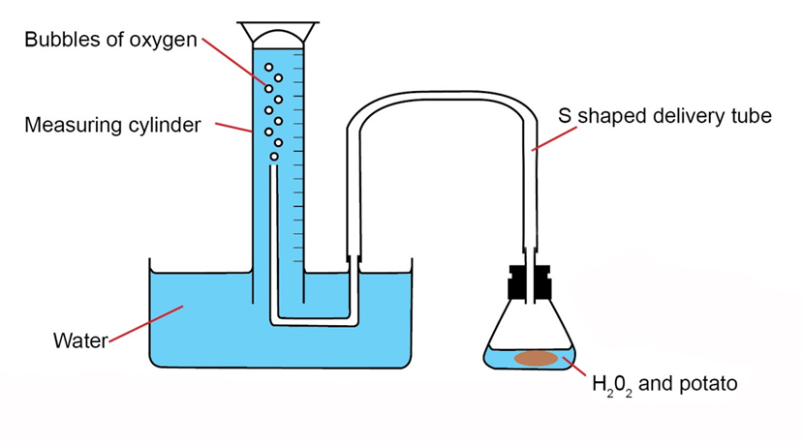
Figure 1: Equipment set up
- Use the cork borer to cut out 5 cylinders of potato.
- Cut the cylinders of potato into 4 cm pieces.
- Add 20 cm³ of 10% hydrogen peroxide to the conical flask.
- Drop the first piece of potato into the conical flask and start the stopwatch. Make sure the bung is fixed firmly back in place.

- After 5 minutes record the volume of oxygen in the measuring cylinder in your results table.
- Discard the hydrogen peroxide and potato into a container as directed by your teacher.
- Rinse out the conical flask.
- Repeat steps 4 – 8 for all of the hydrogen peroxide concentrations.

Results
Concentration of hydrogen peroxide (%) | Volume of oxygen produced  (cm³)
10
20
30

Rates of enzyme-controlled reactions – temperature

The effect of temperature on the activity of lipase
You will be investigating how the activity of the enzyme lipase changes with temperature, using an indicator.

Equipment

- Test tubes x 4
- Test tube bungs x 4
- Test tube rack
- 10 cm³ measuring cylinders x 2
- Milk
- Sodium carbonate solution
- Lipase

- 2 cm³ syringe
- Stopwatch
- Ice bath
- Water baths at 40ºC and 70ºC
- Thermometer
- Phenolphthalein

Method
- Label 4 test tubes with the temperatures you will be testing (0ºC, 20ºC, 40ºC, 70ºC) and place them in a test tube rack.
- Add 5 drops of phenolphthalein to each of the test tubes.
- Measure out 5cm³ of milk using a measuring cylinder and add this to each of the four test tubes.

- Using another measuring cylinder, measure out 7 cm³ of sodium carbonate solution and add this to each test tube. The solution should now be pink.

- There is;
  - An ice bath containing a cold lipase solution (0ºC),
  - A conical flask containing lipase at room temperature (20ºC)
  - Two water baths containing hot lipase solution (40ºC, 70ºC).

- Use a syringe to measure 1 cm³ of lipase solution and place the lipase solution into the corresponding test tube (cold lipase into test tube labelled 0ºC). Place a bung in the test tube, shake for 5 seconds and then remove the bung. Repeat this step for each of the four test tubes.

- Get your stopwatch ready and stand the test tube back in the ice bath, water bath, or in your test tube rack for room temperature (where the lipase came from).
- Quickly start the stopwatch.
- Stir the contents of the test tube with a glass rod, until the solution loses its pink colour.
- Stop the stopwatch and record the time in a results table.

- Take the temperature of the lipase solution, with the thermometer and record the temperature your results table.

- Calculate the rate of reaction, using the formula:

Rate of reaction = 1
Time taken

Temperature of Lipase  (ºC) | Time taken for solution to go from pink to colourless  (mins/secs) | Rate of reaction  (1÷ time taken)

Now plot two graphs:
- a line graph of temperature against rate of reaction.
- a line graph of temperature against time taken.
What is the difference between a ‘time taken’ and a ‘rate of reaction’ curve for this investigation?

Transport in and out of cells

Osmosis
You will be investigating the movement of molecules in and out of cells by osmosis.

Equipment

- Potato / potato chips
- Cork borer
- Knife
- White tile
- Ruler
- 100 cm³ measuring cylinder
- Distilled water
- Sucrose solutions – 0.0M, 0.2M, 0.4M and 0.6M
- Small beakers x 4
- Marker pen / labels for beakers
- Balance
- Paper towel
- Forceps

Method
- Label the beakers ‘0.0M’, ‘0.2M’, ‘0.4M’ and ‘0.6M’ using a marker pen.

- Cut four potato chips using a cork borer and a knife. The chips should be 5 cm long. Check the length using a ruler and place one chip in each beaker.

- It is important that each potato chip stays with the same concentration of sucrose. Take care to always keep the same potato chip with the same beaker.

- Weigh each potato chip on a balance. Record the mass in the table, to one decimal place, and then return the chip into its correct beaker.

- Add 50 cm³ of the correct solution to each beaker. Make sure the chips are completely covered by the solution. Leave the chips in the solutions for 30 minutes.

- Remove the chips with forceps. Blot each chip dry using a paper towel.

- Re-weigh each chip and record the results in a table.

Results
Sucrose solution concentration (M) | Initial mass  (g) | Final mass (g) | Change in mass (g) | Percentage change in mass  (%) | Rate of water up take  (g/min)
0.0
0.2
0.4
0.6

- Calculate the change in mass and the percentage change in mass.
- Plot a graph of sucrose solution concentration against percentage change in mass.
- Calculate the rate of water uptake using the following equation:
rate of water uptake = | final mass – initial mass
 | time

Use your graph to determine the sucrose concentration of the potato chips and explain how you decided.
What do you notice about the rate of water uptake?

Photosynthesis

Investigating the effect of light intensity on the rate of photosynthesis
You will be investigating how light intensity affects the rate of oxygen production in photosynthesis.

Equipment
- Lamp
- Metre ruler
- 10 cm³ measuring cylinder
- 200 cm³ measuring cylinder
- 250 cm³ beaker
- Funnel
- Pondweed, 1 strand
- 185 cm³ pond water or 185 cm³ of 1% sodium hydrogen carbonate
- Stopwatch
- Plastic gloves (if using 1% sodium hydrogen carbonate)

Method
- Set up the equipment as shown in the diagram (Figure 1).

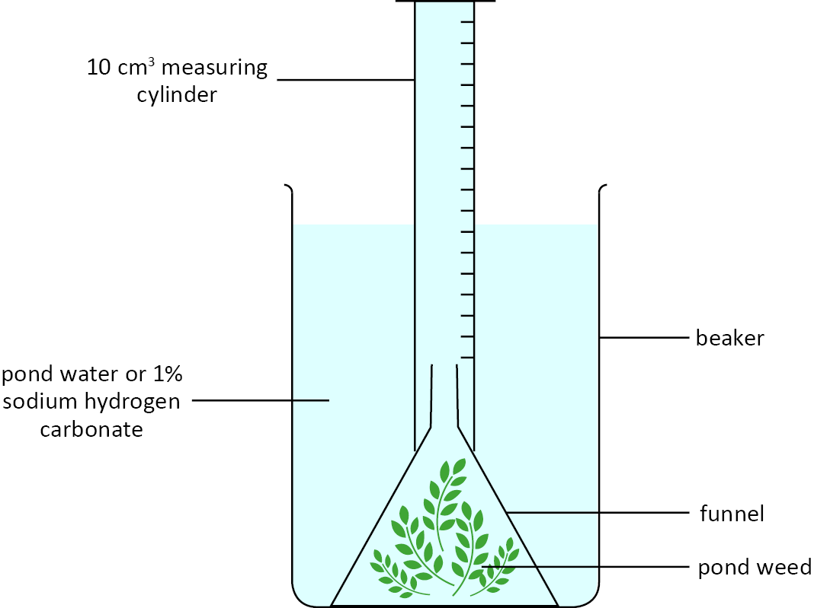
Figure 1: Equipment set up
- Measure 175 cm³ of pond water or 1% sodium hydrogen carbonate and pour it into a beaker.

- Place the strand of pondweed into the beaker and put the funnel over the pondweed.

- Fill the 10 cm³ measuring cylinder with pond water or 1% sodium hydrogen carbonate, place your thumb over the measuring cylinder.

- Turn the measuring cylinder upside down and place it over the spout of the funnel. Your thumb should be kept over the measuring cylinder as close to the spout as possible to keep the liquid in.

- Place the lamp 10 cm away from the beaker containing the pondweed.
- Record the level of pond water/1% sodium hydrogen carbonate in the 10ml measuring cylinder.
- Start the stopwatch and time for 10 minutes.
- After 10 minutes, record the level of liquid in the measuring cylinder.
- Repeat steps 4 to 9 with the lamp at 20 cm, 30 cm, 40 cm and 50 cm. Record the results in your table.

Results
Distance from the beaker  (cm) | Oxygen production  (cm³)
10
20
30
40
50

Microbiological techniques

Investigating antimicrobials
You will be investigating how good different household antimicrobial products are at preventing growth of bacteria.

Equipment
- Petri dish with bacterial culture in nutrient broth/agar
- Sterile forceps x 4
- Filter paper discs x 4
- Distilled water
- Marker pen
- Sticky tape
- Antimicrobial products x 3
- Beaker of disinfectant

Method
- Set up the equipment as shown by your teacher, dividing the petri dish into 4 sections as shown below.
- Label each section with the name of the antimicrobial you are testing and label the last section ‘control’.
- Using sterile forceps dip the paper disc into the first antimicrobial and place the disc in the centre of its labelled section. Now place these forceps in the beaker of disinfectant.
- Repeat steps 3 to 4 for the remaining two antimicrobial products using a new pair of forceps each time.
- Dip the final disc into distilled water using sterile forceps and place it in the centre of the section labelled ‘control’.
- Seal the petri dish with sticky tape. Do not tape around the rim of the petri dish. Make a cross of sticky tape across the petri dish. Return to the technician for incubation.
- After incubation, draw your results on the petri dish on the next page:

shape

control

Results
Antimicrobial | Diameter cleared by antimicrobial | Rank order  (1 best, 4 worst)
Control

Chemistry

The effect of temperature on the rate of reaction

Magnesium and hydrochloric acid
You will be carrying out the reaction of hydrochloric acid with magnesium to determine how temperature effects the rate of reaction.

Equipment

- Eye protection
- 100 cm³ conical flask
- Bung and delivery tube
- 25 cm³ measuring cylinder
- 50 cm³ measuring cylinder
- Thermometer
- Stand, boss and clamp
- Trough / ice-cream tub or similar
- Hydrochloric acid
- Magnesium
- Stopwatch
- Electric water bath or kettle and 250 cm³ beaker
- Waste bucket and sieve

Method
- Set up the apparatus as shown in the diagram (Figure 1). If the trough is too small to place the measuring cylinder on its side, fill the measuring cylinder to the top, hold a folded dampened piece of scrap paper over the top, and invert into the filled trough.
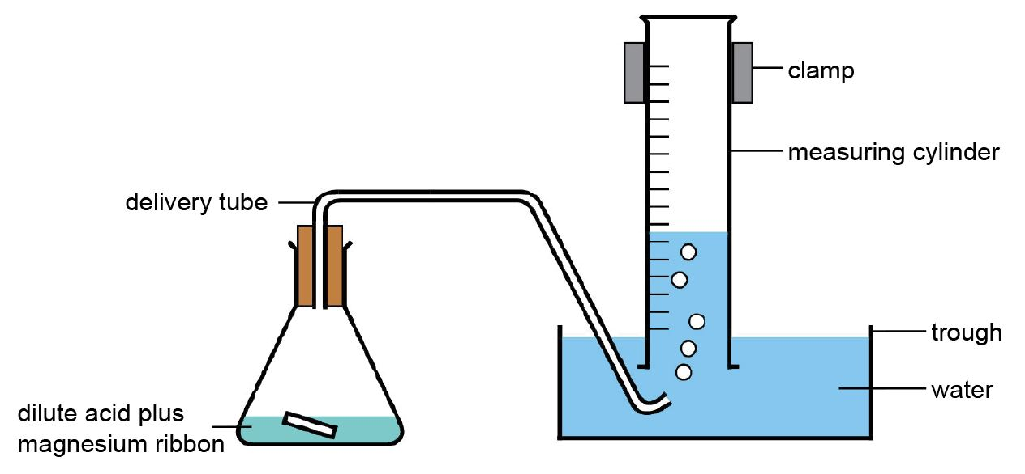
Figure 1: Equipment set up
- For each temperature of hydrochloric acid, HCl:
  - Measure 50 cm³ of hydrochloric acid into the conical flask.
  - Heat the acid in a water bath to the required temperature – use a thermometer to measure the temperature of the acid.
  - Add a 4 cm strip of magnesium to the conical flask, attach the bung/delivery tube and start the stop watch.
  - Look at the volume of gas produced – stop the stop-watch when 30 cm³ of gas has been produced.
  - Pour the acid/magnesium mixture into the waste bucket through the sieve, and rinse out the conical flask.

Results
You can draw your own table, or use the one below:
Temperature of HCl(aq)  (°C) | Time taken to produce 30 cm³ H₂(g) = t  (s) | Rate of reaction  (rate of reaction = 30/t)  (s^{–1})
(room temperature) =
30
40
50
60

- Calculate the rate of each reaction by dividing 30 by the time taken to produce the 30 cm³ of hydrogen gas.

- Plot a graph of temperature of HCl against rate of reaction – include a line of best fit (THINK should this be a straight or curved line; should the graph extrapolate beyond the data points; should it start at the origin?)

- Describe the relationship between temperature of HCl and its rate of reaction with magnesium.

Electrolysis

Electrolysis of brine
You will carry out the electrolysis of sodium chloride solution, collecting two gaseous products, and testing the pH of the remaining solution. From your results you can then work out what the products of the electrolysis are.
The ions present in brine solution are:
sodium ions Na⁺ hydrogen ions H⁺
chloride ions Cl– hydroxide ions OH–

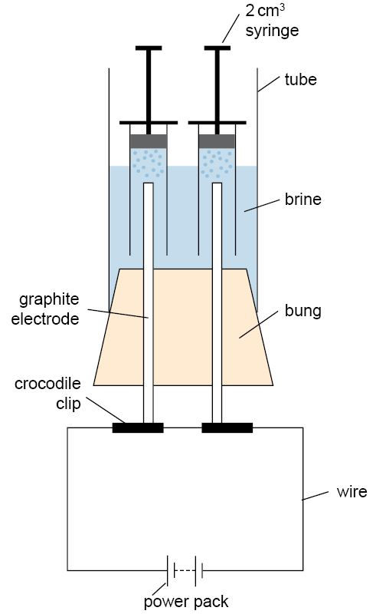
Equipment

- Electrolysis apparatus
- Stand, boss and clamp
- Sodium chloride solution
- Pipettes
- Power pack
- Wires x 2
- Crocodile clips x 2
- Micro test tubes x 2 OR plastic syringes with tip–end cut off at the 0 cm³ mark x 2
- Bunsen burner, heat proof mat and splint
- Blue litmus paper
- Universal indicator solution

Figure 1: The set-up of the apparatus. If you are using micro test tubes, these replace the syringes.

Health and safety
- Eye protection should be worn at all times.
- Ensure the laboratory is well-ventilated.
- If using a power pack, ensure it is positioned away from the electrolysis to minimise liquid getting on the power pack.

Method
- Clamp the electrolysis apparatus to the stand with the boss and clamp.
- Fill the tube of the electrolysis apparatus with sodium chloride solution to within 1 cm of the top.
- If using plastic syringes: draw solution in the tube into the syringe barrel and place over one of the electrodes.
- If using micro test tubes: use a plastic pipette to fill the test tube with sodium chloride solution, place your finger over the end, invert the tube and submerge the end of the tube into the solution in the electrolysis apparatus.
- Repeat for the second electrode. If necessary, top up the sodium chloride solution to within 1cm of the top.
- Connect the wires to the power pack and to the electrodes with the crocodile clips.
- Set the power pack to 9 V d.c. and run the electrolysis until both tubes are full of gas.
If the bubbles are forming very slowly, tip the syringes / test–tube to allow flow within the solution.
- Turn off the power pack.
- Decide which test tube you think contains hydrogen – carry out the ‘squeaky pop’ test to confirm this.
- Consider the charge on the hydrogen ion, and therefore which electrode the ions would be attracted to.
SQUEAKY POP TEST: Carefully remove the syringe from the solution and quickly place your finger over the end to prevent the gas from escaping. Then light a splint, move your finger and place the splint next to the end of the barrel. If hydrogen is present, you will hear a ‘squeaky pop’ and see a flame.
- Decide which test tube you think contains chlorine gas – test the gas with damp blue litmus paper to confirm this.
- Consider the charge on the chloride ion, and therefore which electrode the ions would be attracted to.
- Add 2-3 drops of universal indicator solution to the solution remaining in the electrolysis apparatus.
- With the hydrogen and chloride ion concentration decreasing, consider which ions remain in solution, and therefore the pH of the solution.
- If you have time, empty the electrolysis apparatus, rinse with tap water, and repeat the experiment.
- Dismantle your experimental set up. Place the indicator paper in the bin, and rinse the apparatus before returning to your teacher.

Results
You can draw your own table, or use the one below:
Test carried out | Product from where? | Observation
squeaky pop test | cathode / anode
damp blue litmus paper | cathode / anode
universal indicator | Remaining solution

1. |  | Hydrogen is a flammable gas.  Describe and explain your evidence for the production of hydrogen gas.

2. | Chlorine is an acidic gas.  Describe and explain your evidence for the production of chlorine gas.

3. | Sodium hydroxide forms an alkaline solution.  Describe and explain your evidence for the production of sodium hydroxide.
Draw a simple diagram of the apparatus you actually used.

Distillation

Fractional distillation of a crude oil substitute
You will separate a crude oil substitute, and investigate the properties of the fractions.

Equipment

- Eye protection
- Mineral wool
- Side-arm boiling tube
- Bung with hole for thermometer
- Thermometer glass OR digital
- Test tubes x 3
- Test tube bungs x 3
- Watch-glass x 3
- Glass marker pen
- Stand, boss and clamp
- Heat proof mat
- Bunsen burner
- Splints
- Stopwatch
- Paper towels
- 8 cm³ crude oil substitute

Health and safety
- Eye protection should be worn at all times.
- Check the boiling tube for any cracks before heating – return any damaged glassware to your teacher.
- When smelling the fractions, hold the tube about 15 cm from your nose and waft your hand over the top towards your nose. DO NOT place the tube next to your nose.
- Ensure the watch–glasses are on heat–proof mats before lighting the fractions.
- Watch carefully the top of the boiling tube – if any fumes/smoke starts to escape, stop heating.

Method

Separation of the crude oil substitute
- Place mineral wool to a depth of about 5 cm in the bottom of the side-arm boiling tube.
- Add about 7–8 cm³ of crude oil substitute to the mineral wool.
- Clamp the boiling tube at about 30°, place the bung and thermometer into the end of the tube, and ensure the bulb of the thermometer is at the same level as the side-arm.
- Label three test tube A, B, C, and place the delivery tube in test tube A.
- Holding the Bunsen burner by the base, and using a half-blue flame, GENTLY heat the side-arm boiling tube around the base and the side.

- Collect fractions over these approximate ranges:
  - room temperature – 100°C (GENTLE heating is required here to ensure good fractional distillation of this fraction)
  - 100–150°C
  - 150–200°C (this fraction requires stronger heating).

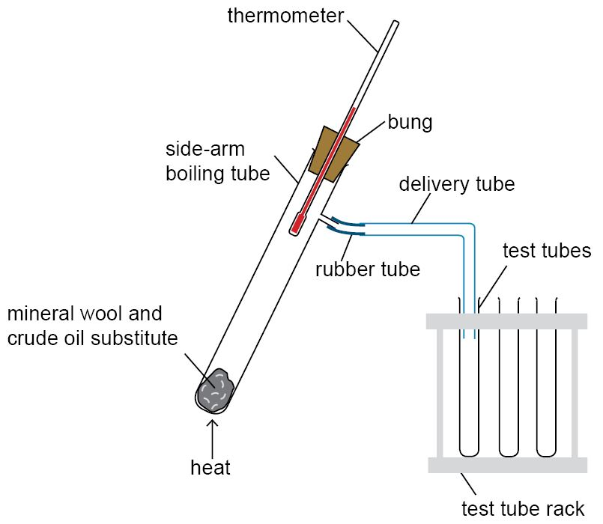

Figure 1: The experimental setup for small scale fractional distillation.

Analysis of the fractions
- Test the odour of fraction: gently waft the fumes towards your nose – DO NOT smell directly from the test tube.
- Test the viscosity of the fraction: place 2–3 drops at one end of the watch glass, tip to about 45°, and time how long the drop takes to move across the watch glass.
- Test the ease of lighting the fraction: add about 0.5 cm³ of the fraction to the watch-glass (or a prepared bottle top – you teacher will let you know which) and light the fraction with a lit splint.

Results
You can draw your own table, or use the one below:
 | Fraction property
Fraction | Boiling range  (°C) | Odour | Time until liquid start to drip on pouring  (s) | Ease of combustion
A
B
C

1. | Describe and explain the trends in the properties of the fractions as the boiling point increases

Notes page

Separation techniques

Chromatography of food dyes
You will separate a range of food colouring dyes by paper chromatography. By varying the proportion of water to organic solvent, you can observe different separation of the coloured components of the food colouring.

Equipment

- Food colourings solutions/gels Solvents: distilled water, ethanol, acetone
- Non-plastic containers, e.g. ceramic egg-cups
- Coffee filters – preferably white
- Small drinking glass
- Large measuring spoon
- Fine tipped paint brush
- Pencil
- Ruler
- Bull-dog clip

Health and safety
- Many non-aqueous solvents are highly flammable – ensure there are no naked flames or other sources of ignition present when carrying out this activity.
- Wear eye protection
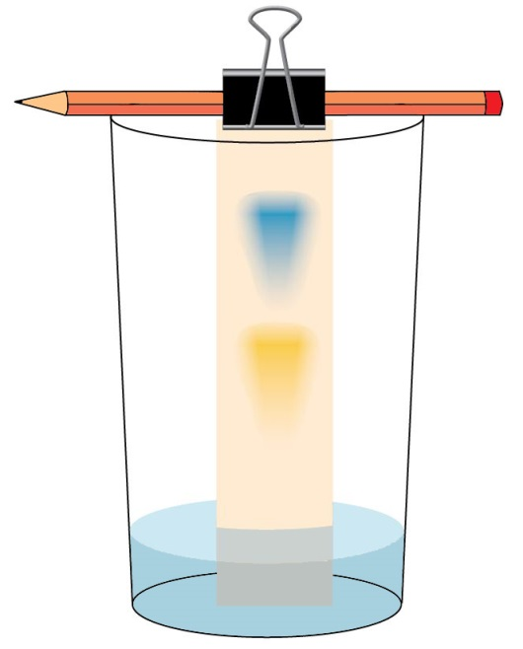
- Ensure any kitchen apparatus used in the experiment is thoroughly cleaned after use.

Method
Students should set up the equipment as shown in Figure 1:

STAGE 1: Setting up the chromatogram
- Cut enough chromatogram papers from the coffee filter for each of the solvents you are using (plus one for water) - about 5 cm wide and about as tall as your glass
Figure 1: Equipment set up

- Draw pencil lines about 2 cm from one end of your pieces of paper
- Mix a small amount of the food colouring in about the same volume of water in a small container (e.g. egg cup)
- Using a fine paint brush, paint small spots of the food colouring mixture onto the pencil lines and gently blow to dry the spots. Repeat once more.
- Repeat Steps 3 and 4 with the remaining food colourings.

STAGE 2: Running the chromatogram
- Add about 1 cm of water into the glass
- Using the bulldog clip, attach the top of your paper to the pencil, and lower the paper into the flask – ENSURE the top of the water is BELOW the pencil base line.
- Allow the water to soak up the paper until about 1 cm from the pencil.
- Remove the paper from the glass, and mark the highest point of the solvent with a pencil line.
- Place the chromatogram on a piece of absorbent towel until dry.
- Repeat stage 2 with the remaining solvents.

Results
- Describe the separation results for each solvent:

Production of salts

Making copper sulfate crystals
You will carry out a micro-scale synthesis and purification of hydrated copper sulfate.

Equipment

- Universal indicator paper
- Cotton wool
- Dropping pipette
- Forceps
- Glass marker pen
- Glass vial
- 2 or 5 cm³ Plastic syringe
- Stopwatch
- Watch glass
- Weighing boat
- White tile
- Balance
- Sand bath (baking tray of sand on a hot plate)
- 1.4 mol/dm³ sulfuric(VI) acid (WARNING: causes skin and serious eye irritation)
- Copper(II) oxide (WARNING: harmful if swallowed)

Health and safety
- Eye protection should be worn at all times.
- Take care when transferring glassware to and from the sand bath – do not touch the sand.
- The product, copper sulfate, is harmful (WARNING: harmful if swallowed, causes skin and serious eye irritation) – dispose of as instructed by your teacher.

Method
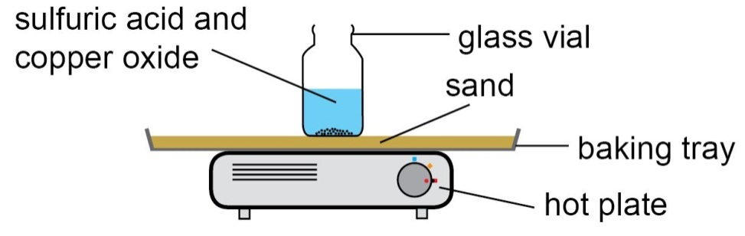
Figure 1: Producing copper sulfate with a sand bath

- Using a dropping pipette, add 1.5 cm³ of sulfuric acid to a glass vial.

- Measure the pH of the acid with universal indicator paper.

- Weigh out 0.18–0.20 g of copper oxide in a weighing boat, and add to the acid.

- Place the vial in the sand-bath for 1–2 minutes (figure 1).
- The solution will turn blue with the formation of copper sulfate.
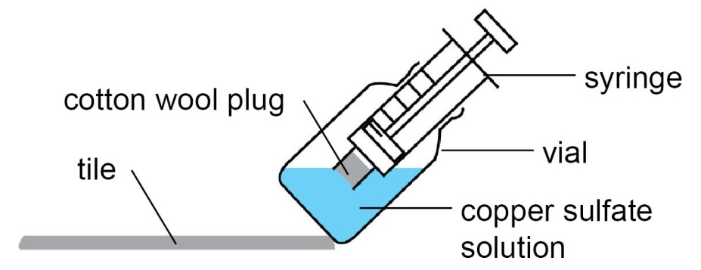

Figure 2: Purifying the copper sulfate by filtering

- Measure the pH of the solution with universal indicator paper.

- Remove the vial from the sand bath and allow to cool.

- Using forceps, place a small piece of cotton wool in the nozzle of a syringe.
- Make sure you don’t press the cotton wool all the way into the nozzle.

- Using a tile to help hold the vial at an angle, draw all of the reaction mixture up into the syringe through the cotton wool (figure 2)
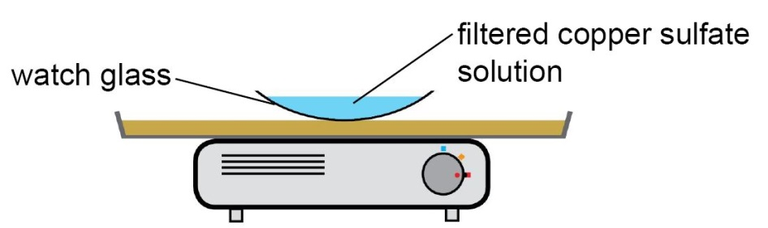

Figure 3: Purifying the copper sulfate by evaporation and crystallisation.

- Remove the cotton wool, and carefully dispense the filtered solution into a watch glass.

- Using forceps, carefully place the watch glass on the sand bath (figure 3).

- Watch the solution carefully – when white solid appears at the edge of the solution remove the watch glass to a white tile.
- It is important not to evaporate too much solution on the sand-bath, otherwise you won’t get good quality crystals.

- Observe the solution over 5-10 minutes – if available, take a photo of your solution with a camera/smart phone for your records.

Results
1. | Print and stick in a photo of your crystals and/or accurately sketch one of the crystals.

2. | pH measurements
 | before reaction: | after reaction:

Notes page

The effect of concentration on the rate of reaction

The disappearing cross
You will investigate the effect of concentration on the rate of reaction between hydrochloric acid and sodium thiosulfate.
sodium thiosulfate + hydrochloric acid → sodium chloride + sulfur dioxide + sulfur
Na₂S₂O₃(aq) + 2HCl(aq) → 2NaCl(aq) + SO₂(g) + S(s)

Equipment
- Plastic reaction box
- Glass vials × 2
- 10 cm³ measuring cylinder × 2
- 250 cm³ beaker
- 100 cm³ beaker × 2
- Plastic dropper pipette with volume readings
- Glass marker pen
- Distilled water
- Stop watch
- 1.00 mol/dm³ Hydrochloric acid
- 0.100 mol/dm³ Sodium thiosulfate solution
- 1 mol/dm³ Sodium carbonate solution (WARNING: Causes serious eye irritation)
- Universal indicator solution (WARNING: Flammable)

Health and safety
- Eye protection should be worn at all times.
- Small quantities of sulfur dioxide gas (DANGER: Toxic and corrosive gas) are made in each reaction – minimise your exposure by keeping your face at least 30 cm from the reaction and pouring the solution into the ‘STOP BATH’ as soon as possible after taking your readings.
- Let your teacher know if you are asthmatic.
- Ensure the laboratory is well ventilated.

Method

STAGE 1: Set up
- Put about 50 cm³ of sodium thiosulfate solution in a labelled 100 cm³ beaker and 50 cm³ distilled water in a separate labelled 100 cm³ beaker.
- Measure out about 25 cm³ of sodium carbonate solution into a 250 cm³ beaker, and add a few drops of universal indicator solution – label this 'STOP BATH'
- Measure 10 cm³ of hydrochloric acid into the 'acid' vial and place the vial into the correct hole in the plastic container (i.e. the one without the cross).
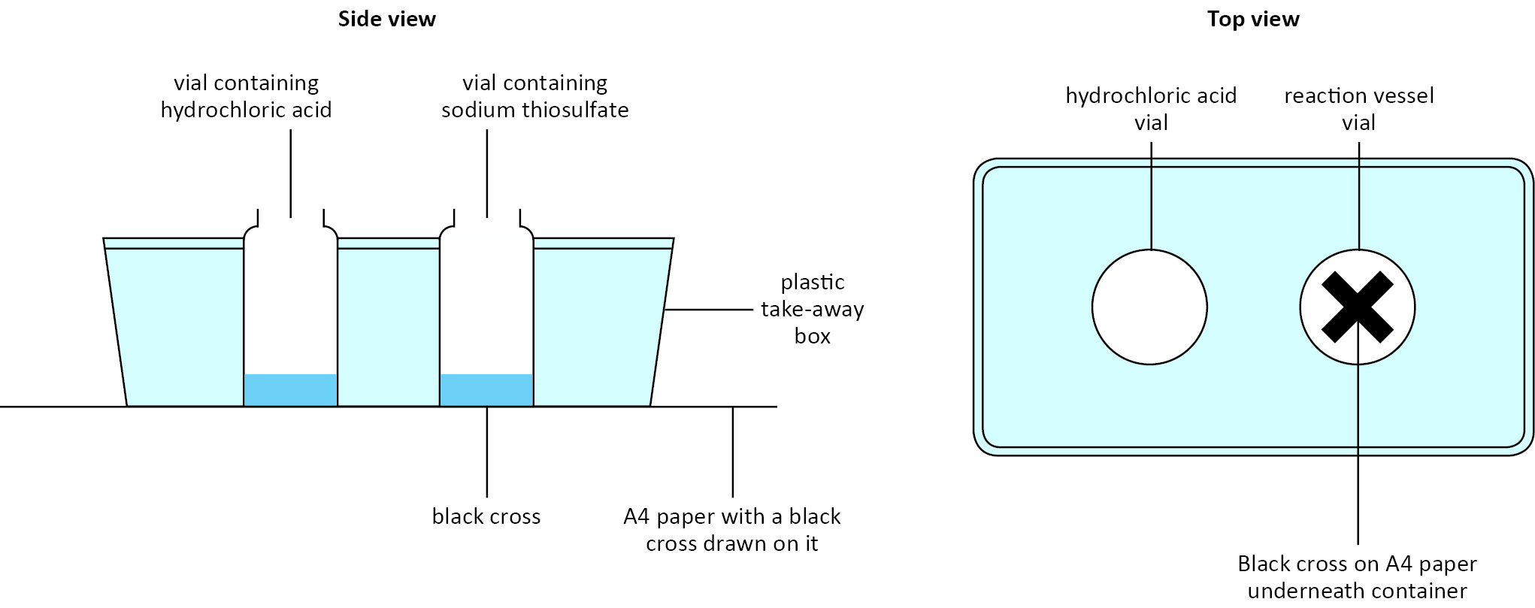
Figure 1: The equipment set-up

STAGE 2: The reactions
- Using a 10 cm³ measuring cylinder, measure 3 cm³ of sodium thiosulfate into the reaction vial, then 7 cm³ of distilled water. Place the vial in the 'reaction' hole (i.e. the one with the cross).
- Measure out 1.0 cm³ of hydrochloric acid into a dropping pipette.
- Holding the dropping pipette in one hand, and the stop watch in the other, simultaneously add the acid to the reaction vial and start the stop watch.
- Give the vial a quick swirl to ensure complete mixing.
- Look down through the 'reaction' vial from above and record the time taken for the cross to disappear from view.
- Pour the cloudy contents of 'reaction' vial into your 'STOP BATH', and rinse the vial several times with tap water and shake dry.
- Repeat the procedure using different volumes of sodium thiosulfate and water as shown in the results table on the opposite page.

You can draw your own table, or use the one below.
Volume of 0.1 mol dm^{–3} sodium thiosulfate solution (cm³) | Volume of deionised water  (cm³) | Time  (s) | Rate of reaction as 1/time  (s^{–1})
3 | 7
4 | 6
5 | 5
6 | 4
7 | 3
8 | 2
9 | 1

STAGE 3: End notes
- If you have the time and reagents available, carry out repeat experiments to help you increase the accuracy of your results.
- All solutions can be rinsed down the sink with plenty of water and glassware rinsed with tap-water.

Results
1. | Calculate the rate of each reaction by dividing 1 by the time taken for the black cross to disappear.
2. | Plot a graph of volume of sodium thiosulfate against rate of reaction.
3. | Describe the mathematical relationship between concentration of sodium thiosulfate and the rate of reaction.  As the volume and concentration of sodium thiosulfate are proportional, you can assume the graph you plotted in question 2 will have the same shape as the concentration against rate graph.

Notes page

Endothermic and exothermic reactions

Measuring rates of reaction
You will investigate a series of chemical reactions and determine whether they are exothermic or endothermic.

Equipment

- Eye protection
- Polystyrene cup
- 250 cm³ beaker
- Thermometer
- 10 cm³ measuring cylinder
- Spatula
- Paper towel
- Magnesium ribbon
- Magnesium powder (DANGER: Flammable)
- Citric acid solid (WARNING: Irritant)
- Copper(II) sulfate (DANGER: Corrosive and irritant)
- Hydrochloric acid
- Sodium hydroxide (WARNING: Irritant)
- Sulfuric acid
- Sodium hydrogen carbonate

Health and safety
- Eye protection should be worn at all times.
- Ensure that there are no open flames in the laboratory.
- DO NOT remove any chemical from the classroom.

Method
- Place the polystyrene cup in the beaker to stabilise the cup, and provide some insulation.
- Add 20 cm³ of hydrochloric acid into the cup.
- Measure and record the temperature of the solution.
- Add 20 cm³ of sodium hydroxide into the cup.
- Stir the mixture with the thermometer and note the temperature once it stops changing.
- Dispose of the reaction mixture down the sink with plenty of water.
- Rinse and dry the cup.
- Repeat for the remaining mixtures.

Results table
Reaction | Final temperature (°C) | Initial temperature (°C) | Change in temperature (°C) | Exothermic or endothermic reaction
20 cm³ hydrochloric acid
+ 20 cm³ sodium hydroxide
20 cm³ sodium hydrogen carbonate solution
+ 4 spatulas citric acid solid
20 cm³ copper sulfate solution + 2 spatulas magnesium powder
20 cm³ sulfuric acid
+ 4 cm magnesium ribbon

Results
1. | Which reactions are neutralisation reactions?

2. | Which reactions are displacement reactions?

Physics

Materials

Determining the density of materials
You will be investigating how to determine the density of different materials and objects. The material could be solid or liquid, and the object could be a regular or an irregular shape.

Equipment
- Cubes of wood, lead and plastic
- Plasticine and a pebble
- Vegetable oil
- Balance
- Ruler
- Eureka can (displacement vessel)
- Measuring cylinder

Method
- Choose a sample. Decide if it is a regularly shaped solid, and irregularly shaped solid or a liquid. Measure the mass and volume of your sample using the appropriate method.

Regular shaped solid – method for measuring density
- Measure the height, width and depth of the material cube in cm to one decimal place (d.p.).
- Multiply height × width × depth to calculate the volume of the cube in cm³.
- Divide the volume by 10⁶ to convert it to m³.
- Measure the mass of the material cube in g to one decimal place (d.p.).

Irregular shaped solid – method for measuring density
- Fill the eureka can up to the spout and wait for it to stop overflowing.
- Place the measuring cylinder under the spout to catch the overflow of water from the eureka can.
- Gently lower sample into the eureka can and then the measure the volume of water that overflows in cm³.
- Divide the volume by 10⁶ to convert it to m³.
- Measure the mass of the sample in g to one d.p.

Liquid – method for measuring density
- Measure the mass of the measuring cylinder in g to one d.p.
- Fill the measuring cylinder to a depth of about 2 cm and measure the volume of the sample to the nearest cm³.
- Divide the volume by 10⁶ to convert it to m³.
- Measure the mass of the measuring cylinder plus sample in g to one d.p.
- Subtract the mass of the measuring cylinder from the mass of the total mass to calculate the mass of the sample in g to one decimal place.
- Divide the mass by 10³ to convert it to kg.
- Apply the equation $\frac{mass in kg}{volume in m^{3}} =density in {kg}/{m^{3}}$
- Record your results in the table below.
- Repeat the procedure from step 1 with a new sample.

Results
Sample | Volume  (cm³) | Mass  (g) | Volume  (m³) | Mass  (kg) | Density  (kg/m³)
 | Observations |  | Processed data

Forces

Extension of a spring
You will be investigating the extension of a spring when a force is applied. You will apply the force to the spring by hanging different masses on it.

Equipment
- Eye protection
- Clamp, stand and boss
- Metre ruler
- 30 cm ruler
- Extendable steel spring
- Mass hanger and slotted masses
- Graph paper

Method
- Put on your eye protection and then set up the equipment as shown in the diagram.
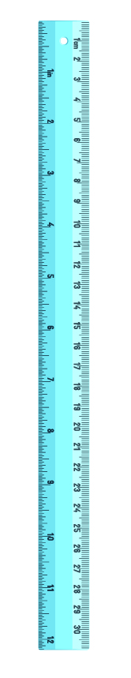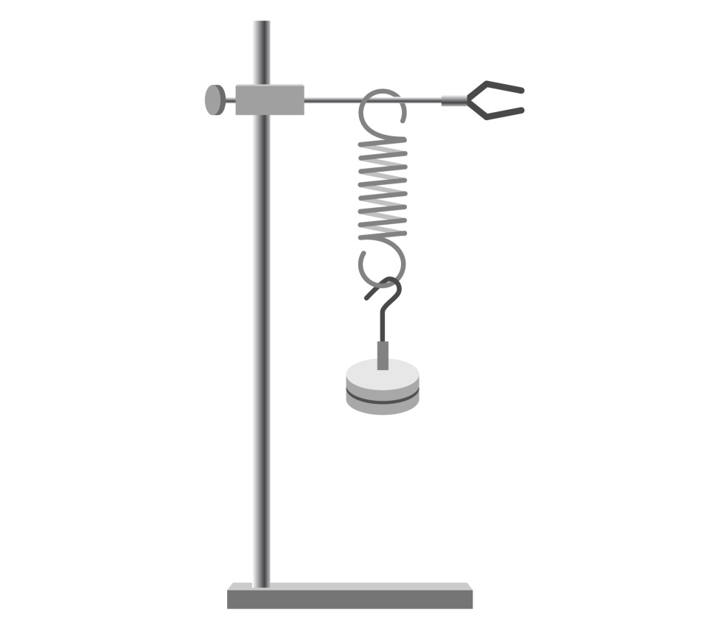
Ruler
Clamp
Mass hanger
Boss head
Retort stand
Spring
Figure 1: Equipment set up
- Measure the length of the spring between clamp and the base of the hanger.
- Add a mass to the hanger and then measure the length of the spring and hanger.
- $extension= \left(length of spring +mass\right)-(original length of spring+hanger)$.
- $force \left(N\right)=mass \left(kg\right)×gravitational field strength (10 m/{s^{2})}$.
- Add another mass to the hanger and repeat from step 1.
- $spring constant= \frac{force (N)}{extension (m)}$
- Plot your results on a graph. Plot force on the x-axis and extension on the y-axis, then draw a line of best fit.
- $gradient of line of best fit = \frac{force (N)}{extension (m)} =spring constant$

Results
Mass  (kg) | Length  spring–hanger  (m) | Length  spring+mass  (m) | Extension  (m) | Spring constant  (N/m)
Raw data |  |  | Processed data

Motion

Acceleration of a trolley down a ramp
You will be investigating the acceleration of a trolley down a ramp. You will time how long the trolley takes to travel the last 30 cm of the ramp. You will then compare your method to using light gates and/or data loggers to measure acceleration.

Equipment (per group)
- Eye protection
- Trolley
- Ramp
- Wooden block to prop up the ramp
- Metre ruler
- Stopwatch
- 30 cm³ ruler
- Graph paper

Equipment (per class)
- 2 x Light gates
- Card for top of trolley
- Data logger

Method
- Put on your eye protection and then set up the equipment as shown in the diagram (Figure 1).
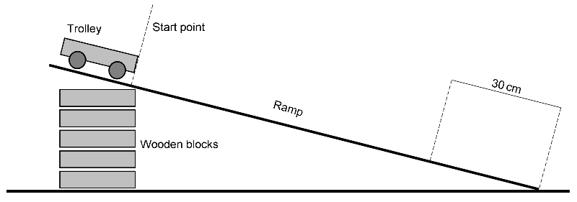
Figure 1: Equipment set up
- Mark the start point and the final 30 cm onto the ramp using a pencil or tape.
- Place the trolley at the top of the ramp as shown. Release the trolley and allow it to accelerate down the ramp, and use the stop watch to time it over the last 30 cm.
- $speed (m/s)= \frac{distance (metre)}{time (second)}$
- Replace the trolley at the top of the ramp. Release the trolley and use the stop watch to time it from the start point to the end of the ramp.
- $acceleration (m/s^{2}) = \frac{speed over 30cm (m/s) -speed at start point (0 m/s) }{time over length of ramp (s)}$
- Complete the table column headings and record your data.
- Repeat steps 3 to 6 four more times and record your data.
- Calculate the average acceleration of the trolley down the ramp.
- Compare your results to the acceleration calculated using the light gates or data logger.

Results
Speed at start point (m/s) | Time last  30 cm (s) | Time whole ramp ( ) | (m/s) | Acceleration  ( )
Raw data |  |  | Processed data

The effect of depth on the speed of water waves

Speed of waves
You will be investigating how depth of water affects the speed of a wave in a ripple tank. Using your data you will predict the speed of a tsunami.

Equipment
- Plastic tray
- Metre ruler
- Stopwatch
- Access to water

Method
- Fill the bottom of the tray to a depth of about 2 cm as shown in the diagram (Figure 1). Measure the length of the tray.
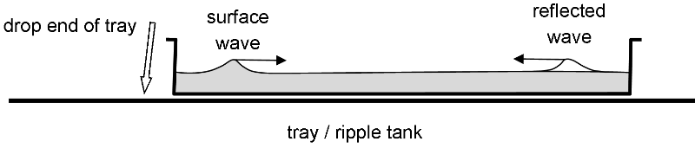
Figure 1: Equipment set up
- Measure the water depth in the tray to the nearest mm. Lift one end of the tray a couple of centimetres and drop it back onto the desk. A surface ripple will travel from that side across the tray and reflect off the opposite side.
- Measure how long it takes for the wave to travel four times across the tray.
- $wave speed\left(m/s\right)= \frac{distance (m)}{time (s)}$
- Complete the headings on the table and record your data.
- Add around 0.5 cm of water to the tray and repeat from Step 2 until you have at least six data points.
- Plot your results on a graph. Plot water depth (m) on the x-axis and wave speed (m/s) on the y-axis, then draw a line of best fit.
- Calculate the average gradient of the line of best fit.

Results
Depth (m) | Length (m) | Time to cross tray four times (s)

The average depth of the Indian Ocean is 4000 m. Predict the speed of the tsunami on the 26th December 2004 using the line of best fit from your graph.
The actual tsunami took 7 hours to reach the coast of Africa travelling at 180 m/s.
Predict the speed of tsunami in the Indian Ocean using this formula:
$$speed of tsunami \left(m/s\right) =gradient of line of best fit×4000 m$$

The method you used makes a single ripple in the tray of water. If you wanted to measure wave frequency you would need to modify the method to produce a regular pattern of ripples. Compare the three methods below and decide which would give the most accurate results for measuring wave frequency:
- Student taps on the bench beside the tray, to make ripples in the water.
- Student sets a phone to vibrate and places it under the tray, and then rings the phone.
- Student uses an electric motor to control a paddle at one end of the tray

Waves – reflection and refraction

Reflection and refraction of light
You will be investigating the reflection of light off a plane mirror and the refraction of light through a rectangular prism.

Equipment
- Low voltage power supply
- Ray box
- Single slits
- Plane mirror
- Holders for mirror
- Glass/Perspex block
- Protractor
- White paper
- Pencil and ruler

Method
- Using the power supply, ray box and single slit set up the equipment so that you have a ray of light to carry out your investigation on the behaviour of light waves.

Reflection of light –measuring angles of incidence and reflection (plane mirror)
  - Set up the plane mirror so that it reflects the ray of light (Figure 1).
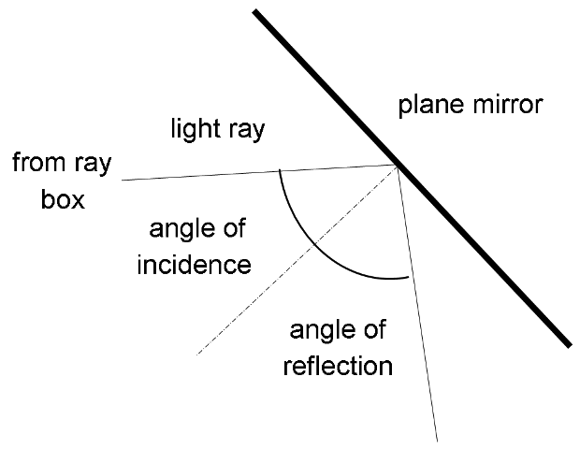
Figure 1: Equipment set up with mirror
  - Measure the angle of incidence and the angle of reflection.
  - Record your observations in the table
  - Change the angle of incidence of the ray of light and repeat your measurements to determine the relationship between the two angles

Refraction of light –measuring angles of incidence and reflection (Perspex/glass block)
- Set up the Perspex/glass block so that the ray of light passes through it (Figure 2)
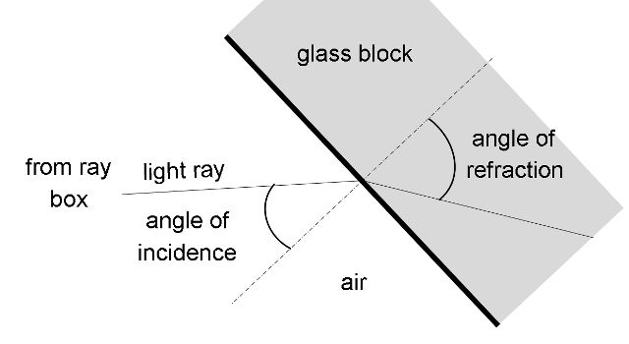
Figure 2: Equipment set up with perspex/glass block
- Measure the angle of incidence and the angle of refraction. They will be easier to measure if you mark them onto a sheet of paper
- Record your observations in the table
- Change the angle of incidence of the ray of light and repeat your measurements to determine the relationship between the two angles

Results
Comments

Comments

Energy

Specific heat capacity in a metal
You will be investigating the specific heat capacity of a metal block. Using a circuit diagram you will construct a circuit to power the electric heater and then you will use your measurements to determine the energy transferred to the metal block.

Equipment
- Metal blocks - copper, aluminium, lead
- Power pack
- Voltmeter
- Ammeter
- Low voltage electric heater
- Connecting leads
- Thermometer
- Stopwatch
- Heatproof mat
- Insulating material

Method
- Using the electrical components that are listed above, construct the circuit shown in the circuit diagram (Figure 1). The heater is labelled as this is a new component symbol to you.
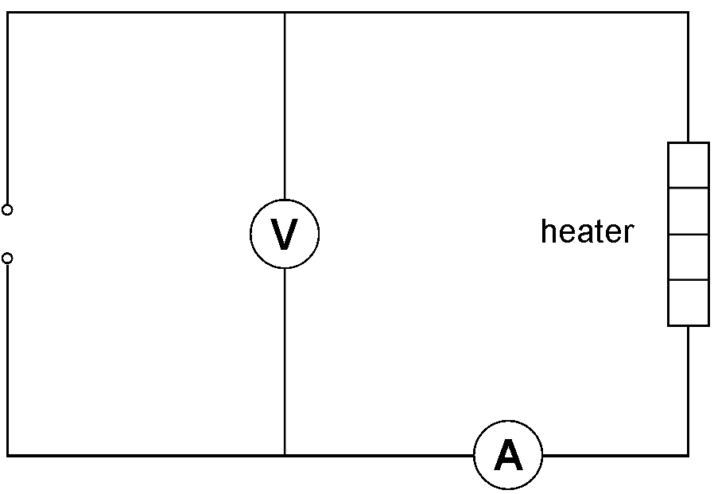
Figure 1: Circuit set up
- Place the metal block on the heat mat and insert the thermometer and heater into separate holes in the metal block.
- Measure the temperature of the metal block. Now start the stop clock and switch on the heater. Take a temperature measurement every minute for ten minutes.
- Record the voltage and current in your results table.

- Wrap the metal block in insulating material and repeat from Step 3.
- Calculate the energy transferred to the metal block using this foumula:
$$Energy transfered \left(J\right)=current \left(A\right)×potential difference \left(V\right)×time (s)$$
- Compare your results to the measurements of energy transfer using a joulemeter and a data logger.
- Plot your results on a graph. Plot time (s) on the x-axis and temperature (°C) on the y-axis, then draw two line of best fit.

Results
Time  (s) | (°C)
Observations |  |  |  | Processed Results

Circuits

Current and voltage
You will be investigating the current and potential difference (I-V) characteristics of three electrical components, a resistor, a filament bulb and a diode.

Equipment
- 4 x 1.5 V Cells and cell holder
- Variable resistor (rheostat)
- Connecting leads
- Ammeter (multimeter)
- Voltmeter
- Fixed Resistor
- Bulb 12 V
- Semiconductor diode
- Switch
- Heat proof mat

Method
- Using the electrical components that are listed above, construct the circuit shown in the circuit diagram.
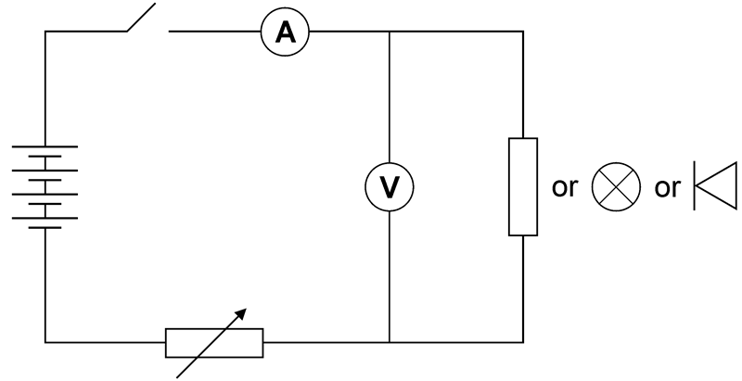
Figure 1: Circuit set up
- Use the variable resistor to change the potential difference across the component.
- Record values of the current (I) for at least five different values of potential difference (V) across the electrical component being investigated.
- Change over the connections to the cell holder and repeat your readings. The potential difference measurements will now be negative (–) V.
- Now replace the fixed resistor with the next electrical component (filament bulb or diode) and repeat steps 2 to 4. You may have to change the ammeter scale on the mustimeter from when investigating the diode.
- Plot your results for each component on a separate graph. Plot potential difference (V) on the x-axis and current (I) on the y axis, then a draw line of best fit. The scale on the x-axis will need to go from -6V to 6V, and the y-axis will also need to display negative and positive current. The origin (0,0) will be in the middle of your graph.

Results
Fixed Resistor |  | Filament Bulb |  | Diode
(V) | (mA) | Voltage | Current

