# Foundation Check In - 1.04 Inverse operations

Fill in the missing values.

1. 
2. 
3. 
4. 
5. Find the reciprocal of 0.8.
6. Jai thinks of a number. He multiplies it by 6 and finds the square root of the answer. Explain how you would find the number Jai thought of.
7. Given that , show that .
8. Asher says that if  then . What mistake has Asher made?
9. A triangle has an area of 96 cm2 and a height of 8 cm. How long is the base of the triangle?
10. Material costs £12.50 per square metre. Asif pays £75 for a piece of material 1.5 m wide. How long is the piece of material Asif buys?

**Extension**

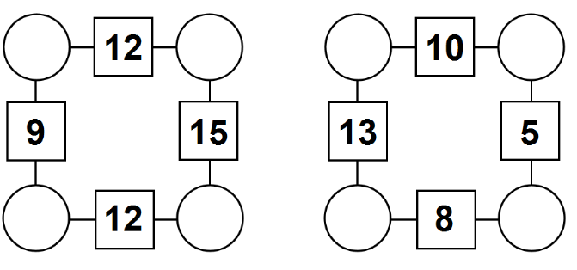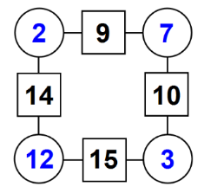

+

+

+

These are also arithmagons.

Can you work out what numbers could go in the blank circles?

Can you find different solutions?

Make some of your own arithmagons.

This is an arithmagon.

The numbers in the square boxes are made by adding the numbers in the circles on either side.

Answers

1. 
2. 18
3. 36
4. -3
5. 1.25
6. You would square the answer and then divide by 6
7. , 
8. Asher has doubled *x* instead of squaring it
9. Area , so base cm
10. m long

**Extension**

E.g.

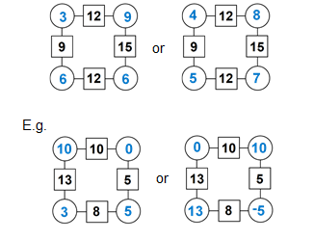

We’d like to know your view on the resources we produce. By clicking on ‘[Like’](mailto:resources.feedback@ocr.org.uk?subject=I%20liked%20the%20GCSE%20(9-1)%20Mathematics%20Check%20In%201.04%20Foundation) or ‘[Dislike’](mailto:resources.feedback@ocr.org.uk?subject=I%20disliked%20the%20GCSE%20(9-1)%20Mathematics%20Check%20In%201.04%20Foundation) you can help us to ensure that our resources work for you. When the email template pops up please add additional comments if you wish and then just click ‘Send’. Thank you.

Whether you already offer OCR qualifications, are new to OCR, or are considering switching from your current provider/awarding organisation, you can request more information by completing the Expression of Interest form which can be found here: [www.ocr.org.uk/expression-of-interest](http://www.ocr.org.uk/expression-of-interest)

Looking for a resource? There is now a quick and easy search tool to help find free resources for your qualification:   
[www.ocr.org.uk/i-want-to/find-resources/](http://www.ocr.org.uk/i-want-to/find-resources/)

**OCR Resources**: *the small print*OCR’s resources are provided to support the delivery of OCR qualifications, but in no way constitute an endorsed teaching method that is required by the Board, and the decision to use them lies with the individual teacher. Whilst every effort is made to ensure the accuracy of the content, OCR cannot be held responsible for any errors or omissions within these resources. This formative assessment resource has been produced as part of our free GCSE teaching and learning support package. All the GCSE teaching and learning resources, including delivery guides, topic exploration packs, lesson elements and more are available on the qualification webpages. If you are looking for examination practice materials, you can find Sample Assessment Materials (SAMs) and Practice Papers on the qualification webpage <http://www.ocr.org.uk/qualifications/gcse-mathematics-j560-from-2015/>

© OCR 2019 - This resource may be freely copied and distributed, as long as the OCR logo and this message remain intact and OCR is acknowledged as the originator of this work.

OCR acknowledges the use of the following content: n/a

Please get in touch if you want to discuss the accessibility of resources we offer to support delivery of our qualifications: [resources.feedback@ocr.org.uk](mailto:resources.feedback@ocr.org.uk)

|  |  |  |  |  |  |  |  |  |  |  |  |  |
| --- | --- | --- | --- | --- | --- | --- | --- | --- | --- | --- | --- | --- |
| **Assessment Objective** | **Qu.** | **Topic** | **R** | **A** | **G** |  | **Assessment Objective** | **Qu.** | **Topic** | **R** | **A** | **G** |
| AO1 | 1 | Solve single step equation by finding square root |  |  |  |  | AO1 | 1 | Solve single step equation by finding square root |  |  |  |
| AO1 | 2 | Solve two step equation using inverse operations |  |  |  |  | AO1 | 2 | Solve two step equation using inverse operations |  |  |  |
| AO1 | 3 | Use inverse operations involving negative numbers |  |  |  |  | AO1 | 3 | Use inverse operations involving negative numbers |  |  |  |
| AO1 | 4 | Use two step inverse operations involving negative numbers |  |  |  |  | AO1 | 4 | Use two step inverse operations involving negative numbers |  |  |  |
| AO1 | 5 | Find a reciprocal |  |  |  |  | AO1 | 5 | Find a reciprocal |  |  |  |
| AO2 | 6 | Communicate solution involving inverse operations |  |  |  |  | AO2 | 6 | Communicate solution involving inverse operations |  |  |  |
| AO2 | 7 | Reason using inverse operations to achieve a given result |  |  |  |  | AO2 | 7 | Reason using inverse operations to achieve a given result |  |  |  |
| AO2 | 8 | Assess validity of statement involving inverse operations |  |  |  |  | AO2 | 8 | Assess validity of statement involving inverse operations |  |  |  |
| AO3 | 9 | Solve geometric problem using inverse operations |  |  |  |  | AO3 | 9 | Solve geometric problem using inverse operations |  |  |  |
| AO3 | 10 | Solve a problem in context using inverse operations |  |  |  |  | AO3 | 10 | Solve a problem in context using inverse operations |  |  |  |
|  |  |  |  |  |  |  |  |  |  |  |  |  |
| **Assessment Objective** | **Qu.** | **Topic** | **R** | **A** | **G** |  | **Assessment Objective** | **Qu.** | **Topic** | **R** | **A** | **G** |
| AO1 | 1 | Solve single step equation by finding square root |  |  |  |  | AO1 | 1 | Solve single step equation by finding square root |  |  |  |
| AO1 | 2 | Solve two step equation using inverse operations |  |  |  |  | AO1 | 2 | Solve two step equation using inverse operations |  |  |  |
| AO1 | 3 | Use inverse operations involving negative numbers |  |  |  |  | AO1 | 3 | Use inverse operations involving negative numbers |  |  |  |
| AO1 | 4 | Use two step inverse operations involving negative numbers |  |  |  |  | AO1 | 4 | Use two step inverse operations involving negative numbers |  |  |  |
| AO1 | 5 | Find a reciprocal |  |  |  |  | AO1 | 5 | Find a reciprocal |  |  |  |
| AO2 | 6 | Communicate solution involving inverse operations |  |  |  |  | AO2 | 6 | Communicate solution involving inverse operations |  |  |  |
| AO2 | 7 | Reason using inverse operations to achieve a given result |  |  |  |  | AO2 | 7 | Reason using inverse operations to achieve a given result |  |  |  |
| AO2 | 8 | Assess validity of statement involving inverse operations |  |  |  |  | AO2 | 8 | Assess validity of statement involving inverse operations |  |  |  |
| AO3 | 9 | Solve geometric problem using inverse operations |  |  |  |  | AO3 | 9 | Solve geometric problem using inverse operations |  |  |  |
| AO3 | 10 | Solve a problem in context using inverse operations |  |  |  |  | AO3 | 10 | Solve a problem in context using inverse operations |  |  |  |