Preparing for the moderated unit - R013

Checklist for teachers
What | When | Done
- Get exam accounts set up (with internet access) for each candidate with all the normal software you can on the school system.  Candidates will need to be able to password protect documents if needed and create macros if needed.  These must be accessible only during the lessons. | - As soon as you decide which session you will submit work for.  It may take time for your technical team to set them up.
- Download and distribute the set assignment and data files to each of the exam accounts for the candidates to use. | - December if submitting in May/June  OR  - June if submitting in January.
- Download and read the TEACHER guidance document | As soon as possible so that you know what is required.
- Print out the assignment tasks for candidates (and yourself to refer to) | For you - as soon as you can so you can understand it clearly when providing generic guidance.  For candidates - so that they have them in the classroom - they cannot take them out or home.
- Open/close the exam accounts | This needs to be done each lesson/session while the assignment is being completed.
Watch our short video ‘Unboxing your assignment’ for advice on how to prepare your candidates for this unit: https://www.youtube.com/watch?v=3yYEGAVtkN0

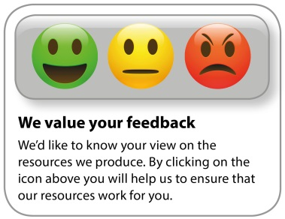
Whether you already offer OCR qualifications, are new to OCR, or are considering switching from your current provider/awarding organisation, you can request more information by completing the Expression of Interest form which can be found here: www.ocr.org.uk/expression-of-interest
Looking for a resource? There is now a quick and easy search tool to help find free resources for your qualification:
https://www.ocr.org.uk/i-want-to/find-resources/

OCR Resources: the small print
OCR’s resources are provided to support the delivery of OCR qualifications, but in no way constitute an endorsed teaching method that is required by the Board, and the decision to use them lies with the individual teacher. Whilst every effort is made to ensure the accuracy of the content, OCR cannot be held responsible for any errors or omissions within these resources.

Our documents are updated over time. Whilst every effort is made to check all documents, there may be contradictions between published support and the specification, therefore please use the information on the latest specification at all times. Where changes are made to specifications these will be indicated within the document, there will be a new version number indicated, and a summary of the changes. If you do notice a discrepancy between the specification and a resource please contact us at:
resources.feedback@ocr.org.uk.
© OCR 2019 - This resource may be freely copied and distributed, as long as the OCR logo and this message remain intact and OCR is acknowledged as the originator of this work. OCR acknowledges the use of the following content: n/a
Please get in touch if you want to discuss the accessibility of resources we offer to support delivery of our qualifications: resources.feedback@ocr.org.uk

