Teaching pack

Unit 6: Control of hazards in the laboratory

Teaching delivery
Unit documentation:
https://www.ocr.org.uk/Images/272153-control-of-hazards-in-the-laboratory.pdf
Grading Criteria:
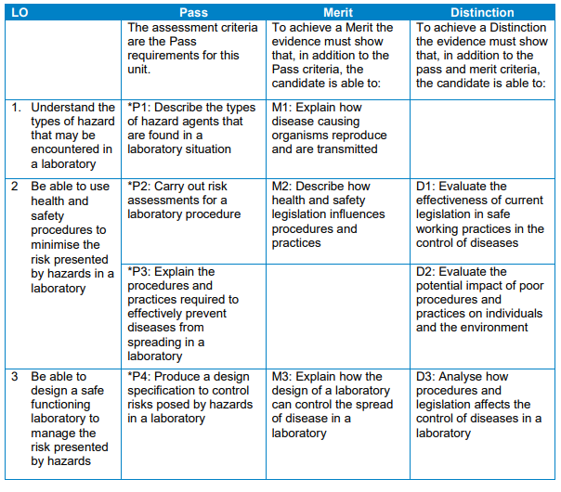

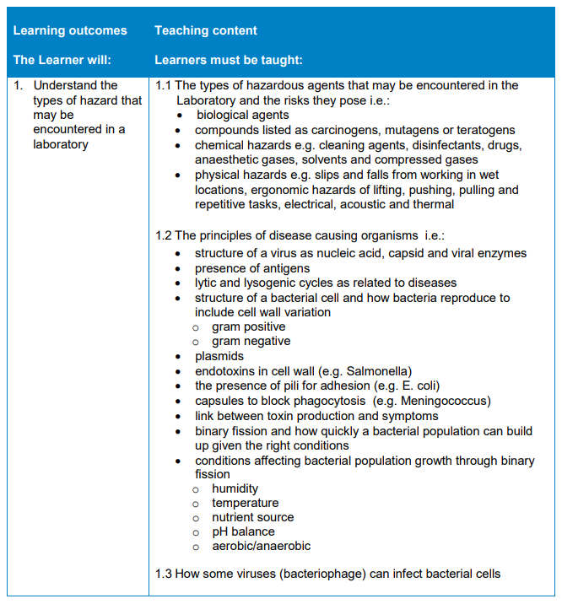

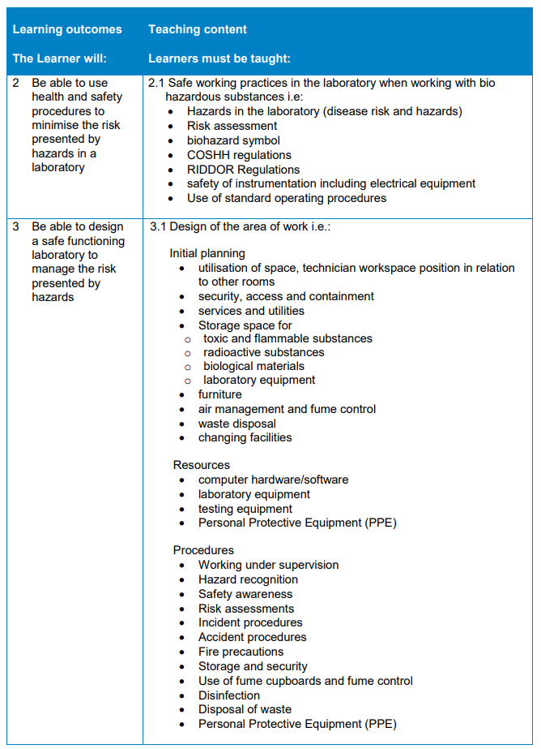

Section 1: LO3 Be able to design a safe functioning laboratory to manage the risk presented by hazards
When working with organisms that can present different levels of biohazards. There are different designed laboratories for different levels of biohazards - there are 4 levels of containment laboratories.
Students will be used to working in a laboratory at level 1 containment but not realise the procedures required when handling very contagious microorganisms. Students should look at the laboratory they are in, then compare it to working in a level 2 containment laboratory.
Level 2 laboratories cover work with agents associated with human diseases (i.e. pathogenic or infections organisms) that pose a moderate health hazard. Examples of agents typically worked include equine encephalitis viruses and HIV, as well as Staphylococcus aureus (staph infections).
A level 3 laboratory includes work on microbes that are either indigenous or exotic, and can cause serious or potentially lethal disease through inhalation. Examples of microbes worked with in a level 3 laboratory includes; yellow fever, West Nile virus, and the bacteria that causes tuberculosis.
The microbes are so serious that the work is often strictly controlled and registered with the appropriate government agencies. Laboratory personnel are also under medical surveillance and could receive immunizations for microbes they work with.
As the highest level of biological safety, a level 4 laboratory consists of work with highly dangerous and exotic microbes. Infections caused by these types of microbes are frequently fatal, and come without treatment or vaccines. Two examples of such microbes include Ebola and Marburg viruses.
When planning a laboratory students could consider information provided by the ASE, that can be found at: www.ase.org.uk/resources/school-science-architecture-special-report and from NERC guidance on design of safe laboratories http://www.nerc.ac.uk/about/policy/safety/procedures/guidance-laboratories/
An overview of the relevant health and safety legislation and other guidance that should be consulted when working with biological agents in any type of microbiological containment laboratory as well as containment control regulation (learner resource 1) and the specific controlling legislation (learner resource 2) affecting the control of diseases in a laboratory.

Section 2: LO2 Be able to use health and safety procedures to minimise the risk presented by hazards in a laboratory
Students are introduced to the regulations that will “keep them safe from risk”.
Central to most health and safety legislation is the requirement for an assessment of the risks arising from work. A risk assessment is simply a means of determining the risk associated with work with a particular hazard. In the workplace, this is most often broken down into five steps (learner resource 3).
The methods chosen to control the risks identified by the risk assessment should follow the hierarchical approach (learner resource 3) which is common to both MHSWR and COSHH. The hierarchy reflects the fact that eliminating and controlling risk by using physical engineering controls and safeguards is more dependable than relying solely on systems of work. Example of a risk assessment (learner resource 4).
Students should consider how laboratory acquired Infections can be prevented (learner resource 5). Infectious agents are transmitted through one or more routes of exposure.
Practical opportunity
Students might carry out – Practical procedures preventing spread of disease (learner resource 6) in a laboratory - reflecting on why the procedures are carried out in terms of risk.
Link to unit 10 – LO5 – practical opportunity (learner resource 7).
At this point you might link to unit 2 LO6 Be able to use aseptic technique – questions could be introduced for exam preparation.
Unit 2, LO6: Be able to use aseptic technique Microbiology
Exemplification:
Explain the reason for using aspects of aseptic technique such as: sterilisation methods; decontamination of surfaces and equipment; avoiding contamination of material by the environment and by people; preventing people coming into direct contact with pathogens; controlled airflow cabinets

Recognise the types of practical work where aseptic technique is essential e.g. cell and tissue culture, preparation of medical test kits, pharmaceutical production, microbiology, medical and surgical procedures.

Be able to streak a plate
Explain how to carry out the technique correctly
Interpret the appearance of streaked plates in terms of the purity of the culture used to make the streak plate.

Clone a cauliflower
Explain aspects of aseptic technique in relation to this process
Students should consider the legislation and guidance for working with biological agents and how it influences procedures and practices.
There have been a number of surveys of infection in various types of laboratory. In the UK, there was a series of surveys carried out between 1970 and 1989 looking at the rates of infection among workers in UK clinical laboratories. Data from the 1988/89 survey suggested an infection rate of 82.7 infections per 100 000 person-years. Students could research data to evaluate the effectiveness of current legislation (learner resource 8).

Section 3: LO1 Understand the types of hazard that may be encountered in a laboratory
Students will have considered some of risks within a laboratory.
Examples of common hazards include the following:
- Chemical hazards: Toxins, corrosives, flammables, reactives, cleaning agents, disinfectants, drugs, anaesthetic gases, solvents and compressed gases.
- Biological hazards: Microbes, animals, plants, and genetically modified agents.
- Radiation hazards: All unsealed radioactive material is a potential internal radiation hazard (e.g. it can be inhaled, ingested or absorbed through the skin, leading to dangerous exposure).
- Physical hazards: slips and falls from working in wet locations, acoustic and thermal.
- Electrical hazards: typical laboratory contains a wide variety of electrically powered equipment and can cause hazards if poorly installed or maintained systems and fires due to sparks.
- Mechanical hazard: Machinery, its parts, tools, objects and materials processed or used in the work process are often a source of mechanical hazards leading to injuries.
- Airborne hazardous materials: including vapours and dust.
- Ergonomic factors: hazards of lifting, pushing, pulling and repetitive tasks.

Addition for Radiology Coverage (learner resource 9)
- Physical hazards: slips and falls from working in wet locations, acoustic and thermal
- Electrical hazards: typical laboratory contains a wide variety of electrically powered equipment and can cause hazards if poorly installed or maintained systems and fires due to sparks.
- Mechanical hazard: Machinery, its parts, tools, objects and materials processed or used in the work process are often a source of mechanical hazards leading to injuries.
- Airborne hazardous materials: including vapours and dust
- Ergonomic factors: hazards of lifting, pushing, pulling and repetitive tasks
Students will need to know how organisms cause disease and how pathogens are transmitted to be able to reduce risks in a laboratory, as well as to categorise hazard substances (learner resource 10) such as:
- Carcinogens - a carcinogen is a substance that causes cancer.
- Mutagens - a mutagen is a substance or agent that causes an increase in the rate of change in genes.
- Teratogens - a teratogen is an agent that can cause malformations of an embryo or unborn child (foetus).

Student assessment
Students are required to produce a portfolio of evidence that meets the grade criteria.
This can be done in part as the unit is delivered or as a large assignment at the end of the teaching delivery.
OCR provides a model assignment or if you wish you can development your own assignment but it must allow students to meet all of the grade criteria. A sample model assignment is provided in this pack.

Learner resource 1

Containment control regulation
Containment control regulation
Regulation | Notes
Control of Substances Hazardous to Health Regulations 2002 (COSHH) https://www.hse.gov.uk/pUbns/priced/l5.pdf | COSHH classifies biological agents into four hazard groups based on their ability to infect and cause harm to humans. COSHH does not consider environmental risks
Specified Animal Pathogens Order 1998 (SAPO)  https://www.hse.gov.uk/biosafety/sapo.htm | The purpose of SAPO is to prevent the introduction and spread of animal pathogens that cause serious exotic diseases in livestock and poultry and economic loss to the British livestock and poultry industries.  Specified animal pathogens are classified into three main categories by DEFRA: DEFRA Group 2, DEFRA Group 3 and DEFRA Group 4 – Group 4 requiring the highest level of containment.
Genetically Modified Organisms (Contained Use) Regulations 2000 (GMO(CU))  https://www.hse.gov.uk/pUbns/priced/l29.pdf | The GMO(CU) Regulations provide for human health and safety and environmental protection from genetically modified micro-organisms in contained use
Anti-terrorism, Crime and Security Act 2001 (ATCSA)  https://www.gov.uk/government/publications/anti-terrorism-crime-and-security-act-2001-consultation-relaunch-and-amendmenst | Contains further legal requirements to ensure that the storage and use of dangerous pathogens and toxins

Learner resource 2

Specific controlling legislation affecting the control of diseases in a laboratory
Hazard | Legislation | Further guidance
Chemical
Flammables | Chemicals (Hazard Information and Packaging for Supply) Regulations 2002  Regulatory Reform (Fire Safety) Order 2005 | The safe use and handling of flammable liquids.  The storage of flammable liquids in containers.
Carcinogens | Control of Substances Hazardous to Health Regulations 2002 (as amended) (COSHH) | COSHH Approved Code of Practice Fifth edition.
Toxins | Anti-terrorism, Crime and Security Act 2001 – Part 7; Schedule 5 | Security standards for laboratories.
Radiation
Radionuclides  Equipment that Work with ionising radiation. Ionising produces radiation | Radioactive Substances Act 1993  Ionising Radiations Regulations 1999 | Work with ionising radiation. Ionising produces radiation.  Radiations Regulations 1999. Approved Code of Practice and guidance
Physical
Pressure systems  (autoclaves) | Pressure Systems and Transportable  Gas Containers Regulations 1989  Pressure Equipment Regulations 1999 | Safety at autoclaves.
Electricity | Electricity at Work Regulations 1989 | Electricity at work: Safe working practices.
Ergonomics
General | Non-specific – general controls under HSW Act and Management Regulations

Learner resource 3

Determining risk, 5 step

Unit 6, P2
Central to most health and safety legislation is the requirement for an assessment of the risks arising from work. A risk assessment is simply a means of determining the risk associated with work with a particular hazard. In the workplace, this is most often broken down into five steps:
- Deciding who is at risk from the hazard and how harm could arise).
- Assessing how likely it is that harm will arise and whether existing precautions are adequate.
- Making a record of findings, including the control measures you have selected and any action you have identified as necessary to reduce the risk of exposure further.
- Reviewing and revising the assessment as necessary especially if the nature of the work changes or if something else suggests that it may no longer be valid, e.g. as a result of an incident.
- Controlling the risks.

Hierarchical approach
The methods chosen to control the risks identified by the risk assessment should follow the hierarchical approach which is common to both MHSWR and COSHH. The hierarchy reflects the fact that eliminating and controlling risk by using physical engineering controls and safeguards is more dependable than relying solely on systems of work:
- Eliminating risks: e.g. by substituting a hazardous biological agent with something less/non-hazardous, e.g. using a non-toxigenic strain of a biological agent when carrying out laboratory quality control (QC) tests.
- Controlling risks at source: by using engineering controls and giving collective protective measures priority, e.g. using a microbiological safety cabinet when work could create an infectious aerosol, or using needle safety devices to prevent and control needlestick injuries.
- Minimising risks by designing suitable systems of working: e.g. having an effective hand hygiene policy in place in laboratory or healthcare settings. This option also includes the use of personal protective clothing and equipment (PPE), but PPE should only be used as a last resort after considering elimination or tackling at source.

Learner resource 4

An example of a risk assessment
Risk assessment
Substance | Hazard | Comment
Crystal violet | Harmful/ Irritant | Skin contamination will be very obvious. This should be avoided. Dusts of most dyes can irritate the eyes and lungs while some may act as sensitisers.
Acetone | 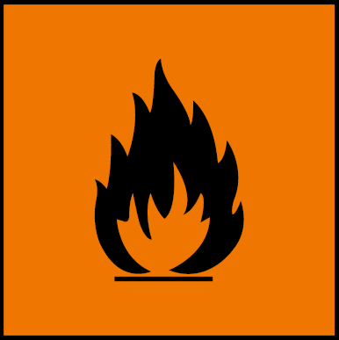  Highly flammable  Irritant | There is a serious risk of the liquid catching fire. Its vapour may catch fire above -20°C. It can cause severe eye damage and will degrease the skin.
Dilute iodine solution, | LOW HAZARD
Safranin | LOW HAZARD
Purchased cultures | 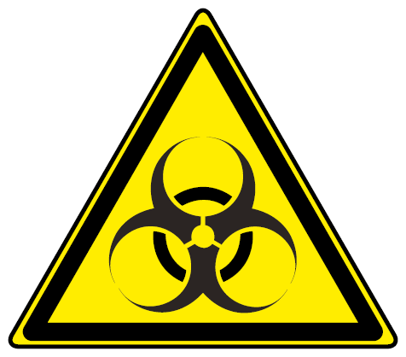  Biohazard | Cultures bought from reputable suppliers should be safe but may have become contaminated.
Reduce risk
- Use the lowest concentration possible and wear eye protection for all but the most-dilute solutions.
- Reduce the risk of skin contact by wearing disposable gloves.
Using Acetone:
- Wear eye protection.
- Make sure the room is well ventilated or, in a laboratory, use a fume cupboard if possible.

Using cultures
- After work is complete, treat surfaces using a suitable disinfectant, for a sufficient length of time.
- Dispose of all cultures (including mould on food) by sterilisation in an autoclave (pressure cooker).
- Always wash hands after handling cultures and before handling food.
Wear a clean laboratory coat.
Emergency action
In the eye
Flood the eye with gently running tap water for at least 10 minutes. See a doctor.
Swallowed
Do no more than wash out the mouth with water. Do not induce vomiting. Sips of water may help cool the throat and help keep the airway open. See a doctor.

Learner resource 5

Preventing laboratory acquired infections
Procedure - Basic risks when streaking a plate, if not followed then risk of infection.
Source of hazard | Hazard and risk | Safety precautions
Bacteria (Escherichia coli) | If the bacteria escape into the room, they could infect anyone and cause disease. | Do not let the bacteria come into contact with skin.  Sellotape up the agar plate (and at no point open it again). Incubate the agar plate at a temperature lower than body temperature (30°C). Autoclave the agar plate after use.
Agar plate | The agar plate is of low risk when it is inoculated.  After incubation, it will contain millions of bacteria. | Sellotape up the agar plate after it has been set up with the antimicrobial (and at no point open it again). Incubate the agar plate at a temperature lower than body temperature (30°C). Autoclave the agar plate after use.

Learner resource 6

Practical procedure preventing spread of disease in a laboratory

Unit 6, P3
Basic Aseptic Technique
Ensure windows and doors are closed to prevent drafts.  Wear a lab coat, tie back hair and wash hands.  Collect all the equipment you will need and place near to the Bunsen burner, this minimises the need to move around and so reduce draughts. | 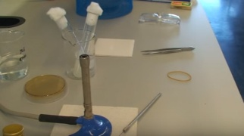
Disinfect the work area before starting, this will reduce potential contaminates on the bench top. Repeat after work to protect others from possible contamination. | 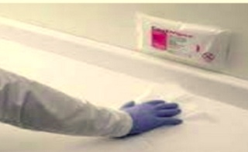
Flame the inoculating loop before and after making a transfer of bacteria from one container to another.  Never lay an inoculating loop on the bench top. | 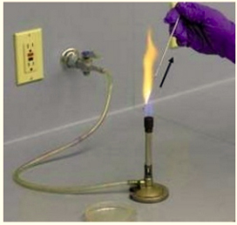
If inoculating an agar dish – open the dish slightly away from oneself, keeping the dish open for the minimum of time to reduce contamination. Spread the bacteria over the agar. Make sure the surface of the agar is kept intact and smooth.  Work quickly and efficiently to minimise the time the culture is exposed to the atmosphere. | 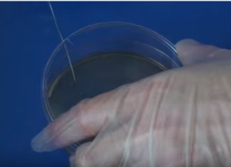
Seal the lid with two pieces of Sellotape, turn the dish upside down and label the bottom of the dish. | 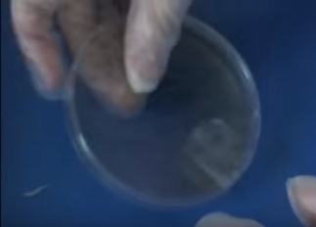
Place the dish in an incubator at the appropriate temperature. | 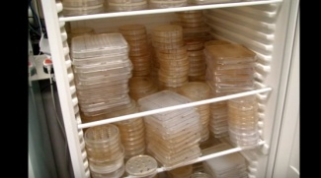

If using a jar or boiling tube - Flame the opening of glass containers before removing bacteria from them and again after bacteria have been removed.  Flame the opening before transferring bacteria to a container and again after transfer is completed. | 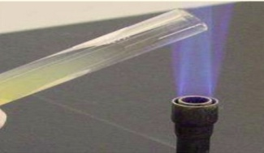
Do not lay the cap of containers of bacteria on the bench top while bacteria are removed from or transferred to the container. The cap should be held throughout transfer. | 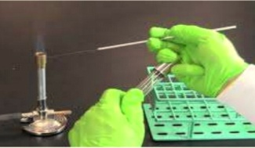
On completion, gather the equipment together and sterilise. All waste should be place in the appropriate container.

Learner resource 7

UNIT 10: Testing consumer products – LO5
Grade Criteria
LO5. Be able to test the effectiveness of consumer product tests | P7: Carry out data analysis on consumer products | M5: Report on data analysis from consumer product testing | D1: Analyse and evaluate the effectiveness of consumer product testing

Antimicrobial Susceptibility
Test data from a disk diffusion test
A ruler was used to measure the diameter of clear zones of inhibition. Measurements to the nearest millimetre. Experiment repeated 5 times.
Concentration of antimicrobial A (%) | Diameter of clear zone (mm)
 | 1 | 2 | 3 | 4 | 5 | mean | range
 |  |  |  |  |  |  | lowest | highest
100 A | 40.0 | 40.0 | 40.0 | 38.0 | 41.0 | 39.8 | 38.0 | 41.0
90 B | 40.0 | 40.0 | 40.0 | 35.0 | 38.0 | 38.6 | 35.0 | 40.0
70 C | 30.0 | 40.0 | 40.0 | 23.0 | 35.0 | 36.25 (33.6) | 30.0  (23) | 40.0
50 D | 25.0 | 40.0 | 40.0 | 2.01 | 40.0 | 33.2 | 21.0 | 40.0
40 E | 23.0 | 25.0 | 20.5 | 20.5 | 20.3 | 22.4 | 20.5 | 25.0
30 F | 22.0 | 22.0 | 20.0 | 20.0 | 20.0 | 20.8 | 20.0 | 22.0
20 G | 21.0 | 20.0 | 20.0 | 20.0 | 20.0 | 20.2 | 20.0 | 21.0
0 H | 20.0 | 20.0 | 20.0 | 20.0 | 20.0 | 20.0 | 20.0 | 20.0

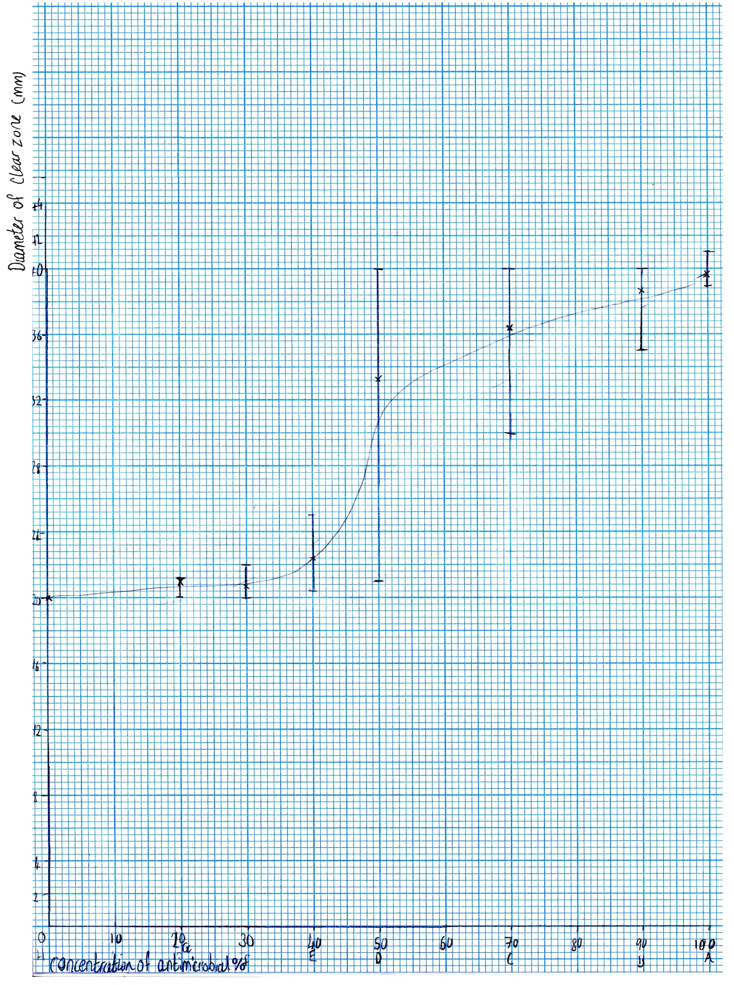
One anomalous result (outlier) highlighted in the table.
The repeatability for the test was good for the concentration of antimicrobial 0% - 30% as precision within 9%. At a concentration of antimicrobial of 50% the precision went up to 47.5%. This may be due to the physical/mechanical problem of the relative thickness of the solution passing through the disc material causing “drag”. This drag may be the cause of the plateauing of the graph at higher concentrations. A possible improvement to the method would be to use the well and pipette method not using the disc so removing the physical/mechanical property of the disc.
Every group got 20mm for 0% which would be correct as it has no antimicrobial on it (no systematic error). There also wasn’t much difference in the results between the rest of the concentrations in this range. From the concentration 50% - 90%, the data collected from the group was not as accurate or repeatable because there was a bigger difference in clear zones than in the first four.
The method was repeated for a variety of antimicrobials.
Concentration of antimicrobial B (%) | Diameter of clear zone (mm)
 | 1 | 2 | 3 | 4 | 5 | mean | range
 |  |  |  |  |  |  | lowest | highest
100 A | 32.5 | 32.0 | 32.0 | 30.0 | 33.0 | 31.9 | 30.0 | 32.5
90 B | 32.0 | 32.0 | 32.0 | 27.0 | 30.0 | 30.6 | 27.0 | 32.0
70 C | 22.0 | 22.0 | 23.0 | 12.0 | 24.0 | 22.2 | 22.0  (23) | 24.0
50 D | 17.0 | 18.0 | 16.0 | 9.01 | 15.5 | 16.6 | 15.5 | 18.0
40 E | 15.0 | 15.0 | 15.5 | 15.5 | 16.5 | 15.5 | 15.0 | 16.5
30 F | 14.0 | 14.0 | 14.5 | 14.0 | 15.0 | 14.0 | 14.0 | 15.0
20 G | 13.0 | 13.0 | 13.0 | 13.0 | 13.0 | 13.0 | 13.0 | 13.0
0 H | 12.0 | 12.0 | 12.0 | 12.0 | 12.0 | 12.0 | 12.0 | 12.0

Specifications
5.1 Data analysis i.e.:
• statistical tests and methods depending on type and scope of data
• record results in an appropriate format
• experimental uncertainties (e.g. systematic and random, assessing and combining)
• use of significant figures (e.g. in measurement, in calculations)
• graphical methods
o types of plot (pie chart, bar chart, scatter plot)
o choice of plot to best present/interpret data

5.2 Conclusions and evaluation i.e.:
• patterns, trends
• unexpected results
• strengths
• areas for improvement
• recommendations for further research

Learner resource 8

Evaluation of the effectiveness of current legislation

Unit 6, D1
There have been a number of surveys of infection in various types of laboratory. In the UK, there was a series of surveys carried out between 1970 and 1989 looking at the rates of infection among workers in UK clinical laboratories. Data from the 1988/89 survey suggested an infection rate of 82.7 infections per 100 000 person-years.
A more recent study of clinical laboratories (1994/95) gave an estimate of infection rates as 16.2 per 100 000 person-years, with the majority of these being associated with HG2 agents in diagnostic laboratories. It might be argued that the apparent reduction in infection rates has come about in part because of ACDP guidance, and more recently the application of COSHH to control exposure. Safety technology has also undergone a period of development and improvement. However, analysis of reports of laboratory-acquired infections is just one means of monitoring the effectiveness of control measures. Other methods would include looking at incidents and accidents involving biological agents. RIDDOR also requires that any incident which results in or could have resulted in the release of a biological agent likely to cause severe human disease is reported.
Cases of laboratory-acquired infection with HG4 agents worldwide over the past 30 years
Virus | Cases | Fatalities | Source(s) and route of infection
Lassa | 2 | 1 | Aerosol – processing infected rodent tissue
Junin | 21 | 1 | Aerosol – processing infected rodent tissue
Sabia | 3 | 1 | Aerosol – centrifuging infected tissue culture
Crimean/Congo haemorrhagic fever | 8 | 1 | Aerosol – processing infected rodent tissue
Machupo | 1 | 1 | Aerosol – processing infected rodent tissue
Marburg | 15 | 1 | Direct contact with infected monkey tissue
Ebola | 1 | 0 | Direct through needle stick
Herpesvirus B | ~50 | 29 | Direct contact with monkeys

Learner resource 9

Addition for radiology coverage

P1 Describe the types of hazard agents that are found in a laboratory situation
Working Arrangements with X-Ray Equipment
HAZARD
- Setting
- Exposure
- The safety features
- Incorrect assembly

Radiological protection in nuclear medicine: https://youtu.be/APBoBX_42-U

P2 Carry out risk assessments for a laboratory procedure
SAFE PRACTICE Regulation 8 of the Ionising Radiations Regulations 1999 requires that all necessary steps be taken to keep exposure to ionising radiation as low as reasonably practicable.
1. Where the work is to be carried out in a room, purpose made structure, other enclosure or a cabinet:
a. adequate shielding
b. interlocks or trapped key systems

2. In other cases, adequate local shielding as far as reasonably practicable and, in the case of site radiography, a suitable system for ensuring that:
a. persons excluded
b. restricting access to the controlled area;
c. warning notices

Radiation Safety Training: https://youtu.be/V4z_S4Snhis

P3 Explain the procedures and practices required to effectively prevent disease from spreading in a laboratory
1. Where there is a risk of significant exposure
2. Initiation of exposures
3. Suitable warning devices
4. Adequate and suitable personal protective equipment
5. Suitable maintenance and testing schedules
6. For non-routine operations protection from the risk of exposure should be produced,
Radiology's Nuclear Medicine's Hot Lab: https://youtu.be/WdjZyzoiR9U

M2 Describe how health and safety legislation influences procedures and practices
Before ionising radiation can be used in any application there is a code of practice to regulate its safe use despite the associated risk. By following the code risks will be reduced to a tolerable and acceptable level.
LEGISLATION SUMMARY
Ionising Radiations Regulations 1999
- Coverage
- Use of accelerators
- Exposure

Where Ionising Radiations Regulations 1999 DOSE LIMITS states
Ionising Radiations (Medical Exposure) Regulations 2000

Environmental Permitting Regulations 2010

Work with ionising radiation: https://www.hse.gov.uk/pUbns/priced/l121.pdf

D1 Evaluate the effectiveness of current legislation in safe working practices in control of diseases
Risks of the use of X-rays
Exposure to X-rays can carry an extremely low risk of cancer.
https://www.nhs.uk/conditions/x-ray/

How safe are X-rays
Medical News Today https://www.medicalnewstoday.com/articles/219970.php

- There is a life time chance of getting cancer
- Putting it into perspective – more than 1 in 3 in the UK will develop cancer.
- Figures from the Health Protection Agency (HPA)

- Examples of exposures to harmful radiation:
- every day:- ultraviolet light from the sun; background radiation (radioactive decay of rock such as radium
- human activities enhance exposure, e.g. flying at altitude (greater levels of cosmic radiation)
- the generation of nuclear energy, and other industrial uses of radioactive material
Risks of Nuclear medicine
Nuclear medicine imaging uses relatively safe, painless techniques to image the body and treat disease.
Nuclear medicine therapy uses varying amounts of radiation to treat disease and cancer
http://snmmi.files.cms-plus.com/Fahey_PAAB_Risk_May2012_final.pdf
Radiotherapy
Overview of radiotherapy: https://www.nhs.uk/conditions/radiotherapy/
Side effects of radiotherapy: https://www.cancer.net/navigating-cancer-care/how-cancer-treated/radiation-therapy/side-effects-radiation-therapy
Patient safety: https://www.radiologyinfo.org/en/info.cfm?pg=safety-xray

Learner resource 10

Carcinogens, Mutagens and Teratogens

Unit 6, P3
Carcinogens
A carcinogen is a substance that causes cancer (or is believed to cause cancer).
COSHH definition: ‘substances and preparations which, if they are inhaled or ingested or if they penetrate the skin, may induce cancer or increase its incidence
Several radioactive substances are considered carcinogens, but their carcinogenic activity is attributed to the radiation, for example gamma rays and alpha particles, which they emit. Common examples of non-radioactive carcinogens are inhaled asbestos, certain dioxins, and tobacco smoke.
Control measures should be selected that are suitable to reduce exposure to a carcinogenic material to as low a level as reasonably practicable. This is often dependent on the quantity of material handled. There are four ‘carcinogen containment levels’ which describe these control measures.
Carcinogen containment levels
Level 1 | Open bench.
Level 2 | Local ventilation (a ventilated enclosure, or recirculating biosafety cabinet).
Level 3 | Containment (A fume hood, chemical safety hood or Class I/II biosafety cabinet which is externally exhausted or specially designed for the containment of chemicals).
Level 4 | Isolation (A totally contained system, isolator or Class III biosafety cabinet).

Mutagens
A mutagen is a substance or agent that causes an increase in the rate of change in genes (subsections of the DNA of the body's cells). These mutations (changes) can be passed along as the cell reproduces, sometimes leading to defective cells or cancer.
Examples of mutagens include certain biological and chemical agents as well physical conditions.
- Biological agents:
Biological mutagen is a mutation agent in the form of virus or bacteria, which can include mutation in every living organism.
When a cell divides the virus will change the genetic material (DNA) composition of the attacked cell in order to damage the cell and tissues. Toxin produced by bacteria can also cause disorder or damage on genetic material or certain cell and tissues. Hepatitis, chickenpox, measles, yellow fever, or food poisoning (botulism) may begin from genetical material change induced either by virus or bacteria.
- Chemical agents:
Deaminating agents, for example nitrous acid which can cause transition mutations by converting cytosine to uracil. Polycyclic aromatic hydrocarbon (PAH), when activated to diol-epoxides can bind to DNA and form adducts. Alkylating agents such as ethylnitrosourea.
- Physical conditions:
Ionizing radiations such as X-rays, gamma rays and alpha particles cause DNA breakage and other damages.
Ultraviolet radiations with wavelength above 260 nm are absorbed strongly by bases, producing pyrimidine dimers, which can cause error in replication if left uncorrected.
A large number of chemicals may interact directly with DNA. However, many such as PAHs, aromatic amines, benzene are not necessarily mutagenic by themselves, but through metabolic processes in cells they produce mutagenic compounds.
Teratogens
A teratogen is an agent that can cause malformations of an embryo or unborn child (foetus). This can be a chemical substance, a virus or ionizing radiation.
As well as alcohol, prescription/non-prescription medications, illegal drugs, vaccines, illnesses, environmental exposures, occupational exposures, or maternal autoimmune disorders.
Alcohol drinking in pregnancy:
An infant born to a mother who drinks alcohol during pregnancy can have problems included in a group of disorders called fetal alcohol spectrum disorders (FASDs). FASDs include the following:
- Fetal alcohol syndrome (FAS). These are the most severe effects that can occur when a woman drinks during pregnancy, and include fetal death. Infants born with FAS have abnormal facial features and growth and central nervous system (CNS) problems, including intellectual disability.
- Alcohol-related neurodevelopmental disorder (ARND). Children with ARND may not have full FAS but have learning and behavioural problems due to prenatal exposure to alcohol. These problems may include mathematical difficulties, impaired memory or attention, impulse control and/or judgment problems, and poor school performance.
- Alcohol-related birth defects (ARBD). Birth defects related to prenatal alcohol exposure can include abnormalities in the heart, kidneys, bones, and/or hearing.

Sample model assignment
LO 1: Understand the types of hazard that may be encountered in a laboratory
Task: Produce a guide to laboratory hazards with an appendix about how viruses and bacteria grow and are spread.
P1: Describe the types of hazard agents that are found in a laboratory situation |  | M1: Explain how disease causing organisms reproduce and are transmitted
Produce a guide to hazards in the pathology laboratories in the form of a leaflet.

The guide should comprise of a general section covering the different types of hazards.
- For each type of hazard, biological, chemical and physical, include a paragraph in which you define the type of hazard, and give specific examples.
- Briefly describe the effect of each hazard on human health.

You need to include examples of carcinogens, mutagens and teratogens.

Include a detailed section on organisms which cause disease. Describe and illustrate specific examples of each of a virus and a bacterial organism.
For each of the organisms include detail on:
- the structure of the organism
- the organism’s method of reproduction
- an explanation of the function of the organism in causing disease
- an explanation of the optimal conditions for survival and reproduction of the organism.
LO2: Be able to use health and safety procedures to minimise the risk presented by hazards in a laboratory
Task: Produce and explain a risk assessment for a school/college microbiology procedure.
Explain how procedures and practices used in a microbiology laboratory prevent the spread of disease.
Describe how, by carrying out risk assessments, an organisation is complying with legislation and describe how, as a result, the COSHH Regulations and RIDDOR and other relevant health and safety legislation may have an influence on procedures and practices.
Evaluate how effective legislation is in promoting safe working practices and evaluate the consequences of adopting poor procedures and practices.
P2: Carry out risk assessments for a laboratory procedure | M2: Describe how health and safety legislation influences procedures and practices |  | D1: Evaluate the effectiveness of current legislation in safe working practices in the control of diseases

P3: Explain the procedures and practices required to effectively prevent diseases from spreading in a laboratory |  | D2: Evaluate the potential impact of poor procedures and practices on individuals and the environment
You should produce a document, in which you explain how to carry out a risk assessment based on carrying out a risk assessment for a microbiology laboratory,
- e.g. producing a streak plate or carrying out serial dilutions of a solution of a bacterial culture.

The document should summarise the outcome of the risk assessment and explain the risk assessment process and the decisions that you have made in relation to the process, showing how the control measures work to prevent diseases from spreading in the laboratory.

Write an informational leaflet, explaining how using particular procedures and practices would prevent the spread of disease in the laboratory in a hospital or research laboratory.

(Consider all the procedures and the practices used in connection with the work that is carried out with micro-organisms in your school/college laboratory, including preparative work and waste disposal.)

The final section of the informational leaflet should provide a comprehensive justification for following good procedures and practices.
- You should describe to what extent having good laboratory procedures and practices helps laboratories to comply with health and safety legislation.
- Evaluate what may happen to the health of individual laboratory workers, the laboratory and its wider surroundings and other employees if laboratory practice were poor.
Illustrate your evaluation with examples of what may happen in the best case/worst case scenarios.

Evaluate how effective health and safety legislation on safe working practices is in controlling diseases in the laboratory. Include a description of the sort of evidence that you need to carry out this evaluation and an analysis of the extent to which this information is available
LO 3: Be able to design a safe functioning laboratory to manage the risk presented by hazards
Produce a laboratory design which minimises the risks posed by the hazards in the laboratory with an explanation of how the design of the laboratory controls the spread of disease.

You should consider legislation and guidance relating to workplace design in general and laboratory design in particular.

You should then analyse the contributions of procedures and legislation to the control of diseases in the laboratory.
P4: Produce a design specification to control risks posed by hazards in a laboratory | M3: Explain how the design of a laboratory can control the spread of disease in a laboratory | D3: Analyse how procedures and legislation affects the control of diseases in a laboratory
You must produce a laboratory design on graph paper (with as much drawn to scale as possible – estimating the footprint of the pieces of equipment).

- Include in your design: work bench facilities, storage, waste disposal, air management and health and safety requirements and other aspects of the teaching content, relevant to the scenario provided by your tutor.

You must write a report, explaining how your laboratory design minimizes the spread of disease, referring to best practice information where possible

In developing a laboratory design which controls risks from hazards and the spread of disease in laboratories, you will have carried out research on the management, design and operation of microbiological containment laboratories and clinical laboratories. You will have become familiar with additional procedures and practices used in working biological laboratories.
Prepare a PowerPoint presentation with accompanying notes which provides an analysis of how this wider range of procedures and practices affects the control of diseases in a microbiological laboratory.
- Explain the advantages of following particular procedures and practices and the consequences of not following those procedures/practices.
- Explain to what extent legislation determines whether the diseases are controlled. Justify your conclusions (for example, consider whether the diseases in the laboratory would be controlled if no legislation were in place) .

Resource links
Area | Description | Link
Biohazard containment laboratories, Levels 1-4 | Do You Know the Difference in Laboratory Biosafety Levels 1, 2, 3 & 4? | https://consteril.com/biosafety-levels-difference/  https://www.hse.gov.uk/biosafety/laboratories.htm
 | Working in a level 2 laboratory | www.yourgenome.org/video/life-in-the-lab-working-with-human-gut-microbiota
 | Working in a level 3 laboratory | www.yourgenome.org/video/life-in-the-lab-working-in-a-malaria-lab
 | Working in a level 4 containment laboratory | https://www.youtube.com/watch?v=nx6GxmNqJ4I
HSE: Biological agents: Managing the risks in laboratories and healthcare premises | Figure 1 Legislation and guidance for work with biological agents, page 4. | https://www.gla.ac.uk/media/Media_196331_smxx.pdf
Overview of the relevant health and safety legislation | An overview of the relevant health and safety legislation and other guidance that should be consulted when working with biological agents in any type of microbiological containment laboratory. | http://www.hse.gov.uk/biosafety/index.htm
Specific controlling legislation affecting the control of diseases in a laboratory | Further details on laboratory hazards. | https://www.hse.gov.uk/biosafety/management-containment-labs.pdf  Pages 19-20, Table 3.1
Preventing laboratory acquired infections |  | https://www.ehs.iastate.edu/research/biological/microbial/laboratory-acquired-infection-prevention
Clinical Infectious Diseases | Overview of Commonly Used Susceptibility Testing Methods | https://academic.oup.com/cid/article/49/11/1749/344384
Laboratory-Acquired Infections |  | https://academic.oup.com/cid/article/49/1/142/371797
Risk assessment A brief guide to controlling risks in the workplace |  | https://www.hse.gov.uk/pubns/indg163.pdf
High-containment laboratories – UK case study |  | https://www.nap.edu/read/13315/chapter/26
Details of UK BSL-4 laboratories, covering data for 2010 |  | https://www.nap.edu/read/13315/chapter/26#176
BSL accidents in the UK |  | https://www.birminghammail.co.uk/news/health/smallpox-death-locked-down-birmingham-11322667  https://www.telegraph.co.uk/news/science/11274543/Safety-breaches-at-UK-labs-handling-lethal-viruses.html  https://www.independent.co.uk/news/uk/home-news/scientists-specialist-laboratories-exposed-deadly-diseases-salmonella-shigella-health-and-safety-a8204136.html  https://crofsblogs.typepad.com/h5n1/2018/02/safety-blunders-expose-lab-staff-to-potentially-lethal-diseases-in-uk.html  https://www.theguardian.com/science/2018/feb/09/safety-blunders-expose-uk-lab-staff-to-potentially-lethal-diseases  https://www.theguardian.com/science/2018/feb/09/safety-blunders-expose-uk-lab-staff-to-potentially-lethal-diseases
Biological agents: Managing the risks in laboratories and healthcare premises | Table 1 (page 12) General COSHH measures to control exposure to biological agents | https://www.gla.ac.uk/media/Media_360368_smxx.pdf
The potential impact of poor procedures and practices on individuals and the environment |  | https://www.theguardian.com/science/2014/dec/04/-sp-100-safety-breaches-uk-labs-potentially-deadly-diseases  https://thebulletin.org/2019/02/supplementary-material-for-human-error-in-high-biocontainment-labs-a-likely-pandemic-threat/
 | Impact on environment | https://www.theguardian.com/science/2014/dec/04/-sp-100-safety-breaches-uk-labs-potentially-deadly-diseases
 | Live anthrax being sent from a government facility to unsuspecting  laboratories across the UK, a mistake that exposed other scientists to the disease. | https://www.telegraph.co.uk/news/science/11274543/Safety-breaches-at-UK-labs-handling-lethal-viruses.html
 | Failure of an air handling system that helped contain foot and mouth disease at a large animal laboratory. | https://www.theguardian.com/science/2014/dec/04/-sp-100-safety-breaches-uk-labs-potentially-deadly-diseases
Biological agents | Biological agents: Managing the risks in laboratories and healthcare premises – HSE. | https://www.gla.ac.uk/media/Media_196331_smxx.pdf
Disease causing organisms | Structure and function | https://www.ncbi.nlm.nih.gov/books/NBK8174/
Transmission of pathogens |  | https://www.bode-science-center.com/center/glossary/transmission-paths.html
HSE, Control of substances hazardous to health | Approved Code of Practice and guidance | https://www.hse.gov.uk/pUbns/priced/l5.pdf
HSE, Exposure to carcinogens, mutagens and biological agents |  | https://www.hse.gov.uk/riddor/carcinogens.htm
Science direct, Mutagens |  | https://www.sciencedirect.com/topics/neuroscience/mutagens
Wikipedia, Mutagens |  | https://en.wikipedia.org/wiki/Mutagen

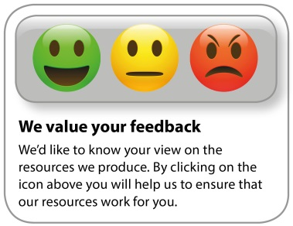
Whether you already offer OCR qualifications, are new to OCR, or are considering switching from your current provider/awarding organisation, you can request more information by completing the Expression of Interest form which can be found here: www.ocr.org.uk/expression-of-interest
Looking for a resource? There is now a quick and easy search tool to help find free resources for your qualification: www.ocr.org.uk/i-want-to/find-resources/
OCR Resources: the small print
OCR’s resources are provided to support the delivery of OCR qualifications, but in no way constitute an endorsed teaching method that is required by the Board, and the decision to use them lies with the individual teacher. Whilst every effort is made to ensure the accuracy of the content, OCR cannot be held responsible for any errors or omissions within these resources.
© OCR 2019 - This resource may be freely copied and distributed, as long as the OCR logo and this message remain intact and OCR is acknowledged as the originator of this work.
OCR acknowledges the use of the following content: n/a
Please get in touch if you want to discuss the accessibility of resources we offer to support delivery of our qualifications: resources.feedback@ocr.org.uk

