Lesson Element: Microscale colorimetry

A simple and low-cost way of making a colorimeter that can be used to determine unknown solution concentrations.

Introduction
This activity involves the use of a microscale colorimeter fashioned from a film canister and two light emitting diodes (LEDs). The LEDs are used to both transmit and detect light through a coloured solution. Photons of light from one LED produce a current in the other, leading to a detectable voltage. This voltage varies depending on the transmittance of light through the solution being tested.

Equipment
- 1 film canister with two 5 mm holes drilled for LEDs
- 2 red LEDs
- 1 cuvette
- Crocodile clips and wires
- Suitable resistor (e.g. 300Ω)
- 2 1.5 volt batteries or power pack
- Multimeter

Setting up the microscale colorimeter
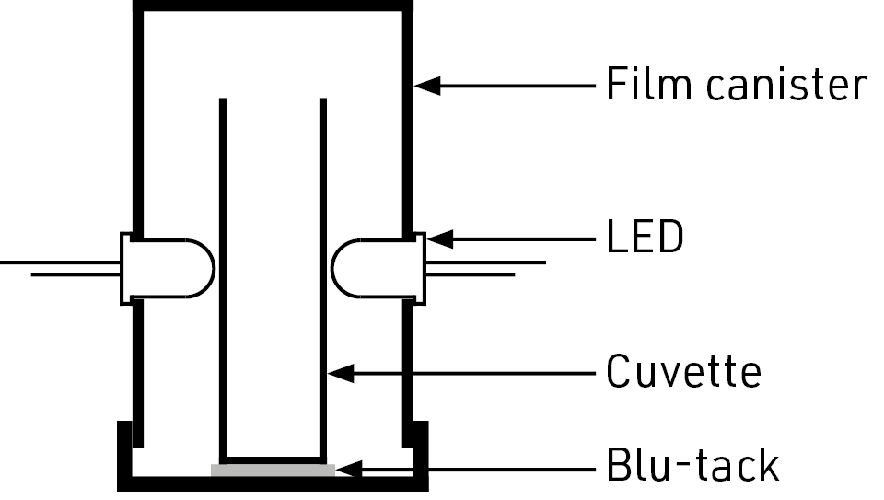

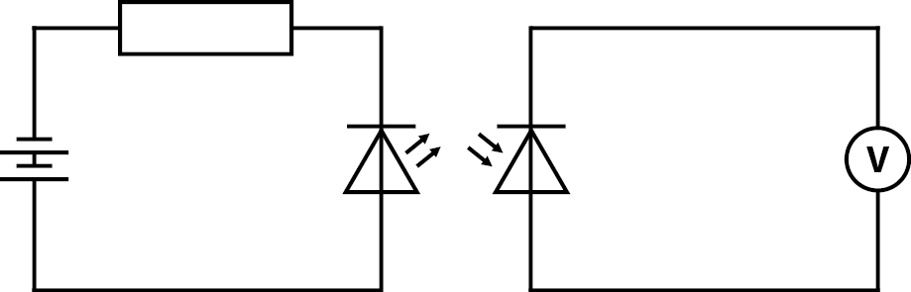

Determining an unknown concentration
- Set up the colorimeter as shown in the diagrams above. If using a power pack, the LED will usually light up at around 3V. The current can only go one way through the LED – if at first it doesn’t work, switch the poles of the battery and try again.
- Fill the cuvette with distilled water and place in the colorimeter. Set the multimeter to millivolts and turn on the circuit, then record the voltage.
- Repeat the above step with several solutions of known concentration, recording the voltage observed with each.
- Plot a graph of concentration vs voltage with your recorded results, and draw a line of best fit.
- You can now use your colorimeter to test solutions of unknown concentration. Use your graph to determine the concentration of the solution from the voltage observed.

References
This activity was adapted from the following blog post: https://www.chemedx.org/blog/analytical-chemistry-and-led-colorimeter
There is an alternative version here which uses Lego pieces to construct the colorimeter housing: https://pubs.acs.org/doi/abs/10.1021/ed400838n

