Learner Resource 1

The Dodo (source date: 1807)
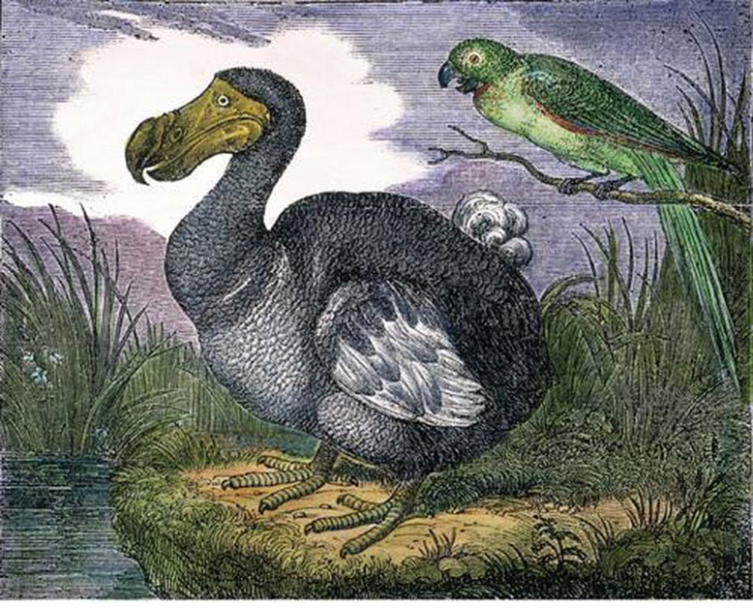
The Dodo, Didus, is a bird that inhabits some of the islands of the East Indies. Its history is little known; but if the representation of it be at all just, this is the ugliest and most disgusting of birds, resembling in its appearance one of those bloated and unwieldy persons who by a long course of vicious and gross indulgences are become a libel on the human figure.

The Baiji Dolphin (source date 2016)
The last documented sighting of China's baiji
dolphin, or Yantze River dolphin, was in 2002,
and while the species is listed as critically
endangered, scientists say it may already be
extinct.
The decline in the baiji dolphin population is
attributed to a variety of factors including
overfishing, boat traffic, habitat loss, pollution
and poaching. Deemed "the goddess of the
river" the dolphin's skin was highly valuable
and used to make gloves and handbags.

OCR Resources: the small print
OCR’s resources are provided to support the delivery of OCR qualifications, but in no way constitute an endorsed teaching method that is required by the Board, and the decision to use them lies with the individual teacher. Whilst every effort is made to ensure the accuracy of the content, OCR cannot be held responsible for any errors or omissions within these resources.
© OCR 2020 - This resource may be freely copied and distributed, as long as the OCR logo and this message remain intact and OCR is acknowledged as the originator of this work.
OCR acknowledges the use of the following content: Dodo – The Granger Collection/UIG/Britannica (ED), Dolphin – Mark Carwardine/Oceans Image/UIG/Britannica (ED)
Please get in touch if you want to discuss the accessibility of resources we offer to support delivery of our qualifications: resources.feedback@ocr.org.uk

