Fieldwork Skills Factsheet
This factsheet is designed to provide guidance for teachers to support the delivery of fieldwork skills through the content of the GCSE A and B specifications. Both GCSE specifications have a list of six fieldwork skills (GCSE A, p15 and B, p19) and these will be explained throughout this document. The fieldwork questions in the examinations are derived from the list of six fieldwork skills, so they are important to understand.
More specifically, it should help teachers new to the profession or those who are non-specialists develop their understanding of the use of fieldwork in the Geography GCSE course.
Geographical fieldwork may be defined as the experience of understanding and applying specific geographical knowledge, understanding and skills to a particular and real out-of-classroom context. Geographical fieldwork is about finding out new things about people, places and environments.
This might involve:
- Designing activities to test a geographical question or questions,
- Collecting information which is useful and relevant to the question chosen.
- Presenting the data and information in a variety of formats, so that analysis can take place. The analysis can potentially find patterns and relationships to try and help answer the question/s.
Fieldwork skills may be assessed in relation to either physical or human geography contexts or for both in any set of assessments. They are assessed through both students’ own experiences of fieldwork and unfamiliar contexts in the areas outlined below.

1. Understanding of the kinds of question capable of being investigated through fieldwork and an understanding of the geographical enquiry processes appropriate to investigate these.
Fieldwork in Geography is based around the idea of an ‘enquiry’. An enquiry is a question that a geographer sets out to prove or disprove. Some of the most valid questions are based around a ‘real life’ geographical issue which has a spatial ‘hook'. Enquiry questions are linked to the content of the GCSE specification and they provide an opportunity to explore these geographical issues in a place specific context. This place specific context is the spatial ‘hook’ in which to set the enquiry question. An enquiry question example might be: ‘To what extent are the traffic improvements on Arbury Road in Cambridge sustainable?’ This is an important issue for local residents (real life geography) and the spatial hook is reference to both the road name (Arbury), in the context of the city of Cambridge. The specification links are - GCSE A, 1.2.6 and GCSE B, 5.2b.
The process of enquiry can be outlined through a series of stages (as shown below). Student understanding of each of these stages is important. The weblinks below provide useful information about each stage of the enquiry process.
https://www.geography-fieldwork.org/gcse/before-starting/planning/geographical-questions/
https://www.bbc.co.uk/bitesize/guides/zypb6fr/revision/1
Useful support is also available from the OCR endorsed textbook:
https://insightandperspective.co.uk/publications/gcse-geography-fieldwork-for-ocr

Geography fieldwork is all about asking questions and providing students with an opportunity to apply what they are learning in the classroom to a real location.
Thought should be given to the scale and location of the enquiry and whether a process (e.g. erosion), concept (e.g. Sustainability), issue (e.g. traffic congestion or flooding) or case study has helped to create the enquiry question.
When posing an enquiry question to be answered, a series of further questions may result, leading to different areas for exploration. A geographical enquiry will often therefore begin with one ‘big’ question and a series of smaller sub-questions. These may be physical or human in nature.
Physical enquiry questions will often look at a natural landscape such as a river or coast and examine the processes that form this landscape or the ways in which humans are trying to manage it.
Human enquiry questions can focus on issues in man-made environments, whether urban or rural such as economic growth, challenges (housing, transport or waste) and/ or sustainability. There are also opportunities to explore issues related to people e.g. ways of life (ethnicity, leisure), ageing or migration.
Instead of a question students could also use a hypothesis, this is a testable statement which can be investigated and it needs to be something that is measurable. The Field Studies Council have some example hypotheses: https://www.geography-fieldwork.org/gcse/before-starting/planning/geographical-questions/
The title or key question of the enquiry might be set up to investigate a geographical process, a geographical concept (see page 7 for further ideas) or people’s opinion about a geographical issue. The location for the investigation also needs careful consideration, where an appropriate scale, such as a named town, village, beach or river will provide enough opportunities for effective data collection yet still be manageable.
The title of the investigation might be set out as a simple statement or a question. Two such examples are shown below.
“An investigation into transport issues affecting the village of Castleton.”
Issue clearly identified e.g. transport. |  | Location is clear and feasible for a study of this kind.
Links to the specification content (GCSE A – 1.2.6 and GCSE B – 5.2.a)
Students can unpack what those issues are facing Castleton, this could be done in part prior to the fieldwork trip through secondary data / information e.g. photographs and news reports. The transport issues could be – volume of traffic, space for parking, lack of public transport etc.

“How do the channel characteristics of the Burbage Brook change along its course?”

Study will be based around the impact of geomorphic processes. |  | Named river identified which can provide appropriate opportunities for study.
This enquiry question example demonstrates how it is possible for the specification topic content and a fieldwork investigation to work effectively together. It can help students understand and relate some of what they learn on the classroom ‘out in the field’. The enquiry at Burbage Brook provides an opportunity to explore (geomorphic) processes in action and how they can change / impact on the landscape i.e. landforms (meander, floodplains etc.)

2. Understanding of the range of techniques and methods used in fieldwork, including observation and different kinds of measurement.
Fieldwork investigations should set out to collect data that will enable students to answer their enquiry question. Data collection methods are the range of techniques used to gather information (this can include data) related to the enquiry question. (Some ideas are listed in Section 6).
Depending on the enquiry in question, this data is likely to be either:
- human – providing some information about people and their use of an area
- physical – providing some information about the processes affecting natural landscapes, e.g. rivers and coasts
Quantitative data is usually numerical and provides information that can be statistically analysed. For example, measuring river velocity using a flow meter. It is objective and precise. Other examples include traffic or pedestrian counts, or measuring cliff angles.
Qualitative data provides detailed information collected in real life settings, for example by recording people’s opinions in a survey or questionnaire. Other examples might include field sketches, interviews or photographic evidence.
Data may also be quantitative or qualitative. Students should have an understanding of both these terms and when it might be advantageous to collect one or the other. At times geographers may use both in a mixed methods approach e.g. collect information via a questionnaire (qualitative), the information could then be pulled together, categorised, counted and calculations done (e.g. averages or percentages) and this becomes more quantitative.
Both primary and secondary data should be considered, with students able to explain the strengths and limitations of each.
Primary data is collected first hand by the students themselves, as part of their fieldwork in order to investigate the geographical question or hypothesis they have chosen. An example of this could be to interview people to find out how they feel about traffic issues in their town.
Secondary data is collected by someone other than the students themselves, written before the enquiry began and usually for a different purpose. It therefore often will not directly answer a specific question or hypothesis that the students have designed. An example of this would be a newspaper article about a new housing development.
Students should be able to explain the strengths and limitations of each. For example:
 | Strengths | Limitations
Primary Data | Students will know exactly where and when data was collected. | Lots of different types of data collected, which can be unmanageable and not always related to the student’s enquiry question/s.
Secondary Data | Quicker and sometimes easier to retrieve information. Students able to gain a larger sample size | The source used might be out of date or come from a highly biased report.
When data / information is collected, it is important to think about how this will be achieved as it is not possible to collect data on everything. This can be referred to as sampling – what do you want to collect, how and why?
Students should understand the different sampling strategies that they have used and be able to justify or identify limitations with the methods they have used in their investigation.
Sampling methods that might be considered include:
- Random sampling -where each member of a population is equally likely to be included.
- Systematic sampling – where observations are taken at regular intervals.
- Stratified Sampling - where a proportionate number of observations is taken from each part of the population to match
- Line sampling – where recordings are taken along a straight line
For more information:
https://www.geography-fieldwork.org/a-level/before-starting/methods/sampling/
There are clearly a wide range of primary data collection methods that students might choose depending upon the nature of their fieldwork aims. The list below is intended to provide a selection of potential methods, rather than an exhaustive list:
Physical Fieldwork | Human Fieldwork
Measuring slope or cliff angles  Measuring velocity, width and depth of a river.  Measurements of stone size, shape or orientation.  Measuring longshore drift  Quadrat sampling of ecosystems  Field sketches or photographs | Bipolar surveys  Likert Surveys  Questionnaires  Environmental Quality Surveys  Traffic or pedestrian count  Shop/ Land Use surveys

3. Processing and presenting fieldwork data in various ways including maps, graphs and diagrams
Processing the data collected will allow students to see what the evidence is telling them about the aims or questions that have been set.
Processing of quantitative data might involve finding the average or amount of dispersion in a data set. The average might be expressed as a mode, mean or median, students should have some knowledge of the reasons why one average might be chosen over another.
Dispersion can most simply be measured by consideration of the range of data. This also provides an opportunity to develop students’ statistical skills, as required by the specification, to consider the interquartile range of a set of data.
Presentation of data might involve the use of a range of graphs, pictograms, maps, sketches or photographs. Students should be encouraged to choose from the range of geographical skills listed on page 13-14 of the specification for Geography A and page 17-18 for Geography B.
Students should be expected to explain why a particular form of data presentation has been chosen for a particular set of data or information and the strengths and weaknesses of this form of presentation.
Graphs to be considered might include:
- Dispersion graphs
- Line Graphs
- Bar charts and divided bar charts
- Histograms
- Pie Charts
- Scatter graphs
The full list of graphs and charts to be studied can be found in the specifications. Page 13 of Geography A. Page 17 of Geography B.
For each graph, the advantages of locating any of these graphs on a map might also be considered.
Mapping techniques might include:
- Location maps
- Desire line maps
- Flow line maps
- Proportional symbols
- Isoline
- Choropleth
A full list of both graphical and mapping techniques that might be assessed in the unseen fieldwork element can be found on page 13 of the Geography A specification and page 17-18 of the Geography B specification.

4. Analysing and explaining data collected in the field using knowledge of relevant geographical case studies and theories.
Analysis of the data collected will allow students to assess the strength of evidence and connections, patterns or trends in the data they have collected.
In analysing quantitative data students should be encouraged to look for:
- An overall trend or pattern - is it an even or uneven pattern? Is the trend increasing or decreasing?
- The range of the data is the difference between the highest value and the lowest value.
- Any data that does not fit the overall trend or pattern. These are known as outliers or anomalies.
Analysis of qualitative data might use some basic categorisation of key themes or frequency analysis, for example in a questionnaire about traffic issues, what percentage of respondents mentioned delays as an issue? Alternatively, students might use a narrative approach to consider the similarities and differences between chosen areas which have been photographed or sketched for example.
Students should also be encouraged to look for connections between the evidence. Looking for evidence of cause and effect for example, might help students to explain the evidence they are presenting.
Students should also have an understanding of the basis for their study in order to effectively analyse and explain the data they have collected. This might be through the use of a geographical concept such as those outlined in the table below, a case study location where a similar process has taken place or a geographical model that can be used to compare data against.
Concept | How might it be used in an enquiry?
Sustainability – how well a location is coping with social, economic or environmental change | How sustainable is the transport provision in the city of …………?
Inequality – how services, facilities, investment or infrastructure might be unevenly distributed. | What is the evidence the town of ………… is undergoing a period of economic decline?
Place – the features that give a location its unique character. | How is gentrification changing the nature of …………………?
Mitigating Risk – how people can manage natural environments to reduce the risk if hazards | An investigation into management of the flood risk in …………………
For example, a river fieldwork study might use the Bradshaw model to test student fieldwork results against the expectations of the model. https://en.wikipedia.org/wiki/Bradshaw_model
A coastal study which measures transportation via longshore drift might consider this in the context of sediment cells.

A human fieldwork study on land use in an urban area might compare a transect to land use models to see which applies https://www.3dgeography.co.uk/settlement-diagrams
Students may wish to look at sustainability in a specific area and this can be explored through the Egan Wheel e.g.
https://www.rgs.org/schools/teaching-resources/sustainable-communities/
https://www.geography.org.uk/download/GA_GCSEToolkitFutureSussedLesson2.pdf
If a model is not appropriate for the study in question, students might suggest how their data compares with a chosen case study with similar characteristics, for example comparing the impact of coastal erosion at their chosen location to another coastal case study, such as the Skipsea coast, Yorkshire as in the photograph below.

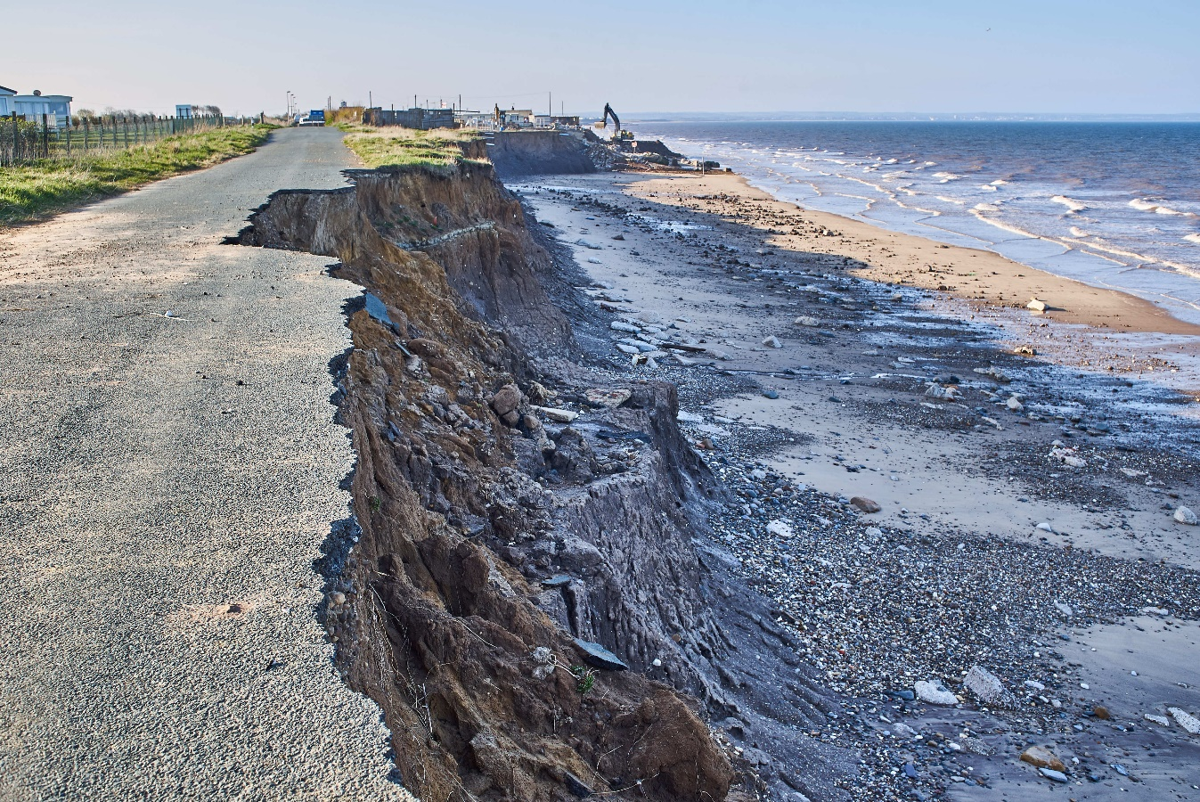

5. Drawing evidenced conclusions and summaries from fieldwork transcripts and data
Once the data has been collected, processed, presented and analysed, students should be in the position to consider their conclusions to their fieldwork investigation. A conclusion should make use of the evidence that has been collected and analysed.
To draw conclusions on their own enquiry, or for data from an unseen piece of fieldwork, students should be encouraged to:
- Return to the aims of the investigation – was it linked to a key concept, geographical theory or case study?
- Consider the data / information collected from both primary and secondary sources– how does the data collected and presented help answer the questions or hypothesis that the student designed? How does it fit with the overall aim of the investigation?
- Summarise the overall findings of their enquiry – (linking back to each sub-question or hypothesis used). They should seek to bring the different parts of the enquiry together and focus back on their stated enquiry question or hypothesis.
- Finally, students should consider an overall judgement/answer to their original aim or question.
Students should also be encouraged to consider the strength of the conclusions reached and how certain they can be in their judgement. Fieldwork data often presents a simplistic view of a much more complex picture and students might want to reflect upon and recognise this.

6. Reflecting critically on fieldwork data, methods used, conclusions drawn and knowledge gained.
The final stage of the enquiry process is for students to critically reflect on the different elements of their fieldwork investigation.
Students will need to show awareness that their conclusions are based on the data collected, so if there were any problems or faults with the way that the data was collected, then their conclusions may be incorrect.
Two main things to consider are accuracy and reliability.
Accuracy – For data to be accurate the recording equipment must have been used correctly or conversely the correct equipment used to record the result, whilst the results recorded must have been noted carefully in the appropriate units.
Reliability – For data to be reliable, it needs to be collected in a way such that if the fieldwork were to be repeated, a similar set of data would be collected.
When considering primary data, limitations might include;
- Lack of access to specialist equipment, leading to less accurate results.
- Incorrect recording of results, such as the wrong choice of units.
- Issues with the sampling methods chosen – this however may be linked to the difficulties of collecting suitable data on only one fieldwork day.
A student who has collected data on river velocity using only a timed float for example, might consider the weaknesses in measuring the speed of water in this way, rather than through the use of a flowmeter.
Reflection on a traffic count completed at a given moment during a fieldwork day might consider why multiple counts might yield a more accurate result.
When considering secondary data, limitations which might be considered include;
- Bias – where the accuracy of the information may be a matter of opinion
- Age – the use of maps, graphs or any data drawn from secondary sources which have been collected some time ago.
A student whose enquiry focuses on the effectiveness of local flood defences and made use of the following news report might consider the audience and timing of the report when reflecting on its accuracy for example
‘Yorkshire flood damage 'will take a lot of recovery'.’
From BBC News 03.03.2020 https://www.bbc.co.uk/news/uk-england-humber-51720928
Students should be encouraged to reflect critically on the data, methods and conclusions rather than their own fieldwork experience. Simply suggesting that they could have done more or had an enjoyable day’s fieldwork is not the aim of this final part of their study.
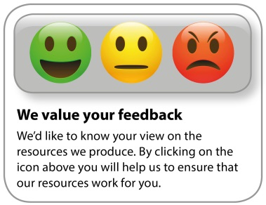
OCR Resources: the small print
OCR’s resources are provided to support the delivery of OCR qualifications, but in no way constitute an endorsed teaching method that is required by the Board, and the decision to use them lies with the individual teacher. Whilst every effort is made to ensure the accuracy of the content, OCR cannot be held responsible for any errors or omissions within these resources.

Our documents are updated over time. Whilst every effort is made to check all documents, there may be contradictions between published support and the specification, therefore please use the information on the latest specification at all times. Where changes are made to specifications these will be indicated within the document, there will be a new version number indicated, and a summary of the changes. If you do notice a discrepancy between the specification and a resource please contact us at:
resources.feedback@ocr.org.uk.
© OCR 2020 - This resource may be freely copied and distributed, as long as the OCR logo and this message remain intact and OCR is acknowledged as the originator of this work. OCR acknowledges the use of the following content: Page 8, Coastal erosion/Matthew J Thomas/Shutterstock.com
Please get in touch if you want to discuss the accessibility of resources we offer to support delivery of our qualifications: resources.feedback@ocr.org.uk

