Building a topic test in ExamBuilder
For our GCE Chemistry A qualification we have created some end of topic tests using the ExamBuilder tool. These tests are designed to reflect the overall assessment requirements of the qualification and each test focuses on content from individual modules of the specification.
The tests are approximately 50 marks with a suggested duration of one hour. You can create your own topic tests using ExamBuilder by using the following guidance.

Design your own end of topic test
Select the GCE science subject and specification for which you wish to select question items for your end of topic test.
Questions can be filtered by topic, sub-topic, question type, level of difficulty, assessment objective (AO) and more.
The following criteria are suggested for a 50 mark end of topic test to cover the skills and question styles that students can expect to encounter during an assessment.

Question style and demand
To ensure broad content coverage and to ensure students are familiar with a broad range of assessment styles, we suggest a test of approximately 50 marks will require:
- six to eight multiple choice questions (MCQ filter)
- one 6-mark level of response style question (6 mark/QWC filter)
- short-answer style questions for the remaining marks on a range of sub-topics
- a mix of low, medium and high demand questions.

Assessment objectives (AOs)
To cover the range of assessment objectives it is suggested that of the overall marks:
- at least 30% are AO1 (e.g. 15 out of 50 marks)
- at least 30% are AO2 (e.g. 15 out of 50 marks)
- at least 20% are AO3 (e.g. 10 out of 50 marks)
The % figures above do not sum to 100% to allow for flexibility. Specific weightings for our assessments are published in the specification.

Practical skills
Questions can also be filtered by practical skills. Practical questions assess skills from module 1.1 of the specification and the questions relate to practical activities students may carry out in class. There are also weightings in the assessment for mathematical skills so it is suggested that of the overall marks:
- at least 15% assess practical skills
- at least 20% assess maths skills.

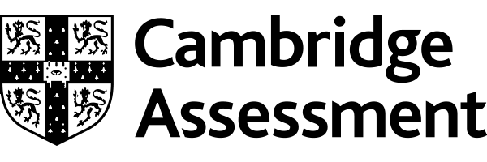

We’d like to know your view on the resources we produce. Click ‘Like’ or ‘Dislike’ to send us an auto generated email about this resource. Add comments if you want to. Let us know how we can improve this resource or what else you need. Your email will not be used or shared for any marketing purposes.
Looking for another resource? There is now a quick and easy search tool to help find free resources for your qualification.
OCR is part of Cambridge Assessment, a department of the University of Cambridge.
For staff training purposes and as part of our quality assurance programme your call may be recorded or monitored.
Oxford Cambridge and RSA Examinations is a Company Limited by Guarantee. Registered in England. Registered office
The Triangle Building, Shaftesbury Road, Cambridge, CB2 8EA. Registered company number 3484466. OCR is an exempt charity.
OCR operates academic and vocational qualifications regulated by Ofqual, Qualifications Wales and CCEA as listed
in their qualifications registers including A Levels, GCSEs, Cambridge Technicals and Cambridge Nationals.
OCR provides resources to help you deliver our qualifications. These resources do not represent any particular teaching method we expect you to use. We update our resources regularly and aim to make sure content is accurate but please check the OCR website so that you have the most up to date version. OCR cannot be held responsible for any errors or omissions in these resources.
Though we make every effort to check our resources, there may be contradictions between published support and the specification, so it is important that you always use information in the latest specification. We indicate any specification changes within the document itself, change the version number and provide a summary of the changes. If you do notice a discrepancy between the specification and a resource, please contact us.
© OCR 2021 - You can copy and distribute this resource freely if you keep the OCR logo and this small print intact and you acknowledge OCR as the originator of the resource.
OCR acknowledges the use of the following content: N/A
Whether you already offer OCR qualifications, are new to OCR or are thinking about switching, you can request more information using our Expression of Interest form.
Please get in touch if you want to discuss the accessibility of resources we offer to support you in delivering our qualifications.

