Lesson Element 1.01a Four rules
Below are eight different representations of various divisions.

Cut up all of the below into 48 individual cards and give them to students.

Can they sort the cards into groups, where each group shows the same division?

36 $÷$ = 4 | 36 $÷$ = 9
36 $÷$ 8 = | 36 $÷$ = 8
36 $÷$ = 5 | 36 $÷$ 5 =
9 36 | 4 36
8 36 | 8  36
7 36 | 5 36
0 36 | 0 36
0 36 | 0 36
0 36 | 0 36
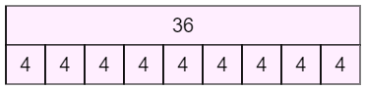 | 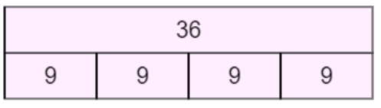
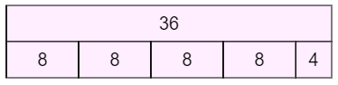 | 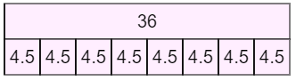
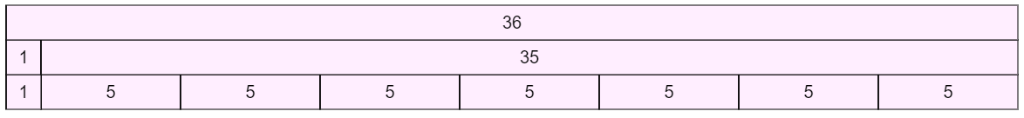 | 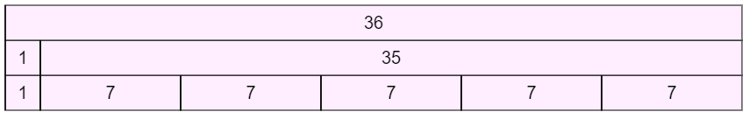
9  36 | 36  4
36  8 | 4.5  36
7  36 | 5  36
llll | 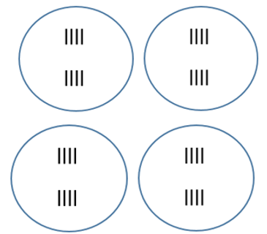  llll
l | l
36  27  9  3  1 | 36  16  20  5  4
36  16  20  2  2  16  4 | 36  9  27  4  18  2  2  9
36  14  22  3  2  21  1 | 36  20  16  3  4  15  1
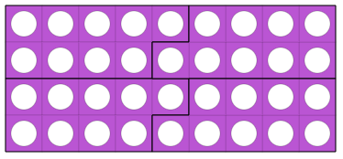 | 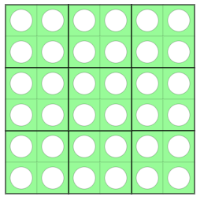
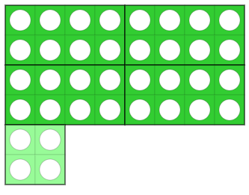 | 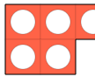  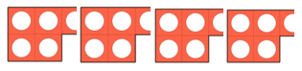
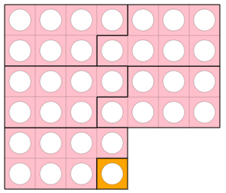 | 