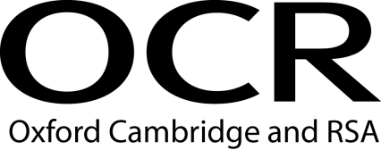 |  |  | Evidence Record Sheet  OCR Level 4 Diploma in Career Information and Advice
Unit Title: | Obtain and organise career-related information to support clients
OCR unit number: | Unit 16
Learner Name:
I confirm that the evidence provided is a result of my own work.
Signature of learner: |  |  |  | Date:

Learning Outcomes | Assessment Criteria | Evidence Reference | Assessment Method*
1. Understand the nature of career-related information required by clients and organisations | 1.1 analyse the career-related information needs of clients  1.2 describe the characteristics of career-related information, advice and guidance available to clients
2. Understand the organisation and management of career-related information | 2.1 evaluate methods to organise and manage career-related information in organisations
3. Be able to obtain career-related information to meet organisational and client needs | 3.1 identify career-related organisation and client information requirements  3.2 apply methods to research and obtain career-related information for the organisation and for clients  3.3 evaluate the information obtained against the career-related information needs of the organisation and clients
*Assessment method key: O = observation of learner, EP = examination of product; EWT = examination of witness testimony; ECH = examination of case history; EPS = examination of personal statement; EWA = examination of written answers to questions; QL = questioning of learner; QW = questioning of witness; PD = professional discussion

I confirm that the learner has demonstrated competence by satisfying all of the criteria for this unit and that I have authenticated the work.

Signature of assessor: _____________________ Name (in block capitals): _____________________ Date: ______________

Countersignature of qualified assessor (if required) and date:

IV initials (if sampled) and date: Countersignature of qualified IV (if required) and date:

