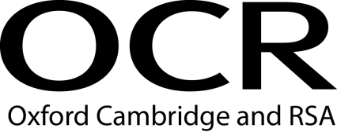 |  |  | Evidence Record Sheet  OCR Level 6 Diploma in Career Guidance and Development
Unit Title: | Use diagnostic and assessment tools with clients
OCR unit number: | Unit 08
Learner Name:
I confirm that the evidence provided is a result of my own work.
Signature of learner: |  |  |  | Date:

Learning Outcomes | Assessment Criteria | Evidence Reference | Assessment Method*
1. Understand the purpose and application of diagnostic and assessment tools | 1.1 explain the reasons for diagnosing and assessing the needs of clients  1.2 evaluate the purpose of different diagnostic and assessment tools used with clients  1.3 analyse the outcomes from use of diagnostic and assessment tools
2. Be able to use diagnostic and assessment tools with clients | 2.1 review diagnostic or assessment tools to meet client needs  2.2 inform clients about the purpose and use of diagnostic or assessment tools  2.3 question clients to determine selection of diagnostic or assessment tools  2.4 apply diagnostic or assessment tools to determine client needs  2.5 interpret the results of the diagnostic or assessment tools  2.6 discuss with clients the outcomes of the diagnosis or assessment in relation to their career guidance and development needs
*Assessment method key: O = observation of candidate, EP = examination of product; EWT = examination of witness testimony; ECH = examination of case history; EPS = examination of personal statement; EWA = examination of written answers to questions; QL = questioning of learner; QW = questioning of witness; PD = professional discussion

I confirm that the learner has demonstrated competence by satisfying all of the criteria for this unit and that I have authenticated the work.

Signature of assessor: _____________________ Name (in block capitals): _____________________ Date: ______________

Countersignature of qualified assessor (if required) and date:

IV initials (if sampled) and date: Countersignature of qualified IV (if required) and date:

