OCR-set Assignment
Sample Assessment Material
OCR Level 1/Level 2 Cambridge National in Engineering Manufacture Sample Set Assignment

Unit R015: Manufacturing a one-off product

This is a sample set assignment which should only be used for practice.
This assignment must not be used for live assessment of students.

The live assignments will be available on our secure website, ‘Teach Cambridge'.

The OCR administrative codes associated with this unit are:
- unit entry code R015
- certification code J823

The regulated qualification number associated with this unit is:
603/7087/7

Duration: Approximately 10 - 12 hours
ALL OF THIS MATERIAL MAY BE PHOTOCOPIED. Any photocopying will be done under the terms of the Copyright Designs and Patents Act 1988 solely for the purposes of assessment.

Contents

Information for teachers - Using this assignment 3
Scenario for the assignment 4
Your tasks and marking grids 5
Task 1 – Planning the manufacture 5
Task 2 – Risk assessment 7
Task 3 – Measuring and marking out 8
Task 4 – Machining 9
Task 5 – Use tools and equipment 10
Appendix 1 11
Working Drawing of the Clamp 11
Marking criteria command words 12
Teacher Observation Record 15
Teacher Observation Record 16
Teacher observation record guidance notes 17
Risk Assessment Template 18

Information for teachers
Using this assignment

You must:
- make sure you are familiar with the Assessment Guidance relating to the tasks. This is with the unit content in Section 4 of the Specification.
- make sure that you have read and understood all the rules and guidance provided in Section 6 of the Specification before your students complete and you assess the set assignments.
- make sure that completion and assessment fully adhere to the rules and guidance provided in Section 6 of the Specification.
- provide students with the Engineering Manufacture Student guide to NEA assignments before they start the assignments.
- allow students approximately 10-12 guided learning hours (GLH) to complete all tasks.
- complete the Teacher Observation Record provided on page 15 for Task 4 and the Teacher Observation Record provided page 16 for Task 5. You must adhere to the guidance given on page 17 when completing them.

You must not:
- change or modify this assignment in any way.

Additional information:
- the aluminium channel listed in the working drawing is a standard off-the-shelf product that comes in a ¼ (6.4) mm thickness.
- a steel channel may be used as an alternative to aluminium.

Scenario for the assignment
Replacement clamp

You are a production engineer in an engineering company. You have been asked to make a replacement clamp needed to support production activities.

The original clamp was a one-off item, designed so that the end slots into a jig, holding it in place. Unfortunately, this clamp was accidentally damaged. The replacement is urgently needed to allow production activities to continue.

A working drawing of the clamp is shown below and enlarged in Appendix 1.
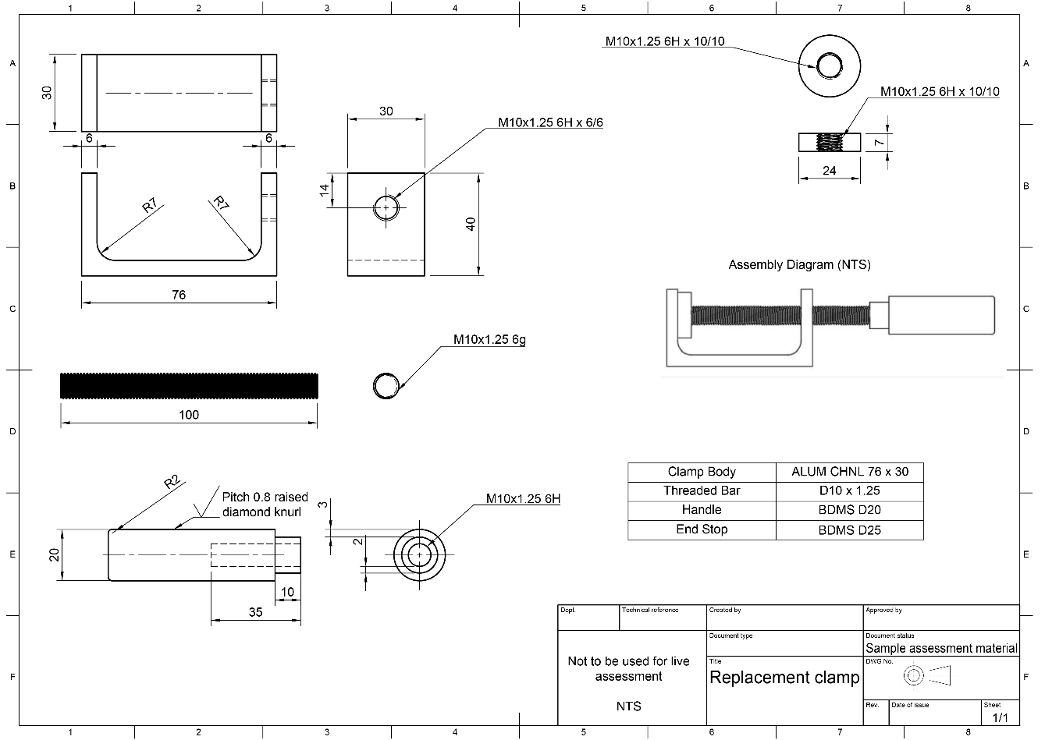

Read through all of the tasks carefully, so that you know what you will need to do to complete this assignment.
Important:
- You will need to refer to the marking criteria grid. Your teacher can explain the marking criteria if you need further clarification.

- You will need to draw upon relevant skills/knowledge/understanding from other units you have studied in this qualification.

- You can use the template provided on page 18 as part of Task 2.

Your tasks and marking grids

Task 1 – Planning the manufacture
Topic Areas 1.1 and 1.2 are assessed in this task.

A working drawing for the clamp is provided in Appendix 1. You must use this to identify the information needed to make the clamp.

You must prepare a production plan that includes:
- the materials needed.
- the processes, tools and equipment required.
- the sequence in which the operations must be carried out.
- any health and safety considerations.
- actions needed for quality control.

Total marks for Task 1: 14 marks
Task 1 Tips

- Identify all the materials, processes, tools and equipment that you will need.
- Think about the order in which things will need to be done.
- Make sure your plan indicates any safety considerations.

Topic Area 1.1, 1.2: Interpret an engineering drawing and prepare a production plan

MB1: 1–5 marks | MB2: 6-10 marks | MB3: 11-14 marks
A basic plan that includes information that could be used when making the product, however additional content would be required to facilitate manufacture. | An adequate plan that includes information that could be used when making the product to facilitate manufacture. | A comprehensive plan that includes all the information required to facilitate manufacture of the product.
A few of the materials needed are identified. | Some of the materials needed are identified. | All materials needed are accurately identified.
Few suitable processes, tools and equipment are identified. | Some of the processes, tools and equipment are suitable and presented in a workable sequence. | All processes, tools and equipment are appropriate and presented in a logical sequence.
Few health and safety issues have been considered. | Some health and safety issues have been considered. | All health and safety issues have been considered.
At least one quality control measure has been identified. | Some quality control measures identified. | Appropriate quality control measures identified to support the manufacture of an effective outcome.
If your work does not meet Mark Band 1 criteria, you will be awarded zero marks for this task.

Task 2 – Risk assessment
Topic Area 1.3 is assessed in this task.

You must prepare a risk assessment for the process used to make the handle for the clamp.

The risk assessment must include:
- the potential hazards.
- the risks (the probability of each hazard occurring).
- the control measures.
Total marks for Task 2: 6 marks

Task 2 Tips

- You should include any potential hazards in your risk assessment.
- Make sure that your risk assessment identifies the risks and control measures required for every potential hazard you identify.
- You can use the template we provide on page 18 for your risk assessment.

Topic Area 1.3: Risk assessment

MB1: 1–2 marks | MB2: 3-4 marks | MB3: 5-6 marks
At least one potential hazard is identified and the risk of occurrence estimated. | Some potential hazards are identified and the risk of occurrence for each is estimated. | All of the potential hazards of the process are identified and the risk of occurrence for each is estimated.
At least one control measure has been identified. | Appropriate control measures identified for some of the hazards. | Appropriate control measures identified for all of the hazards.
If your work does not meet Mark Band 1 criteria, you will be awarded zero marks for this task.

Task 3 – Measuring and marking out
Topic Areas 2.1 and 2.2 are assessed in this task.

You need to measure and mark out the parts required for your clamp.

You must:
- select and safely use equipment to measure and mark out the parts of your clamp.
- take images of the marked out materials.
Total marks for Task 3: 12 marks

Task 3 Tips

- Use annotated photos or a video to show the measuring and marking out of the different parts.
- Don’t forget to take photos of the materials once you have marked them out.

Topic Areas 2.1 and 2.2: Measuring and marking out

MB1: 1–4 marks | MB2: 5-8 marks | MB3: 9-12 marks
Use at least one item of measuring equipment. | Select and use some appropriate items of measuring equipment. | All measuring equipment is selected and used appropriately.
Safely use a few items of marking out equipment. | Select and safely use marking out equipment for some of the features. | Select and safely use appropriate marking out equipment for all of the features.
Dependent upon assistance or help from other sources to measure and mark out. | Measuring and marking out is carried out with some assistance or help from other sources. | Able to measure and mark out independently.
If your work does not meet Mark Band 1 criteria, you will be awarded zero marks for this task.

Task 4 – Machining
Topic Area 3.1 is assessed in this task.

You need to manufacture the handle for your clamp.

You must:
- safely use a manually controlled machining process to manufacture the handle for your clamp.
- take images of the safe use of the machining process and the completed handle. You should add labels pointing out important features and practices.
- ask your teacher to complete a Teacher Observation Record for this task.

Total marks for Task 4: 14 marks

Task 4 Tips

- Refer to your risk assessment when manufacturing the handle for your clamp to ensure that you work safely.
- Use annotated photos or a video to show step by step how the handle was produced safely.

Topic Area 3.1: Manually controlled machining processes

MB1: 1–5 marks | MB2: 6-10 marks | MB3: 11-14 marks
Dependent upon reminders of safety requirements in order to work safely. | Worked safely with some reminders of safety requirements. | Worked safely at all times without additional instruction.
Basic application of understanding and skills to partly achieve the intended result, but it would not be useable without further input/work. | Adequate application of understanding and skills to produce the intended result in a way that would be useable for its purpose. | Effectively applies understanding and skills to successfully produce the intended result in a way that would be fit-for-purpose.
Dependent upon assistance or help from other sources to use machinery. | Machinery is used with some assistance or help from other sources. | Able to use machinery independently.
If your work does not meet Mark Band 1 criteria, you will be awarded zero marks for this task.

Task 5 – Use tools and equipment
Topic Areas 3.2 and 3.3 are assessed in this task.

You need to manufacture the other parts for your clamp and assemble the finished item.

You must:
- safely use tools and processes to manufacture the other parts for your clamp.
- assemble your finished product.
- take images of the safe use of the tools and the assembled clamp. You should add labels pointing out important practices and features.
- ask your teacher to complete a teacher observation record for this task.
Total marks for Task 5: 14 marks

Task 5 Tips

- Refer to your risk assessment when manufacturing the other parts for your clamp to ensure that you work safely.
- Use annotated photos or a video to show step by step how the other parts for your clamp were produced safely.

Topic Areas 3.2 and 3.3: Tools and equipment and joining techniques

MB1: 1–5 marks | MB2: 6-10 marks | MB3: 11-14 marks
Dependent upon reminders of safety requirements in order to work safely. | Worked safely with some reminders of safety requirements. | Worked safely at all times without additional instruction.
Basic application of understanding and skills to partly achieve the intended result, but it would not be useable without further input/work. | Adequate application of understanding and skills to produce the intended result in a way that would be useable for its purpose. | Effectively applies understanding and skills to successfully produce the intended result in a way that would be fully fit-for-purpose.
Dependent upon assistance or help from other sources to use tools and equipment. | Tools and equipment are used with some assistance or help from other sources. | Able to use tools and equipment independently.
If your work does not meet Mark Band 1 criteria, you will be awarded zero marks for this task.

Appendix 1

Working Drawing of the Clamp
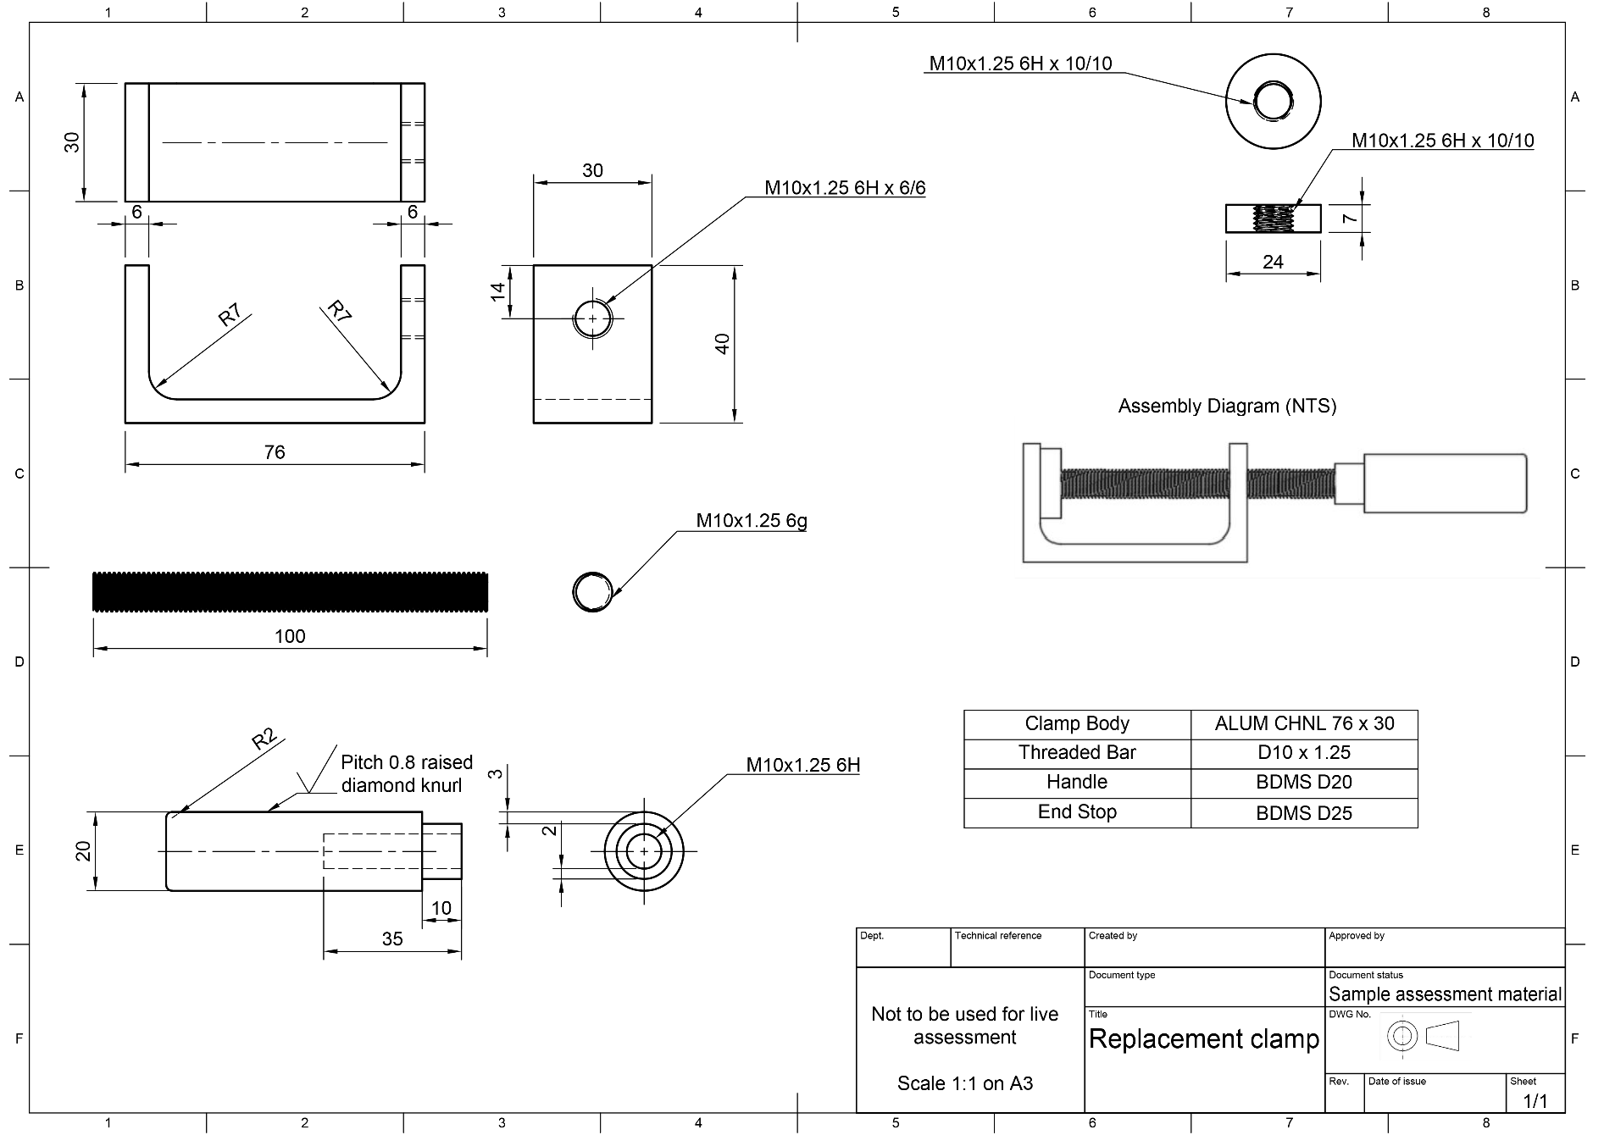

Marking criteria command words
The tables below show the command words that will be used in the NEA Marking Criteria grids. They explain the type of evidence that you should expect to see to meet each command word.

Mark Band (MB1) Words:

Command word | Meaning
Basic | - Work includes the minimum required. It is a starting point but is simplistic and not developed.  - Understanding and skills are applied in a way that partly achieves the wanted or intended result, but it would not be useable without further input or work.
Brief/Briefly | - Work includes a small number of relevant facts or concepts but lacks detail, contextualisation or examples.
Dependent | - The student can perform a task when given regular assistance or help
Few | - Work produced is restricted or narrow. It includes less than half of the information or examples expected for a full response.
Inefficient | - Outputs are produced but with great expense or effort because of poor organisation or design and not making the best use of available resources.
Limited | - Work produced is restricted in range or scope and includes only some of the information required. It evidences partial rather than full understanding.  - Work produced is a starting point rather than a developed process, concept or output.
Minimal | - Includes very little in amount or quantity required.
Simple | - Includes a small number of relevant parts, which are not related to each other.
Superficial | - Work completed lacks depth and detail.

Mark Band (MB2) Words:

Command word | Meaning
Adequate(ly) | - Work includes the appropriate number of relevant facts or concepts but does not include the full detail, contextualisation or examples.
Assisted | - The student can perform a task with occasional assistance or help.
Part(ly)/Partial | - To some extent but not completely.  - Work produced is inclusive in range and scope. It evidences a mainly developed application of understanding, performance or output needed.  - Work produced results in a process, concept or output that would be useable for its purpose.
Some | - Work produced is inclusive but not fully comprehensive. It includes over half the information or examples expected for a full response.
Sound | - Valid, logical, shows the student has secured most of the relevant understanding, but points or performance are not fully developed.  - Applies understanding and skills to produce the wanted or intended result in a way that would be useable.

Mark Band (MB3) Words:

Command word | Meaning
Accurate(ly) | - Acting or performing with care and precision.  - Correct in all details.
All | - Work produced is fully comprehensive and wide-ranging. It includes almost all, or all the information or examples expected for a full response.
Clear(ly) | - Focused and accurately expressed, without ambiguity.
Complex | - Includes many relevant parts, all of which relate to each other logically.
Comprehensive(ly) | - The work produced is complete and includes everything required to show depth and breadth of understanding.  - Applies the understanding and skills needed to successfully produce the wanted or intended result in a way that would be fully fit-for-purpose.
Consistent(ly) | - A level of performance which does not vary in quality over time.
Critical | - Objective analysis and evaluation in order to form: a judgement, evaluation of the evidence or effective trouble shooting/fault finding.
Detailed | - Gives point by point consideration of all the key information.
Effective | - Applies the skills required to the task and is successful in producing the desired or intended result.  - The work produced is effective in relation to a brief.
Efficient | - Able to produce results or outputs with the minimum expense or effort, because of good organisation or design and making the best use of available resources.
Full(y) | - Work produced is comprehensive in range and scope. It evidences a fully developed application of understanding, performance or output needed.  - Work produced results in a process, concept or output that would be fully fit-for-purpose.
Independent(ly) | - The student can perform a task without assistance or reliance on others
Justify/Justified | - The reasons for doing something are explained in full.
Most(ly) | - Includes nearly all of what is expected to be included.
Wide (ranging) | - Includes many relevant details, examples or contexts; all of which are fully detailed, contextualised or exemplified.

Teacher Observation Record
Please read the guidance notes on page 17 before completing this form.

Student name:
Qualification: | OCR Level 1/Level 2 Cambridge National in Engineering Manufacture
Unit number and title: | Unit number: R015
 | Unit title: Manufacturing a one-off product
Activity observed: | Task title: Machining
 | Task number: 4
Date activity completed:
Additional evidence attached:

TEACHER SECTION:
How did the student complete the activity?
Your response must provide details of what the student did and how this relates to the relevant marking criteria.
STUDENT SECTION:
I agree with my teacher’s description of how I completed this activity. |  |  |  |  | Yes ☐
Additional student comments:

Student signature |  | Date:  (DD/MM/YYYY)
Teacher name:
Teacher signature: |  | Date:  (DD/MM/YYYY)

Teacher Observation Record
Please read the guidance notes on the following page before completing this form.

Student name:
Qualification: | OCR Level 1/Level 2 Cambridge National in Engineering Manufacture
Unit number and title: | Unit number: R015
 | Unit title: Manufacturing a one-off product
Activity observed: | Task title: Use tools and equipment
 | Task number: 5
Date activity completed:
Additional evidence attached:

TEACHER SECTION:
How did the student complete the activity?
Your response must provide details of what the student did and how this relates to the relevant marking criteria.
STUDENT SECTION:
I agree with my teacher’s description of how I completed this activity. |  |  |  |  | Yes ☐
Additional student comments:

Student signature |  | Date:  (DD/MM/YYYY)
Teacher name:
Teacher signature: |  | Date:  (DD/MM/YYYY)

Teacher observation record guidance notes

The class teacher and student being observed are responsible for completing this form.

The Teacher Observation Record is used by the teacher to detail their observation of a student completing an activity. In order to provide sufficient evidence, the completed form must give contextualised details of what the student did and how this relates to the marking criteria. Simply providing statements from the marking criteria is not acceptable. The evidence provided must be individual to the student.

The Teacher Observation Record is also used to show that the student agrees with the teacher’s assessment of this activity.

The information given by the teacher must be shared with the student for the student to agree, or otherwise. If the student does not agree with the teacher’s comments and links to the marking criteria, they must have the chance to talk about these further with the teacher to reach an agreed outcome before the work is submitted for moderation.

Both the teacher and student must sign and date the form to provide evidence of this agreement.

Additional evidence of the student completing the activity must also be provided with the form. The types of additional evidence that are acceptable are detailed in Tasks 4 and 5.

Teacher observation records must:

- describe what the teacher observed the student doing
- include how well the activity was completed and the reasons for this evaluation
- include confirmation from the student that they agree with the comments and reasons
- be accompanied by additional evidence as required in Tasks 4 and 5

Teacher observation records must not:

- be a simple repeat of the grading criteria
- be completed by anyone but the teacher observing the activity and the student completing the activity
- be written by the student for the teacher to sign
- contain just a list of skills
- be used to evidence the achievement of a whole unit or task in isolation

Risk Assessment Template
Risk assessment for

The Potential Hazards
Risks
Control Measures

