 ENTRY LEVEL CERTIFICATE
ART and DESIGN R300 – R306
Instructions and Guidance for Visiting Moderation of candidate work from June 2012
Instructions
Centres are reminded that candidate work selected, presented and assessed for moderation should represent candidates’ best achievement for both the Coursework Portfolio and the OCR-set Work components.

The sample of work which is presented for moderation must show how the marks have been
awarded in relation to the marking criteria.

Candidates should select and present their own work for assessment purposes
from the work that they have undertaken in response to this component. In this respect it is envisaged that the amount of work presented for moderation will not be excessive or bulky.
If appropriate, candidates should photograph selected work to be displayed in an e-portfolio. This can be referred to by candidates and teachers may use as exemplar if suitably referenced to build an in-house resource for candidates. Centres may consider photographing the work as a display.
Centres are encouraged to submit outcome(s) and a supporting sketchbook or a small number (2-3) of mounted sheets A1 in size as a way to facilitate the moderation.
A completed ‘Centre Authentication’ form should be either sent or given to the moderator before the moderation commences. http://www.ocr.org.uk/download/forms/ocr_10868_form_ccs160.pdf
A completed ‘Assessment Summary’ form all candidates entered in the Centre should be sent to the moderator with the MS1, there are two versions on our website one interactive or the download and complete version available from the address below. http://www.ocr.org.uk/download/forms/ocr_57759_form_el_asf.pdf
OCR will notify Centres, upon receipt of the complete MS1 mark sheets, details of the work selected for moderation.
Centres may also be required to complete a copyright permission form for all the candidates selected for award/ standardisation/INSET purposes. Photographs taken of candidate work during the moderation visit also require a completed copyright form.
Instructions for the use of address labels and dispatch arrangements for award/standardisation/INSET selections will be addressed by the visiting moderator at the end of the moderation visit.
OCR will provide packaging material including individual candidate bags, candidate and Centre identification labels and related stationery. If necessary additional stationery may be downloaded from the OCR website.
OCR is painstaking in the care and tracking of candidates’ work however it is essential that Centres ensure that all work that has been requested for Awarding and training purposes is packaged in a manner that is appropriate, safe and secure. For example cardboard inserts in candidate folders provides additional protection and support.
The transportation of glass picture frames, delicate ceramic items and other fragile pieces is prohibited for health and safety reasons and therefore work of this nature will be photographed by the visiting moderator. Further guidance can be found in the Teachers Handbook available on our website.
All work will be returned to Centres in the Autumn Term post-moderation. Centres should be aware that it is a Code of Practice requirement that selected work is retained by OCR for Award and Standardisation purposes. A letter will be sent to each centre by the end of the Autumn Term detailing items kept and when they will be returned.
Guidance for Teachers
Whilst there is no preferred method of presentation teachers should ensure that all work submitted for moderation represents the Centre marks in relation to the Assessment Criteria for the Entry Level Certificate in Art and Design.
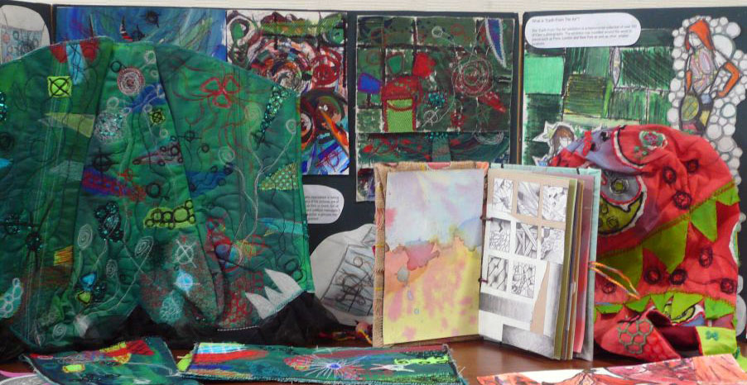

Mounted sheets; final pieces supported by a sketchbook/journal or a combination of both are widely used in Entry Level Art and Design. Whichever method or approach is used selection and organisation are important elements in establishing candidate achievements.
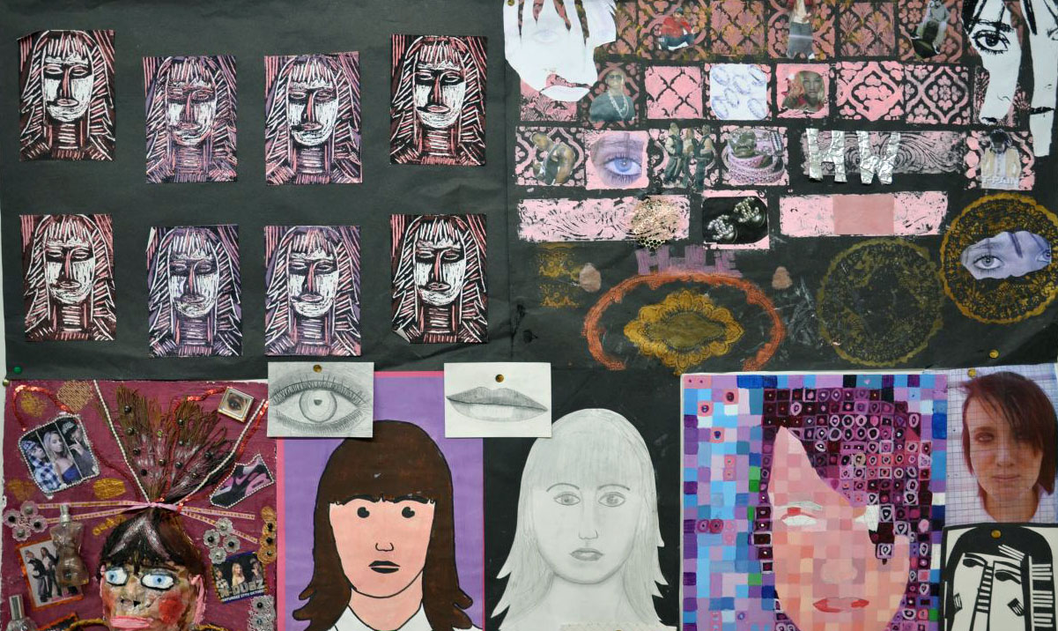

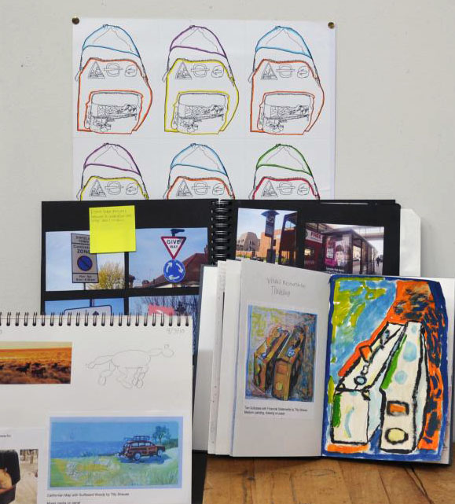

Teachers must ensure that every item of work from each individual candidate is correctly labelled, ideally on the reverse or underside of the work. An outer label should also be attached to the individual candidate bag with Centre, candidate and component details clearly filled in.

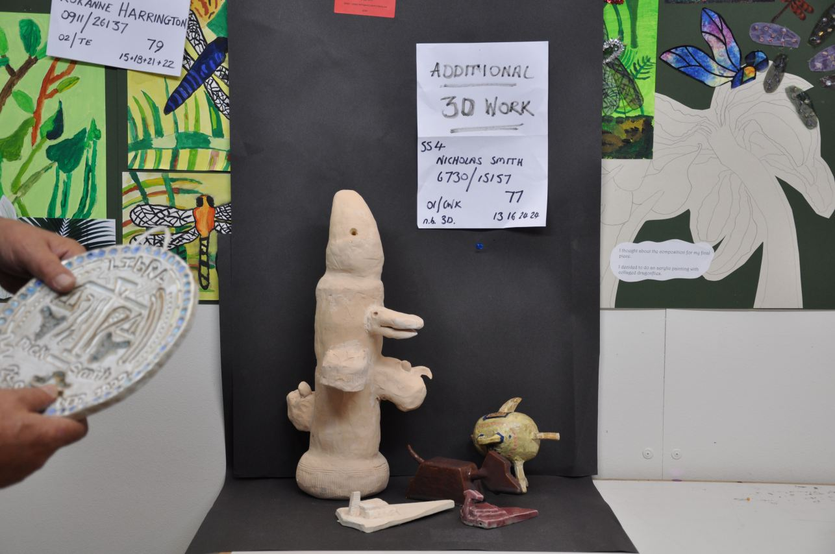

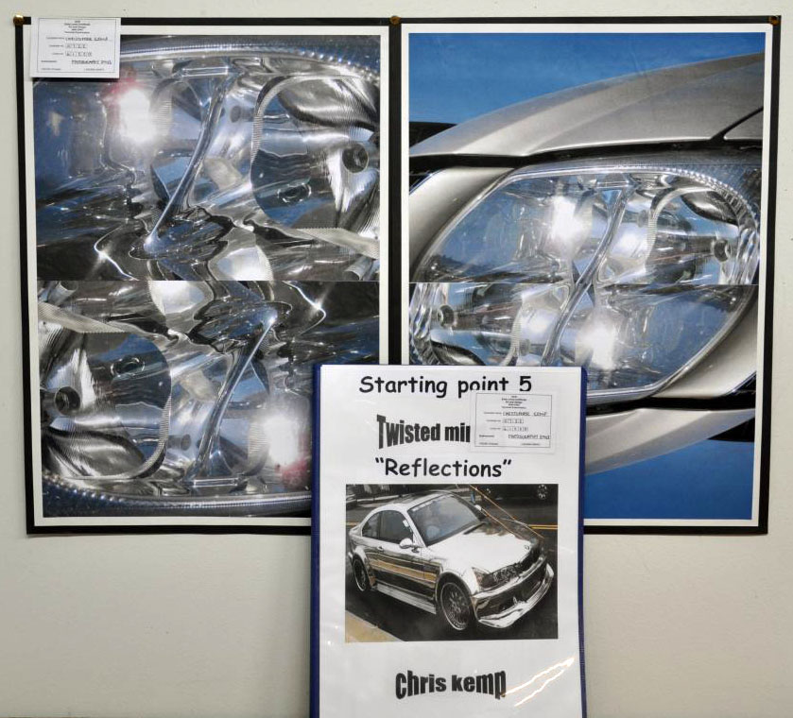

Teachers are required to ensure that where candidates are submitting digital work that it is in a clearly named and easily retrievable format. A PC or laptop needs to be available in a quiet location on the day for the work to be moderated in centre.
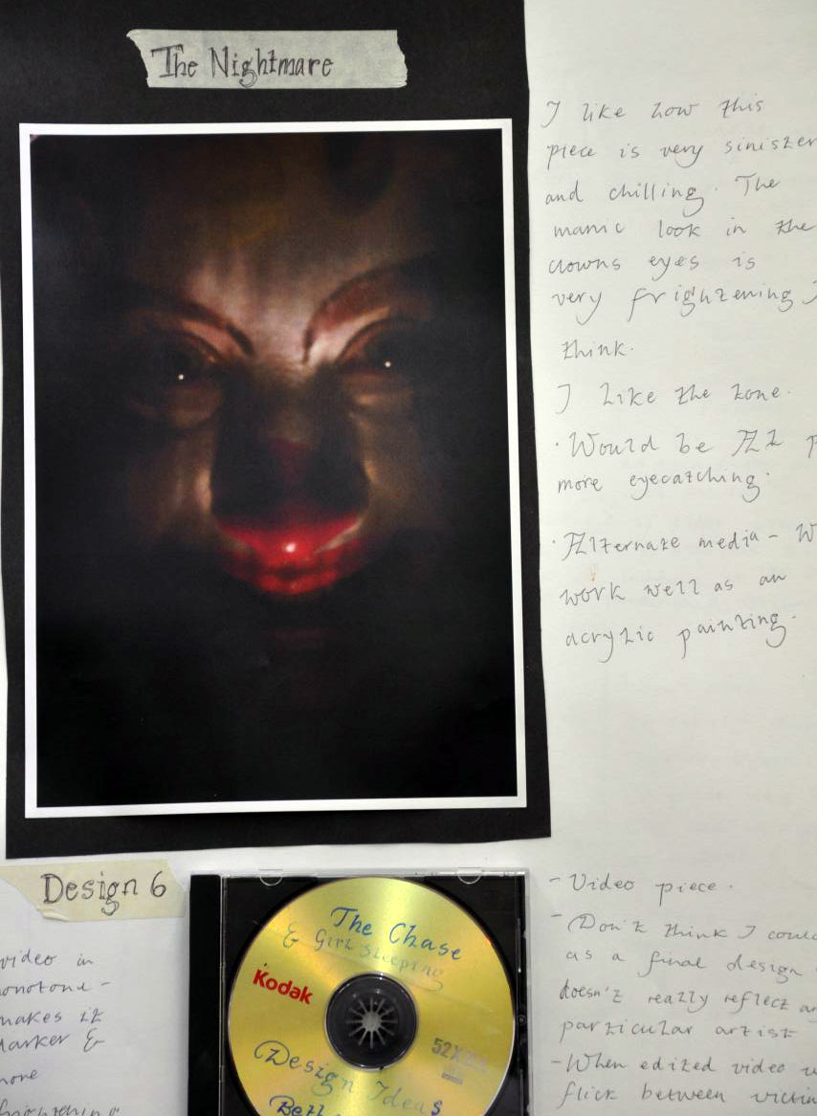

Examples of labels and packaging requirements are provided below. If work is selected by the Visiting Moderator for OCR awarding and training purposes


