OCR-set Assignment
Sample Assessment Material
OCR Level 3 Alternative Academic Qualification Cambridge Advanced National in Engineering

Unit F137: Electrical devices and circuits

Scenario Title: OCR Radio Repair

Valid for assessment from September 20XX to 20XX.
For use by students beginning the qualification in September 20XX.

This is a sample OCR-set assignment which should only be used for practice.

This assignment must not be used for live assessment of students.

The live assignments will be available on our secure website, ‘Teach Cambridge’.

The OCR administrative codes linked to this unit are:
- unit entry code F137
- certification code H127

The regulated qualification number linked to this unit is:
L/651/0640

Duration

About 20 hours of supervised time (GLH)
(work that must be completed under teacher supervised conditions)
All this material can be photocopied. Any photocopying will be done under the terms of the Copyright Designs and Patents Act 1988 solely for the purposes of assessment.

Contents

Information and instructions for Teachers 3
Using this assignment 3
Information for delivering tasks 4
Tasks for students and assessment criteria 5
Scenario 5
Task 1 5
Task 2 8
Task 3 12
Task 4 16
Task 5 19
Appendix A 23
Template for identifying three operating regions of a BJT on a graph 23
NEA Command Words 24

Information and instructions for Teachers

Using this assignment

This assignment provides a scenario and set of related tasks that reflect the use of electrical devices and circuits.

You can give this to students on or after 1 June 20XX to help them understand it before they start using it for assessment. The dates for which students can use it for assessment are shown on the front cover.
The assignment:
- Is written so that students have the opportunity to meet the requirements of all assessment criteria for the unit.
- Will tell students if their evidence must be in a specific format. If the task does not specify a format, students can choose the format to use.
- Must be completed under teacher supervision. Any unsupervised time allowed will be explained in the assessment guidance.
- We have estimated that this assignment will take about 20 hours of supervised time to complete.
Students should need approximately:
- 2 hours to complete Task 1
- 3 hours to complete Task 2
- 4 hours to complete Task 3
- 4 hours to complete Task 4
- 7 hours to complete Task 5

You must:

- Use an OCR-set assignment for summative assessment of students.
- Familiarise yourself with the assessment criteria and assessment guidance for the tasks. These are given at the end of each student task. They are also with the unit content in Section 5 of the Specification.
Assessment guidance is only given where additional information is needed. There might not be assessment guidance for each criterion.
- Make sure students understand that the assessment criteria and assessment guidance tell them in detail what they need to do in each task.
- Read and understand all the rules and guidance in Section 7 of the Specification before your students start the set assignments.
- Make sure that your students complete the tasks and that you assess the task fully in line with the rules and guidance in Section 7 of the Specification.
- Make students aware of all relevant health and safety considerations before starting any practical work.
- Make sure that students are appropriately supervised during any practical work and are working safely.

- Intervene during practical work if necessary to ensure students’ safety. In such instances, staff should assist the student to ensure their safety and so that they can continue with the subsequent assessment tasks, but they cannot be credited for the criteria directly addressing the practical skills where they have had to be helped unless the assessment guidance states otherwise.

- Give your students the engineering Student guide to NEA assignments before they start the assignments.

You must not:
- Use live OCR-set assignments for practice or formative assessment. (This sample assessment material can be used for practice or formative assessment.)
- Use this sample assessment material for live assessment of students.
- Allow group work for any task in this assignment.

You can:
- Make modifications to this assignment, as follows:
- You can change the values listed in tables within the tasks in this assignment as appropriate for the resources they have available. You must provide the same number of unique combinations as given in the original tables and use values which are appropriate for the context.
- No changes are allowed to the:
- assessment criteria.
- complexity and demand of the requirements of the task.
- unit content that is assessed.
- the amount and detail of guidance you give your students.

Section 6.2 of the Specification gives you more information about what to do with modified assignments for moderation.

Information for delivering tasks

Task | Requirements
All | - A range of electronic components and equipment as listed in the unit content.
Task 2 | - If the circuit for P3 is an RL or RC circuit, further information will be provided in relation to making it an RLC circuit for P4.

Pages 1-4 are for teachers only. Please do not give Pages 1-4 to your students.
You can give any or all of the pages that follow to your students.

Tasks for students and assessment criteria

Unit F137: Electrical devices and circuits

Scenario Title: OCR Radio Repair

Valid for assessment from September 20XX to 20XX.
For use by students beginning the qualification in September 20XX.

Scenario

You are a trainee starting at OCR Radio Repair. As part of your induction you are going to investigate different types of circuits often found within radios to understand their function.

Task 1
DC Circuits
Topic Area 1 is assessed in this task.
Your first tasks are about DC circuits. You have been asked to investigate the two DC resistor circuits shown in Fig.1 and Fig. 2.
Fig. 1 is a circuit of resistors in series and Fig 2 is a circuit of resistors in parallel:
Fig. 1  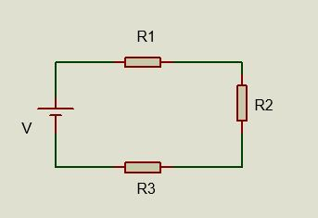 | Fig. 2  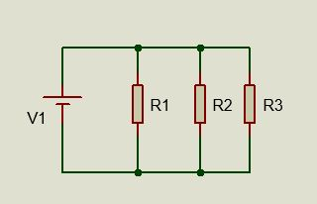

You will be allocated resistor ($Ω$) and voltage (V) values from Table 1 to use in your resistor circuits.

Table 1
Student: | Resistance value in k$Ω$ |  |  |  | Power Supply Voltage (DC)
 | R1 | R2 | R3
Student 1 | 10 | 15 | 12 |  | 6V
Student 2 | 15 | 27 | 27 |  | 9V
Student 3 | 27 | 10 | 33 |  | 12V
Student 4 | 10 | 15 | 47 |  | 6V
Student 5 | 15 | 27 | 12 |  | 9V
Student 6 | 27 | 10 | 27 |  | 12V
Student 7 | 10 | 15 | 33 |  | 6V
Student 8 | 15 | 27 | 47 |  | 9V
Student 9 | 27 | 10 | 12 |  | 12V
Student 10 | 10 | 15 | 27 |  | 6V
Student 11 | 33 | 10 | 15 |  | 9V
Student 12 | 27 | 12 | 33 |  | 12V
Student 13 | 10 | 47 | 33 |  | 6V
Student 14 | 47 | 10 | 27 |  | 9V
Student 15 | 27 | 15 | 10 |  | 12V

The task is:
To simulate and build the physical circuits in Fig. 1, measuring the:
  - Total resistance of the circuit.
  - Current taken from the power supply.
  - Voltage across each resistor.

And to simulate and build the physical circuit in Fig. 2, measuring the:
  - Total resistance of the circuit.
  - Current taken from the power supply.
  - Current through each resistor.

Your evidence must include:
  - The results from your simulations, including screenshots, and a comparison of the results.
  - Annotated photographs of building the physical circuits and measurements of their operation.

Use the assessment criteria below to tell you what you need to do in more detail.
Pass | Merit | Distinction
P1: Simulate two DC circuits, measuring the required currents, voltages and resistances.  (PO4) | M1: Compare the results from the simulated DC circuits and the physical DC circuits, giving reasons for any differences.  (PO3)
P2: Build two physical DC circuits, measuring the required currents, voltages and resistances safely.
(PO4)

Assessment Guidance
This assessment guidance gives you information to meet the assessment criteria. There might not be additional assessment guidance for each criterion. It is only given where it is needed. You must read this guidance before you complete your evidence.
Assessment Criteria | Assessment Guidance
P1 | - Circuits will contain at least three resistors in series, parallel or combination arrangement, and one or two power sources.  - Physical circuits could be built using either a breadboard or stripboard method.  - The values students are asked to measure in relation to currents, voltages and resistances may change depending on the circuits given in each assignment and changes centres may make to values of the components as appropriate for the resources they have available.  - For P2, students must be able to perform the task safely to achieve this criterion. Staff must intervene if safe working practices are not being followed but where this happens the criteria cannot be awarded as achieved.
P2

Task 2
AC circuits
Topic Area 1 is assessed in this task.
For your next task, you have been asked to investigate single-phase AC circuits containing passive components and voltage waveforms.

Fig. 3 is an AC circuit containing three passive components.
Fig. 4 shows two voltage waveforms V1 and V2.
Fig. 5 is a discharge lighting circuit with an inductive load and internal resistance.
Fig. 3
Fig. 4
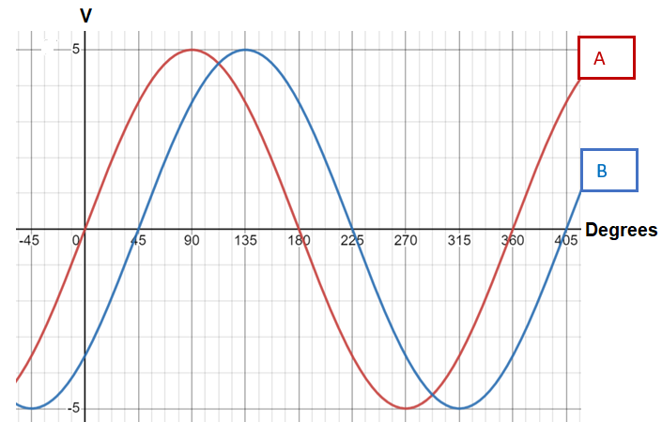
The following is confirmed.
- Amplitude is 5 volts for both waves.
- Wave B lags wave A by 45 degrees which is pi/4.
- Both waves have the same frequency.

Fig. 5
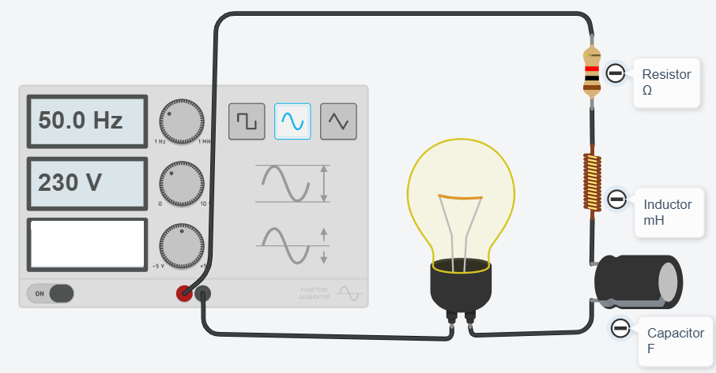

You will be allocated:
- resistor ($Ω$), inductor ($mH$), capacitor ($μF$) and supply voltage (V) values from Table 3 to use in your resistor, inductor and capacitor (RLC) circuit
- an amplitude for each of the two voltage waveforms values from Table 4
- inductance ($mH$) and resistor ($Ω$) values from Table 5 to use in your discharge lighting circuit.
Table 3
Student: | Component values |  |  | Supply voltage (Volts AC) at 50Hz.
 | $$R (Ω)$$ | $$L (mH)$$ | $$C (µF)$$
Student 1 | 10 | 15 | 12 | 100V
Student 2 | 15 | 27 | 27 | 110V
Student 3 | 27 | 10 | 33 | 120V
Student 4 | 10 | 15 | 47 | 130V
Student 5 | 15 | 27 | 12 | 140V
Student 6 | 27 | 10 | 27 | 150V
Student 7 | 10 | 15 | 33 | 160V
Student 8 | 15 | 27 | 47 | 170V
Student 9 | 27 | 10 | 12 | 180V
Student 10 | 10 | 15 | 27 | 190V
Student 11 | 33 | 10 | 15 | 200V
Student 12 | 27 | 12 | 33 | 220V
Student 13 | 10 | 47 | 33 | 230V
Student 14 | 47 | 10 | 27 | 240V
Student 15 | 27 | 15 | 10 | 250V

Table 4
Student | 1 | 2 | 3 | 4 | 5 | 6 | 7 | 8 | 9 | 10 | 11 | 12 | 13 | 14 | 15
Amplitude (V/division) for each of the waves. | 2 | 5 | 10 | 0.2 | 0.5 | 1 | 2 | 5 | 10 | 0.2 | 0.5 | 1 | 2 | 5 | 10

Table 5
Student | $$L (mH)$$ | $$R (Ω)$$
Student 1 | 15 | 10
Student 2 | 27 | 15
Student 3 | 10 | 25
Student 4 | 15 | 40
Student 5 | 25 | 15
Student 6 | 10 | 27
Student 7 | 27 | 40
Student 8 | 27 | 15
Student 9 | 40 | 27
Student 10 | 25 | 10
Student 11 | 10 | 33
Student 12 | 12 | 27
Student 13 | 47 | 10
Student 14 | 10 | 47
Student 15 | 47 | 12

The task is:
- Calculate, for the AC circuit in Fig. 3 the:
  - total current
  - voltage across each element
  - power factor
  - phase angle
  - apparent, real, and reactive power
  - resonant frequency and Q-factor.
- Model graphically the voltages V1 and V2 in Fig. 4. You should use a software package and the radian unit of measure. Then combine the V1 and V2 waveforms together graphically.
- Calculate, for the discharge lighting circuit in Fig. 5, the value of capacitor required to correct the Power Factor (PF) to 0.9. Evaluate the advantages of power factor correction in this situation.

Your evidence must include:
- The working and results from your calculations, results of simulations and a written evaluation.

Use the assessment criteria below to tell you what you need to do in more detail.
Pass | Merit | Distinction
P3: Calculate reactance, impedance, phase angle, current, voltage, power in a circuit with two or three passive RLC components in series or parallel configuration.  (PO2) | M2: Produce the resultant waveform graphically by the addition or subtraction of two sinusoidal waves with the same frequency.  (PO4) | D1: Evaluate the advantages of using power factor correction in a circuit.  (PO3)
P4: Calculate the resonance and Q-factor or bandwidth in a RLC circuit with series and/or parallel configuration.
(PO2)

Assessment Guidance
This assessment guidance gives you information to meet the assessment criteria. There might not be additional assessment guidance for each criterion. It is only given where it is needed. You must read this guidance before you complete your evidence.
Assessment Criteria | Assessment Guidance
P3 | - Circuits provided could be RL, RC or RLC in any combination of series or parallel configuration.
M2 | - Students must provide evidence of the waveform(s) modelled graphically.

Task 3
Diodes and transistors
Topic Area 2 is assessed in this task.
Diode and transistor circuits are commonly used in radios and sometimes fail and need repair. OCR Radio Repair want you to investigate the design of a rectifier circuit, diodes that make up the circuit and the operating regions of a bipolar junction transistor (BJT).
Fig. 6 is a rectifier circuit. The value of R_{L} should be around 1k$Ω$.
Fig. 7 is the voltage and current (V-I) characteristic curve for a bipolar junction transistor (BJT).
Fig. 8 is the voltage and current (V-I) characteristic curves for a rectifier and Zener diodes.
Fig. 6
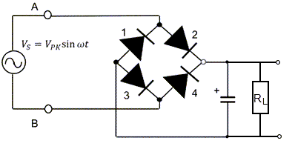

Fig. 7
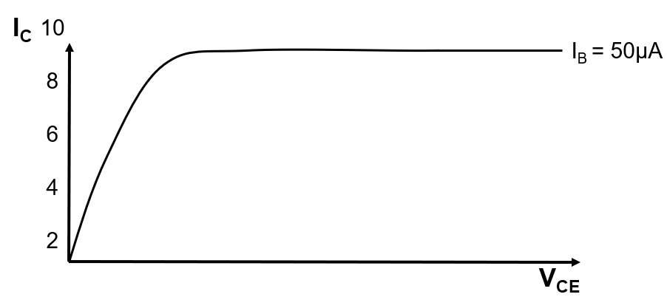

Fig. 8
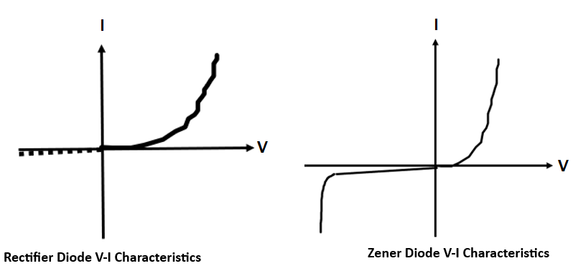

You will be allocated voltage ($V_{PK}$) and capacitor ($C)$ values from Table 6 to use in your rectifier circuit.
Table 6
Student | $$V_{PK}$$ | $$C (µF)$$
Student 1 | 2 | 12
Student 2 | 3 | 27
Student 3 | 4 | 33
Student 4 | 5 | 47
Student 5 | 6 | 12
Student 6 | 7 | 27
Student 7 | 8 | 33
Student 8 | 9 | 47
Student 9 | 10 | 12
Student 10 | 2 | 47
Student 11 | 3 | 33
Student 12 | 4 | 27
Student 13 | 5 | 12
Student 14 | 6 | 47
Student 15 | 7 | 33

The task is:
- Simulate the operation of the rectifier circuit in Fig. 6 , selecting appropriate diodes, and record the input and output waveforms.
- Safely build the physical rectifier circuit in Fig. 6 and the input and output voltage waveforms measure from the physical circuit using an oscilloscope.
- Explain how the rectification has been achieved, comparing the simulated results and measured results from the physical circuit.
- Illustrate the regions of operation of a bipolar junction transistor (BJT) in Fig. 7 (Appendix A).
- Evaluate the performance of rectifier and Zener diode in forward and reverse biasing modes. Compare their performance by using voltage and current (V-I) characteristics in Fig. 8. Identify their regions of operation and show the breakdown and Zener voltages.

Your evidence must include:

- Screenshots of the simulation circuit and of the input and output waveforms
- Annotated photographs of building the physical circuit and measurements of its operation
- A written explanation of rectification and evaluation of the rectifier and Zener diodes.
- An annotated graph showing the regions of operation for the bipolar junction transistor (Appendix A).

Use the assessment criteria below to tell you what you need to do in more detail.
Pass | Merit | Distinction
P5: Simulate the correct operation of a rectifier circuit.
(PO4)
P6: Build and test the operation of a rectifier circuit safely, recording the input and output waveforms.  (PO4) | M3: Explain how the rectification has been achieved, comparing the results of the simulated and physical circuits.  (PO3) | D2: Evaluate the performance of two types of diodes in forward and reverse biasing modes, comparing the voltage and current characteristics.  (PO3)
P7: Identify three operating regions of a bipolar junction transistor (BJT) on a graph.
(PO2)

Assessment Guidance
This assessment guidance gives you information to meet the assessment criteria. There might not be additional assessment guidance for each criterion. It is only given where it is needed. You must read this guidance before you complete your evidence.
Assessment Criteria | Assessment Guidance
P6 | - Physical circuits could be built using either a breadboard or stripboard method.  - Students must be able to perform the task safely to achieve this criterion. Staff must intervene if safe working practices are not being followed but where this happens the criteria cannot be awarded as achieved.
P7 | - Students must provide a graph with their annotations showing the regions of operation for the bipolar junction transistor

.

Task 4
Analogue circuits
Topic Area 3 is assessed in this task.
Analogue circuits are commonly used in radios and sometimes fail and need repair.
You have been asked to investigate the design of a transistor amplifier circuit.
Fig. 9 is a Bipolar Junction Transistor (BJT) amplifier circuit.
Fig. 9
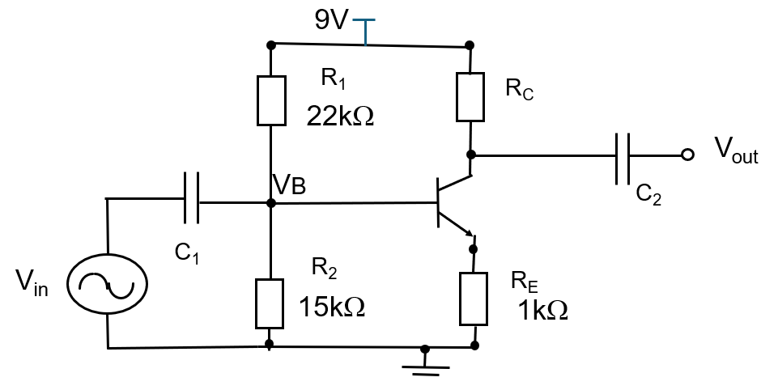

You will be allocated a value of current gain ($β$) from Table 7 for use in your transistor amplifier circuit. You will need to decide on suitable characteristics for the input waveform (e.g. frequency and amplitude) and suitable values for the capacitors.

Table 7
Student | Target Voltage Gain ($β$)
Student 1 | 1.1
Student 2 | 1.3
Student 3 | 1.5
Student 4 | 1.7

The task is:
- Identify a suitable value of $R_{C}$ to ensure $V_{CE}≥$3.5.
- Simulate the operation of the transistor amplifier circuit in Fig. 9. Record the operation of the circuit, to achieve the target voltage gain by changing the value of $R_{C}$.
- Apply a suitable input waveform and record the input and output waveforms.
- Safely build the physical transistor amplifier circuit in Fig. 9 Apply a suitable input waveform and record the input and output waveforms. Safely measure and record the voltage gain.
- Explain the operation of a Class B amplifier and why it would be more appropriate for use in a battery powered radio.
- Evaluate the performance of simulated BJT transistor amplifier circuit and physical BJT transistor amplifier circuit, giving reasons for any differences.

Your evidence must include:

- The results from your simulations, including screenshots and identification of specific values.
- Annotated photographs of building the physical circuit and measurements of its operation.
- A written evaluation, comparing the performance of a simulated transistor amplifier against a physical circuit.
- A written comparison of two classes of BJT amplifier circuits.

Use the assessment criteria below to tell you what you need to do in more detail.
Pass | Merit | Distinction
P8: Simulate the correct operation of a BJT amplifier circuit to achieve the given gain.  (PO4) | M4: Explain how one class of amplifier operates and is suitable for a specific application.  (PO2) | D3: Evaluate the performance of the simulated and physical BJT amplifier circuits, giving reasons for any differences.  (PO3)
P9: Build and test the operation of a BJT amplifier circuit safely.
(PO4)

Assessment Guidance
This assessment guidance gives you information to meet the assessment criteria. There might not be additional assessment guidance for each criterion. It is only given where it is needed. You must read this guidance before you complete your evidence.
Assessment Criteria | Assessment Guidance
P8 | - It may be necessary to identify or establish suitable missing resistor/capacitor values in order for circuits to operate as intended, depending on the information provided.
P9 | - Physical circuits could be built using either a breadboard or stripboard method.  - Students must be able to perform the task safely to achieve this criterion. Staff must intervene if safe working practices are not being followed but where this happens the criteria cannot be awarded as achieved.
M4 | - Students will explain the theoretical operation of an amplifier circuit for a given application and will outline the advantages/disadvantages, input/output signals and efficiency.

Task 5
Combinational Logic and Sequential Logic Circuits
Topic Area 4 is assessed in this task.

Digital logic circuits are used in modern radios and are another potential cause of fault which can require repair.
You have been asked to investigate the design of combinational logic and sequential logic circuits.
You will:
- be allocated the sum of the product values from Table 9 to use in your combinational logic circuits.
- use the present state and next state values from Table 10 to use in your sequential logic circuits.

Table 9
Student | Sum of Product
Student 1 | $$Q\left(X,Y,Z\right)=\sum{(0,1,5,6)}$$
Student 2 | $$Q\left(X,Y,Z\right)=\sum{(2,3,5,6)}$$
Student 3 | $$Q\left(X,Y,Z\right)=\sum{(1,4,5,6)}$$
Student 4 | $$Q\left(X,Y,Z\right)=\sum{(3,4,5,6)}$$
Student 5 | $$Q\left(X,Y,Z\right)=\sum{(2,5,6,7)}$$
Student 6 | $$Q\left(X,Y,Z\right)=\sum{(3,5,6,7)}$$
Student 7 | $$Q\left(X,Y,Z\right)=\sum{(4,5,6,7)}$$
Student 8 | $$Q\left(X,Y,Z\right)=\sum{(0,5,6,7)}$$
Student 9 | $$Q\left(X,Y,Z\right)=\sum{(1,5,6,7)}$$
Student 10 | $$Q\left(X,Y,Z\right)=\sum{(1,2,6,7)}$$
Student 11 | $$Q\left(X,Y,Z\right)=\sum{(0,3,6,7)}$$
Student 12 | $$Q\left(X,Y,Z\right)=\sum{(1,3,6,7)}$$
Student 13 | $$Q\left(X,Y,Z\right)=\sum{(2,3,6,7)}$$
Student 14 | $$Q\left(X,Y,Z\right)=\sum{(3,4,6,7)}$$
Student 15 | $$Q\left(X,Y,Z\right)=\sum{(1,2,4,7)}$$

Table 10
Present State |  |  | Next State
A | B | C | X | Y | Z
0 | 0 | 0 | 0 | 0 | 1
0 | 0 | 1 | 0 | 1 | 0
0 | 1 | 0 | 0 | 1 | 1
0 | 1 | 1 | 1 | 0 | 0
1 | 0 | 0 | 1 | 0 | 1
1 | 0 | 1 | 1 | 1 | 0
1 | 1 | 0 | 1 | 1 | 1
1 | 1 | 1 | 0 | 0 | 0

The task is to:
- Design a combinational logic circuit to produce the sum of the product value of the binary equivalent to produce Q=1.
- Simulate the operation of the combinational logic circuit.
- Safely build the physical combinational logic circuit and test the operation of the circuit.
- Redesign the combinational logic circuit using Boolean laws to minimise the gates used. Simulate the redesigned circuit. Compare the performance of the minimised circuit with the original simulated combinational logic circuit.
You will then need to:
- Design a sequential logic circuit for the present state and next state values and using a flip-flop of your choice.
- Simulate the operation of the sequential logic circuit for the given values.
- Safely build the physical sequential logic circuit and safely test the correct operation of the circuit.
- Redesign the sequential logic circuit using a different flip-flop. Simulate the redesigned circuit. Compare the performance of the redesigned sequential logic circuit with the original simulated circuit.

Your evidence must include:

- Your design and redesign for a combinational logic circuit, including your simulation results with annotated screenshots and a comparison of the performance of the circuits.
- Annotated photographs of building the physical circuit and measurements of its operation.
- Your design and redesign for a sequential logic circuit, including your simulation results with annotated screenshots and a comparison of the performance of the circuits.
- Annotated photographs of building the physical circuit and measurements of its operation.

Use the assessment criteria below to tell you what you need to do in more detail.
Pass | Merit | Distinction
P10: Design and simulate the correct operation of the combinational logic circuit.  (PO4) | M5: Build and test the correct operation of the combinational logic circuit safely.  (PO4) | D4: Simplify the combinational logic circuit using Boolean laws, comparing the performance with the original simulated circuit.  (PO3)
P11: Design and simulate the correct operation of the sequential logic circuit.  (PO4) | M6: Build and test the correct operation of the sequential logic circuit safely.  (PO4) | D5: Redesign the sequential logic circuit using a different flip-flop type, comparing the simulated performance with that of the original circuit.  (PO3)

Assessment Guidance
This assessment guidance gives you information to meet the assessment criteria. There might not be additional assessment guidance for each criterion. It is only given where it is needed. You must read this guidance before you complete your evidence.
Assessment Criteria | Assessment Guidance
P10 | - The circuits will need to be designed initially in order to then simulate them.
M5 | - Physical circuits could be built using either a breadboard or stripboard method.  - Students must be able to perform the task safely to achieve M5 and M6. Staff must intervene if safe working practices are not being followed but where this happens the criteria cannot be awarded as achieved.
M6

Appendix A

Template for identifying three operating regions of a BJT on a graph

Fig. 7, Task 3 – for use in criteria P7
The voltage and current (V-I) characteristic curve for a bipolar junction transistor (BJT)
Figure 7

NEA Command Words

The table below shows the command words that may be used in the NEA assignments and/or assessment criteria.
Command Word | Meaning
Adapt | - Change to make suitable for a new use or purpose
Analyse | - Separate or break down information into parts and identify their characteristics or elements  - Explain the pros and cons of a topic or argument and make reasoned comments  - Explain the impacts of actions using a logical chain of reasoning
Assess | - Offer a reasoned judgement of the standard or quality of situations or skills. The reasoned judgement is informed by relevant facts
Calculate | - Get a numerical answer, showing how it has been worked out
Classify | - Arrange in categories according to shared qualities or characteristics
Compare | - Give an account of the similarities and differences between two or more items, situations or actions
Conclude | - Judge or decide something
Describe | - Give an account that includes all the relevant characteristics, qualities, or events
Discuss (how/whether/etc) | - Present, analyse and evaluate relevant points (for example, for/against an argument) to make a reasoned judgement
Evaluate | - Make a reasoned qualitative judgement considering different factors and using available knowledge/experience
Examine | - To look at, inspect, or scrutinise carefully, or in detail
Explain | - Give reasons for and/or causes of something  - Make something clear by describing and/or giving information
Interpret | - Translate information into recognisable form  - Convey one’s understanding to others, e.g. in a performance
Investigate | - Inquire into (a situation or problem)
Justify | - Give valid reasons for offering an opinion or reaching a conclusion
Research | - Do detailed study in order to discover (new) information or reach a (new) understanding
Summarise | - Express the most important facts or ideas about something in a short and clear form

We might also use other command words but these will be:
- commonly used words whose meaning will be made clear from the context in which they are used (e.g. create, improve, plan)
- subject specific words drawn from the unit content.

