OCR-set Assignment
Sample Assessment Material
OCR Level 3 Alternative Academic Qualification Cambridge Advanced National in Engineering

Unit F133: Computer Aided Design (CAD)

Scenario Title: Hand drill

Valid for assessment from September 20XX to 20XX.
For use by students beginning the qualification in September 20XX.

This is a sample OCR-set assignment which should only be used for practice.

This assignment must not be used for live assessment of students.

The live assignments will be available on our secure website, ‘Teach Cambridge’.

The OCR administrative codes linked to this unit are:
- unit entry code F133
- certification code H127

The regulated qualification number linked to this unit is:
A/651/0636

Duration

About 20 hours of supervised time (GLH)
(work that must be completed under teacher supervised conditions)

All this material can be photocopied. Any photocopying will be done under the terms of the Copyright Designs and Patents Act 1988 solely for the purposes of assessment.

Contents

Information and instructions for Teachers 3
Using this assignment 3
Information for delivering tasks 4
Tasks for students and assessment criteria 5
Scenario 5
Task 1 6
Task 2 9
NEA Command Words 11

Information and instructions for Teachers

Using this assignment

This assignment provides a scenario and set of related tasks that reflect the uses of computer aided design to model products and to be able to put these products through non-destructive testing to further amend and optimise the design.

You can give this to students on or after 1 June 20XX to help them understand it before they start using it for assessment. The dates for which students can use it for assessment are shown on the front cover.
The assignment:
- Is written so that students have the opportunity to meet the requirements of all assessment criteria for the unit.
- Will tell students if their evidence must be in a specific format. If the task does not specify a format, students can choose the format to use.
- Must be completed under teacher supervision. Any unsupervised time allowed will be explained in the assessment guidance.
- We have estimated that this assignment will take about 20 hours of supervised time to complete.
Students should need approximately:
- 15 supervised hours to complete Task 1
- 5 supervised hours to complete Task 2

You must:

- Use an OCR-set assignment for summative assessment of students.
- Familiarise yourself with the assessment criteria and assessment guidance for the tasks. These are given at the end of each student task. They are also with the unit content in Section 5 of the Specification.
Assessment guidance is only given where additional information is needed. There might not be assessment guidance for each criterion.
- Make sure students understand that the assessment criteria and assessment guidance tell them in detail what they need to do in each task.
- Read and understand all the rules and guidance in Section 7 of the Specification before your students start the set assignments.
- Make sure that your students complete the tasks and that you assess the task fully in line with the rules and guidance in Section 7 of the Specification.
- Give your students the Engineering Student guide to NEA assignments before they start the assignments.

You must not:
- Use live OCR-set assignments for practice or formative assessment. This sample assessment material can be used for practice or formative assessment.
- Use this sample assessment material for live assessment of students.
- Allow group work for any task in this assignment.
- Change any part of the OCR-set assignments or assessment criteria.

Information for delivering tasks

Task | Requirements
All | - 3D modelling software, e.g. Autodesk inventor, Fusion 360, OnShape, Solidworks.  - Access to software that can do CFD and FEA e.g. inbuilt in software or Simscale.  - Access to screen recording software

Pages 1-4 are for teachers only. Please do not give Pages 1-4 to your students.
You can give any or all of the pages that follow to your students.

Tasks for students and assessment criteria

Unit F133: Computer Aided Design (CAD)
Scenario Title: Hand drill

Valid for assessment from September 20XX to 20XX.
For use by students beginning the qualification in September 20XX.

Scenario
The product is a hand drill.
You are a junior design engineer for OCR Tools. They want you to produce and optimise a three-dimensional (3D) Computer Aided Design (CAD) assembly of a hand drill.
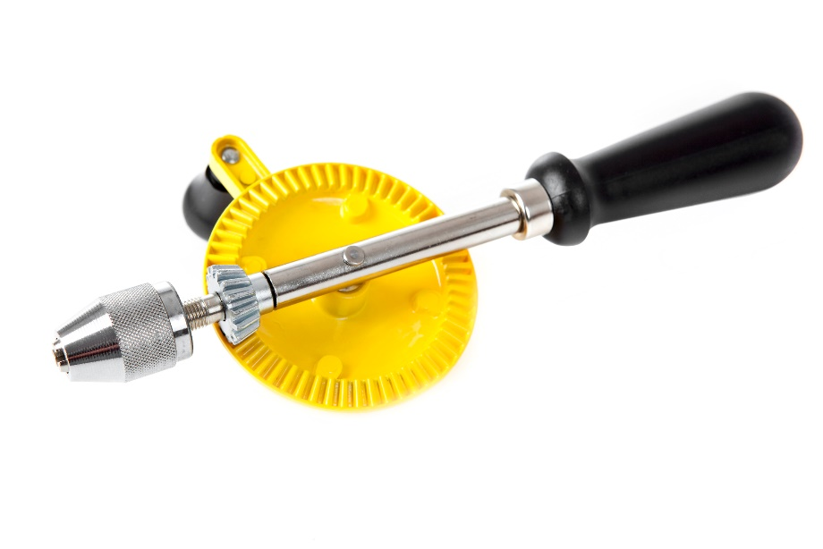
An example of a hand drill and associated components is shown below.
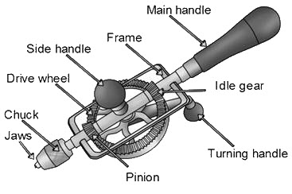
You do not need to disassemble the product to complete the tasks.

Task 1
Produce a 3D CAD assembly and drawings of the product.
Topic Area 1, 2 and 3 are assessed in this task.
For this task you will be given a hand drill similar to the image provided, and appropriate measuring devices.
Your manager at OCR Tools wants you to show that you can produce a 3D model and assembly of a product from scratch.
You need to measure the dimensions from the physical product you have been given using appropriate devices, produce an initial 2D sketch and then develop this to produce 3D models, a 3D CAD assembly and technical drawings.

The task is:
To produce a 3D CAD assembly and technical drawings of the hand drill, including:
- individual 3D models of at least six non-standard components of the hand drill, using appropriate dimensions and scale.
- interface the modelled components together into an assembly using standard components as appropriate.
- demonstrate the appropriate movement of some of the components within the 3D CAD assembly.
- produce an appropriate technical drawing of your assembly.

Your evidence must include:
- Annotated screenshots:
  - of 2D sketches, including any mathematics used to create the sketches.
  - showing the use of 3D CAD software tools.
  - showing the 3D models of the individual components.
  - of the 3D assembly.
  - of the exploded view.
- An audio-visual recording showing any animation.
- A technical drawing.

Use the assessment criteria below to tell you what you need to do in more detail.
Pass | Merit | Distinction
P1: Produce an appropriate 2D sketch using dimensions from the product.  (PO4) | M1: Use appropriate variables or equations in a sketch or extrude.  (PO2) | D1: Produce a surface model of a component of the design using appropriate tools and techniques.  (PO4)

P2: Use the pattern tool within a sketch of a component.  (PO2) | M2: Use advanced features that involve multiple planes and sketches.  (PO2) | D2: Produce a to scale, complete, animated 3D assembly of the physical product.  (PO4)
P3: Use a mirror tool in a sketch of a component.
(PO2)
P4: Use extrude and revolve tools in a sketch of a component.  (PO2) | M3: Produce an exploded view of a 3D assembly.  (PO4)
P5: Use applied features to add details to a 3D model of a component.
(PO2)
P6: Produce a 3D assembly of at least six interfacing non-standard components.
(PO4)
P7: Use constraints within a 3D assembly that appropriately define the position or movement of the components within the model.
(PO2)
P8: Produce an orthographic technical drawing with more than one view of a non-standard component within a 3D assembly.  (PO4) | M4: Apply accurate dimensioning and annotations to a technical drawing.  (PO4) | D3: Produce a detailed technical assembly drawing that conforms to engineering drawing standards.  (PO4)

Assessment Guidance
This assessment guidance gives you information to meet the assessment criteria. There might not be additional assessment guidance for each criterion. It is only given where it is needed. You must read this guidance before you complete your evidence.
Assessment Criteria | Assessment Guidance
P1 | - It is not necessary to disassemble the product to complete any of the tasks.
P6, D2 | - P6 can be achieved with an assembly of at least six interfacing non-standard components. It may not have to be an assembly of the whole product (depending on the product in the assignment).  - However more than six non-standard components may be needed to produce a 3D assembly of the whole product, which is required for D2.
P8 | - This must be one technical drawing of one non-standard component within the assembly which includes multiple views of that component. It does not have to be dimensioned or annotated but must have a scale.
M4 | - Applying annotations, callouts and dimensions to a component (P8) or assembly (D3) technical drawing.
D3 | - The technical assembly drawing must be produced using an appropriate drawing standard, such as British Standard (BS) 8888.  - Correct nesting and orientation of dimensions, labels and callout boxes must be demonstrated. Presentation of the assembly must also conform to the standard and may include different views if they are appropriate.

Advice:
- Technical drawings must be produced using an appropriate drawing standard, such as British Standard (BS) 8888.
- Remember to clearly reference any information used from books, websites or other sources to support your evidence.

Task 2
Investigate an alternative design of the product.
Topic Area 1, 2 and 4 is assessed in this task.
OCR Tools wants you to investigate an alternative design for the hand drill product. They have investigated the potential users and determined that the handle may be subjected to a range of forces from an adult from 300 to 600 Newtons.
They would like you to set-up and run an appropriate type of simulation for the original 3D CAD assembly of the hand drill under the specified operating conditions.
You then need to use the results and engineering design principles to create an alternative design of the 3D CAD assembly of the hand drill.
The task is to:
- Simulate, using finite element analysis (FEA), the operation of the original 3D CAD assembly of the hand drill you created in Task 1.
- Use the simulation results and engineering design principles to create an alternative design of the 3D CAD assembly and determine if it is an improvement on the original.

Your evidence must include:
- Annotated screenshots or images of:
  - the simulation setup and simulation results.
  - the alternative design of the 3D CAD assembly, including any use of configuration tables or table-driven features.
  - the simulation results for the alternative 3D CAD design of the assembly.

Use the assessment criteria below to tell you what you need to do in more detail.
Pass | Merit | Distinction
P9: Set up an appropriate simulation for the assembly, using the operating conditions given.  (PO4) | M5: Conclude the results of the simulation of an assembly.  (PO3) | D4: Recommend alternative design ideas based on the results of the simulation.  (PO3)
P10: Complete a simulation for the assembly to produce appropriate results.
(PO4)
P11: Create an alternative design for a component of the assembly.  (PO4) | M6: Use table-driven features or configurations in designs to create variable designs of a component or assembly.  (PO2) | D5 Evaluate whether the alternative design is an improvement using simulation software and design principles.  (PO3)

Assessment Guidance
This assessment guidance gives you information to meet the assessment criteria. There might not be additional assessment guidance for each criterion. It is only given where it is needed. You must read this guidance before you complete your evidence.
Assessment Criteria | Assessment Guidance
P9/10 | - Where possible the assembly already produced should be used. However, where an assembly was not successfully created one can be provided by the teacher for the student to use when trying to meet these assessment criteria.
M5 | - Students must draw appropriate conclusions from their simulation results about the performance of the components and/or assembly under the given operating conditions.
P11 | - Evidence of a change in the model should be provided, along with documentation about what was changed and how it affects the model. The alternative design must be a noticeable change to the geometry of at least one component.
M6 | - This is to demonstrate that the model can be altered, but in such a way that it is table driven. For example, a client can control it from a table (depending on software) to alter the design.
D4 | - The alternative design ideas must each have a noticeable change to the geometry of at least one component. The ideas could be applied to the same component, or to different components.
D5 | - This must include a response to the simulation results, alterations to the design, a retest and justifications of the change made. The criteria can still be met if the change does not lead to an improvement in the model. However. justification for the change, showing understanding of the simulation and design principles, would be needed.

NEA Command Words

The table below shows the command words that may be used in the NEA assignments and/or assessment criteria.
Command Word | Meaning
Adapt | - Change to make suitable for a new use or purpose
Analyse | - Separate or break down information into parts and identify their characteristics or elements  - Explain the pros and cons of a topic or argument and make reasoned comments  - Explain the impacts of actions using a logical chain of reasoning
Assess | - Offer a reasoned judgement of the standard or quality of situations or skills. The reasoned judgement is informed by relevant facts
Calculate | - Get a numerical answer, showing how it has been worked out
Classify | - Arrange in categories according to shared qualities or characteristics
Compare | - Give an account of the similarities and differences between two or more items, situations or actions
Conclude | - Judge or decide something
Describe | - Give an account that includes all the relevant characteristics, qualities, or events
Discuss (how/whether/etc) | - Present, analyse and evaluate relevant points (for example, for/against an argument) to make a reasoned judgement
Evaluate | - Make a reasoned qualitative judgement considering different factors and using available knowledge/experience
Examine | - To look at, inspect, or scrutinise carefully, or in detail
Explain | - Give reasons for and/or causes of something  - Make something clear by describing and/or giving information
Interpret | - Translate information into recognisable form  - Convey one’s understanding to others, e.g. in a performance
Investigate | - Inquire into (a situation or problem)
Justify | - Give valid reasons for offering an opinion or reaching a conclusion
Research | - Do detailed study in order to discover (new) information or reach a (new) understanding
Summarise | - Express the most important facts or ideas about something in a short and clear form

We might also use other command words but these will be:
- commonly used words whose meaning will be made clear from the context in which they are used (e.g. create, improve, plan)
- subject specific words drawn from the unit content.

OCR would like to acknowledge the following: Page 5 Hand Drill stock photo – Nathan Blaney /Gettyimages.com

