GCSE Separate Sciences

Practical Skills Supplement

Student Extension Tasks Book
Contents
Biology 2
Physiology 2
Testing for Biological Molecules 3
Chemistry 5
Identification of species 5
Titration 6
Physics 7
Series and parallel circuits 7
Measuring frequency of waves 9
DISCLAIMER
This resource was designed using the most up to date information from the specification at the time it was published. Specifications are updated over time, which means there may be contradictions between the resource and the specification, therefore please use the information on the latest specification at all times. If you do notice a discrepancy please contact us on the following email address: resources.feedback@ocr.org.uk
We’d like to know your view on the resources we produce. By clicking on ‘Like’ or ‘Dislike’ you can help us to ensure that our resources work for you. When the email template pops up please add additional comments if you wish and then just click ‘Send’. Thank you.
If you do not currently offer this OCR qualification but would like to do so, please complete the Expression of Interest Form which can be found here: www.ocr.org.uk/expression-of-interest
Looking for a resource? There is now a quick and easy search tool to help find free resources for your qualification:
www.ocr.org.uk/i-want-to/find-resources/

Biology

Physiology
Physiology, responses, respiration
You have investigated and monitored changes in pulse, breathing rate and recovery after exercise.
Quiz - test your knowledge and understanding
1. | Calculate the difference in the pulse and breathing rate after exercise. Add your results to the table. [2 marks]
2. | What effect did exercise have on the number of heartbeats in 1 minute (pulse rate) and on the number of breaths in 1 minute (breathing rate)? [2 marks]
3. | Compare and explain the measurements for pulse and breathing rate at the following time points: before exercise, immediately after exercise and 10 minutes after exercise.  [5 marks]
4. | What are the differences between aerobic respiration and anaerobic respiration? Which process produces more energy in the form of adenosine triphosphate (ATP)?  [2 marks]

Testing for Biological Molecules
Banana nutrition
You have been investigating and monitoring changes in biological molecules during the breakdown of starch using a range of food tests to test for starch and reducing sugar.
Quiz - test your knowledge and understanding
4. | What colour would indicate a positive result in a test for starch? [1 mark]
 | A | Blue-black
 | B | Purple
 | C | Orange
 | D | Brick red
 | Your answer
5. | What would be the most appropriate equipment for adding approximately 3cm³ of Benedict’s solution to a boiling tube? [1 mark]
 | A | Burette
 | B | Dropping pipette
 | C | 100cm³ measuring cylinder
 | D | Teaspoon
 | Your answer

- A test for reducing sugar is done on three different foods. The results of the tests are as follows:
  - Food A - orange colour
  - Food B - green colour
  - Food C - brick red colour
Write down the foods in order from most sugar to least sugar. Suggest what the foods might be and explain your answer. [2 marks]

Chemistry

Identification of species
Precipitation and flame tests
You have used precipitation and flame test analysis to identify eight samples of unknown composition.
Quiz - test your knowledge and understanding
1. | Write word and ionic equations for each positive test that you carried out for the substances you tested. [4 marks]

2. | An analytical chemist has received a small sample of a contaminant found in a batch of pain killers. They need to identify the chemical identity of the contaminant quickly. Discuss the advantages of using instrumental techniques. [3 marks]

Titration
Titration of sodium hydroxide with hydrochloric acid
You have carried out a titration of an acid against an alkali of known concentration, and then repeat the titration technique for an alkali of unknown concentration.
Quiz - test your knowledge and understanding
1. | Write word, symbol and ionic equations for the reaction between hydrochloric acid and sodium hydroxide. [3 marks]

2. | Describe how replacing hydrochloric acid with sulfuric acid (H₂SO₄) of the same concentration would affect your results. [2 marks]
3. | Explain why you carry out a rough titration. [2 marks]
4. | Explain the purpose of carrying out repeated titrations until you obtain concordant results. [3 marks]

Physics

Series and parallel circuits
The brightness of bulbs in series and parallel
You have investigated how the brightness of bulbs change depending on whether they are connected in series or parallel.
Quiz - test your knowledge and understanding
1. | A student wants to measure the current and potential difference for a fixed resistor in a circuit. Draw the circuit diagram that they could use to measure these values.  [3 marks]

2. | In the experiment the current reading is 0.15 A and the potential difference is 2.0 V. What formula could the student use to find the resistance of the resistor? [1 mark]

3 | Work out the resistance of the resistor to 3 significant figures and write down the units. [4 marks]

 | Name the following circuit components. [4 × 1 mark]
4. | 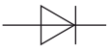

5. | 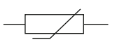

6. | 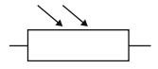

7. | 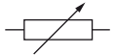

Measuring frequency of waves
Barton’s pendulums
You have investigated the frequency of a wave in a string, and the changes in frequency of pendulums suspended from the string. Using your observations you made a prediction and then modified the experiment to test your prediction.
Quiz - test your knowledge and understanding
1. | What does the driver do in the Barton’s pendulum experiment? [1 mark]
 | A | Generates waves in the string
 | B | Makes potential energy
 | C | Synchronises all the pendulums
 | D | Transfers kinetic energy
 | Your answer
2. | The velocity of the wave in the string is constant. Decide which statement about the wave in the string is true. [speed = frequency × wavelength] [1 mark]
 | A | Its wavelength increases when the driver gets shorter.
 | B | Its frequency increases when the driver gets longer.
 | C | Its wavelength increases when driver gets longer.
 | D | Its frequency decreases when the driver gets shorter
 | Your answer
- Stringed instruments (like a guitar or violin work) in a similar way to the pendulum experiment. The strings of the instrument act as a driver and energy is transferred to the body of the instrument. Explain how the hollow wooden body of the musical instrument can amplify the sound of the vibrating string. [3 marks]
- LIMPET was an experimental wave power station on the Isle of Islay. The average period of the Atlantic waves at Islay is 12.3 seconds.
What is the frequency of these waves? [2 marks]
Hz
- It takes 90.3 s for the waves to travel the final 1200 m to the LIMPET power station. Calculate the wavelength of the waves using the information above and your answer to question 4. [3 marks]
m
- As each wave travels past the cliff they cause the level of the sea to move up and down by several meters. LIMPET is a large hollow concrete tube built into the cliff. As the seawater moves up and down inside LIMPET it forces air through a turbine which generates electricity.
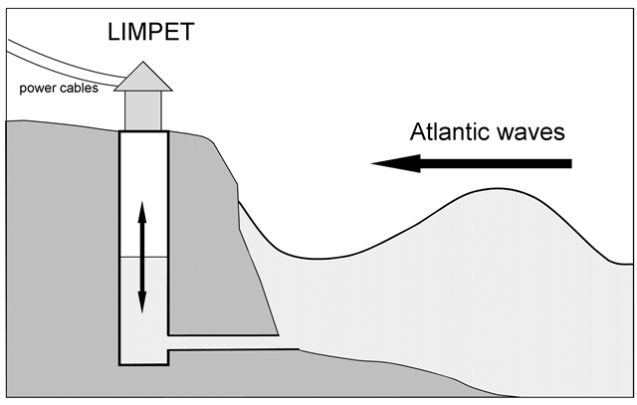
LIMPET was designed so that the natural period of water oscillating up and down in the column was 12.3 s. Explain the advantage of this design? [2 marks]

