- Complete the sentences. Use words from the list.
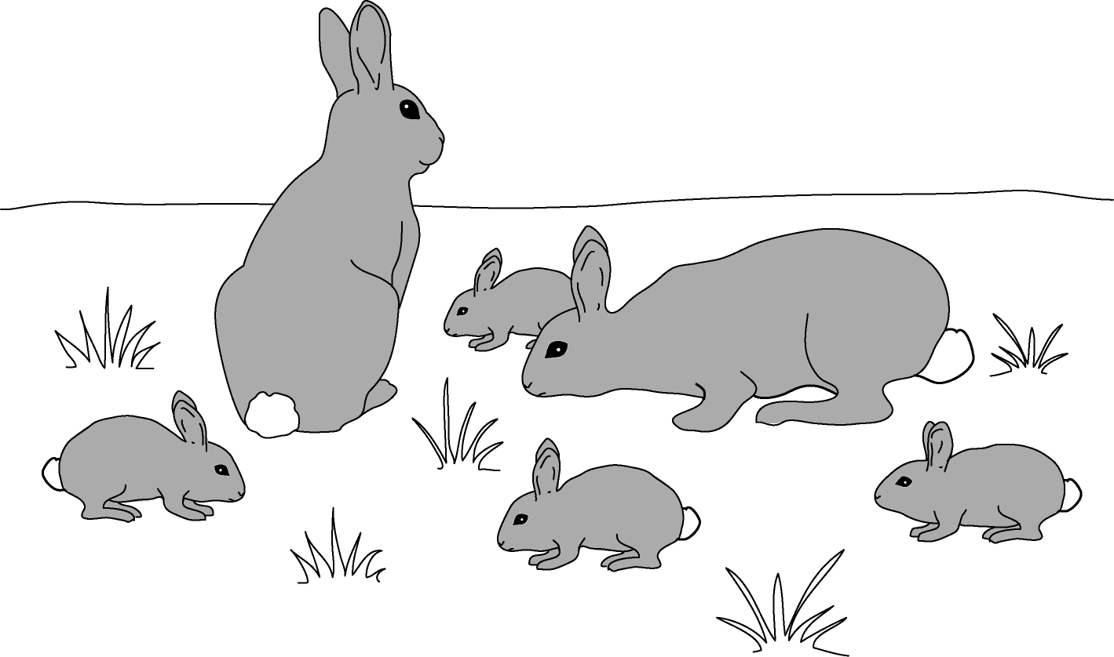
excrete nutrition grow move respiration reproduce sense

- Rabbits feed on grass. The grass gives them .
- The rabbits break down the food to release energy. This is called
. They the waste products left over
from this process.
- The rabbits use some of the food to and become larger.
The rabbits , making more rabbits.
- When the rabbits danger, they
somewhere safer.

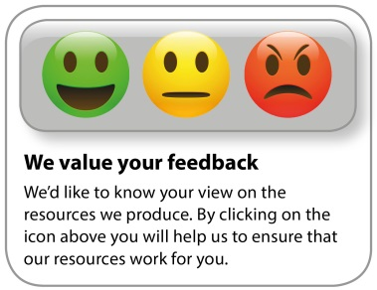
Whether you already offer OCR qualifications, are new to OCR, or are considering switching from your current provider/awarding organisation, you can request more information by completing the Expression of Interest form which can be found here: www.ocr.org.uk/expression-of-interest
Looking for a resource? There is now a quick and easy search tool to help find free resources for your qualification:
www.ocr.org.uk/i-want-to/find-resources/
OCR Resources: the small print
OCR’s resources are provided to support the delivery of OCR qualifications, but in no way constitute an endorsed teaching method that is required by the Board, and the decision to use them lies with the individual teacher. Whilst every effort is made to ensure the accuracy of the content, OCR cannot be held responsible for any errors or omissions within these resources.
© OCR 2020 - This resource may be freely copied and distributed, as long as the OCR logo and this message remain intact and OCR is acknowledged as the originator of this work.
OCR acknowledges the use of the following content: n/a
Please get in touch if you want to discuss the accessibility of resources we offer to support delivery of our qualifications: resources.feedback@ocr.org.uk

