States of matter

- Put the name of each state of matter in the boxes. Use words from the list.
gas solid liquid

Changes of state
- Complete the sentences. Use words from the list.
All broken condenses Energy evaporates freezes gas melts solid liquid
Ice is a ____________.
Water is a ______________.
Steam is a _____________.
When ice is heated, it __________ and becomes water.
Some bonds are ____________.
When water is heated, it ____________ and becomes steam.
____________ bonds are broken.
____________ is required to break bonds.
When steam is cooled, it ____________ and becomes water.
When water is cooled, it ____________ and becomes ice.

State symbols
- Draw a line from the state symbols to their states.

(s) | gas
(l) | liquid
(g) | solid
(aq) | dissolved in water

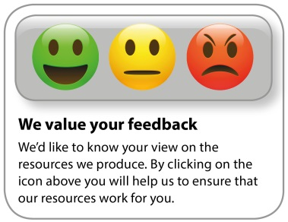
Whether you already offer OCR qualifications, are new to OCR, or are considering switching from your current provider/awarding organisation, you can request more information by completing the Expression of Interest form which can be found here: www.ocr.org.uk/expression-of-interest
Looking for a resource? There is now a quick and easy search tool to help find free resources for your qualification:
www.ocr.org.uk/i-want-to/find-resources/
OCR Resources: the small print
OCR’s resources are provided to support the delivery of OCR qualifications, but in no way constitute an endorsed teaching method that is required by the Board, and the decision to use them lies with the individual teacher. Whilst every effort is made to ensure the accuracy of the content, OCR cannot be held responsible for any errors or omissions within these resources.
© OCR 2020 - This resource may be freely copied and distributed, as long as the OCR logo and this message remain intact and OCR is acknowledged as the originator of this work.
OCR acknowledges the use of the following content: n/a
Please get in touch if you want to discuss the accessibility of resources we offer to support delivery of our qualifications: resources.feedback@ocr.org.uk

