Overview
This Item uses simple circuits to show how electricity can be used to transfer and process information.
It explores the possible risks of microwave radiation from mobile phones, and makes clear there is scientific uncertainty about this.
The final activity provides an opportunity to interpret simple information about radiation from mobile phone masts.
Activity ELP 1a Messaging
Requirements (per student):
- Activity sheet ELP 1a
Teaching notes: This activity can be used to introduce the whole topic, and lead to discussion about sound waves and molecule motion.

Medium and message
Teaching notes: Introduce this with a game of Chinese whispers. Arrange your students in a loop. Whisper a message to one student, perhaps the classic ‘Order the troops to advance’. They relay the message in whispers around the loop. Compare the final message with the original, to show how noise has degraded the message. It might have become ‘Oh dear, he trips to a dance’.
For comparison, try passing a message written on a piece of paper around the loop. This shows a communication system with no noise.

Signal, range, and noise
Requirements (for the class or a demo):
- pair of walkie-talkies
Teaching notes: Introduce this activity using walkie-talkies. Have one student walk away from the classroom to show how the range is limited by noise.
Students complete sentences to record the key ideas.

String telephone
Requirements (per group):
Make a string telephone from a pair of yogurt pots and a length of string. Matches behind the knots will stop the string from slipping through the holes in the pot bases when students stretch the string.
The system only works when the string is stretched.
Teaching notes: This activity provides an opportunity to consolidate ideas of message, medium, and noise.
Activity ELP 1d-1e Coding signals
Requirements (per student):
- Activity sheet ELP 1de

Secure code
Teaching notes: You could start this by inviting a pair of students to communicate across the room using only hand signals. Discourage any communications that are inappropriate in a classroom.
Students should work in pairs on the code. They could use text language instead of standard English.

Morse code
Requirements (per group):
- switch
- buzzer
- battery
- leads
Teaching notes: Invite a student to build the circuit on a bench, using the circuit diagram. Then demonstrate how a simple message, e.g. SOS, can be sent in Morse code.
Students will naturally want to connect the components in a loop, so most circuits should work first time.
You could use the linked website for the Morse code alphabet to use with this activity,
Health and safety notes:
Avoid wires trailing from one bench to another.
Activity ELP 1f Analogue or digital?
Requirements (for the teacher):
- microphone
- oscilloscope
- infrared photodiode
- resistor (100 Ω)
- battery (6 V)
- TV ‘remote control’ unit
- leads
(per student):
- Activity sheet ELP 1f

Teaching notes: Connect a microphone to an oscilloscope to demonstrate analogue signals. Speaking into the microphone gives wavy lines on the screen, showing that there is continuous variation of the signal from the microphone.
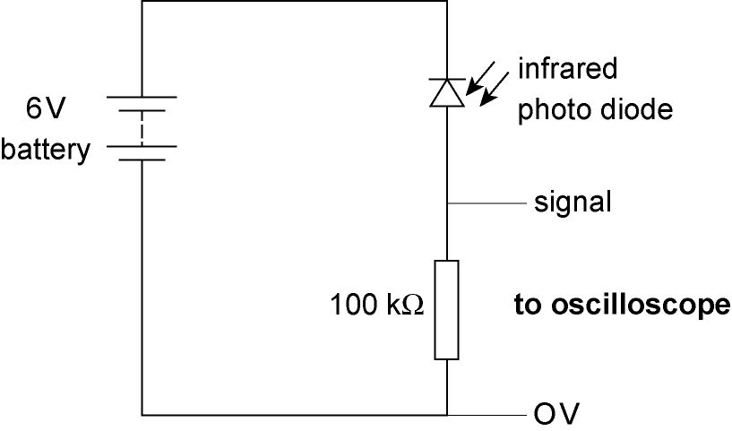
Connect the circuit shown and show the pulses from a TV remote controller on the oscilloscope screen. Start off with the remote close to the photodiode. If it doesn’t seem to be working, try reversing the battery terminals.
Students then sort a variety of communication technologies into ‘digital’ and ‘analogue’. (AM and vinyl disc are examples of analogue technologies; the others are digital.)
This video can be used to illustrate the differences between digital and analogue signals and technologies.

Activity ELP 1h,1k-1n Wireless communication
Requirements (per student):
- Activity sheet ELP1h,k-n

Infrared, radio, and microwaves
Requirements (for the teacher):
- two students with school computers or similar devices (if appropriate)
Teaching notes: Ask one student to send a short message to another on their device. Keying in the message will take more time than it takes for it to get between the devices, even though the microwaves have to go to and from the nearest base station(s), probably several hundred metres away (if using a mobile).

Wireless technology
Requirements (for the class):
- pair of walkie-talkies
Teaching notes: Introduce this activity with a pair of walkie-talkies. Put one student outside the room with one walkie-talkie, where the rest of the class can see them through the window. Use the other walkie-talkie to order various actions from the student. If these include moving rapidly from one place to another, students should appreciate the advantages of wireless technology.

Carrier waves
Requirements (for the teacher):
- long metal slinky spring
Teaching notes: Arrange the students around a single table. Ask a student to stand at one end and firmly hold one end of the spring at the edge. Stand at the other end of the table, stretch the spring and send brief pulses of transverse wave towards the fixed end. Demonstrate the ideas of frequency, wavelength and amplitude. Point out that radio waves and light waves behave like the waves along the spring, but travel a lot faster.
This animation can also be used to demonstrate the ideas of wavelength, frequency and amplitude.

Source, and detectors of radiation
Requirements (for the teacher):
- TV ‘remote control’ unit
- digital camera
- microwave source and receiver such as
2.8 cm wave kit
- metal plate to act as microwave reflector
- oscilloscope with a plain lead having a bare end connected to the Y-input
Technical note: If necessary, replace the oscilloscope with a radio set and amend the instruction card appropriately.
Teaching notes: Every kind of radiation can be thought of in terms of its source, journey, and detection (absorption by a receiver). This provides a useful model for thinking (later) about radiation risks. Use the digital camera to detect otherwise unseen infrared from the TV ‘remote’; the microwave kit to show a ‘journey’ involving absorption and/or reflection; the oscilloscope plus lead to detect radio waves produced by mains circuits in the classroom.

Activity ELP1i & 1j Optical communications
Requirements (per student):
- Activity sheet ELP 1ij

Internal reflection
Requirements (for each student pair):
- ray box (care: heat)
- power supply, low voltage
- comb, to fit ray box
- sheet of plain paper
- perspex blocks (×3) (semicircular, rectangular, and right-angle triangle)
Technical notes: Partial blackout is needed for this activity.
Teaching notes: Although this is a simple activity, some students will need help in setting up their apparatus to match the diagrams shown. The correct diagrams are A, B, C, and D.
Some other intriguing examples of internal reflection:
- Look upwards while swimming under water. The water surface can look like a mirror .
- Make a water jet at the bottom of a lemonade bottle by using fine glass tubing through a bung. Back-light the jet with a projector so that light is trapped inside the jet. Move a finger along the jet and you will see light on the finger.

Optical fibres
Requirements (per group):
- (optional) laser, (e.g. He–Ne or diode type), and glass fibre
- (optional) various fibre-optic novelties
Teaching notes: You could use a laser to demonstrate that light passes along an optical fibre, even when it is twisted into loops. Or discuss one of the many fibre-optic novelties now available, from pound stores and the like.
Health and safety notes:
Check that the laser is labelled ‘Class 2’ and warn students not to stare into the beam. The teacher should keep control of the laser.
This page from BBC Bitesize shows how light travels down an optical fibre, and is an alternative to using lasers.

Digital code
Teaching notes:
You can link this activity to ideas already met this unit such as: analogue v digital signals, and the use of optical fibres in other communication networks (e.g. TV and telephone networks).

Optical fibres ... | T OR F
... link computers on the Internet. | true
... transmit less data than radio waves. | false
... can only transmit spoken messages. | false
... don't have problems with electrical interference. | true

Activity ELP1o Are phones fatal?
Being able to interpret information about mobile phones involves:
- understanding how health might be harmed
(e.g. heating effect a possible mechanism)
- weighing up risks against benefits
- data analysis – comparing the power of some microwave sources
Requirements (per student):
- Activity sheet ELP 1o

Comparing the power of microwave sources (the heating effect of microwaves)
Requirements (for the teacher):
- microwave oven
- jelly babies
- dinner plate
- mobile phone
Teaching notes: Water absorbs microwaves readily. Jelly babies are mostly water held in place by a network of protein.
Take out the turntable of a microwave oven and put in a large plate of jelly babies. Have each jelly baby upright, separated from its neighbours by a couple of centimetres. Those jelly babies which heat up will do so from the inside. Where waves cancel out, jelly babies won’t heat so rapidly. The dry plate won’t get hot at all.
Finally place a single jelly baby by a mobile phone in use. The jelly baby won’t heat up at all, showing that the power of a phone is much lower than the power of an oven.
Health and safety notes
Dispose of hot jelly babies with care.

Reducing the risk from mobile handsets
Teaching notes: Students consider ways of reducing the time and intensity of exposure to microwaves from a mobile phone handset.

Mobile phone masts
Teaching notes: Explain that the strength of a beam from any microwave source falls quickly with distance. A handset is by far the closest source of microwaves users will experience. The further that a mobile mast is from the user, the stronger a signal the handset produces. This means having more (and so nearer) mobile phone masts reduces a user’s exposure to microwaves.

Definitions and Discussion
- Meanings of words
Signal: carries the message (information) through a communication system.
Noise: meaningless data that gets picked up in a communication system, and interferes with the signal received.
Code: a rule for converting information (for example, a letter, word, or phrase) into another form or representation, carried by the communications medium. Coding can be used to make a message clearer or shorter. It can also ensure that communication is secure (confidential).
Analogue: an analogue signal carries information that changes smoothly across a range of values (can have any value).
Digital: a digital signal carries information that has fixed values, usually ‘off’ and ‘on’.
- Discussion points
Mobile phones make people safer. In an emergency, a mobile phone lets you communicate with others; it is not yet known whether the microwaves they use can affect a user’s health.
Digital devices work no better than analogue ones. Noise picked up in a communication system can easily be removed from a digital signal by the receiver. Noise is much harder to remove from an analogue signal. Digital signals are more easily converted into other forms, e.g. image processing of a photo.

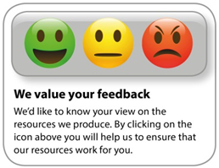
OCR Resources: the small print
OCR’s resources are provided to support the delivery of OCR qualifications, but in no way constitute an endorsed teaching method that is required by the Board, and the decision to use them lies with the individual teacher. Whilst every effort is made to ensure the accuracy of the content, OCR cannot be held responsible for any errors or omissions within these resources.
© OCR 2020 - This resource may be freely copied and distributed, as long as the OCR logo and this message remain intact and OCR is acknowledged as the originator of this work.
OCR acknowledges the use of the following content: n/a
Please get in touch if you want to discuss the accessibility of resources we offer to support delivery of our qualifications: resources.feedback@ocr.org.uk
Whether you already offer OCR qualifications, are new to OCR, or are considering switching from your current provider/awarding organisation, you can request more information by completing the Expression of Interest form which can be found here: www.ocr.org.uk/expression-of-interest
Looking for a resource? There is now a quick and easy search tool to help find free resources for your qualification:
www.ocr.org.uk/i-want-to/find-resources/

