Medium and message
- Match each type of message with its transmission medium.
Type of message | Transmission medium
speech … | … light waves
picture fax … | … radio waves
walkie-talkie … | … microwaves
text message … | … air vibrations
body language … | … copper wires

Signal, range, and noise
- Match the start and end of the sentences.
The error is … … meaningless data in the system.
The noise is … … caused by signals being lost in the noise.
The range is … … the message being transferred through the system.
The signal is … … how far the message can be sent without error.

String telephone
- Use the words below to label the diagram of a string telephone.
match
sender
receiver
plastic pot
tight string

- The sentences explain how the system works. Put them in the correct order.
The receiver hears the message.
The sound makes the base vibrate.
The sender speaks into the pot.
The vibrating base makes sound.
The vibrations travel along the string.
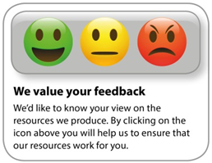
OCR Resources: the small print
OCR’s resources are provided to support the delivery of OCR qualifications, but in no way constitute an endorsed teaching method that is required by the Board, and the decision to use them lies with the individual teacher. Whilst every effort is made to ensure the accuracy of the content, OCR cannot be held responsible for any errors or omissions within these resources.
© OCR 2020 - This resource may be freely copied and distributed, as long as the OCR logo and this message remain intact and OCR is acknowledged as the originator of this work.
OCR acknowledges the use of the following content: n/a
Please get in touch if you want to discuss the accessibility of resources we offer to support delivery of our qualifications: resources.feedback@ocr.org.uk
Whether you already offer OCR qualifications, are new to OCR, or are considering switching from your current provider/awarding organisation, you can request more information by completing the Expression of Interest form which can be found here: www.ocr.org.uk/expression-of-interest
Looking for a resource? There is now a quick and easy search tool to help find free resources for your qualification:
www.ocr.org.uk/i-want-to/find-resources/

