Using a light microscope to study mitosis

Aim
To use a light microscope to observe and identify the stages of mitosis including calibrating and using an eyepiece graticule and making annotated scientific drawings showing cells in different stages of mitosis.
Time required for activity: 1 hour

Introduction
In this activity, you will be examining the main stages of mitosis in Allium sp. Cells in prophase show chromosomes condensing and may not have a nuclear envelope. Cells in metaphase have chromosomes aligned to the equator of the cell. Cells in anaphase show chromosomes in a ‘v’ shape as they are pulled towards the poles of the cell. Cells in telophase have two nuclei and in plant cells, the cell wall may be visible forming along the metaphase plate before the cell divides during cytokinesis. Each phase within mitosis does not take the same duration of time, so numbers of cells observed in each phase will not be equal.
You will also be gaining experience of observing and drawing annotated scientific diagrams from the microscope and will use a calibrated graticule to carry out a measuring activity of the chromosomes observed. You are expected to know how to use a light microscope and to have carried out some observing activities before this activity.

Specification content links
Biology A H420: 2.1.1 a; 2.1.1 b; 2.1.2 d; 2.1.6 c; 2.1.6 d.
Biology B H422: 2.1.1 a; 2.1.1 i; 3.1.1 b.

Health and Safety
The microscope is heavy and delicate. Carry it carefully if you need to move it, holding it by the arm and supporting it beneath the base.
You need to be sure to move the microscope stage up so the lens is almost touching the microscope slide while not looking down the microscope and then to focus DOWN. This will avoid broken cover slips and slides.

Equipment
- Light microscope with low power and high power objective lenses, e.g. ×4, ×10 and ×40
- Eyepiece graticule
- Stage micrometer
- Permanent slides showing transversal section (TS) of an Allium sp. root tip.

Procedure | Understanding
Calibration method
- Use a stage micrometer. This is a microscope slide with an accurate scale etched on it. In the example in Fig. 1, 1 mm is divided into 10 parts. So on this stage micrometer, each small division is equal to 0.1 mm, which is 100 micrometres (µm). | How do you convert millimetres into micrometres?  How do you convert micrometres into millimetres?
- Insert the graticule into the eyepiece lens and line up the two scales similar to Fig. 1. | Why is it important to calibrate a microscope?
- It is then possible to count the number of divisions on the eyepiece graticule equivalent to each division on the stage micrometer and hence calculate the length that one eyepiece division is equivalent to. | What is the resolution of the eyepiece graticule at this magnification?
- For the example in Fig. 2, three divisions (shown in red) are equal to 100 µm, so each division is equal to 33.3 µm. This might be, for example, at low power. | How can magnification of an image be calculated when the actual length of an object is known?
- The process should be repeated with each objective lens and you will then have a calibration factor for each lens. You are now ready to examine the prepared slide. | What happens to the field of view as the objective lens magnification power increases?

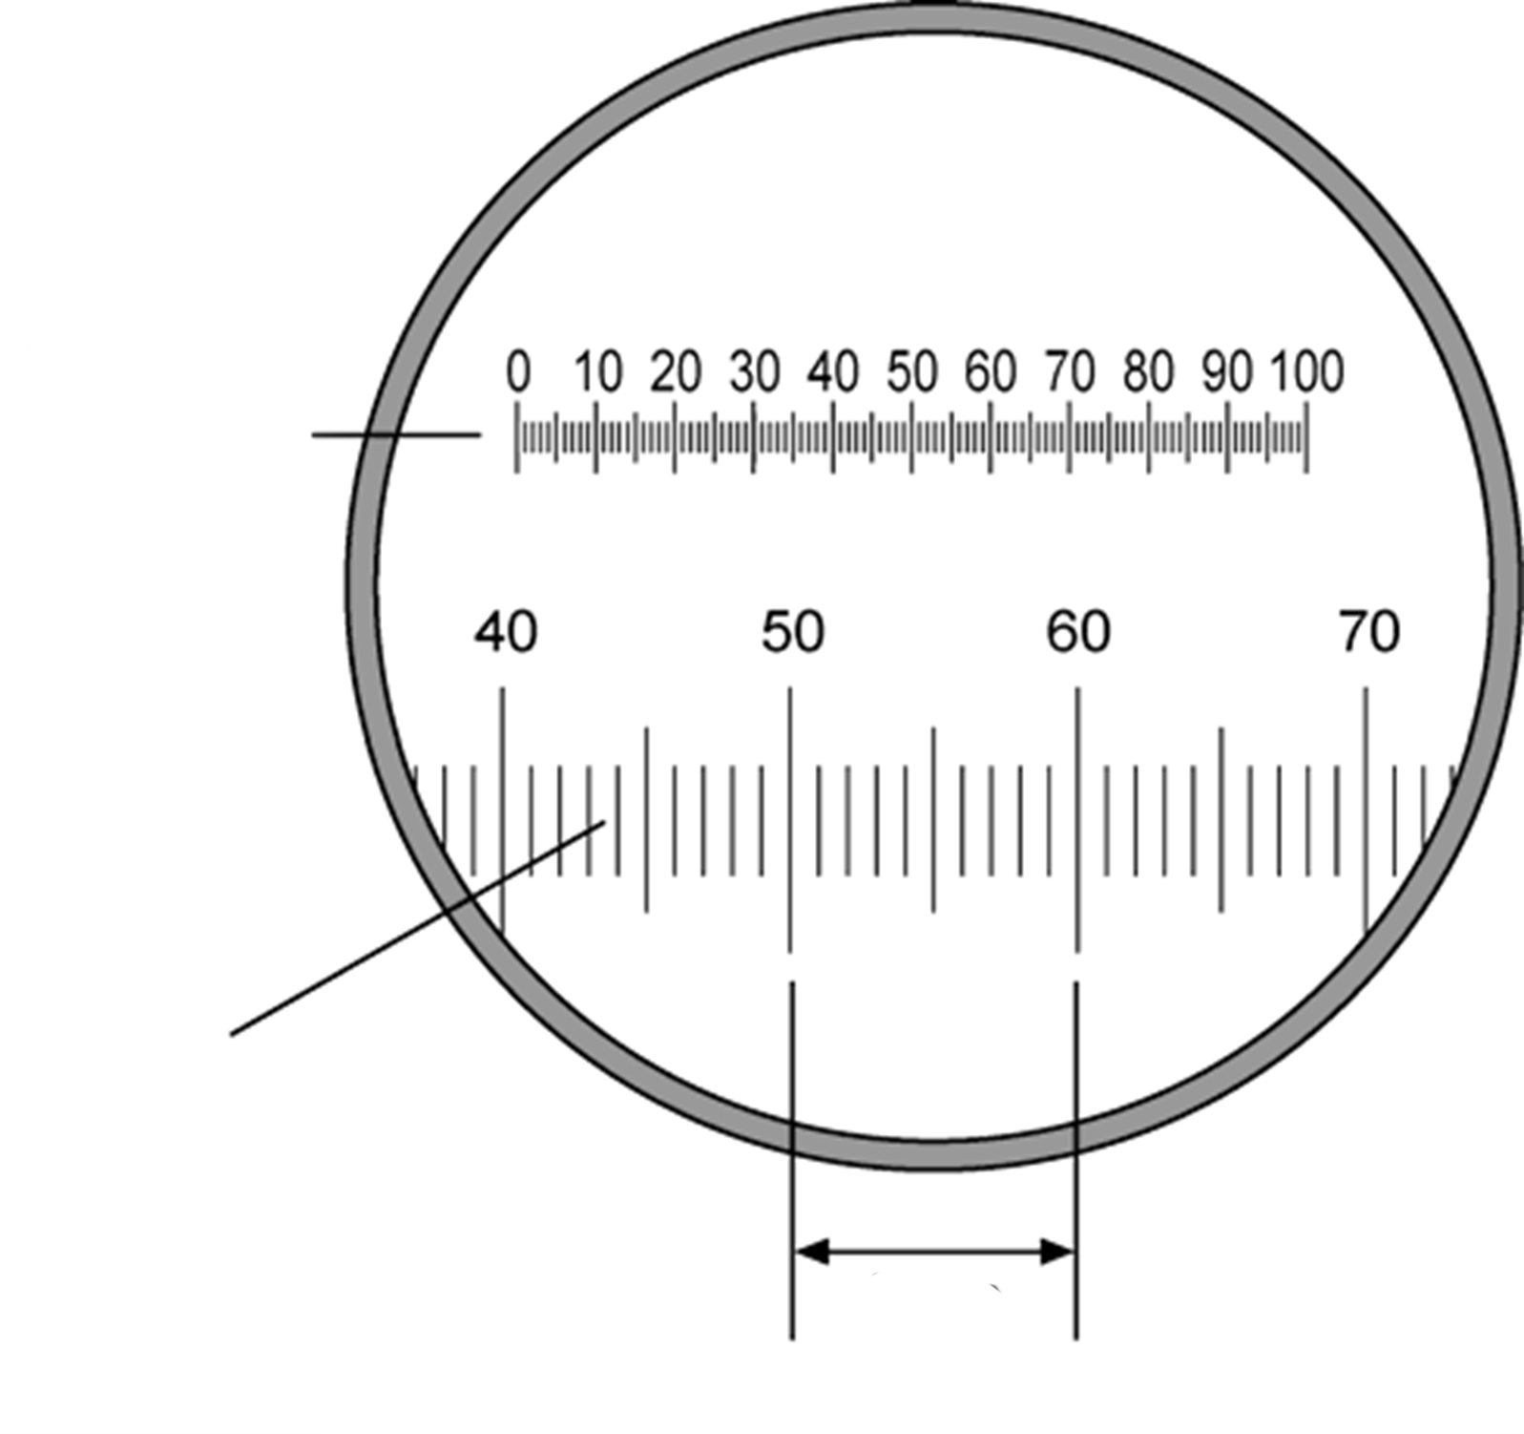
Stage micrometer
1 mm
therefore each small division = 100 µm
Eyepiece
graticule
scale
Fig. 1 How the eyepiece graticule scale and stage micrometer should appear when viewing through the eyepiece lens
therefore each small division = 100 µm
1 mm
Stage micrometer
Stage micrometer
1 mm
therefore each small division = 100 µm
Eyepiece
graticule
scale

Fig. 2 How to use the stage micrometer to calibrate the eyepiece graticule.

Procedure | Understanding
Observing the specimen
- Place the slide showing the stages of mitosis on the microscope stage. | What is used to increase the contrast of a specimen viewed with a microscope?  Suggest a property of methylene blue that causes it to interact with the sugar-phosphate backbone of DNA.
- Without putting your eye to microscope but looking at the slide itself, twist the focusing dial until the microscope stage has moved up so that the slide is just about to touch the lens. | Why is this step important?
- Use the coarse focusing dial to focus down until you can clearly see the cells in the field of view. Make sure the cells are in the centre of the field of view (the circle of light you can see when looking down the microscope). | What is the maximum resolution of a light microscope?
- Rotate to the medium power lens and again focus until you can see the cells and the chromosomes in them clearly. | How does the resolution of the eyepiece graticule change as the objective lens magnification power increases?
- Then rotate to the high power lens and use the fine focusing dial only to bring the chromosomes into distinct view. | Why are the chromosomes clearly visible when cells are undergoing mitosis?
- Take time to look carefully and identify each stage of mitosis that can be seen. | What are the key characteristics of the stages of mitosis?
- Use the eyepiece graticule to measure the length of the chromosomes. Do this carefully for three separate chromosomes depending on the actual slide being used. | What affects the accuracy of your measurements?
- Make scientific annotated drawings of the stages of mitosis that you have seen and identified. It should be possible from your drawings to know which stage has been drawn. An example of a labelled scientific drawing is shown in Fig. 3. | What are the key criteria for a biological drawing?

Practical skills, apparatus and techniques assessed
a | Reference | Description of skill/technique
 | 1.2.1 (c) | Followed the instructions carefully without guidance.
 | 1.2.1 (e) | Measured the length of three chromosomes and recorded these in a table using appropriate units.
 | 1.2.1 (j) | Demonstrated competency in using a microscope.
 | 1.2.2 (a) | Used a stage graticule to calibrate the microscope and used the eyepiece graticule to measure the length of three chromosomes.
 | 1.2.2 (d) | Used a microscope with an eyepiece graticule without guidance.
 | 1.2.2 (e) | Produced a biological drawing of stage of mitosis seen.

Checklist for your drawing
1 | Your drawing and its label lines must be done with a really sharp pencil (not a pen).
2 | Your drawing should take up at least half the page/space available.
3 | Lines need to be clear and continuous – not ragged or broken – and no shading or colouring is allowed.
4 | Make sure the proportions are correct, i.e. different areas are the right size relative to each other, and that your drawing is a true likeness of the specimen that you are drawing.
5 | Label all the different areas of tissue that you have shown, writing the words in pencil or pen.
6 | Rule the label lines (in pencil). Don’t let the label lines cross each other and do not write on the label lines.
7 | Make sure the label lines touch the part you are labelling.
8 | Annotations - add concise notes about the structures/features labelled on your drawing.
9 | Include a scale - add a scale bar immediately below the drawing if necessary.
10 | Include a title stating what the specimen is.

Further investigations and extended questions
Mitosis is not constant during the day, or over the course of the year. Students could compare the mitotic index of Allium sp. garlic root tips prepared at different times of the day following the method provided by SAPS. You can also use onion root tips as an alternative.
Science and Plants for Schools Practical

- What is the purpose of mitosis for a living organism?
- What is a key distinguishing visible feature of each stage of mitosis?
- Once active cell division ends, the cells will enter interphase. Explain why it is incorrect to say that these cells are ‘resting’.
- Why is a sample from the roots of Allium sp. a good specimen for studying mitosis?
- State which stage of the cell cycle the majority of the cells in your specimen were in and suggest why.

Scientific and Practical Understanding
Mitosis is the process of cell division resulting in two genetically identical daughter cells. It has four main stages: prophase, metaphase, anaphase and telophase. To identify the stages of mitosis you need to observe under the microscope actively growing tissues, such as those in root tips and shoot tips have a high mitotic index. The mitotic index refers to the proportion of cells undergoing mitosis within the total number of cells sampled. Mitotic cells can be identified as they appear different from cells within interphase.
Calibrating a microscope is an essential process that ensures accurate and consistent magnification and resolution, which are crucial for making accurate measurements and observations. Magnification is the number of times larger an image is compared to the actual object. It does not have a unit. The resolution is the smallest change in the input quantity being measured by a measuring instrument that gives a perceptible change in the reading of the measuring instrument. This is the minimum distance that two objects can be apart from each other and still distinguished as separate objects. The resolution of a light microscope is limited by the wavelength of light but is also affected by the refractive index of the slide components.
Calibration allows instruments to be used accurately as potential zero errors are addressed. A measurement result is considered accurate if it is judged to be close to the true/acceptable value. When calibrating any instrument, an object of known value is used, for example a 1 kg mass, a 1 mol dm^{–3} sucrose solution, or in this case a 1 mm length, to which the instrument can be calibrated against.
Observing the specimen and making biological drawings are an important area in the field of microscopy. Focus on the specimen under the microscope by moving the microscope stage up so the lens is almost touching the microscope slide while not looking down the microscope and then focus DOWN. This will avoid broken cover slips and slides. Cells should be focused using low power first with the cells to be viewed in the center of the field of view. Then when the power is moved to medium and then to high, the cells will still be in view.
Biological drawings must be done with a sharp pencil, with continuous outlines and no shading or stippling. Annotations are used to describe features of the specimen being drawn, whereas labels are used to identify the features. Both annotations and labels require a ruled line to touch the structure being referred to. It is important to reflect the relative size and shape of the components of the specimen by maintaining the proportions when you create a large drawing. Finally, a scale bar, title and magnification should be included. An example is shown in Fig 3.

Onion cell from the root tip showing metaphase of mitosis

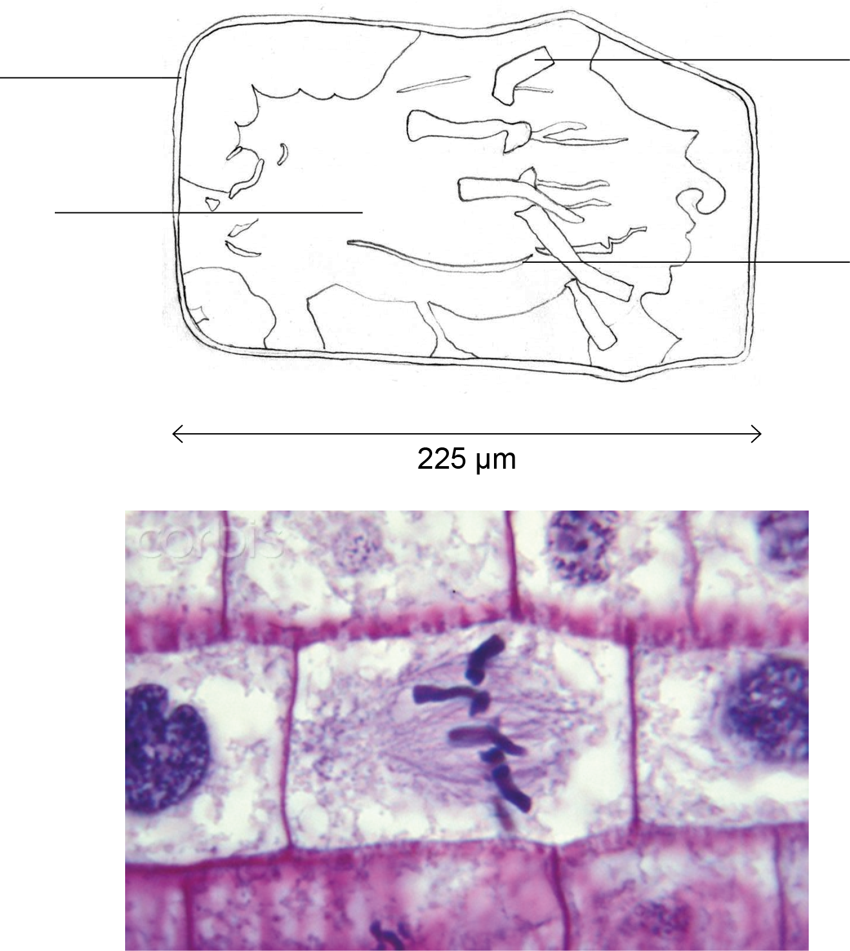
cell wall
- stained
deep pink
chromosome
- stained dark purple
- made up of two
chromatids
spindle fibre
- stained purple
area stained
lighter purple
containing
spindle fibres

Fig. 3 An exemplar drawing of a cell in metaphase from the view with a light microscope. A scale bar has not been included.

Notes and References
Health and safety should always be considered by a centre before undertaking any practical work. A full risk assessment of any activity should be undertaken including checking the CLEAPSS website.
CLEAPSS
Trial this activity in advance to make sure that all stages of mitosis can be found on the slides provided.

