1.1 Determination of the composition of copper(II) carbonate basic LEARNER

Introduction
Copper(II) carbonate basic, CuCO₃⋅Cu(OH)₂(s), is the dull green colour that forms on copper roofs. Copper oxidises in the air to form an approximately equimolar mixture of CuCO₃ and Cu(OH)₂.The percentage of CuCO₃ in the mixture can be determined by reacting the mixture with an acid and calculating the amount of CO₂ evolved.

Aims and Skills
- To determine the percentage by mass of CuCO₃ in a sample of copper(II) carbonate basic
- To accurately measure mass and gas volume, and record in an appropriate format
- To safety and carefully handle solids and liquids

Intended class time
- 1 hour

Chemicals

CuCO₃⋅Cu(OH)₂ | copper(II) carbonate basic, CuCO₃⋅Cu(OH)₂(s) |  | Harmful if swallowed
H₂SO₄(aq) | 1.0 mol dm^{–3} sulfuric(VI) acid, H₂SO₄(aq) |  | WARNING  Causes skin irritation and serious eye irritation

Equipment
- eye protection
- access to a balance reading to at least two decimal places
- weighing boat or filter paper
- spatula
- dropping pipette
- conical flask (250 cm³)
- bung with delivery tube
- measuring cylinder (250 cm³)
- measuring cylinder (50 cm³)
- clamp stand, boss and clamp
- trough

Health and Safety
- Wear eye protection throughout.

Procedure
Before starting your practical work, read the information below.
Decide how you will organise your practical work, and which observations you need to make and/or which measurements you need to take. Ensure that you record all of your results in a suitable format.

- Set up the apparatus as shown in the diagram below.

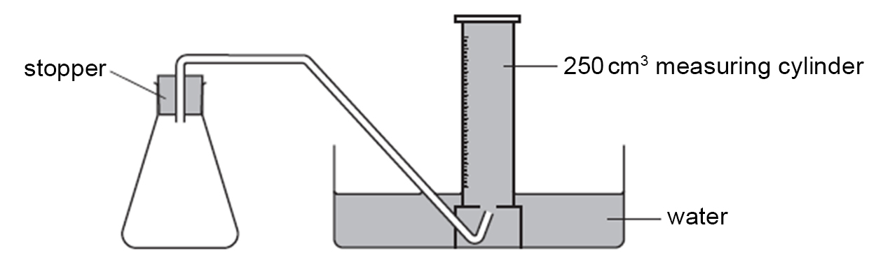

- Weigh approximately 1.5 g of CuCO₃⋅Cu(OH)₂(s). Record the exact mass. Use the correct number of decimals and the correct unit.
- Add the solid to the conical flask and replace the bung.
- Using a 50 cm³ measuring cylinder, measure out 50 cm³ of 1.0 mol dm^{–3} H₂SO₄(aq) (this is an excess).
- Remove the bung from the conical flask, quickly add the acid to the flask, and immediately replace the bung.
- Collect the gas in the 250 cm³ measuring cylinder and record the final volume of carbon dioxide using an appropriate format.
- If you have time, repeat the experiment.

Analysis of results
- Calculate the amount of carbon dioxide, CO₂(g), collected in the measuring cylinder. Assume that 1 mol of gas occupies 24 000 cm³ at room temperature and pressure.
- Copper(II) carbonate basic reacts with sulfuric acid as below:

CuCO₃⋅Cu(OH)₂(s) + 2H₂SO₄(aq) → 2CuSO₄(aq) + 3H₂O(l) + CO₂(g)

Deduce the amount of copper(II) carbonate, CuCO₃(s), that reacted.
- Calculate the percentage by mass of CuCO₃ in the original sample of CuCO₃⋅Cu(OH)₂(s). Give your answer to an appropriate number of significant figures.

Extension Questions
- Assuming that your sample of CuCO₃⋅Cu(OH)₂(s) contains exactly equal amounts, in mol, of CuCO₃ and Cu(OH)₂, what percentage by mass of CuCO₃ in CuCO₃⋅Cu(OH)₂ would you expect?
- Determine the size of the divisions on the measuring cylinder that you used to collect the carbon dioxide. Calculate the percentage uncertainty in the value of the gas volume.
- Determine to how many decimal places the balance measures that you used to weigh the CuCO₃⋅Cu(OH)₂. Calculate the percentage uncertainty in the value of the mass.
- Explain why it is not necessary to calculate the percentage uncertainty in the volume of H₂SO₄(aq) used.
- Suggest two errors in the procedure that could lead to inaccuracies in your experimental value for the percentage by mass of CuCO₃(s) in CuCO₃⋅Cu(OH)₂.
- For each error identified in the previous question, state and explain what effect these errors would have on your final result.
- Suggest two ways in which the experiment could be modified to give a more accurate value for the percentage by mass of CuCO₃(s) in CuCO₃⋅Cu(OH)₂, giving reasons for your choices.
- When copper rooftops turn green, the copper has reacted with oxygen, water vapour and carbon dioxide in the air, to form CuCO₃⋅Cu(OH)₂. Construct an equation for this reaction.
- Find out the names and locations of famous buildings that have copper roofs and discuss why some architects use this material.

What to record
As evidence for the Practical Endorsement, you should have recorded evidence of all of your observations and measurements in a suitable format. All work should be clearly dated.

In addition, in preparation for the assessment of practical work in the written examinations and to help you develop your understanding of the underlying chemical theory, you should complete the questions in the Analysis and Extension Opportunities sections. For calculations, you should show full workings and give final answers to the appropriate number of significant figures.

