Geotechnical desk study

Aim
To use a Geographic Information System (GIS) and spreadsheets to investigate and process data as part of a geotechnical desk study.
To communicate scientific recommendations appropriately in a report for the use of a decision maker.

Introduction
To reduce the school/college energy bills it has been proposed that a 2 MW wind turbine should be built on the school/college grounds.
In this practical activity you will be carrying out a desk study to evaluate the foundation characteristics for a proposed 2 MW wind turbine on the school site.
A desk study is the first stage of any civil engineering project. In a desk study a geologist uses existing data to identify any potential issues so that the project manager can decide the final location and design of the structure.
Using a web-based GIS you will research the geology of the site, then you will use and process this data using a spreadsheet to design foundations that would safely support the load from the wind turbine. Using the information on the attached resource sheet you will model the ground load of the wind turbine tower and the type and size of foundation needed.

Specification theory content links
6.2.1(d), with links across other areas including 6.1.3, 6.2.1 and 6.2.2.
Mathematical skills must be applied in the recording of the data and calculations, and in analysing the data. These steps require the appropriate application of the following mathematical skills:
- M1.1 Recognise and make use of appropriate units in calculations.
- M1.3 Use an appropriate number of significant figures.

Health and Safety
You should follow your centre’s practice on using computers and the internet.

Equipment
- Computer or tablet with internet access.
- Access to spreadsheet software (MS Excel or Google Docs).

Procedure | Understanding
- Go to the BGS View maps webpage and try using the Geology of Britain/iGeology
BGS Geology Viewer - British Geological Survey
GeoIndex (onshore) - British Geological Survey
GIS database browsers.
Both browsers have mobile versions which will run on Android and iOS devices.
- Using either Geology of Britain or GeoIndex (Onshore) research the superficial and bedrock geology at the proposed wind turbine site. Search the database of existing borehole data in the local area and summarise the geology at the site below the surface.  Create a table showing the depths and thicknesses of relevant layers found. | What is the main rock type?  Are the units dipping or folded?  Are there any faults in the area?  What is the depth to the bedrock?  What are the superficial deposits like?
- Summarise the hazards of building in that area.  This should include any information on the strength of each subsurface layer, and any geological features which could be a geotechnical hazard (e.g. differential compaction, subsidence, slope instability). | Think about your study of geohazards and geotechnics so far, what rock properties can cause instability in the surface?  How thick are the layers?  Are they weathered or jointed?  How steeply are they dipping?
- Research the bearing capacities of the different soil and rock layers.  Convert the bearing capacity values to the same units (i.e. N m^{–2}) and add this data to a table. | Remember that to an engineering geologist all loose uncompacted material is soil.
- Using the information on the resource sheet select an appropriate foundation design and calculate the load per unit area of the wind turbine and footings on the ground. (Use correct units i.e. N m^{–2})  Choose a foundation design and check that there is sufficient space for your preferred foundation design on site.  You can use the spreadsheet to make these calculations, the spreadsheet will do some of the calculations, but you will need to add some formulae to make the spreadsheet work. | The spreadsheet works out the area of the footing as it is a complicated formula.  How do you calculate volume?  How do you calculate mass from volume and density?  The spreadsheet works out the load based on gravity (weight), but how do you work out the load per unit area?  The load must not exceed the load bearing capacity of the rock.
- Use a spreadsheet to do your calculations of the load per unit area for different footing sizes, as this will allow you to find the smallest size of foundation that could be safely used to support the load from the wind turbine.  State which size turbine foundation will be suitable for the ground selected for building. | Think about any safety factors from the type of foundation. What does this mean for your load per unit area and load bearing capacity values?
- Once you have finalised your preferred design, write a foundation design report (no more than one side of A4).  Your report should summarise: the geology at the site, identify any potential geotechnical hazards and show the calculations you have used to determine your final recommended foundation design. All sources used must be referenced in your report. | Explain how you chose the source(s) you reference to have confidence in their reliability.

Practical skills, apparatus and techniques assessed
a | Reference | Description of skill/technique
 | 1.2.1 (f) | present information and data in a scientific way  correct formatting and presentation of spreadsheet data.
 | 1.2.1 (g) | use appropriate software and tools to process data, carry out research and report findings.  correctly use a GIS database to extract relevant information and a spreadsheet to process data calculations.
 | 1.2.1 (h) | use online and offline research skills including websites, textbooks and other printed scientific sources of information  correctly use websites to research and gather appropriate data to use.
 | 1.2.1 (i) | correctly cite sources of information  provide correct references for researched information.
 | 1.2.2 (m) | use of ICT to: collect, process and model geological data.  correctly use a GIS system and spreadsheet to provide data models to illustrate findings from a desk study.
 | 1.2.1 (f) | present information and data in a scientific way  correct formatting and presentation of spreadsheet data.

Further investigations and Extension activities
- Add extra columns to your spreadsheet to allow for the safety factors of each type of foundation.
- Modify your foundation design until you have a 50% safety contingency to allow for extreme wind loading so that the load of the wind turbine + foundations ≤ 0.67 × the bearing capacity of the ground.
- Justify your foundation choice using the data and geology.
- Your desk study was very persuasive and the governors have decided to go ahead with the wind turbine project. Outline some geotechnical tests that should be carried out on site before the wind turbine design is finalised.
- The governors have heard that subsidence and differential compaction could be a problem. Explain the difference between subsidence and differential compaction and suggest a method that could be used to identify the relative risks at the wind turbine site.

Scientific and Practical Understanding
Geologists use their knowledge of rock properties such as porosity, compressional strength, density, the inclusion of geological features such as dipping beds, joints, faults and foliation, and the interaction of groundwater with clays, to explain some of the issues with construction of a wind turbine or any other structure.
These factors are the same factors that will have been considered for construction of dams and tunnels and also in the mitigation of landslides.
All of these factors could adversely affect the potential for construction, and that is why datasets of information, such as load bearing capacities of different rocks and geological records such as the BGS database should be consulted before any works are carried out.
It is important to consider carefully that all units are comparable, such as load bearing capacity which could be given in kN m^{–2}, kg m^{–2} or lb ft^{–2}, and in order to directly compare values all units need to be converted to one format.
The spreadsheet will familiarise you with how databases can be used to run multiple calculations simultaneously to save working out each one independently. You are not expected to recall how to enter the different formula, but it will help your understanding if you know what each formula is doing with the data.
It is also important to consider the format of the data. All data should be to a consistent number of decimal places. Spreadsheets can format to however many decimal places required, but will retain the full number in the background for further calculations to prevent any rounding errors later on.

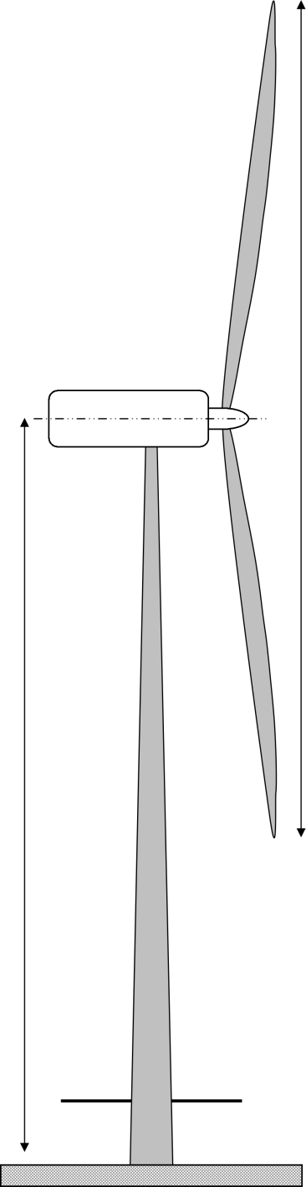
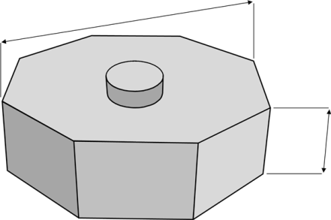
Resource Sheet

2 MW Wind Turbine – design factsheet
Nacelle – 70 t
The nacelle contains the gearbox and generator unit. It rotates on the tower to keep the rotor facing into the wind.
Rotor – 38 t
The three blades and the hub form the rotor. The pitch of the blades changes automatically to optimise efficiency at low speeds, and to reduce the force acting on the blades at high wind speed.
Power is generated between 3 m s⁻¹ to 22 m s⁻¹. The sweep area of this rotor is 6362 m²
Tower – 148 t
The tower is a slender hollow steel tube. The tower has to support the weight of the nacelle and rotor, and resist the force of the wind on the structure which could buckle the tower. They are delivered to site in 20 m sections.
Ground Level
The ground level footprint of the wind turbine will depend on the type of foundation used.
Footing
The footing is a reinforced concrete structure that couples the tower to the foundations. A bolt cage or a steel ring is built into the footing and acts as a collar to couple the tower to the foundation. Wind turbine footings are octagonal in plan and between 1 m and 3 m high.
For shallow foundations the footing is the foundation but for deep foundations the footing acts as a platform connecting the turbine tower to the friction piles.
Height = 90 m
Diameter
= 90 m
height
2 × radius
area of top surface $=2√(2r^{2})$
Safety factor
A safety factor of four means that the bearing capacity of the ground is four times the design load on the foundations.

collar

How do onshore wind turbine foundations work?
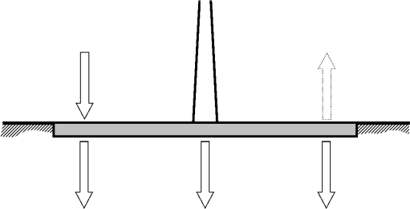
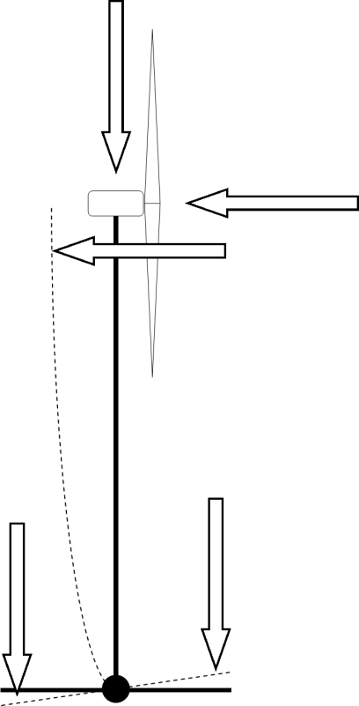
Spread foundation
The large slab at or just below the ground surface spreads the load of the wind turbine over the ground. These are the simplest to construct, however they are only suitable for strong rock/soil. They cannot be used if soil compaction is large or there is the possibility of differential compaction. As it is the radius of the foundation slab that resists the bending moment and prevent overturning of the tower a safety factor of four should be used.
weight of the
wind turbine
wind loading is the force of the wind on the tower and rotor
the bending moment caused by wind loading
the bending moment doubles the load on this half of the foundation and can cause the tower to fall over.
the weight of the soil over this half of the foundation resists overturning

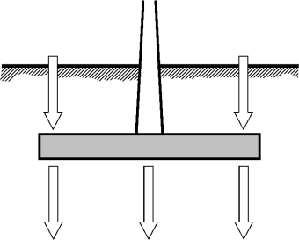
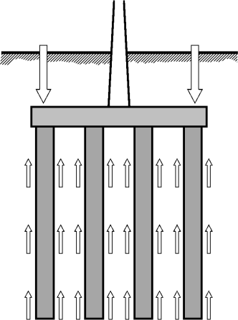
Gravity foundation
By excavating down below the zone of weathering the foundation can be placed on stronger soil/rock (usually at least three metres). Gravity foundations work in the same way as spread foundations however the weight of the soil/rock over the footing will resist overturning and the radius of the footing can be reduced. A safety factor of two should be used.
Density of foundation materials:
- reinforced concrete = 2.55 t m^{–3}
- compacted backfill = 2.00 t m^{–3}

Piled foundation
Friction piles work by increasing the surface area in contact with the soil/rock. The shear strength of the soil acts over surface area of the sides of the piles by friction. In this way the strength of deeper layers is transferred up to the surface. An auger drills a 1 m diameter hole, a steel cage of reinforcing rods is inserted and the hole filled with concrete. The footing is built on top of the piles. A safety factor of two should be used.
Piling to bedrock is not suitable for wind turbines as the piles could fail under the very large tension and compression loads caused by the bending moment.

Notes and References
This is intended as an activity that familiarises students with the use of GIS. The objective is for students to experience how a GIS can help them to access and make sense of a georeferenced database. It is not intended that students will master the use of GIS, however their use of the BGS Map Viewers should provide them with a practical experience of GIS that will help them to understand why GIS is used to analyse spatial data.
The use of the excel spreadsheet is to help students to see that software and programmes can be used to process data rather than completing all calculations by hand. The spreadsheet could be adapted to make it more challenging or more straightforward based on the competence of the students.
It is not expected that students will produce one particular answer or set of results, but that they become familiar with the use of GIS and spreadsheets and tools for processing data.
The BGS Geology of Britain/iGeology app is a map-based index of geological data, intended for the general user, that can be accessed through a web interface on a computer or a mobile device.
BGS Geology Viewer - British Geological Survey
The BGS GeoIndex Onshore is a more powerful map-based index of geological, geochemical and geophysical data that can be accessed through a web interface on a computer or a mobile device.
GeoIndex (onshore) from British Geological Survey
The data for Northern Ireland is available from the GSNI separately.
Northern Ireland Data
The following quick tutorial should give basic familiarity with GeoIndex Onshore.
Go to http://www.bgs.ac.uk/geoindex/ and open the onshore GeoIndex. This will launch GeoIndex in a separate window. Now tile the GeoIndex window and your main browser window so that you can see both on your screen;
In the Enter location box put ‘Wales, Yorkshire’ and then return to search;
Click the Data icon (stacked layers) and add data: Superficial deposits 1:50k, Bedrock geology 1:50k, Borehole scans, Mass movement deposits, and Artificial ground;
Increase the transparency on the Bedrock geology layer so that you can see the underlying base map;
Zoom out until you can see both Wales and Junction 31 on the map. Click the Search icon (magnifying glass) and choose circle. Drag the circle out until both Wales and Junction 31 are in the selected area. You will now see the data listed on the screen;
Select the Create PDF report icon (printer) and generate a report. Now select open pdf in a new window to see the report on your main browser screen.
In the GeoIndex window select the Borehole scans (249) tab and scroll to near the bottom of the list and double click on SK48SE361 SOUTH YORKSHIRE COA NMCS2 UPGRADE M59 to zoom to the location. Now single click on the green well icon on the map. When the pop up appears select Scan to see the borehole record.
Zoom back out and single click cross hatched area between Wales and the M1. You can now click on More information to see the BGS record.
Select the yellow patch to the southeast of Wales. A pop up will appear with information on surficial sediments. Click on More information for information on channel fill deposits.

Example results
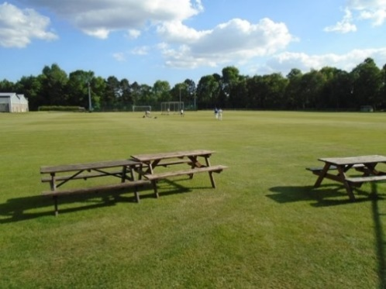
Cambridge University Press Sports Ground. Grid Reference: TL45585637, 14 metres elevation.

The 1886 1:10,560 map shows some small gravel workings and marl pits associated with farms. Surficial geology Quaternary river terrace sands and gravels with pockets of silt and peat. Bedrock West Melbury Marly Chalk Formation, up to 15 m of soft marly chalk overly the Gault Clay. Thickness of river terrace gravels between 1 m–4 m, probably due to old river channels.
Composite log constructed from recent geotechnical boreholes (to 15 m) and older water wells using BGS GeoIndex (Onshore). Shear strength of Gault Clay from BGS report:
Rock/Soil  Description | Thickness / m | Depth to base/m | Geotechnical information  (spt) | Probable Bearing capacity  / kN m^{–2}
Made ground, brown clay gravel with broken brick | 1.0 | 1.0 | – | –
Firm silty clay with some flint gravel. River Terrace Gravels | 2.2 | 3.2 | 12N | 200
Firm to stiff calcareous clayey silt with bands of flint – West Melbury Marly Chalk Fm | 3.9 | 6.1 | 16N | 400
Stiff silty clay, closely fissured with some pockets of very soft clay (19m) – Gault Clay | 46.4 | 52.5 | 26N | 250–150

Spread foundation on the Chalk Marl (400 kN m^{–2}) safety factor of 4 = radius 5m = load of 98 kN m^{–2}.
Gravity foundation on the Gault Clay (150 kN m^{–2}) safety factor of 2 = radius 9m = load of 74 kN m^{–2}.
Piled foundation in Gault Clay (Shear strength = 75 kN m^{–2}), 5 × 10 m piles = 5 × 31.4 m² = 157 m².
Friction on piles 11775 kN, weight of wind turbine on 3 m radius footing = 4103 kN

Typical bearing capacities of British soils and rocks
Type of Rock of Soil | Maximum bearing capacity
 | kN m^{–2} | kg cm^{–2}
Rock – hard crystalline rock with no defects | 3300 | 33.0
Rock – sound unweathered sedimentary rock in beds | 1650 | 16.5
Rock – crystalline/sedimentary with joints or fractures | 900 | 9.0
Rock – soft or weathered | 450 | 4.5
Gravel/sand and gravel – compact | 450 | 4.5
Coarse sand – compact and dry | 450 | 4.5
Medium sand – compact and dry | 250 | 2.5
Fine sand/silt – compact and dry | 150 | 1.5
Gravel/coarse to medium sand – loose | 250 | 2.5
Fine sand – loose and dry | 100 | 1.0
Shale or Clay – stiff | 450 | 4.5
Clay – firm | 250 | 2.5
Clay with sand – soft | 150 | 1.5
Clay – soft | 100 | 1.0
Clay – very soft | 50 | 0.5
Shrinking and swelling clays, dry <50% saturation | Not suitable foundation material for wind turbines
Peat
Made up ground and land fills

Possible website to use for load bearing capacities.
What are Bearing Capacity Values of Different Types of Soil? - The Constructor

Example calculations which assume a density of 2.55 t m^{–3} for reinforced concrete and 2.00 t m^{–3} for soil and back fill. Height of the footing was 2.5 m in all cases.
Octagonal foundation only |  |  |  | Wind Turbine
radius / m | area / m² | volume / m³ | mass / t | weight  / kN | load per unit area  / kN m^{–2}
2.00 | 11.314 | 28.284 | 72.1 | 3219 | 285
2.25 | 14.319 | 35.797 | 91.3 | 3407 | 238
2.50 | 17.678 | 44.194 | 112.7 | 3617 | 205
2.75 | 21.390 | 53.475 | 136.4 | 3849 | 180
3.00 | 25.456 | 63.640 | 162.3 | 4103 | 161
3.50 | 34.648 | 86.621 | 220.9 | 4678 | 135
4.00 | 45.255 | 113.137 | 288.5 | 5342 | 118
4.50 | 57.276 | 143.189 | 365.1 | 6093 | 106
5.00 | 70.711 | 176.777 | 450.8 | 6934 | 98
6.00 | 101.823 | 254.558 | 649.1 | 8879 | 87
7.00 | 138.593 | 346.482 | 883.5 | 11179 | 81
8.00 | 181.019 | 452.548 | 1154.0 | 13832 | 76
9.00 | 229.103 | 572.756 | 1460.5 | 16839 | 74
10.00 | 282.843 | 707.107 | 1803.1 | 20200 | 71

Notes and references

Onsite testing of ground conditions is preferred over laboratory testing as it can be difficult to recover undisturbed samples. Possible in situ testing techniques include:
- penetrometer – handheld spring device that is pushed into the soil to measure the compressive strength of the soil
- Schmidt hammer – similar to a penetrometer but with a much stronger spring that is used to measure in situ rock strength.
- standard penetrometer test (spt)/cone penetrometer – a borehole device with a conical end that is pushed into the soil. Continuous readings or blows per test drive – 75 mm.
- vane test – hand held or borehole device with a crossed vane head that is twisted in the soil and measures peak and residual shear strength
- plate loading tests – a steel plate is placed on the ground surface and a hydraulic jack mounted on a large vehicle pushes down on the plate to measure the settlement resulting from the applied load
- boreholes – standard descriptions of recovered core material, similar process used for description of mechanical excavations
Subsidence may be caused by the compaction of the soil/rock under an imposed load (e.g., weak rock, peat or made ground) or due to subsurface failure (e.g., mines, sinkholes). Differential compaction occurs when the subsurface layers show lateral variation, such as on the edges of buried channels, and the rate of subsidence below the foundation slab varies spatially which can cause the foundation to fail or the wind turbine to overturn.

