Investigation to determine the resistivity of a metal

Aim
In this experiment, you will measure the current through different lengths of a metal wire. You will then determine the resistivity of the metal.
Time required for activity: 60 minutes

Introduction
The resistance, R, of a wire may be found using the equation:
$$\text{R} \text{= }\frac{\text{V}}{\text{I}}$$
where V is the potential difference across the wire, and $\text{I}$ is the current in the wire. The potential difference (p.d.) is sometimes called the voltage.
The resistance, R, of a wire (of uniform diameter) is directly proportional to its length, L.
The resistance, R, of a wire is inversely proportional to its cross-sectional area, A. This may be summarised as:
R = constant × $\frac{\text{L}}{\text{A}}$
This constant of proportionality is called the resistivity of the wire and has symbol, ρ.
The above equation becomes R = $\frac{\text{ρ} \text{L}}{\text{A}}$.
As R = $\frac{\text{V}}{\text{I}} ,$the p.d., V, across the wire is related to the length, L, of the wire by the expression
$\frac{\text{V}}{\text{I}}$ = $\frac{\text{ρ} \text{L}}{\text{A}}$
I, ρ and A are constants for this experiment.
This above expression may also be written as:
V = $\frac{\text{ρ} \text{I}}{\text{A}}$ × L

Key Stages:
You will measure the p.d., V, across various lengths, L, of wire while keeping the current, I, constant.
You will then plot a graph of V against L, determine the gradient of the best fit line and then calculate a value for ρ.

Specification content links
Physics A H556: 4.2.3 a; 4.2.3 b; 4.2.3 c
Physics B H557: 4.2.4 a; 3.1.2 bi; 3.1.2 bii; 3.1.2 ciii; 3.1.2 dii

Health and Safety
The metal wire may get hot.
Record your planned procedure to minimise this hazard and get it authorised by your teacher before proceeding with the experiment.

Equipment
- switch, S
- 1 m length of resistance wire
- micrometer or vernier caliper
- 2 crocodile clips
- 8 connecting leads
- 0–6 V d.c. adjustable power supply or 6 V battery pack and rheostat connected as a potential divider
- voltmeter
- ammeter
- metre rule
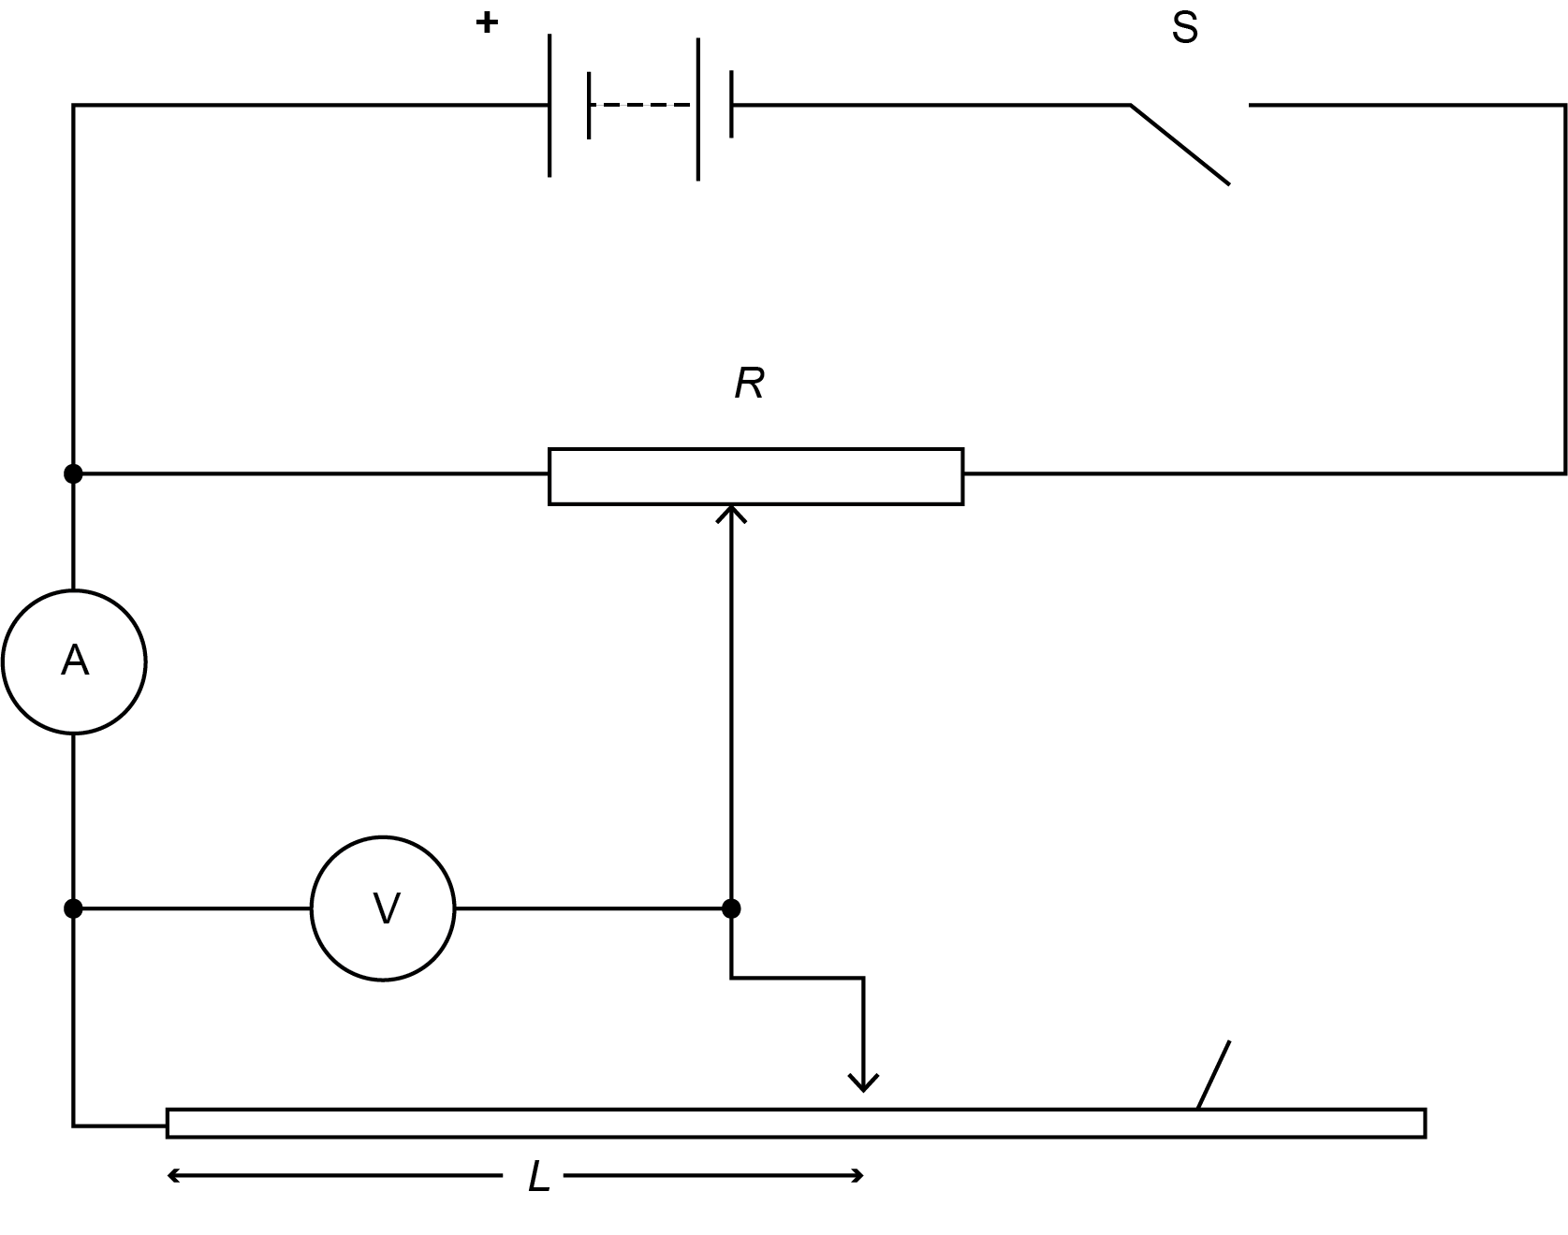
metal wire
Fig. 1

Procedure | Understanding
- Set up the circuit shown in Fig. 1.  The d.c. (variable) supply is in series with an external switch, S, and the metal wire.  The length of wire in the circuit is adjusted and connected into the circuit using crocodile clips. | When a mains power supply is switched off, the p.d. across the terminals does not drop immediately to zero. It is necessary to include a separate switch that is external to the power supply.  Correct connection of the leads to the meters will result in positive readings. What should you do if a meter reading is negative?
- Adjust the length, L, of wire in the circuit so that it is 50.0 cm. | How will you make sure that L is measured accurately? State the uncertainty in the measurement of L.
- Close the switch S, and adjust the power supply (or potential divider) so that the reading on the voltmeter is 3.0 V. | What is the resolution of the voltmeter?  State the number of decimal places to which V should be recorded.
- Record the reading on the ammeter. This must be kept constant throughout the experiment. | What happens to the temperature of a wire when there is a current in it?  Why is it necessary to keep the same current in the wire throughout the experiment?
- For a range of different lengths, L, of the metal wire, record in a table the reading on both the ammeter and voltmeter.  Remember, the ammeter reading must always be the same each time you change the length of wire in the circuit.  Extension: record at least three repeat readings of V. | How will you identify a random error when taking these readings?  Take appropriate action to minimise the chance of making a random error.  Identify the independent and dependent variables.  Which variable should be recorded in the first column of the table?  What might cause the value for V to vary between repeats for the same length L?
- Plot a graph of V (x-axis) against L (y-axis). | Label the axes with appropriate quantities and units.
- Draw a line of best fit. | When you have drawn the best fit line, what do you look for to confirm that it is an acceptable line? (Hint: how are the points distributed about the line?)
- Determine the gradient of your best fit line. | On your graph, show the triangle used to determine the gradient.  Why is it necessary to use a hypotenuse greater in length than half of the length of the line drawn, when determining the gradient?
- By taking appropriate measurements, determine the diameter of the metal wire. Record your value using a standard form (or engineering notation), but without using a prefix. | Why is it necessary to measure the diameter d of the wire at several positions along the length of the wire and at different orientations, before calculating an average value for d?
- Calculate the cross-sectional area, A, of the metal wire. | If you didn’t write the diameter in metres, then you will need to take care to convert the cross-sectional area from mm² into m². How many mm are in 1 m? How many mm² are in 1 m²?
- Use your answers to steps 4, 8 and 10 to determine a value for the resistivity $\text{ρ}$. | What is the unit for $\text{ρ }$? (If you don’t know the answer, use the equation R = $\frac{\text{ρ} \text{L}}{\text{A}}$to work it out.)
- Research a value for the resistivity of the metal used. Cite your source. | Explain how you chose the source you used to have confidence in its reliability.
- Calculate the % difference between your value for $\text{ρ}$ and the source value. | When calculating the % difference between a measured value of ρ and an accepted source value of ρ, which value should be in the denominator position in the equation below?  % difference = $\frac{\text{∆}\text{ρ} }{\text{ρ}}$× 100

Extension Activities and Further Investigations
In order to carry out this extension activity, you will need to have taken the repeat readings of V as indicated in Step 5 above.

Procedure | Understanding
- Plot the three values of V for each L. This will show you the range of V for each L.  Joining these three plots with a straight line will give you a vertical error bar.  Using the uncertainty in your measurements for the p.d., V, across length, L, of the wire, draw a worst acceptable fit line. | The main uncertainty will be in the measurement of the p.d., V.  The uncertainty in the measurement of L will likely be very small in comparison with the uncertainty in V and so the horizontal error bar will be very small or negligible.  This will be either the steepest or shallowest line that can be drawn which passes through each of the vertical error bars.
- Determine the gradient of the worst acceptable fit line and hence calculate the absolute uncertainty in your gradient. | absolute uncertainty in gradient  =  gradient of best fit line  _  gradient of worst fit line
- Determine the uncertainty in the measurement of the diameter d (of the wire) and hence in the measurement of the cross-sectional area of the wire. | If the repeat measurements for d are identical, the uncertainty should be determined using the resolution of the measuring instrument.
- Determine the resistivity of the metal wire and its % uncertainty within which there is confidence that the value lies. | How do you determine the number of significant figures required in your answer?
- Research a value for the resistivity of the metal wire you have been given. Your teacher can tell you the material that the wire is made of. Cite your source. | Explain how you can have confidence in the website/book containing the researched value for the resistivity of your wire?
- Calculate the percentage difference between your value for the resistivity and the researched value and comment on the accuracy of your experiment. | If the experiment has been carried out accurately, the true value will lie within the experimental uncertainty.  Is your % difference smaller than your % uncertainty in ρ ?
- Explain how the value for the resistivity would have been different if the p.d. had been kept constant and the variation of current with length had been measured. | Hint:  What is the effect on the resistance of a resistance wire if the current in it is reduced.  What happens to the resistance of a wire when its length increases?  What is the effect of both of the above changes on the resistance of a wire? Hence what is the overall effect on the resistivity?

Practical skills, apparatus and techniques assessed
a | Reference | Description of skill/technique
 | 1.2.1(b) | safely and correctly use a range of practical equipment including a potentiometer, ammeter, voltmeter and resistance wire, micrometer / vernier caliper, ruler
 | 1.2.1(c) | follow written instructions
 | 1.2.1(d) | make and record measurements of p.d. and current
 | 1.2.1(e) | keep appropriate records of experimental activities
 | 1.2.1(f) | present information and data in a scientific way
 | 1.2.1(h) | use research skills to find a value for the resistivity
 | 1.2.1(i) | cite sources for the resistivity that are reliable
 | 1.2.1(j) | use a wide range of experimental and practical instruments, equipment and techniques appropriate to the knowledge and understanding included in the specification including an ammeter, voltmeter, wire and power supply
 | 1.2.2(b) | use appropriate digital instruments, including electrical multimeters to measure current and p.d.
 | 1.2.2(e) | use micrometer for measuring small distances such as the diameter of the wire
 | 1.2.2(f) | correctly construct circuits using d.c. power supplies and a range of circuit components including an ammeter, voltmeter, wire and power supply

Scientific and Practical Understanding
It is important that errors in measurement are minimised. Repeat readings will hopefully identify potential random errors.
Repeat measurements of V as L is increased and then decreased, will produce a range of values for V. The spread of these values of V (for each L) may be used as an indication of uncertainty.
Uncertainties may be estimated by using either;
- the fraction of the measurement that the instrument resolution produces or
- +/- half of the range of a set of repeat readings
If the uncertainty in a gradient is to be determined, the gradient of the worst acceptable fit line through a series of error bars may be determined and subtracted from the gradient of the best fit line.
When selecting data from the graph to determine the gradient, two points (that lie exactly on the line) should be chosen where their separation is greater than half the length of the best fit line drawn.
The diameter of the wire should be determined from at least three measurements taken at different points along the length of the wire. If there are kinks in the wire or thickness variations due to shear stresses, the wire should be replaced.
Calculating the % difference and making a comparison with the % uncertainty is one way to comment on the accuracy of the experiment. If the experiment has been carried out accurately, the true value of ρ will lie within the experimental uncertainty (or in other words, the % difference < % uncertainty.

Notes and References
The power supplies, and any associated potential divider circuits, should allow a variable adjustment in the range 0 V to about 6 V d.c.
Constantan wire swg 28 has a resistance of about 4.4 Ω m^{–1}, however, any suitable wire that gives a measurable variation in p.d. with change in length may be used.
Learners are expected to take a number of readings for diameter along the length of the wire to account for possible variations along the length and for the cross-sectional area not being circular.
Health and safety should always be considered before undertaking any practical work. A full risk assessment of any activity should always be undertaken.
It is advisable to check the CLEAPSS website in advance of undertaking the practical tasks.
We recommend that this practical is trialled in advance of giving it to students. Keep the trial results as part of centre records for assessing the Practical Endorsement.

