# Section Check In – AL: Algebra

## Questions

1. Express as a single fraction .

[AL2]

|  |  |
| --- | --- |
| **1** |  |
|  |
|  |
|  |
|  |
|  |

2. A sequence of numbers  is given by , .

Find  and 

[AL10]

|  |  |
| --- | --- |
| **2** |  |
|  |
|  |
|  |
|  |

3. On the grid below indicate the region for which the following inequalities hold. You should  
shade the regions which are NOT satisfied.



[AL9]

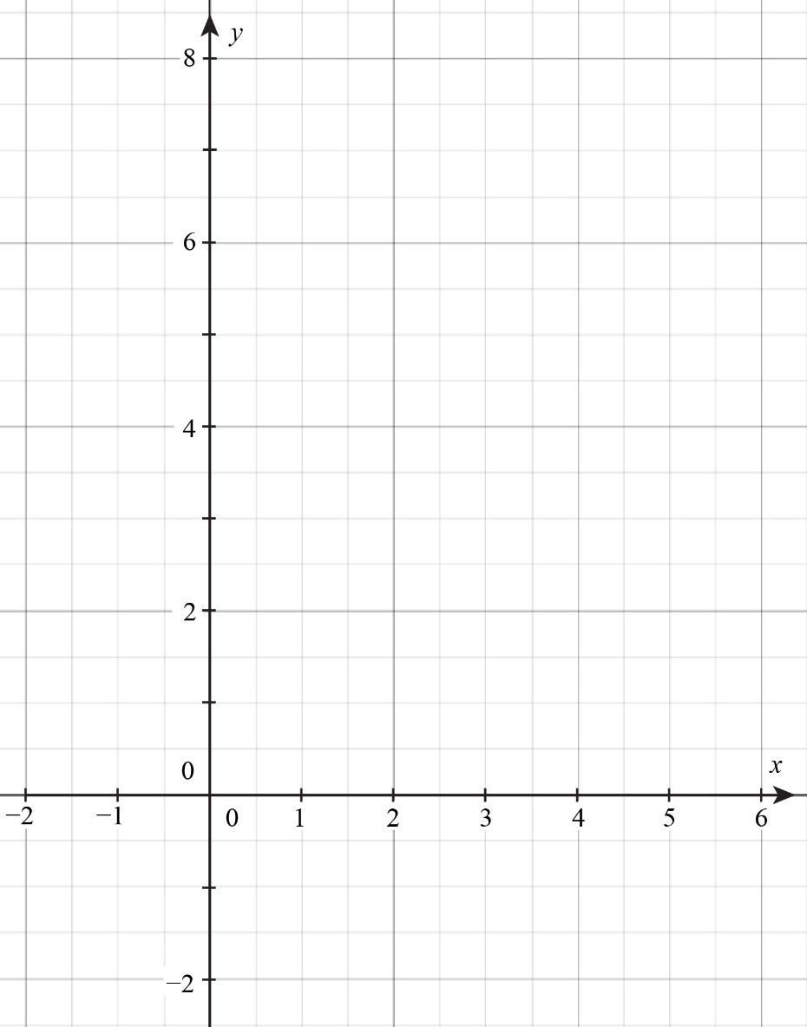

4. Simplify .

[AL2]

|  |  |
| --- | --- |
| **4** |  |
|  |
|  |

5. Find the coefficient of *x* when multiplying out the expression .

[AL1,3]

|  |  |
| --- | --- |
| **5** |  |
|  |
|  |
|  |

6. Solve the inequality , giving your answer in terms of  and .

[AL7,8]

|  |  |
| --- | --- |
| **6** |  |
|  |
|  |

7. Express  in the form .

[AL5]

|  |  |
| --- | --- |
| **7** |  |
|  |
|  |
|  |

8. Use the factor theorem to show that  is a factor of .

[AL4]

|  |  |
| --- | --- |
| **8** |  |
|  |
|  |
|  |
|  |

9. Solve the inequality 

[AL8]

|  |  |
| --- | --- |
| **12** |  |
|  |
|  |
|  |

10. Factorise fully 

[AL4]

|  |  |
| --- | --- |
| **10** |  |
|  |
|  |
|  |

11. An athlete is training for the London marathon. He runs 7 miles on day 1 and then increases his run by 0.8 miles each day until he can run a complete marathon of 26.2 miles.

On which day of his training does he run the full 26.2 miles?

[AL11]

|  |  |
| --- | --- |
| **11** |  |
|  |
|  |
|  |

12. Taxi firm A charges £5 for the first mile and £1.25 for each extra mile. Firm B charges £10 for the first two miles and £1 per mile for each extra mile after the first two. Form and solve an inequality for the distance m for which company B is cheaper.

[AL8]

|  |  |
| --- | --- |
| **12** |  |
|  |
|  |
|  |
|  |

13. An object is projected vertically upwards from ground level and its height, metres, after  seconds is given by the formula . Show that the object is above a height of metres for approximately  seconds.

[AL6]

|  |  |
| --- | --- |
| **13** |  |
|  |
|  |
|  |
|  |
|  |

14. A sequence is given by the rule  . Given that  and , find;

(a) 

(b) 

(c) 

[AL10]

|  |  |
| --- | --- |
| **14(a)** |  |
|  |
| **14(b)** |  |
|  |
| **14(c)** |  |
|  |
|  |
|  |
|  |

15. Simplify fully  giving your answer in the form 

[AL3]

|  |  |
| --- | --- |
| **15** |  |
|  |
|  |
|  |
|  |
|  |
|  |
|  |
|  |
|  |

### Extension

The first 7 terms of a sequence are *a*, *b*, *c*, 12, *e*, *f*, 50. The sequence follows the same rules as the Fibonacci sequence (i.e. the 3rd term is the sum of the 1st & 2nd, the 4th term is the sum of the 2nd & 3rd, etc.). What are the values of *a*, *b*, *c*, *e* & *f* ?

|  |  |
| --- | --- |
| **Ext** |  |
|  |
|  |
|  |
|  |
|  |
|  |
|  |
|  |
|  |
|  |
|  |
|  |
|  |

## Worked solutions

1. 

 oe

2. , , , 

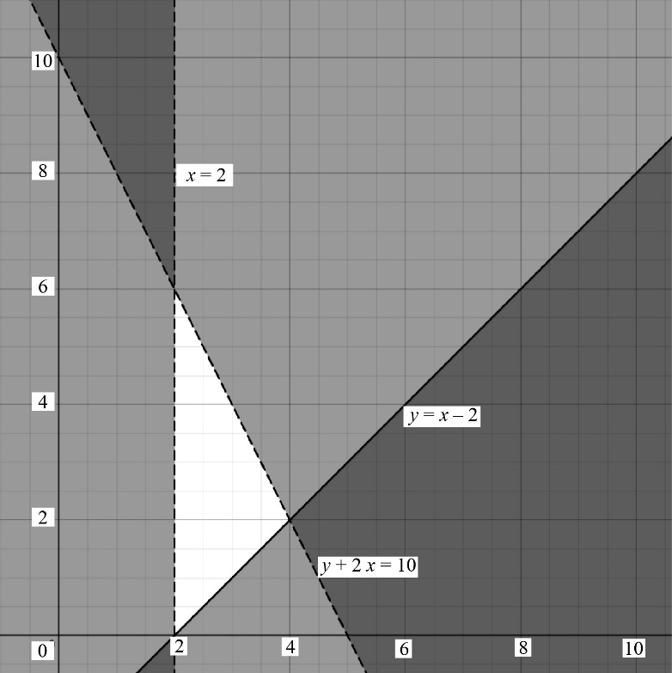

1. Simplifying, 
2. 

Coefficient of is .

1. 

7. 



  ,  and 

8. Let 



Since , by factor theorem, using  shows that  is a factor.

9. 





10. Possible integer roots  {"mathml":"<math xmlns=\"http://www.w3.org/1998/Math/MathML\" style=\"font-family:Arial;font-size:11px;\"/>","origin":"MathType for Microsoft Add-in"}{"mathml":"<math xmlns=\"http://www.w3.org/1998/Math/MathML\" style=\"font-family:Arial;font-size:11px;\"/>","origin":"MathType for Microsoft Add-in"}

 No

  is a factor







11.  , , …



 

12. 











 {"mathml":"<math xmlns=\"http://www.w3.org/1998/Math/MathML\" style=\"font-family:Arial;font-size:11px;\"/>","origin":"MathType for Microsoft Add-in"}

13. Times when object is at a height of metres found by substituting 

Equation is  which rearranges to 

Using quadratic formula,  or 

Time above is 

14. (a) 

(b) 



(c) Let  and 

, , ,





Solving simultaneously gives 

15. 

|  |  |  |  |
| --- | --- | --- | --- |
|  | *x*2 | - 4*x* | +17 |
| *x* | *x*3 | - 4*x*2 | + 17*x* |
| +3 | 3x2 | -12*x* | + 51 |



### Extension











Simultaneous Equations





 ,  ,  ,  and 

Please note – web links are correct at date of publication but other websites may change over time. If you have any problems with a link you may want to navigate to that organisation’s website for a direct search.



We’d like to know your view on the resources we produce. Click ‘[Like’](mailto:resources.feedback@ocr.org.uk?subject=I%20liked%20the%20FSMQ%20Additional%20Mathematics%20Section%20check%20in%20Algebra) or ‘[Dislike’](mailto:resources.feedback@ocr.org.uk?subject=I%20disliked%20the%20FSMQ%20Additional%20Mathematics%20Section%20check%20in%20Algebra) to send us an auto generated email about this resource. Add comments if you want to. Let us know how we can improve this resource or what else you need. Your email will not be used or shared for any marketing purposes.

Looking for another resource? There is now a quick and easy search [tool to help find free resources](https://www.ocr.org.uk/qualifications/resource-finder/) for your qualification.

OCR is part of Cambridge University Press & Assessment, which is itself a department of the University of Cambridge.

For staff training purposes and as part of our quality assurance programme your call may be recorded or monitored.   
© OCR 2024 Oxford Cambridge and RSA Examinations is a Company Limited by Guarantee. Registered in England. Registered office The Triangle Building, Shaftesbury Road, Cambridge, CB2 8EA. Registered company number 3484466. OCR is an exempt charity.

OCR operates academic and vocational qualifications regulated by Ofqual, Qualifications Wales and CCEA as listed in their qualifications registers including A Levels, GCSEs, Cambridge Technicals and Cambridge Nationals.

OCR provides resources to help you deliver our qualifications. These resources do not represent any teaching method we expect you to use. We update our resources regularly and aim to make sure content is accurate but please check the OCR website so that you have the most up to date version. OCR cannot be held responsible for any errors or omissions in these resources.

Though we make every effort to check our resources, there may be contradictions between published support and the specification, so it is important that you always use information in the latest specification. We indicate any specification changes within the document itself, change the version number and provide a summary of the changes. If you do notice a discrepancy between the specification and a resource, please [contact us](mailto:resources.feedback@ocr.org.uk).

You can copy and distribute this resource in your centre, in line with any specific restrictions detailed in the resource. Resources intended for teacher use should not be shared with students. Resources should not be published on social media platforms or other websites.

OCR acknowledges the use of the following content: Graphs/images generated from Desmos content; used under a Creative Commons “Attribution-ShareAlike” License ([CC-BY-SA-4.0](https://creativecommons.org/licenses/by-sa/4.0/)), attributed to Desmos.

Whether you already offer OCR qualifications, are new to OCR or are thinking about switching, you can request more information using our [Expression of Interest form](https://www.ocr.org.uk/qualifications/expression-of-interest/).

Please [get in touch](mailto:resources.feedback@ocr.org.uk) if you want to discuss the accessibility of resources we offer to support you in delivering our qualifications.