Quiz - Topic C1 Particles and Topic C2 Elements, compounds and mixtures

Instructions and answers for teachers

These instructions cover the learner activity section which can be found on page 14. This quiz supports OCR GCSE (9-1) Chemistry A (Gateway Science), J248.
When distributing the activity section to the learners either as a printed copy or as a Word file you will need to remove the teacher instructions section.

The Activity
This quiz is a teaching and learning resource containing 10 multiple choice questions on the theme of Particles and Elements, compounds and mixtures.
This resource can be used to test and consolidate understanding at the end of a topic or to revisit and refresh knowledge at a later point in the course.

Learning Outcomes
This lesson element relates to the specification learning outcomes of
C1.1 – The particle model
C1.2 – Atomic structure
C2.1 – Purity and separating mixtures
C2.2 – Bonding
C2.3 – Properties of materials

Introduction
Multiple choice questions allow rapid coverage of a wide range of sub-topics.
Contrary to a widespread belief among learners, multiple choice questions are not necessarily easy – they can be easy, moderate or difficult.
The questions are written so that the incorrect answers are plausible distractors based on common errors or misconceptions.

Quiz - answers

Topic C1

1 |  | The distances between the particles of a substance in different states vary.  Which order is correct, starting with the shortest distance? [1]
 |  | A | Gas; solid; liquid
 |  |  | Incorrect - particles in a gas are furthest apart.
 |  | B | Liquid; gas; solid
 |  |  | Incorrect - particles in a solid are the closest together.
 |  | C | Solid; liquid; gas
 |  |  | Correct answer.
 |  | D | Solid; gas; liquid
Incorrect - solid correct but particles in a liquid are closer than in a gas.
C
 | Your answer

2 |  | Which of the following describes a chemical change? [1]
 |  | A | Sodium chloride dissolving
 |  |  | Incorrect - physical change.
 |  | B | Ether evaporating
 |  |  | Incorrect - physical change.
 |  | C | Using lemon juice to relieve a wasp sting
 |  |  | Correct answer – neutralisation therefore chemical change.
 |  | D | Ice melting
Incorrect - physical change.
C
 | Your answer

3 |  | What is the distance between the atoms in a molecule of bromine, Br₂. [1]
 |  | A | 1.9 x 10^{–6}
 |  |  | Incorrect – order of magnitude too high.
 |  | B | 1.9 x 10^{–10}
 |  |  | Correct answer.
 |  | C | 1.9 x 10^{–12}
 |  |  | Incorrect – order of magnitude too small.
 |  | D | 1.9 x 10^{–8}
Incorrect – order of magnitude too high.
B
 | Your answer

4 |  | Distances between nitrogen molecules are 300 times the molecular radius. The molecular diameter is 3.64 X10⁻¹⁰ m. What would be the distance between the nitrogen molecules in metres? [1]
 |  | A | 1.1 X10^{–6}
 |  |  | Incorrect - used the diameter rather than the radius and error in powers calculation.
 |  | B | 5.46 x10^{–8}
 |  |  | Correct answer - 150 x diameter = 300x diameter/2
 |  | C | 5.46 x 10^{–7}
 |  |  | Incorrect – error in powers calculation.
 |  | D | 1.1 x 10^{–7}
Incorrect - used the diameter rather than the radius.
B
 | Your answer

5 |  | Chemical changes differ from physical changes as shown by: [1]
 |  | A | A change in arrangement of atoms resulting in a new set of chemical properties.
 |  |  | Correct answer.
 |  | B | A change in arrangement of atoms resulting in no change in chemical properties.
 |  |  | Incorrect - products have different properties.
 |  | C | A change in distance between particles resulting in a change of state.
 |  |  | Incorrect – describes a physical change.
 |  | D | A change in distance between particles, resulting in no change in the particles.
Incorrect – describes a physical change.
A
 | Your answer

6 |  | Which of the following describes the sub-atomic particles in an atom of ⁸¹Br?  (protons, electrons, neutrons) [1]
 |  | A | 35, 46, 35
 |  |  | Incorrect - electrons and neutons transposed.
 |  | B | 35, 35, 46
 |  |  | Correct answer.
 |  | C | 35, 46, 46
 |  |  | Incorrect - wrong number of electrons (matched with neutrons rather than protons).
 |  | D | 46, 35, 35
Incorrect - protons and neutrons transposed.
B
 | Your answer

Topic C2

7 |  | Glucose is the main energy store in biological systems. Its molecular formula is C₆H₁₂O₆  What is the empirical formula of glucose? [1]
 |  | A | CHO
 |  |  | Incorrect – not in correct ratio.
 |  | B | C₂H₄O₂
 |  |  | Incorrect – not in the lowest ratio.
 |  | C | C₃H₆O₃
 |  |  | Incorrect – not in the lowest ratio.
 |  | D | CH₂O
Correct answer.
D
 | Your answer

8 |  | In winemaking, the dead yeast remaining after the fermentation forms a fine, light sludge called the lees.  Which method would the most efficient at removing the lees from the wine? [1]
 |  | A | Distillation
 |  |  | Incorrect – would change wine to a spirit
 |  | B | chromatography
 |  |  | Incorrect – not used for separation.
 |  | C | Filtration
 |  |  | Correct answer.
 |  | D | Sieving
Incorrect - the lees would travel through a sieve as the holes would be too large.
C
 | Your answer

9 |  | The blades in jet engines are grown as single crystals. The structure of the crystal is shown below. What is this substance? [1]  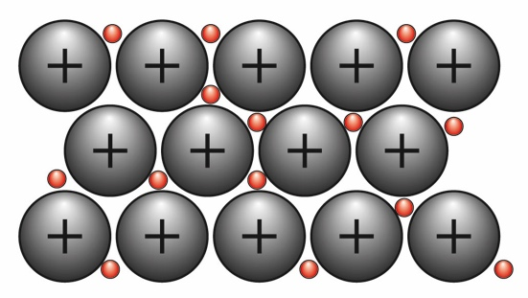
 |  | A | Sulfur
 |  |  | Incorrect - is a non-metal.
 |  | B | Titanium
 |  |  | Correct answer – a metal.
 |  | C | Copper sulfate
 |  |  | Incorrect - it is a salt.
 |  | D | Silicon dioxide
Incorrect - is a covalent compound.
B
 | Your answer

10 |  | What is the electronic configuration for Sulfur? [1]
 |  | A | 6, 8, 2
 |  |  | Incorrect - Order reversed.
 |  | B | 2, 8, 6
 |  |  | Correct answer.
 |  | C | 2, 8, 8
 |  |  | Incorrect - sulpfur is in Group 6 (16) so has 6 electrons in its outer shell.
 |  | D | 8, 2, 6
Incorrect - wrong order.
B
 | Your answer

11 |  | A metal A forms the ion A²⁺ with 10 electrons.  What is the name the ion? [1]
 |  | A | Calcium ion
 |  |  | Incorrect – 2+ charge but 18 electrons.
 |  | B | Magnesium ion
 |  |  | Correct answer.
 |  | C | Beryllium ion
 |  |  | Incorrect –2+ charge but 2 electrons.
 |  | D | strontium ion
Incorrect –2+ charge but 36 electrons.
B
 | Your answer

12 |  | Name the type of bonding and the compound indicated by the diagram. [1]  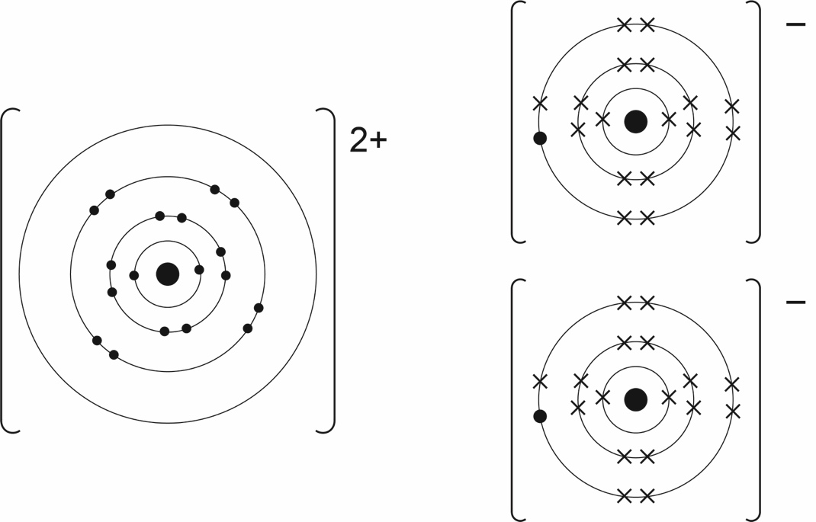
 |  | A | Ionic, magnesium chloride
 |  |  | Incorrect – identification of cation incorrect.
 |  | B | Covalent, calcium chloride
 |  |  | Incorrect - identification of bonding incorrect.
 |  | C | Ionic, calcium fluoride
 |  |  | Incorrect – identification of the anion incorrect
 |  | D | Ionic, calcium chloride
Correct answer.
D
 | Your answer
13 |  | How many covalent bonds can carbon form? [1]
 |  | A | 1
 |  |  | Incorrect.
 |  | B | 2
 |  |  | Incorrect.
 |  | C | 3
 |  |  | Incorrect.
 |  | D | 4
Correct – carbon has 4 electrons in its outer shell to share covalently.
D
 | Your answer

14 |  | Which of the elements conducts electricity as a solid at room temperature? [1]  Melting point ºC Boiling Point º C  Sodium chloride 801 1413  Bromine 8 59  Diamond 3550 4830  Graphite N/A 3730 (sublimes)
 |  | A | Sodium chloride
 |  |  | Incorrect - needs to be molten.
 |  | B | Bromine
 |  |  | Incorrect - covalent molecule.
 |  | C | Diamond
 |  |  | Incorrect - no free electrons.
 |  | D | Graphite
Correct answer – free delocalised electrons.
D
 | Your answer

15 |  | Which of the following Bohr diagrams shows the sodium ion? [1]
 |  | A | 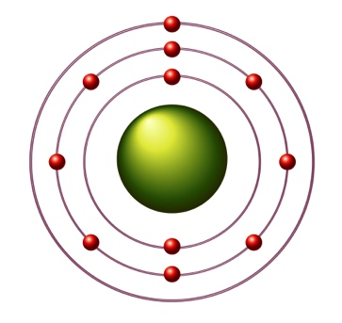
 |  |  | Incorrect – sodium atom.
 |  | B | 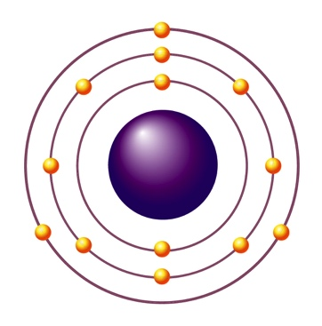
 |  |  | Incorrect - aluminum atom.
 |  | C | 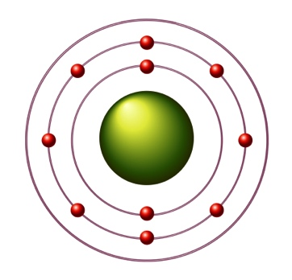
 |  |  | Correct – outer electron missing so sodium ion.
 |  | D | 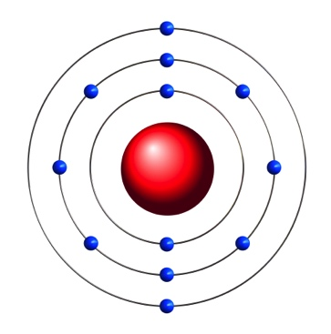
Incorrect – magnesium atom.
C
 | Your answer

16 |  | On a chromatogram, a substance has with an Rf value of 0.77.  If the solvent front travels 12cm from the baseline, at what distance from the baseline will the spot be found. [1]
 |  | A | 9.2cm
 |  |  | Correct answer.
 |  | B | 7.7cm
 |  |  | Incorrect - assumed solvent front moved 10cm.
 |  | C | 9.0cm
 |  |  | Incorrect - estimated three quarters of 12cm.
 |  | D | 0.1cm
Incorrect - divided by 12cm.
A
 | Your answer

17 |  | What is the empirical formula for a substance that has 66.67% carbon, 22.22% oxygen and 11.11% hydrogen? [1]
 |  | A | C_{5.56}H_{11.11}O_{1.39}
 |  |  | Incorrect – ratios not converted to whole numbers by dividing by smallest molarity.
 |  | B | CH₂O_{0.25}
 |  |  | Incorrect – did not use the smallest number of moles to divide down ratios.
 |  | C | C₄H₈O
 |  |  | Correct answer.
 |  | D | C₆H₁O₂
Incorrect – did not convert into moles.
C
 | Your answer

18 |  | Use the Periodic Table to find the element which is in Period 4 and Group 16 (6) How many neutrons are in one atom of this element? [1]
 |  | A | 2
 |  |  | Incorrect – charge of ion.
 |  | B | 34
 |  |  | Incorrect – number of protons.
 |  | C | 79
 |  |  | Incorrect – relative atomic mass
 |  | D | 45
Correct answer.
D
 | Your answer

19 |  | A product development engineer is looking for a material to make a threaded insulating plug for an immersion heater.  Which of the following polymers would be most suitable given the high temperatures that might be encountered? [1]  Polymer Hardness Softening point ºC  Nylon Soft 265  Polyethene Soft 80  Polypropene Soft 171  Bakelite Hard Doesn’t melt
 |  | A | Nylon
 |  |  | Incorrect - softens on heating.
 |  | B | Polyethene
 |  |  | Incorrect - softens on heating.
 |  | C | Polypropene
 |  |  | Incorrect - softens on heating.
 |  | D | Bakelite
Correct answer.
D
 | Your answer

20 |  | Silicon dioxide is a covalent compound with a giant 3D lattice structure. Which best describes the physical properties of silicon dioxide? [1]
 |  | A | Low melting point, soft
 |  |  | Incorrect – substances with giant 3D covalent lattices are hard with high melting points.
 |  | B | High melting point, hard
 |  |  | Correct answer.
 |  | C | Low melting point, hard
 |  |  | Incorrect
 |  | D | High melting point, soft
Incorrect
B
 | Your answer

We’d like to know your view on the resources we produce. Click ‘Like’ or ‘Dislike’ to send us an auto generated email about this resource. Add comments if you want to. Let us know how we can improve this resource or what else you need. Your email will not be used or shared for any marketing purposes.
Looking for another resource? There is now a quick and easy search tool to help find free resources for your qualification.
OCR is part of Cambridge Assessment, a department of the University of Cambridge.
For staff training purposes and as part of our quality assurance programme your call may be recorded or monitored.
Oxford Cambridge and RSA Examinations is a Company Limited by Guarantee. Registered in England. Registered office
The Triangle Building, Shaftesbury Road, Cambridge, CB2 8EA. Registered company number 3484466. OCR is an exempt charity.
OCR operates academic and vocational qualifications regulated by Ofqual, Qualifications Wales and CCEA as listed
in their qualifications registers including A Levels, GCSEs, Cambridge Technicals and Cambridge Nationals.
OCR provides resources to help you deliver our qualifications. These resources do not represent any particular teaching method we expect you to use. We update our resources regularly and aim to make sure content is accurate but please check the OCR website so that you have the most up to date version. OCR cannot be held responsible for any errors or omissions in these resources.
Though we make every effort to check our resources, there may be contradictions between published support and the specification, so it is important that you always use information in the latest specification. We indicate any specification changes within the document itself, change the version number and provide a summary of the changes. If you do notice a discrepancy between the specification and a resource, please contact us.
© OCR 2021 - You can copy and distribute this resource freely if you keep the OCR logo and this small print intact and you acknowledge OCR as the originator of the resource.
OCR acknowledges the use of the following content: N/A
Whether you already offer OCR qualifications, are new to OCR or are thinking about switching, you can request more information using our Expression of Interest form.
Please get in touch if you want to discuss the accessibility of resources we offer to support you in delivering our qualifications.

Quiz - Topic C1 Particles and Topic C2 Elements, compounds and mixtures

Learner Activity

Topic C1

1 |  | The distances between the particles of a substance in different states vary.  Which order is correct, starting with the shortest distance? [1]
 |  | A | Gas; solid; liquid
 |  | B | Liquid; gas; solid
 |  | C | Solid; liquid; gas
 |  | D | Solid; gas; liquid
 | Your answer

2 |  | Which of the following describes a chemical change? [1]
 |  | A | Sodium chloride dissolving
 |  | B | Ether evaporating
 |  | C | Using lemon juice to relieve a wasp sting
 |  | D | Ice melting
 | Your answer

3 |  | What is the distance between the atoms in a molecule of bromine, Br₂. [1]
 |  | A | 1.9 x 10^{–6}
 |  | B | 1.9 x 10^{–10}
 |  | C | 1.9 x 10^{–12}
 |  | D | 1.9 x 10^{–8}
 | Your answer

4 |  | Distances between nitrogen molecules are 300 times the molecular radius. The molecular diameter is 3.64 x10^{–10} m. What would be the distance between the nitrogen molecules in metres? [1]
 |  | A | 1.09 X10^{–6}
 |  | B | 5.46 x10^{–8}
 |  | C | 5.46 x 10^{–7}
 |  | D | 1.09 x 10^{–7}
 | Your answer

5 |  | Chemical changes differ from physical changes as shown by: [1]
 |  | A | A change in arrangement of atoms resulting in a new set of chemical properties.
 |  | B | A change in arrangement of atoms resulting in no change in chemical properties.
 |  | C | A change in distance between particles resulting in a change of state.
 |  | D | A change in distance between particles, resulting in no change in the particles.
 | Your answer

6 |  | Which of the following describes the sub-atomic particles in an atom of ⁸¹Br?  (protons, electrons, neutrons) [1]
 |  | A | 35, 46, 35
 |  | B | 35, 35, 46
 |  | C | 35, 46, 46
 |  | D | 46, 35, 35
 | Your answer

Topic C2

7 |  | Glucose is a main energy store in biological systems. Its molecular formula is C₆H₁₂O₆  What is the empirical formula of glucose? [1]
 |  | A | CHO
 |  | B | C₂H₄O₂
 |  | C | C₃H₆O₃
 |  | D | CH₂O
 | Your answer

8 |  | In winemaking, the dead yeast remaining after the fermentation forms a fine, light sludge called the lees.  Which method would the most efficient at removing the lees from the wine? [1]
 |  | A | Distillation
 |  | B | Chromatography
 |  | C | Filtration
 |  | D | Sieving
 | Your answer

9 |  | 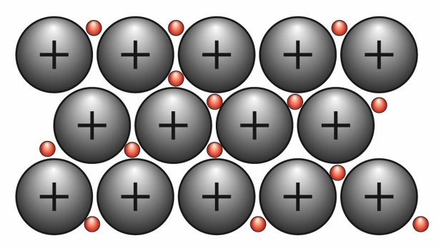  The blades in jet engines are grown as single crystals. The structure of the crystal is shown below. What is this substance? [1]
 |  | A | Sulfur
 |  | B | Titanium
 |  | C | Copper sulfate
 |  | D | Silicon dioxide
 | Your answer

10 |  | What is the electronic configuration for Sulfur? [1]
 |  | A | 6, 8, 2
 |  | B | 2, 8, 6
 |  | C | 2, 8, 8
 |  | D | 8, 2, 6
 | Your answer
11 |  | A metal A forms the ion A²⁺ with 10 electrons.  What is the name the ion? [1]
 |  | A | Calcium ion
 |  | B | Magnesium ion
 |  | C | Beryllium ion
 |  | D | Strontium ion
 | Your answer

12 |  | Name the type of bonding and the compound indicated by the diagram. [1]  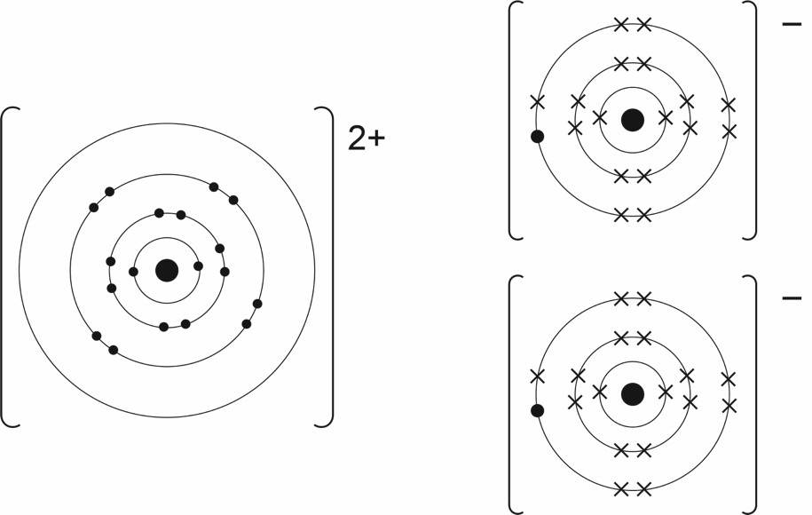
 |  | A | Ionic, magnesium chloride
 |  | B | Covalent, calcium chloride
 |  | C | Ionic, calcium fluoride
 |  | D | Ionic, calcium chloride
 | Your answer

13 |  | How many covalent bonds can carbon form? [1]
 |  | A | 1
 |  | B | 2
 |  | C | 3
 |  | D | 4
 | Your answer
14 |  | Which of the elements conducts electricity as a solid at room temperature? [1]  Melting point in ºC Boiling Point in º C  Sodium chloride 801 1413  Bromine 8 59  Diamond 3550 4830  Graphite N/A 3730 (sublimes)
 |  | A | Sodium chloride
 |  | B | Bromine
 |  | C | Diamond
 |  | D | Graphite
 | Your answer

15 |  | Which of the following Bohr diagrams shows the sodium ion? [1]
 |  | A
 |  | B
 |  | C
 |  | D
 | Your answer

16 |  | On a chromatogram, a substance has an Rf value of 0.77.  If the solvent front travels 12cm from the baseline, at what distance from the baseline will the spot be found. [1]
 |  | A | 9.2cm
 |  | B | 7.7cm
 |  | C | 9.0cm
 |  | D | 0.1cm
 | Your answer

17 |  | What is the empirical formula for a substance that has 66.67% carbon, 22.22% oxygen and 11.11% hydrogen? [1]
 |  | A | C_{5.56}H_{11.11}O_{1.39}
 |  | B | CH₂O_{0.25}
 |  | C | C₄H₈O
 |  | D | C₆H₁O₂
 | Your answer

18 |  | Use the Periodic Table to find the element which is in Period 4 and Group 16. How many neutrons are in one atom of this element? [1]
 |  | A | 2
 |  | B | 34
 |  | C | 79
 |  | D | 45
 | Your answer

19 |  | A product development engineer is looking for a material to make a insulating plug for an immersion heater.  Which of the following polymers would be most suitable given the high temperatures that might be encountered? [1]  Polymer Hardness Softening point ºC  Nylon Soft 265  Polyethene Soft 80  Polypropene Soft 171  Bakelite Hard Doesn’t melt
 |  | A | Nylon
 |  | B | Polyethene
 |  | C | Polypropene
 |  | D | Bakelite
 | Your answer

20 |  | Silicon dioxide is a covalent compound with a giant 3D lattice structure. Which best describes the physical properties of silicon dioxide. [1]
 |  | A | Low melting point, soft
 |  | B | High melting point, hard
 |  | C | Low melting point, hard
 |  | D | High melting point, soft
 | Your answer

