End of topic quiz

Topics C1 Particles and C2 Elements, compounds and mixtures

Instructions and answers for teachers
These instructions cover the learner activity section which can be found on page 18. This end of topic quiz supports OCR GCSE (9–1) Chemistry A, topics C1 and C2.
When distributing the activity section to the learners either as a printed copy or as a Word file you will need to remove the teacher instructions section.

The Activity
This end of topic quiz comprises of 80 marks covering a range of question types. The quiz starts with some multiple choice questions and then moves on to some short answer questions and then finally on to some longer answer questions.
The question worksheet can be used to consolidate understanding at the end of teaching the chapter, to revisit and refresh knowledge at a later point in the course, or during exam preparation.

Learning Outcomes
This end of topic quiz relates to the specification learning outcomes in Topics C1 Particles and C2 Elements, compounds and mixtures. The quiz covers the following topics:
C1.1 The particle model
C1.2 Atomic structure
C2.1 Purity and separating mixtures
C2.2 Bonding
C2.3 Properties of materials

Topic: C1 and C2 of J248 - Answers
Total marks: 80
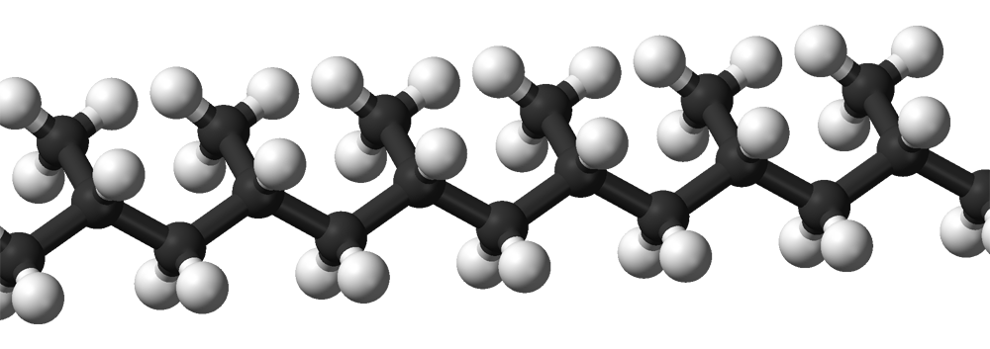
1 The diagram shows the arrangement of atoms in a molecule.

What type of molecule could this be? [1 mark]
A | A metal
B | An ionic compound
C | A polymer
D | A giant covalent structure

Your answer
C
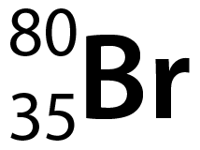
2 The diagram shows the mass number and atomic number for an isotope of the element bromine.

How many protons, neutrons and electrons does each atom of bromine have in this isotope? [1 mark]
A | 35 protons, 35 neutrons and 45 electrons
B | 45 protons, 35 neutrons and 45 electrons
C | 45 protons, 45 neutrons and 35 electrons
D | 35 protons, 45 neutrons and 35 electrons
Your answer
D

3 X₂CO₃ is a compound and has a relative formula mass of 106.
Use the periodic table to work out what element X is. [1 mark]
A | Sodium (Na)
B | Magnesium (Mg)
C | Lithium (Li)
D | Aluminium (Al)
Your answer
A
4 Which measurement is equal to 1 nanometre (nm)? [1 mark]
A | 0.000 000 001m
B | 0.000 001m
C | 0.001m
D | 0.1m
A
Your answer
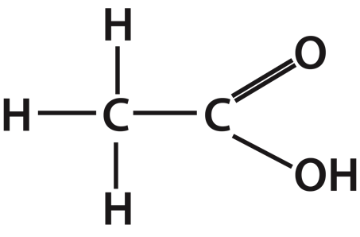
5 What is the empirical formula for acetic acid? The structural formula is shown below. [1 mark]

A | C₂H₄O₂
B | C₂H₃HO₂
C | CH₂O
D | H₃C₂O₂H
C
Your answer
6 Atoms are made up of sub-atomic particles.
The diagram shows the structure of an atom.

 | (a) |  | (i) | Why does an atom have no overall charge? [2 marks]
Relative charges are +1 for a proton and -1 for an electron
Number of protons equal the number of electrons
 |  |  | (ii) | Why does a sodium ion have a positive charge? [1 mark]
 |  |  |  | It has lost one electron
(b) |  | The diagrams show the proton number and mass number for four atoms A, B, C and D.  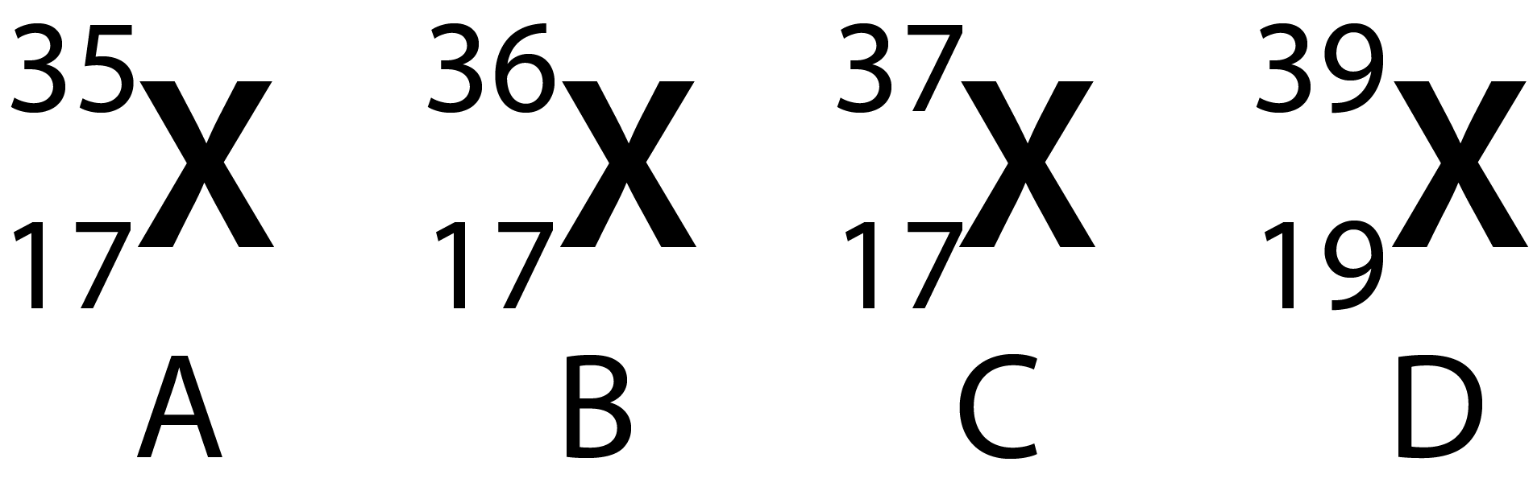
 |  | (i) |  |  | Which atoms are isotopes of the same element? [1 mark]
 |  |  |  |  | A, B and C
 |  | (ii) |  |  | Which atoms have 20 neutrons in their nucleus? [1 mark]
 |  |  |  |  | C and D
 |  | (iii) |  |  | What is the electron configuration of element D? [1 mark]
 |  |  |  |  | 2,8,8,1

 | (iv) | In the periodic table, in which group would element D be found? [1 mark]
 |  | Group 1
 | (v) | What would the charge be on an ion of element A?  Why is this? [2 marks]
-1/1-/-
It has gained an electron/negative charge

7 When ice is heated it will melt to form water.
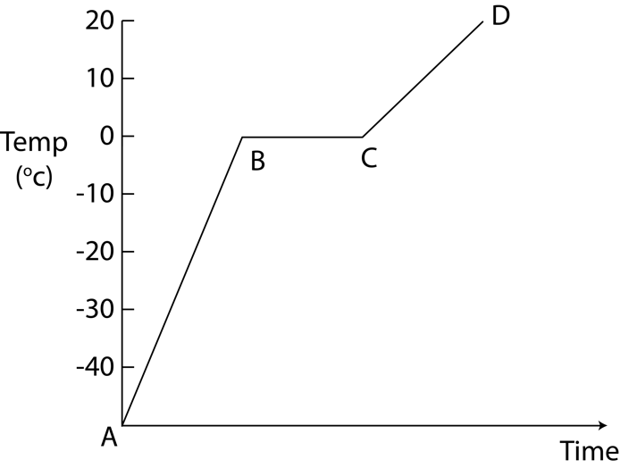
The graph shows a heating curve for ice.

(a) | (i) | What happens to the water particles as the ice is heated between points A and B on the graph? [1 mark]
 |  | Particles vibrate faster around a fixed point/ vibrate faster in the same place
 | (ii) | What is happening to the water particles between points B and C on the graph? [3 marks]
Particles vibrate fast enough to break bonds between them/holding them together
Particles can now move/flow over each other
The ice melts/becomes liquid
 | (iii) | Melting ice is an example of a physical change.  What is meant by the term ‘physical change’? [1 mark]
 |  | No new substance is formed/ the substance is still the same substance

(b) |  | Iron melts at a temperature of 1538ºC.  What does this suggest about the strength of the bonds between iron particles? Why is this? [2 marks]
Strong
A lot/large amount of energy is required to break them (the bonds)
8 Over time our understanding of the structure of an atom has changed.
The table shows a timeline of different scientists’ theories of atomic structure of the atom.

Date | Scientist | Theory | Image
1913 | Bohr |  | 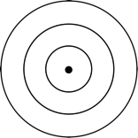
1911 | Rutherford | Planetary Model
1904 | Thomson | Plum-pudding Model | 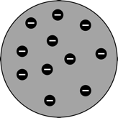
1800’s | Dalton | The smallest component of everything is the atom. It cannot be broken down in to anything simpler.  Atoms of a particular element are the same and atoms of different elements have different masses.

(a) | What is the plum-pudding model of the atom that Thomson proposed? [1 mark]
 | Negative charges/electrons floating in positive charges
(b) | What is the planetary model of the atom that was proposed by Rutherford? [2 marks]
Dense positive nucleus
Surrounded by negative electrons
(c) | How was Bohr’s model of the atom different to Rutherford’s? [1 mark]
 | Electrons are arranged in shells/energy levels
9 Metals and non-metals react to form ionic compounds.
(a) | (i) | Why is the formula for sodium chloride NaCl but the formula for Calcium chloride CaCl₂? [5 marks]
Charge on sodium ion is 1+/+1/+ (as it is in group 1)
Charge on chloride ion is 1-/-1/- (as it is in group 7)
One (negative) sodium ion and one (positive) chloride ion balances the charges/forms a neutral compound
Charge on Calcium ion is 2+/+2/++ (as it is in group 2)
Two (negative) chloride ions needed to balance the (2 positive) charges
 | (ii) | Sodium chloride can conduct electricity when molten. Why does this happen? [1 mark]
 |  | Ions are free/able to move

(b) | (i) | A chlorine atom can also react with another chlorine atom to form chlorine gas.  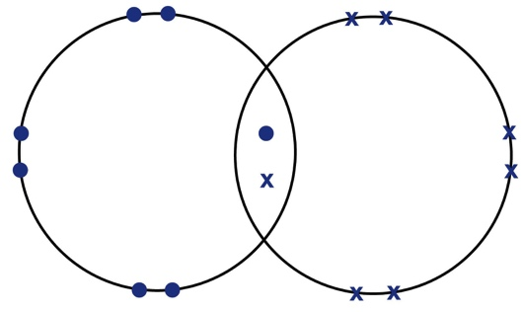  Complete the diagram to show the arrangement of electrons in the outer shells of a molecule of chlorine gas (Cl₂). [2 marks]
 | (ii) | What type of bond is formed between the two chlorine atoms?
 |  | Covalent
 | (iii) | Why is a chlorine molecule a gas at room temperature even though the bond that holds two chlorine atoms together is very strong? [1 mark]
 |  | Weak intermolecular forces/ weak forces between chlorine molecules
10 Different substances have different properties depending on what type of bond they contain, how strong their bonds are and how their bonds are arranged.
The diagrams show the structure of four different substances.
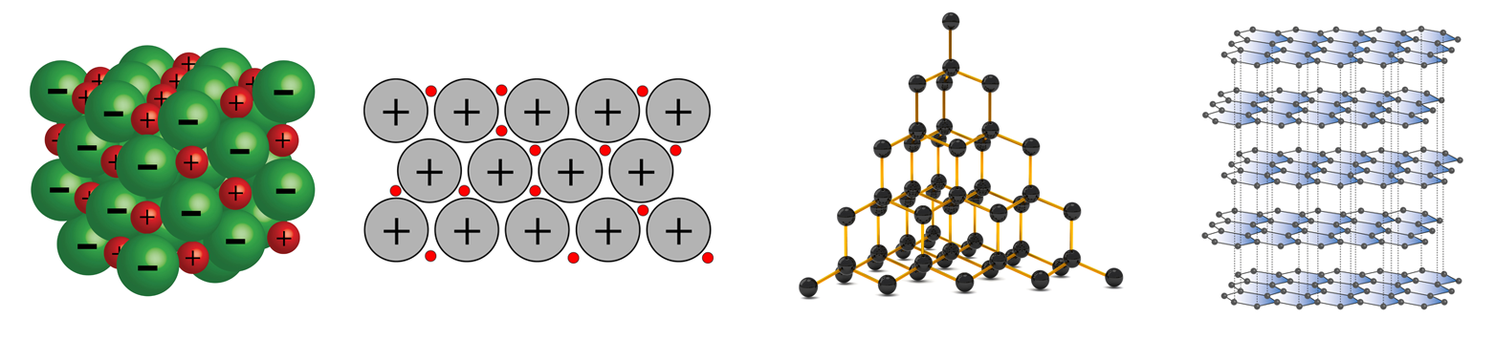
D
C
B
A
(a) | Which diagram or diagrams, A, B, C or D, shows:
 | (i) | A metallic structure [1 mark] | B
 | (ii) | A giant covalent structure [1 mark] | C and D
 | (iii) | An ionic compound [1 mark] | A

 | (iv) | Substances that can conduct electricity when solid [1 mark]
 |  | B and D
(b) | (i) | Substances C and D are forms of carbon.  Why is substance C very hard but substance D is soft? [3 marks]
In C each carbon atom forms four strong bonds with neighbouring (carbon) atoms in each/all directions
In D: (any 2 from)
the bonds within a layer are strong
the forces between layers are weak
layers can slide/move over each other

11 Stephen believes that all black felt pens contain the same dyes.
Carl believes that different brands of black felt pens contain different dyes.
They investigated what dyes were present in two brands of black felt pen using paper chromatography.
The diagram shows their results.
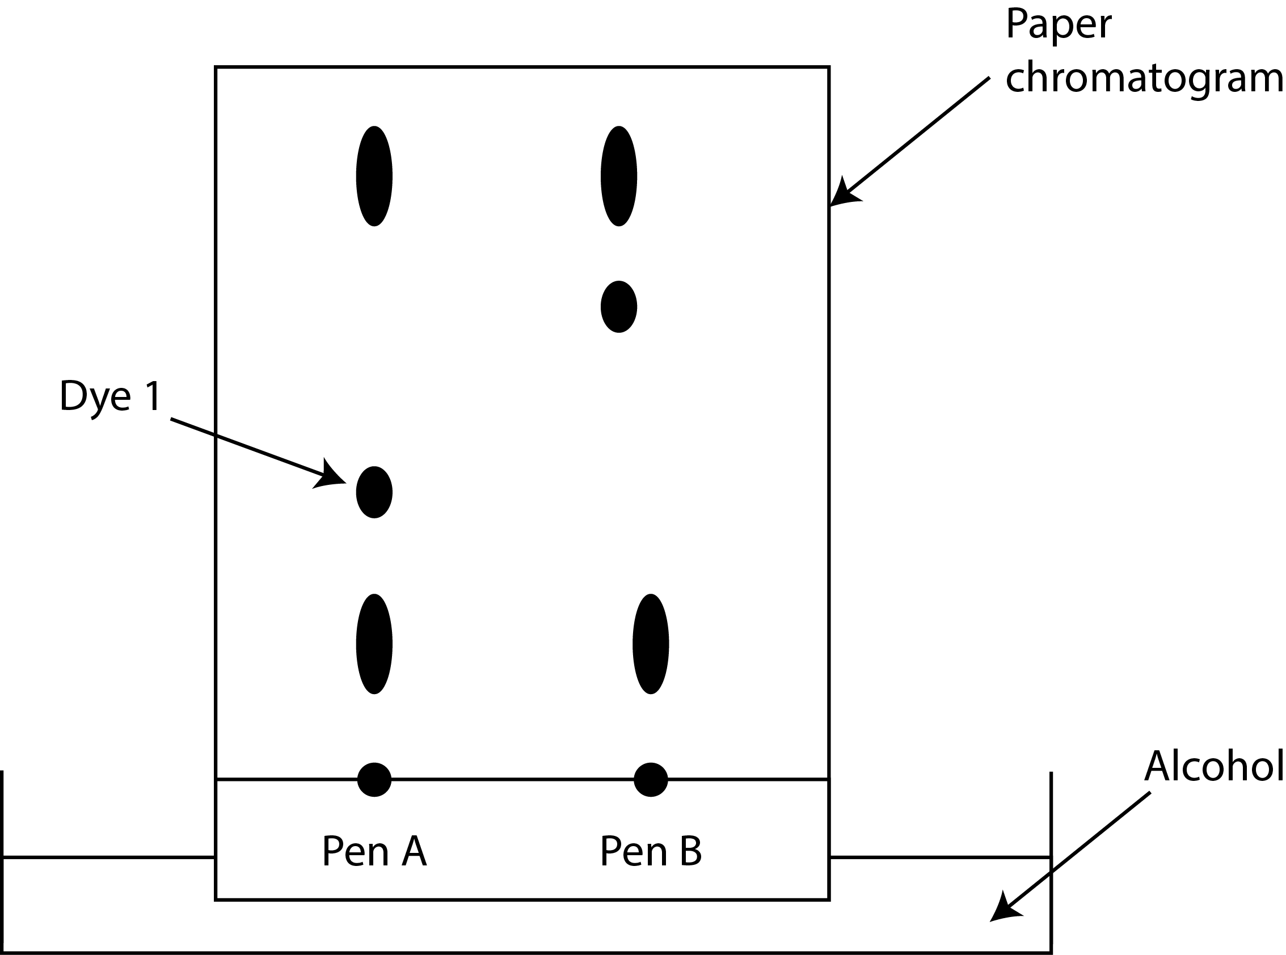

(a) | (i) | What is the stationary phase? [1 mark]
 |  | (Chromatography) paper
 | (ii) | What is the mobile phase? [1 mark]
 |  | Alcohol
 | (iii) | Why did Stephen and Carl draw the start line in pencil rather than in pen? [1 mark]
 |  | Pencil will not run/dissolve

(b) | (i) | The chromatogram shows that Carl was correct. The two black pens contain different dyes.  Which three other conclusions you can draw from their results? [3 marks]
Both pens contain 3 dyes
Both pens contain 2 dyes that are the same
Both pens have 1 dye that is different to the other
 | (ii) | Carl measured the distance dye 1 (labelled on the diagram) had travelled from the start line as being 1.5cm.  He also measured the distance the solvent travelled as 12 cm.  Using this information, find the Rf value for dye 1. [2 marks]
1.5/12
0.125
for correct answer if no working

12 A student investigated the time taken for a headache tablet to dissolve in water.
He put one tablet in 100 ml of water at room temperature and timed how long it took to dissolve completely. He repeated this a second time and calculated the average time taken.
He then cut a tablet in half and put both halves in 100 ml of water and timed how long it took for both halves to dissolve.
He repeated this for a tablet cut into quarters and again for a tablet cut into eighths.
The table shows his results.
Size of tablet particles | Time taken to dissolve (seconds)
 | Repeat 1 | Repeat 2 | Average
Full | 77 | 73 | 75
Half | 28 | 29
Quarter | 20 | 20 | 20
Eighth | 15 | 17 | 16

(a) | (i) | What is the average time taken for the tablet cut in half to dissolve? [1 mark]
 |  | 28.5

 | (ii) | Use the results to draw a graph of time taken for the tablet to dissolve against size of tablet particles.  Draw a curve of best fit for the points you have plotted. [4 marks]  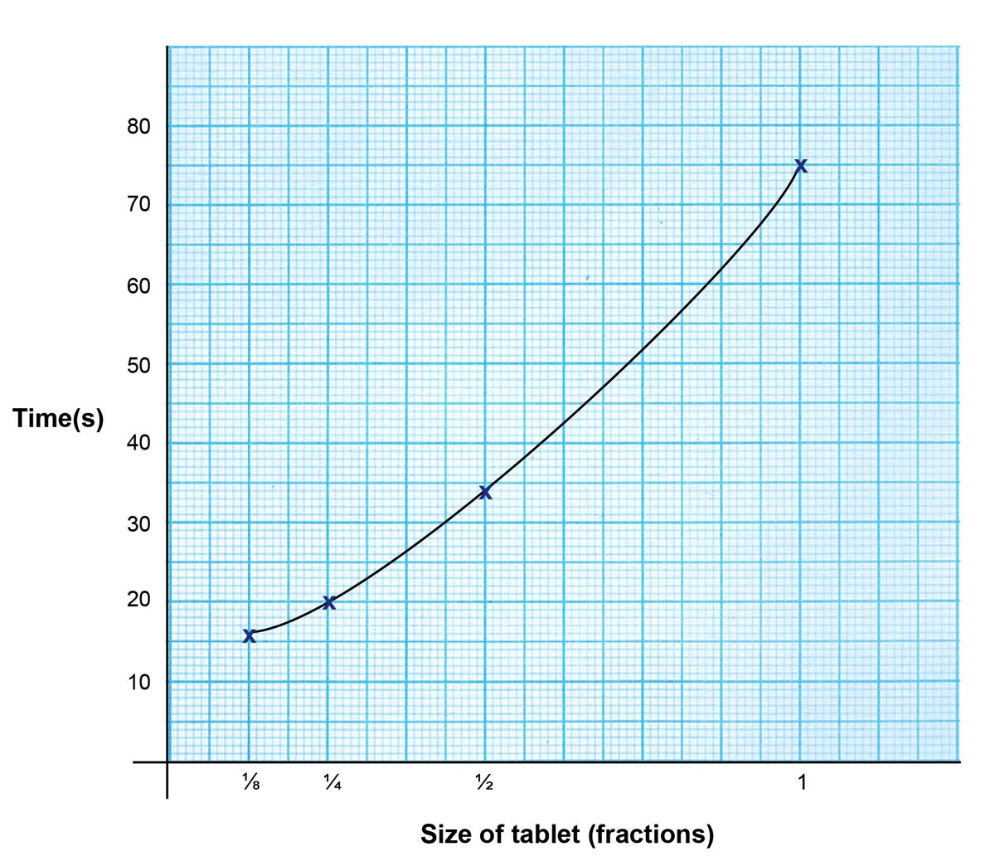
Correct axis:
X axis = size of tablet (fractions)
and
Y axis = time taken (seconds/s)
Correct scale for both axis
Correct plotting of all points
Correctly drawn curve of best fit

(b) | (i) | What is the trend shown by the results? [1 mark]
 |  | The smaller the particle the quicker it dissolved/the faster the reaction
 | (ii) | Why has this happened? [1 mark]
 |  | Smaller particles have a larger surface area to volume ratio so more surface for the water to react with
(c) | (i) | How could the student have made his results more reliable? [1 mark]
 |  | More repeats
13 Nanotechnology is the use and control of substances called nanoparticles.
Silver nanoparticles have a range of uses such as catalysts and killing bacteria on surgical instruments.
(a) | (i) | Put the following in order of size from smallest to largest. [1 mark]  A Silver nanoparticle  B Human cell  C Silver atom  D Bacterium  Smallest C D A B Largest
 | (ii) | In 1999 a new bandage for serious wounds was launched.  It contains silver nanoparticles that dissolve very quickly when they come into contact with moisture such as blood.  Why are silver nanoparticles used in the wound dressing instead of ordinary silver? [2 marks]
(silver nanoparticles) have a larger surface area to volume ratio
They dissolve into the blood quicker

 | (iii) | Titanium oxide is used in white household paint as it reflects light.  Titanium oxide nanoparticles absorb UV radiation so are often used in sun cream.  They absorb and scatter visible light meaning they are invisible to the naked eye.  Why is this property of benefit in sun cream? [1 mark]
 |  | The sun cream appears colourless

(b) | Some doctors are concerned that nanoparticles could cause us harm.  Why would doctors be concerned? [2 marks]
Any two from:
Long term effects are not known
If breathed in they irritate/damage the throat/lungs
They may dissolve quickly in blood and move to organs such as the brain and harm them
They may accumulate in the body over time and become toxic
They may kill ‘good’/useful bacteria

14 The diagrams show the particles in a variety of elements, mixtures and compounds.
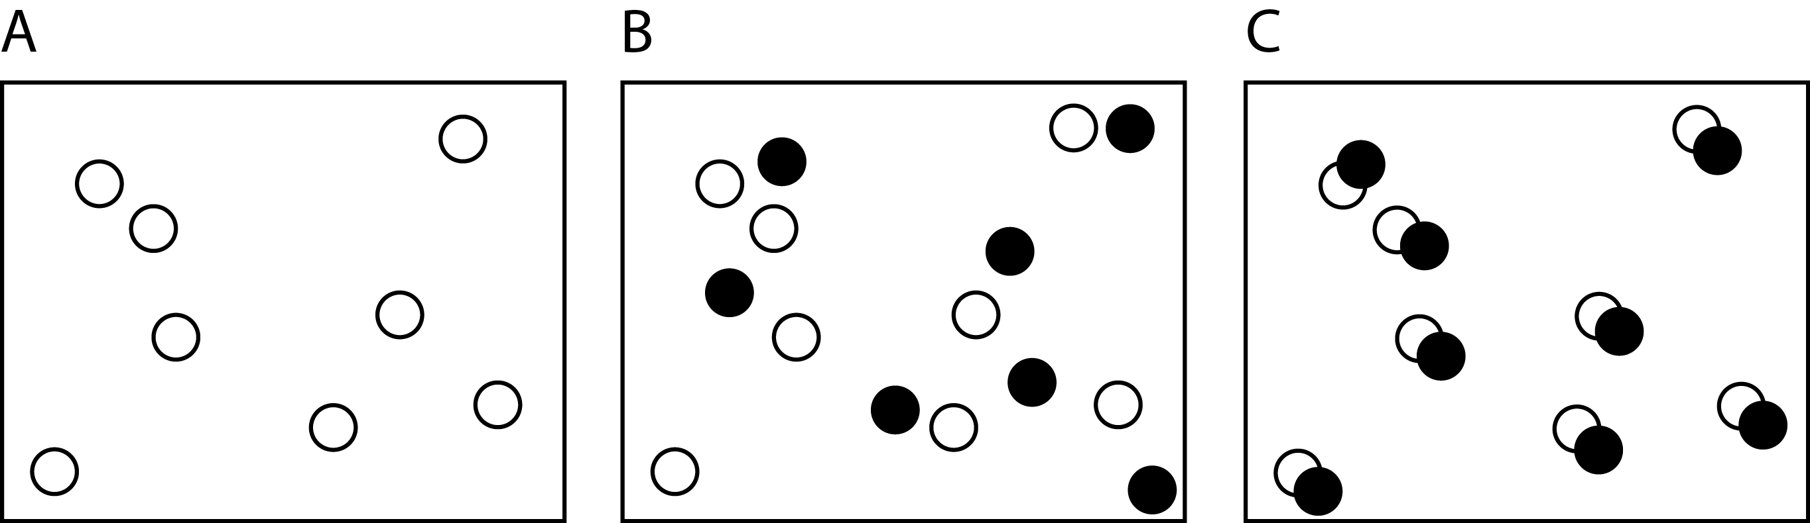
 | (a) | (i) | Which diagram shows a mixture? [1 mark]
 |  |  | B
 | (b) | (i) | A student does an experiment to separate pure salt from a mixture of salt and sand.  The first stage of the method he uses is below.  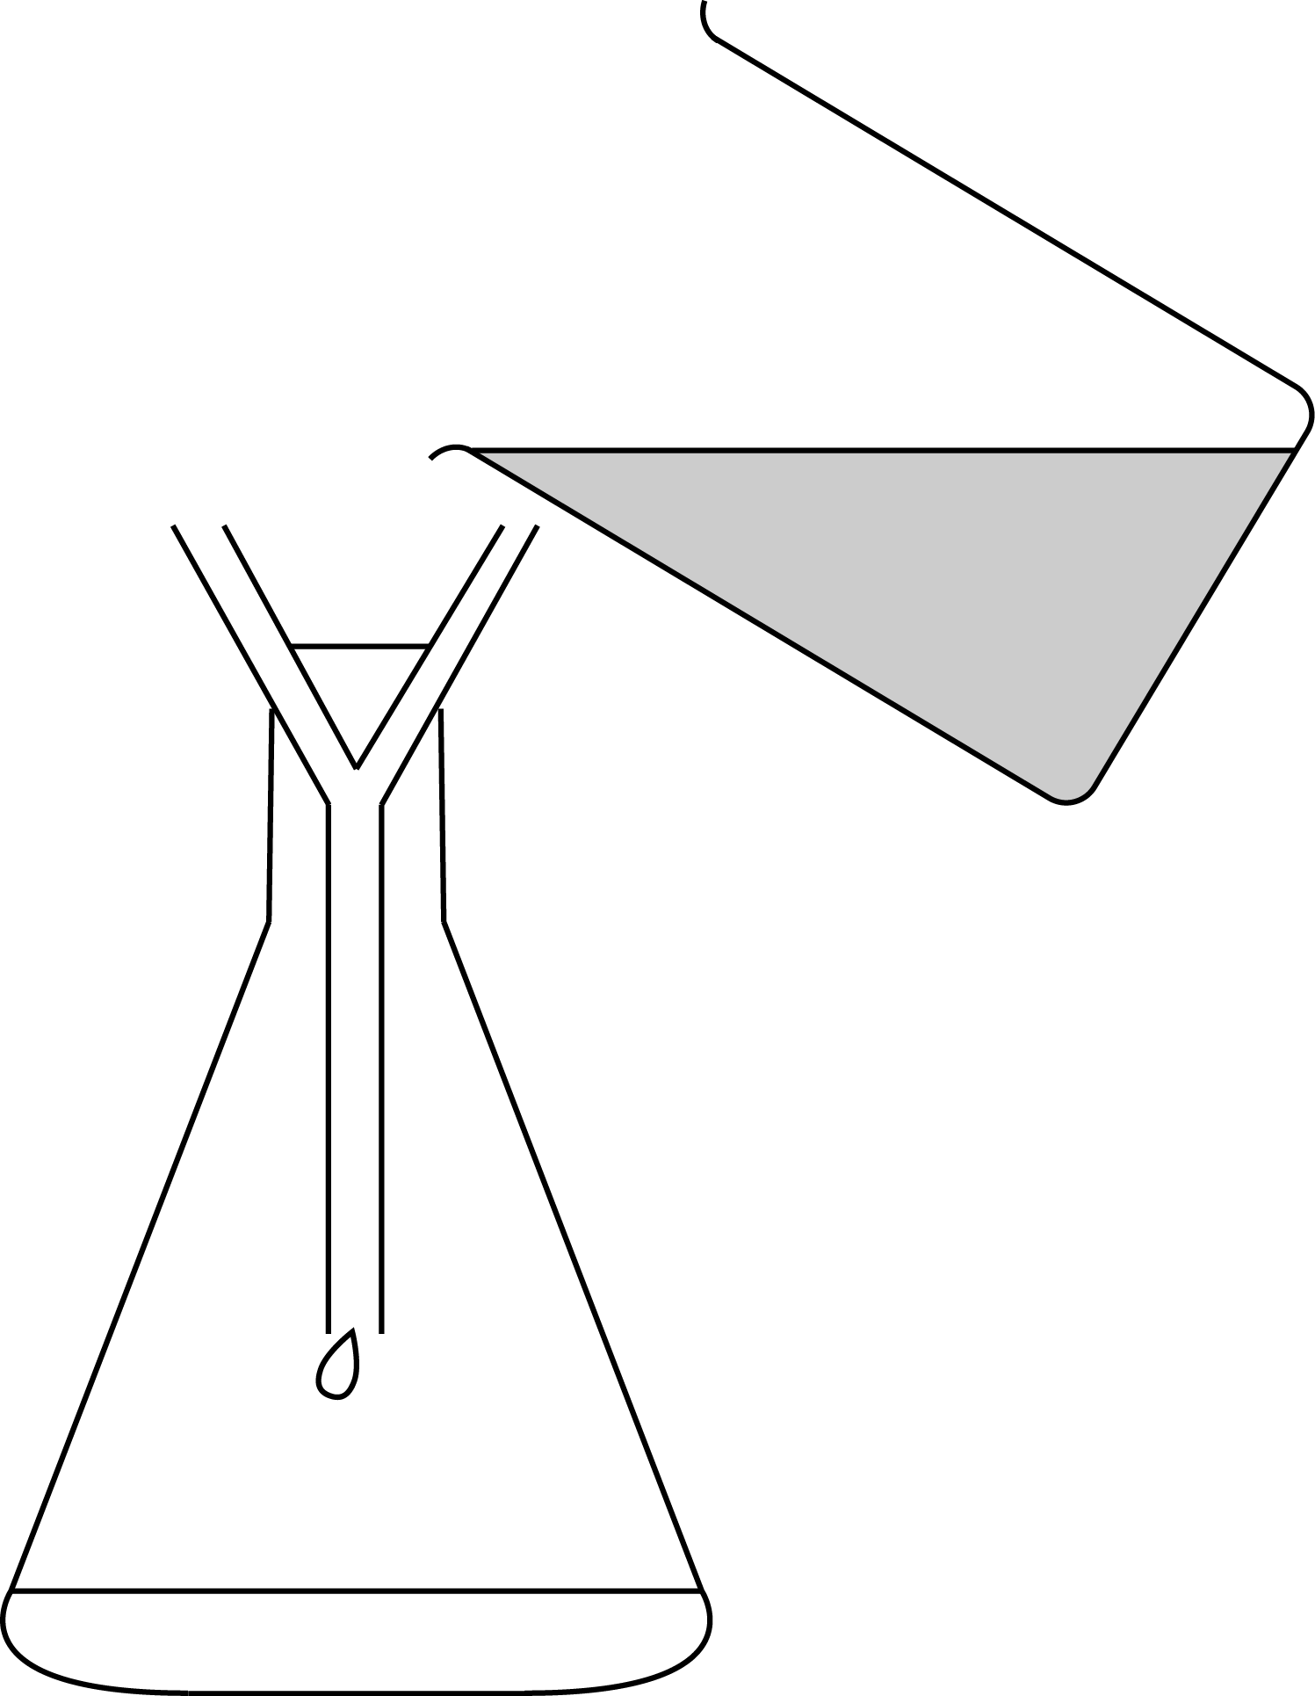  Mix 5g of salt and sand mixture with 50cm³ of water and stir.  Use filter paper and a funnel to filter the sand, salt and water mixture into a conical flask.

 |  | (i) | Why does the student use this first stage of his method? [2 marks]
To dissolve the salt
To separate out/remove the sand

 |  | (ii) | What name do we give the salt solution that has passed through the filter paper? [1 mark]
 |  |  | Filtrate
 |  | (iii) | The student needs to separate the salt from the water.  Write a method for how he can do this. [2 marks]
Pour the filtrate/salt solution into an evaporating basin, heat gently (with a Bunsen)
Let the damp salt cool and dry in a warm place
 |  | (iv) | What is the name of this final stage of separation? [1 mark]
 |  |  | Crystallisation
 | (c) | What technique would be used to separate a pure liquid from a mixture of liquids for example ethanol from a mixture of ethanol and water? [1 mark]
 |  | Distillation

15 There are 118 elements in the periodic table.
(a) | (i) | How is the position of an element in the periodic table related to the arrangement of electrons in its atoms? Use examples in your answer. [5 marks]
Arranged in order of atomic/proton number
The number of electrons in the outer shell are related to the group number
Example of element, number of outer electrons e.g. sodium has 1 outer electron and is in group 1
The number of shells/energy levels an atom has relates to the period the element is in
Example of element, number of shells and period e.g. chlorine has 3 electron shells and is in period 3
 | (ii) | A Russian scientist called Dimitri Mendeleev organised elements into the first known ‘periodic’ table.  Using his method of organisation, iodine would be placed before tellurium in the periodic table however, Mendeleev realised that the chemical and physical properties of these two elements should have tellurium placed before iodine.  The modern periodic table has tellurium placed before iodine.  What was incorrect about the method Mendeleev used to organise the elements that has now been refined to form the modern periodic table? [2 marks]
(Mendeleev) used the relative atomic mass/mass number to organise elements (instead of atomic/proton number)
Iodine has a lower atomic mass than tellurium but Iodine has a bigger atomic/proton number than tellurium

We’d like to know your view on the resources we produce. Click ‘Like’ or ‘Dislike’ to send us an auto generated email about this resource. Add comments if you want to. Let us know how we can improve this resource or what else you need. Your email will not be used or shared for any marketing purposes.
Looking for another resource? There is now a quick and easy search tool to help find free resources for your qualification.
OCR is part of Cambridge Assessment, a department of the University of Cambridge.
For staff training purposes and as part of our quality assurance programme your call may be recorded or monitored.
Oxford Cambridge and RSA Examinations is a Company Limited by Guarantee. Registered in England. Registered office
The Triangle Building, Shaftesbury Road, Cambridge, CB2 8EA. Registered company number 3484466. OCR is an exempt charity.
OCR operates academic and vocational qualifications regulated by Ofqual, Qualifications Wales and CCEA as listed
in their qualifications registers including A Levels, GCSEs, Cambridge Technicals and Cambridge Nationals.
OCR provides resources to help you deliver our qualifications. These resources do not represent any particular teaching method we expect you to use. We update our resources regularly and aim to make sure content is accurate but please check the OCR website so that you have the most up to date version. OCR cannot be held responsible for any errors or omissions in these resources.
Though we make every effort to check our resources, there may be contradictions between published support and the specification, so it is important that you always use information in the latest specification. We indicate any specification changes within the document itself, change the version number and provide a summary of the changes. If you do notice a discrepancy between the specification and a resource, please contact us.
© OCR 2021 - You can copy and distribute this resource freely if you keep the OCR logo and this small print intact and you acknowledge OCR as the originator of the resource.
OCR acknowledges the use of the following content: N/A
Whether you already offer OCR qualifications, are new to OCR or are thinking about switching, you can request more information using our Expression of Interest form.
Please get in touch if you want to discuss the accessibility of resources we offer to support you in delivering our qualifications.

End of topic quiz

Topic C1: Particles and C2: Elements, compounds and mixtures

Learner Activity

Topic: C1 and C2 of J248
Total marks: 80

1 The diagram shows the arrangement of atoms in a molecule.

What type of molecule could this be? [1 mark]
A | A metal
B | An ionic compound
C | A polymer
D | A giant covalent structure

Your answer

2 The diagram shows the mass number and atomic number for an isotope of the element bromine.

How many protons, neutrons and electrons does each atom of bromine have in this isotope? [1 mark]
A | 35 protons, 35 neutrons and 45 electrons
B | 45 protons, 35 neutrons and 45 electrons
C | 45 protons, 45 neutrons and 35 electrons
D | 35 protons, 45 neutrons and 35 electrons
Your answer

3 X₂CO₃ is a compound and has a relative formula mass of 106.
Use the periodic table to work out what element X is. [1 mark]
A | Sodium (Na)
B | Magnesium (Mg)
C | Lithium (Li)
D | Aluminium (Al)
Your answer

4 Which measurement is equal to 1 nanometre (nm)? [1 mark]
A | 0.000 000 001m
B | 0.000 001m
C | 0.001m
D | 0.1m

Your answer

5 What is the empirical formula for acetic acid? The structural formula is shown below. [1 mark]
A | C₂H₄O₂
B | C₂H₃HO₂
C | CH₂O
D | H₃C₂O₂H

Your answer
6 Atoms are made up of sub-atomic particles.
The diagram shows the structure of an atom.
(a) | (i) | Why does an atom have no overall charge? [2 marks]
 | (ii) | Why does a sodium ion have a positive charge? [1 mark]

(b) | The diagrams show the proton number and mass number for four atoms A, B, C and D.
 | (i) | Which atoms are isotopes of the same element? [1 mark]
 | (ii) | Which atoms have 20 neutrons in their nucleus? [1 mark]
 | (iii) | What is the electron configuration of element D? [1 mark]

 | (iv) | In the periodic table, in which group would element D be found? [1 mark]
 | (v) | What would the charge be on an ion of element A?  Why is this? [2 marks]

7 When ice is heated it will melt to form water.
The graph shows a heating curve for ice.
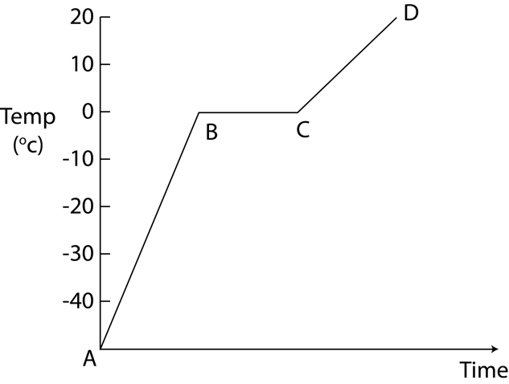
(a) | (i) | What happens to the water particles as the ice is heated between points A and B on the graph? [1 mark]
 | (ii) | What is happening to the water particles between points B and C on the graph? [3 marks]
 | (iii) | Melting ice is an example of a physical change.  What is meant by the term ‘physical change’? [1 mark]

(b) |  | Iron melts at a temperature of 1538ºC.  What does this suggest about the strength of the bonds between iron particles? Why is this? [2 marks]

8 Over time our understanding of the structure of an atom has changed.
The table shows a timeline of different scientists’ theories of atomic structure of the atom.

Date | Scientist | Theory | Image
1913 | Bohr
1911 | Rutherford | Planetary Model
1904 | Thomson | Plum-pudding Model
1800’s | Dalton | The smallest component of everything is the atom. It cannot be broken down in to anything simpler.  Atoms of a particular element are the same and atoms of different elements have different masses.

(a) | What is the plum-pudding model of the atom that Thomson proposed? [1 mark]
(b) | What is the planetary model of the atom that was proposed by Rutherford? [2 marks]
(c) | How was Bohr’s model of the atom different to Rutherford’s? [1 mark]

9 Metals and non-metals react to form ionic compounds.
(a) | (i) | Why is the formula for sodium chloride NaCl but the formula for Calcium chloride CaCl₂? [5 marks]
 | (ii) | Sodium chloride can conduct electricity when molten. Why does this happen? [1 mark]
(b) | (i) | A chlorine atom can also react with another chlorine atom to form chlorine gas.  Complete the diagram to show the arrangement of electrons in the outer shells of a molecule of chlorine gas (Cl₂). [2 marks]  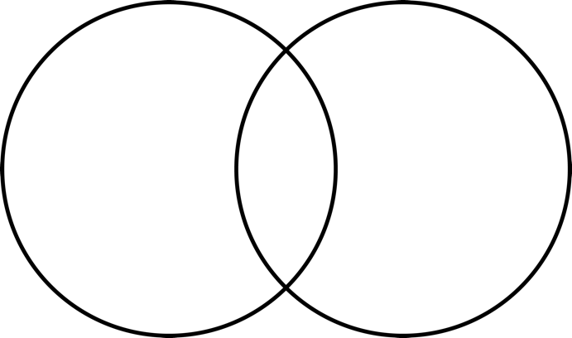
 | (ii) | What type of bond is formed between the two chlorine atoms?
 | (iii) | Why is a chlorine molecule a gas at room temperature even though the bond that holds two chlorine atoms together is very strong? [1 mark]
10 Different substances have different properties depending on what type of bond they contain, how strong their bonds are and how their bonds are arranged.
The diagrams show the structure of four different substances.
D
C
B
A

(a) | Which diagram or diagrams, A, B, C or D, shows:
 | (i) | A metallic structure [1 mark]
 | (ii) | A giant covalent structure [1 mark]
 | (iii) | An ionic compound [1 mark]
 | (iv) | Substances that can conduct electricity when solid [1 mark]

(b) | (i) | Substances C and D are forms of carbon.  Why is substance C very hard but substance D is soft? [3 marks]

11 Stephen believes that all black felt pens contain the same dyes.
Carl believes that different brands of black felt pens contain different dyes.
They investigated what dyes were present in two brands of black felt pen using paper chromatography.
The diagram shows their results.
(a) | (i) | What is the stationary phase? [1 mark]
 | (ii) | What is the mobile phase? [1 mark]
 | (iii) | Why did Stephen and Carl draw the start line in pencil rather than in pen? [1 mark]

(b) | (i) | The chromatogram shows that Carl was correct. The two black pens contain different dyes.  Which three other conclusions you can draw from their results? [3 marks]
 | (ii) | Carl measured the distance dye 1 (labelled on the diagram) had travelled from the start line as being 1.5cm.  He also measured the distance the solvent travelled as 12 cm.  Using this information, find the Rf value for dye 1. [2 marks]

12 A student investigated the time taken for a headache tablet to dissolve in water.
He put one tablet in 100 ml of water at room temperature and timed how long it took to dissolve completely. He repeated this a second time and calculated the average time taken.
He then cut a tablet in half and put both halves in 100 ml of water and timed how long it took for both halves to dissolve.
He repeated this for a tablet cut into quarters and again for a tablet cut into eighths.
The table shows his results.
Size of tablet particles | Time taken to dissolve (seconds)
 | Repeat 1 | Repeat 2 | Average
Full | 77 | 73 | 75
Half | 28 | 29
Quarter | 20 | 20 | 20
Eighth | 15 | 17 | 16

(a) | (i) | What is the average time taken for the tablet cut in half to dissolve? [1 mark]

 | (ii) | Use the results to draw a graph of time taken for the tablet to dissolve against size of tablet particles.  Draw a curve of best fit for the points you have plotted. [4 marks]

(b) | (i) | What is the trend shown by the results? [1 mark]

 | (ii) | Why has this happened? [1 mark]
(c) | (i) | How could the student have made his results more reliable? [1 mark]
13 Nanotechnology is the use and control of substances called nanoparticles.
Silver nanoparticles have a range of uses such as catalysts and killing bacteria on surgical instruments.
(a) | (i) | Put the following in order of size from smallest to largest. [1 mark]  A Silver nanoparticle  B Human cell  C Silver atom  D Bacterium  Smallest B Largest
 | (ii) | In 1999 a new bandage for serious wounds was launched.  It contains silver nanoparticles that dissolve very quickly when they come into contact with moisture such as blood.  Why are silver nanoparticles used in the wound dressing instead of ordinary silver? [2 marks]

 | (iii) | Titanium oxide is used in white household paint as it reflects light.  Titanium oxide nanoparticles absorb UV radiation so are often used in sun cream.  They absorb and scatter visible light meaning they are invisible to the naked eye.  Why is this property of benefit in sun cream? [1 mark]

(b) | Some doctors are concerned that nanoparticles could cause us harm.  Why would doctors be concerned? [2 marks]
14 The diagrams show the particles in a variety of elements, mixtures and compounds.
 | (a) | (i) | Which diagram shows a mixture? [1 mark]
 | (b) | (i) | A student does an experiment to separate pure salt from a mixture of salt and sand.  The first stage of the method he uses is below.  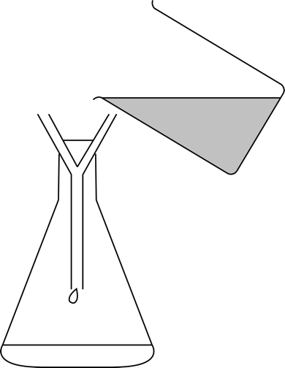  Mix 5g of salt and sand mixture with 50cm³ of water and stir.  Use filter paper and a funnel to filter the sand, salt and water mixture into a conical flask.

 |  | (i) | Why does the student use this first stage of his method? [2 marks]

 |  | (ii) | What name do we give the salt solution that has passed through the filter paper? [1 mark]
 |  | (iii) | The student needs to separate the salt from the water.  Write a method for how he can do this. [2 marks]
 |  | (iv) | What is the name of this final stage of separation? [1 mark]
 | (c) | What technique would be used to separate a pure liquid from a mixture of liquids for example ethanol from a mixture of ethanol and water? [1 mark]
15 There are 118 elements in the periodic table.
(a) | (i) | How is the position of an element in the periodic table related to the arrangement of electrons in its atoms? Use examples in your answer. [5 marks]
 | (ii) | A Russian scientist called Dimitri Mendeleev organised elements into the first known ‘periodic’ table.  Using his method of organisation, iodine would be placed before tellurium in the periodic table however, Mendeleev realised that the chemical and physical properties of these two elements should have tellurium placed before iodine.  The modern periodic table has tellurium placed before iodine.  What was incorrect about the method Mendeleev used to organise the elements that has now been refined to form the modern periodic table? [2 marks]

