End of topic quiz

Topic P2: Forces

Instructions and answers for teachers
These instructions cover the learner activity section which can be found on page 12. This end of topic quiz supports OCR GCSE (9–1) Physics A (J249), Topic P2.
When distributing the activity section to the learners either as a printed copy or as a Word file you will need to remove the teacher instructions section.

The Activity
This end of topic quiz is a teaching and learning resource comprised of 40 marks covering a range of question types. The quiz starts with some multiple choice questions (MCQs) and then moves on to some short answer questions and then finally on to some longer answer questions.
This resource can be used to test and consolidate understanding at the end of teaching the topic or to revisit and refresh knowledge at a later point in the course.

Learning Outcomes
This end of topic quiz relates to the specification learning outcomes in Topic P2: Forces. The questions in this quiz cover a range of the following topics:
P2.1 Motion
P2.2 Newton’s Law
P2.3 Forces in action

Topic: P2 of J249 - Answers
Total marks: 40
- Which of these arrows represents the weight of the child? [1 mark]
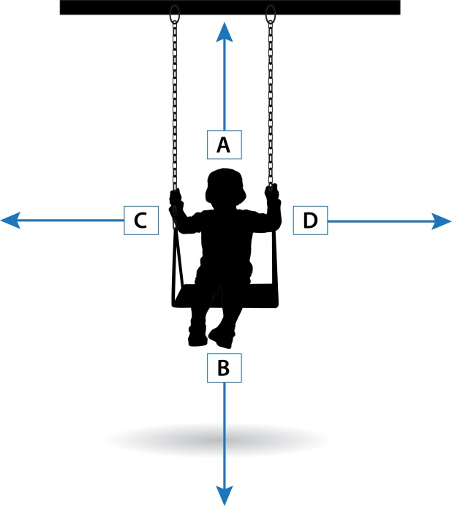

Your answer
B
- A toy car of 500 g is moving at 5 m/s. What is its kinetic energy at this point? [1 mark]
A | 6250 J
B | 12.5 J
C | 6.25 J
D | 12500 J
Your answer
C

- A cork is placed in a beaker of water as shown. Which of the following statements are true? [1 mark]

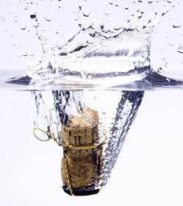

- The cork will sink.
- The cork will rise to the surface.
- The cork with stay in the same place.

A | a
B | b
C | c
D | None of the above
B
Your answer
- Jayne lifts the barbell 120 cm upwards. How much work does she do? [1 mark]
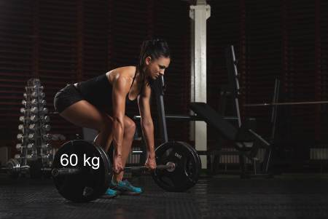
A | 7200 J
B | 72 J
C | 7.2 J
D | 720 J
Your answeYour answer
D

- Bob has a mass of 30 kg and is sitting 50 cm from the centre of the seesaw.
Steve has a mass of 60 kg, so where should he sit to ensure that the seesaw is in equilibrium? [1 mark]
A | 1 m from the centre on the right hand side.
B | 1 m from the centre on the left hand side.
C | 25 cm from the centre on the right hand side.
D | 25 cm from the centre on the left hand side.
Your answer
C
- The equipment above is provided in order to measure the average speed of a toy car going down a ramp.
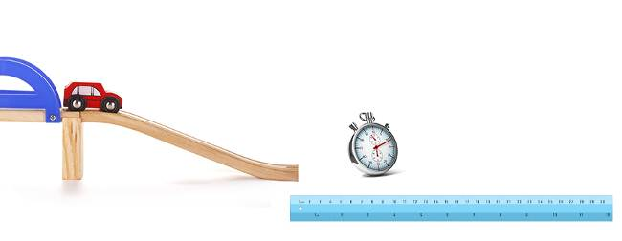
(a) | (i) | What two measurements should be made, using the equipment in the picture, in order to work out the average speed? [2 marks]
Length of ramp.
Time taken to cover that distance.
 | (ii) | Which equation would you use to do this? [1 mark]
 |  | Distance = speed x time
(b) |  | As the height of the ramp is increased, what will happen to the average speed of the toy car? [1 mark]
 |  | It will increase
- In each of these situations, what is the force providing attraction between the two objects?
(a) |  | A proton and an electron [1 mark]
 |  | Electrostatic
(b) |  | The Sun and Earth [1 mark]
 |  | Gravity
(c) |  | A compass needle and the North pole [1 mark]
 |  | Magnetism
(d) |  | You and your chair [1 mark]
 |  | Gravity/contact
- Tom has a weight of 600 N on Earth.

(a) |  | What is the difference between mass and weight? [2 marks]
Mass is the amount of substance/no. of atoms
Weight is the force acting on an object when it is placed in a gravitational field.
(b) |  | How much would Tom weigh on the Moon? (The gravitational field strength on the Moon is 1.7 N/kg) [2 marks]
600 ÷ 10 = 60 kg
60 x 1.7 = 102 N

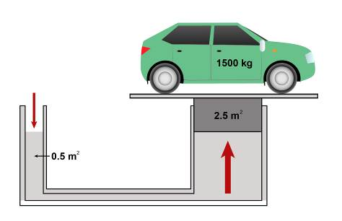
9.
(a) | (i) | The tube between the two pistons is filled with a liquid. Why is a liquid used in hydraulic systems? [1 mark]
 |  | It can be compressed
 | (ii) | What is the weight of the car? [1 mark]
 |  | Weight = 1500 x 10= 15000 N
(b) | (i) | What pressure is needed to lift the car? Give an appropriate unit.  [2 marks]
Pressure = 15000 ÷ 2.5
= 6000 Pa
 | (ii) | What force therefore needs to be applied to the smaller piston?  [1 mark]
 |  | 6000 x 0.5 = 3000 N
- Here is the experimental data collected when a set of masses were hung from a spring.
Force (N): | 1 | 2 | 3 | 4 | 5 | 6 | 7 | 8
Extension (m): | 0.1 | 0.2 | 0.3 | 0.4 | 0.5 | 0.6 | 0.7 | 0.8

(a) | (i) | Using this data, plot a graph of force against extension. [4 marks]
Force plotted on the y axes with units
Extension plotted on the x axes with units.
Points plotted to within 2 mm of correct spot (allow one incorrect with losing mark)
Line of best fit drawn going through the majority of points.

 | (ii) | What was the largest mass hung from the spring? [1 mark]
 |  | 800 g
(b) | (i) | Work out the gradient of the graph. [2 marks]
Data taken from graph
Gradient is 10
 | (ii) | Write down the spring constant of the spring, including the unit.  [1 mark]
 |  | 10 N/m

- Car A has a mass of 1500 kg and is travelling at a speed of 25 m/s. Car B has a mass of 1000 kg and is stationary.
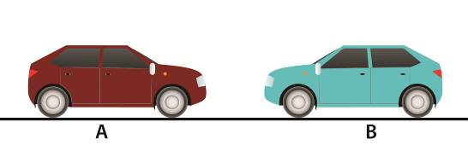
(a) | (i) | What is the momentum of car A? Include units. [2 marks]
37 500
kgm/s
 | (ii) | What is the momentum of car B? [1 mark]
 |  | 0
(b) |  | Car A collides with, and sticks to, car B. Assuming momentum is conserved, what is their combined speed after collision? [3 marks]
Total mass = 2500 kg
Momentum afterwards = momentum before
Speed = 37500 ÷ 2500 = 15 m/s

(c) | (i) | What is the kinetic energy before the collision? [1 mark]
 |  | KE = 0.5 x 1500 x 25²= 470000 J
 | (ii) | What is the kinetic energy after the collision? [1 mark]
 |  | KE = 0.5 x 2500 x 15²= 280000 J
 | (iii) | How much energy has been lost and how has it been lost? [2 marks]
190000J
It has been transferred to the surroundings as thermal energy

We’d like to know your view on the resources we produce. Click ‘Like’ or ‘Dislike’ to send us an auto generated email about this resource. Add comments if you want to. Let us know how we can improve this resource or what else you need. Your email will not be used or shared for any marketing purposes.
Looking for another resource? There is now a quick and easy search tool to help find free resources for your qualification.
OCR is part of Cambridge Assessment, a department of the University of Cambridge.
For staff training purposes and as part of our quality assurance programme your call may be recorded or monitored.
Oxford Cambridge and RSA Examinations is a Company Limited by Guarantee. Registered in England. Registered office
The Triangle Building, Shaftesbury Road, Cambridge, CB2 8EA. Registered company number 3484466. OCR is an exempt charity.
OCR operates academic and vocational qualifications regulated by Ofqual, Qualifications Wales and CCEA as listed
in their qualifications registers including A Levels, GCSEs, Cambridge Technicals and Cambridge Nationals.
OCR provides resources to help you deliver our qualifications. These resources do not represent any particular teaching method we expect you to use. We update our resources regularly and aim to make sure content is accurate but please check the OCR website so that you have the most up to date version. OCR cannot be held responsible for any errors or omissions in these resources.
Though we make every effort to check our resources, there may be contradictions between published support and the specification, so it is important that you always use information in the latest specification. We indicate any specification changes within the document itself, change the version number and provide a summary of the changes. If you do notice a discrepancy between the specification and a resource, please contact us.
© OCR 2021 - You can copy and distribute this resource freely if you keep the OCR logo and this small print intact and you acknowledge OCR as the originator of the resource.
OCR acknowledges the use of the following content: Page 2/12: Child on a swing – Renata Suman/Shutterstock.com, Page 3/13: cork under water – Crisp/Shutterstock.com, Page 4/14: woman with barbell – markos86/Shutterstock.com, Page 5/15: children on see-saw – eladora/Shutterstock.com, Rawpixel/Shutterstock.com, Page 6/16: toy car, ruler and stopwatch – Ostancov Vladislav/Shutterstock.com, koya979/Shuterstock.com, Alhovic/Shutterstock.com, Page 9/19: Blue graph paper – Stephen Rees/Shutterstock.com
Whether you already offer OCR qualifications, are new to OCR or are thinking about switching, you can request more information using our Expression of Interest form.
Please get in touch if you want to discuss the accessibility of resources we offer to support you in delivering our qualifications.

End of topic quiz

Topic P2: Forces

Learner Activity

Topic: P2 of J249
Total marks: 40

- Which of these arrows represents the weight of the child? [1 mark]

Your answer

- A toy car of 500 g is moving at 5 m/s. What is its kinetic energy at this point? [1 mark]
A | 6250 J
B | 12.5 J
C | 6.25 J
D | 12500 J
Your answer

- A cork is placed in a beaker of water as shown. Which of the following statements are true? [1 mark]
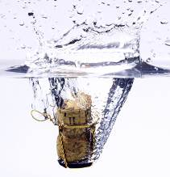

- The cork will sink.
- The cork will rise to the surface.
- The cork with stay in the same place.
A | a
B | b
C | c
D | None of the above
Your answer
- Jayne lifts the barbell 120 cm upwards. How much work does she do? [1 mark]
A | 7200 J
B | 72 J
C | 7.2 J
D | 720 J
Your answeYour answer

- Bob has a mass of 30 kg and is sitting 50 cm from the centre of the seesaw.
Steve has a mass of 60 kg, so where should he sit to ensure that the seesaw is in equilibrium? [1 mark]
A | 1 m from the centre on the right hand side.
B | 1 m from the centre on the left hand side.
C | 25 cm from the centre on the right hand side.
D | 25 cm from the centre on the left hand side.
Your answer

- The equipment above is provided in order to measure the average speed of a toy car going down a ramp.
(a) | (i) | What two measurements should be made, using the equipment in the picture, in order to work out the average speed? [2 marks]
 | (ii) | Which equation would you use to do this? [1 mark]
(b) |  | As the height of the ramp is increased, what will happen to the average speed of the toy car? [1 mark]
- In each of these situations, what is the force providing attraction between the two objects?
(a) |  | A proton and an electron [1 mark]
(b) |  | The Sun and Earth [1 mark]
(c) |  | A compass needle and the North pole [1 mark]
(d) |  | You and your chair [1 mark]
- Tom has a weight of 600 N on Earth.

(a) |  | What is the difference between mass and weight? [2 marks]
(b) |  | How much would Tom weigh on the Moon? (The gravitational field strength on the Moon is 1.7 N/kg) [2 marks]

9.
(a) | (i) | The tube between the two pistons is filled with a liquid. Why is a liquid used in hydraulic systems? [1 mark]
 | (ii) | What is the weight of the car? [1 mark]
(b) | (i) | What pressure is needed to lift the car? Give an appropriate unit.  [2 marks]
 | (ii) | What force therefore needs to be applied to the smaller piston?  [1 mark]
- Here is the experimental data collected when a set of masses were hung from a spring.
Force (N): | 1 | 2 | 3 | 4 | 5 | 6 | 7 | 8
Extension (m): | 0.1 | 0.2 | 0.3 | 0.4 | 0.5 | 0.6 | 0.7 | 0.8

(a) | (i) | Using this data, plot a graph of force against extension. [4 marks]

 | (ii) | What was the largest mass hung from the spring? [1 mark]

(b) | (i) | Work out the gradient of the graph. [2 marks]
 | (ii) | Write down the spring constant of the spring, including the unit.  [1 mark]

- Car A has a mass of 1500 kg and is travelling at a speed of 25 m/s. Car B has a mass of 1000 kg and is stationary.
(a) | (i) | What is the momentum of car A? Include units. [2 marks]
 | (ii) | What is the momentum of car B? [1 mark]

(b) |  | Car A collides with, and sticks to, car B. Assuming momentum is conserved, what is their combined speed after collision? [3 marks]
(c) | (i) | What is the kinetic energy before the collision? [1 mark]
 | (ii) | What is the kinetic energy after the collision? [1 mark]
 | (iii) | How much energy has been lost and how has it been lost? [2 marks]

