Quiz ‒ Topic P2 Forces

Instructions and answers for teachers

These instructions cover the learner activity section which can be found on page 8. This quiz supports OCR GCSE (9-1) Gateway Science Physics A, J249.
When distributing the activity section to the learners either as a printed copy or as a Word file you will need to remove the teacher instructions section.

The Activity
This quiz is a teaching and learning resource containing 10 multiple choice questions on the theme of Forces.
This resource can be used to test and consolidate understanding at the end of a topic or to revisit and refresh knowledge at a later point in the course.

Learning Outcomes
This lesson element relates to the specification learning outcomes of
P2.1 – Motion
P2.2 – Newton’s laws
P2.3 – Forces in action

Introduction
Multiple choice questions allow rapid coverage of a wide range of sub-topics.
Contrary to a widespread belief among learners, multiple choice questions are not necessarily easy – they can be easy, moderate or difficult.
The questions are written so that the incorrect answers are plausible distractors based on common errors or misconceptions.

Quiz ‒ answers

1 |  | Which of these is the correct formula for acceleration? [1]
 |  | A | Change in velocity x time
 |  |  | Incorrect
 |  | B | Change in velocity ÷ time
 |  |  | Correct answer - acceleration = change in velocity/time
 |  | C | Velocity x time taken
 |  |  | Incorrect
 |  | D | Velocity ÷ time taken
Incorrect
B
 | Your answer

2 |  | The end of a syringe containing fluid is pushed in. The area of the plunger of the syringe is 0.5 cm². What is the pressure exerted on the fluid? [1]  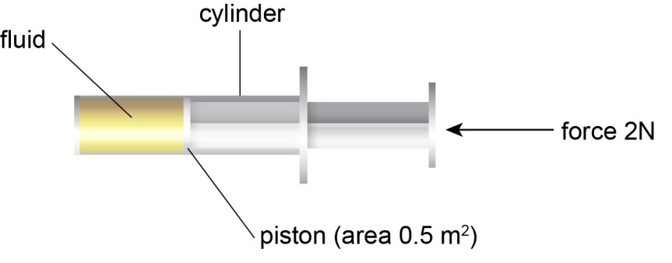
 |  | A | 4 x 10⁴ Pa
 |  |  | Correct answer - calculation using the equation pressure = force/area = 2 x 0.00005 = 40000
 |  | B | 1 x 10^{–4} Pa
 |  |  | Incorrect – pressure ≠ force x area
 |  | C | 4 Pa
 |  |  | Incorrect – pressure = force/area but area not converted into m²
 |  | D | 1 Pa
Incorrect – pressure ≠ force x area (area not converted into m²)
A
 | Your answer

3 |  | An athlete runs a 100 m race in 11 seconds. What is their speed? [1]
 |  | A | 9.1 m/s
 |  |  | Correct answer - Calculation using the equation speed = distance/time = 100/11 = 9.1 m/s
 |  | B | 1100 m/s
 |  |  | Incorrect- s ≠ d x t
 |  | C | 0.11 m/s
 |  |  | Incorrect- s ≠ t/d
 |  | D | 89 m/s
Incorrect- s ≠ d-t
A
 | Your answer

4 |  | Two forces act on an object as shown in the diagram below.  What is the resultant force acting on the object? [1]
 |  | A | 25N
 |  |  | Incorrect - resultant Force (the force that causes the acceleration of the object) ≠ 25N the greatest force
 |  | B | 15N
 |  |  | Incorrect - resultant Force (the force that causes the acceleration of the object) ≠ 15N the smallest force
 |  | C | 40N
 |  |  | Incorrect - resultant Force (the force that causes the acceleration of the object) not ≠ 25N+15N =40N as the two forces are in opposite directions
 |  | D | 10N
Correct answer - resultant Force (the force that causes the acceleration of the object) = 25N-15N =10N as the two forces are in opposite directions
D
 | Your answer

5 |  | A train accelerates from 10 m/s to 50 m/s in 20 seconds.  What is the train’s acceleration?[1]
 |  | A | 2 m/s²
 |  |  | Correct answer - acceleration = Change in Velocity/Time = (50 – 10)/20
 |  | B | 2.5 m/s²
 |  |  | Incorrect-acceleration ≠ final velocity ÷ time
 |  | C | 800 m/s²
 |  |  | Incorrect- acceleration ≠ change in velocity x time
 |  | D | 1000 m/s²
Incorrect - acceleration ≠ final velocity x time
A
 | Your answer

6 |  | Which statement about mass and weight is true?[1]
 |  | A | Mass is a force and weight is a quantity.
 |  |  | Incorrect - weight is a force due to gravity, mass is a quantity (it is the amount of a substance).
 |  | B | Mass and weight are both forces.
 |  |  | Incorrect - weight is a force but mass is a quantity
 |  | C | Mass and weight are both quantities.
 |  |  | Incorrect - weight is a force due to gravity
 |  | D | Mass is a quantity and weight is a force.
Correct answer - mass is a quantity and weight is a force due to gravity
D
 | Your answer

7 |  | Which part of the velocity-time graph below shows the object moving at a constant speed?[1]
 |  | 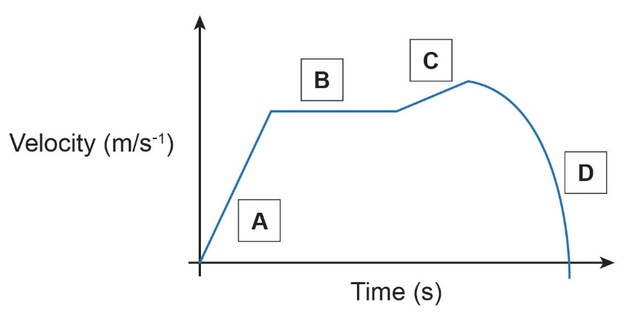
 |  | A | Incorrect- line of increasing gradient on the graph shows the object is increasing in velocity (accelerating).
 |  | B | Correct answer - horizontal line on the graph shows the object is moving at constant velocity (velocity does not change).
 |  | C | Incorrect -this line shows object is increasing in velocity (accelerating but acceleration is less than A as the gradient is less steep).
 |  | D | Incorrect -this line shows that the object is decelerating (curved line indicates deceleration is not constant).  B
 | Your answer

8 |  | On Mars the strength of gravity is 4 m/s².  What is the weight of a 60 kg astronaut on Mars? [1]
 |  | A | 60 N
 |  |  | Incorrect- has not taken the gravity on Mars into account
 |  | B | 240 kg
 |  |  | Incorrect - weight is a force due to gravity so measured in Newtons not kg
 |  | C | 15 N
 |  |  | Incorrect – weight ≠ mass/gravity
 |  | D | 240 N
 |  |  | Correct answer – weight = mass x gravity 60 x 4
 | Your answer
D
9 |  | A car is travelling at a constant velocity of 17.0 m/s. The car has a mass of 995.0 kg.  What is the momentum of the car? [1]
 |  | A | 58.5 kgm/s
 |  |  | Incorrect – momentum ≠ mass/velocity
 |  | B | 0.017 kgm/s
 |  |  | Incorrect – momentum ≠ velocity/mass
 |  | C | 16915.0 kgm/s
 |  |  | Correct answer – momentum = mass x velocity = 995 x 17
 |  | D | 17.0 kgm/s
Incorrect – momentum ≠ velocity
C
 | Your answer

10 |  | A vehicle and driver with a total mass of 1000 kg is travelling at 20m/s.  The driver applies the brake and the vehicle comes to a stop in 4 seconds.  What is the mean force on the vehicle?[1]
 |  | A | 80000 N
 |  |  | Incorrect – incorrect calculation of acceleration, acceleration ≠ 20 x 4
 |  | B | 5000 N
 |  |  | Correct answer - force = mass x acceleration, acceleration = velocity /time = 20/4 = 5, so force = 1000 x 5
 |  | C | 200 N
 |  |  | Incorrect- force ≠ m/a
 |  | D | 20000 N
Incorrect- force ≠ m x v
B
 | Your answer

We’d like to know your view on the resources we produce. Click ‘Like’ or ‘Dislike’ to send us an auto generated email about this resource. Add comments if you want to. Let us know how we can improve this resource or what else you need. Your email will not be used or shared for any marketing purposes.
Looking for another resource? There is now a quick and easy search tool to help find free resources for your qualification.
OCR is part of Cambridge Assessment, a department of the University of Cambridge.
For staff training purposes and as part of our quality assurance programme your call may be recorded or monitored.
Oxford Cambridge and RSA Examinations is a Company Limited by Guarantee. Registered in England. Registered office
The Triangle Building, Shaftesbury Road, Cambridge, CB2 8EA. Registered company number 3484466. OCR is an exempt charity.
OCR operates academic and vocational qualifications regulated by Ofqual, Qualifications Wales and CCEA as listed
in their qualifications registers including A Levels, GCSEs, Cambridge Technicals and Cambridge Nationals.
OCR provides resources to help you deliver our qualifications. These resources do not represent any particular teaching method we expect you to use. We update our resources regularly and aim to make sure content is accurate but please check the OCR website so that you have the most up to date version. OCR cannot be held responsible for any errors or omissions in these resources.
Though we make every effort to check our resources, there may be contradictions between published support and the specification, so it is important that you always use information in the latest specification. We indicate any specification changes within the document itself, change the version number and provide a summary of the changes. If you do notice a discrepancy between the specification and a resource, please contact us.
© OCR 2021 - You can copy and distribute this resource freely if you keep the OCR logo and this small print intact and you acknowledge OCR as the originator of the resource.
OCR acknowledges the use of the following content: N/A
Whether you already offer OCR qualifications, are new to OCR or are thinking about switching, you can request more information using our Expression of Interest form.
Please get in touch if you want to discuss the accessibility of resources we offer to support you in delivering our qualifications.

Quiz ‒ Topic P2 Forces

Learner Activity

1 |  | Which of these is the correct formula for acceleration? [1]
 |  | A | Change in velocity x time
 |  | B | Change in velocity ÷ time
 |  | C | Velocity x time taken
 |  | D | Velocity ÷ time taken
 | Your answer

2 |  | The end of a syringe containing fluid is pushed in. The area of the plunger of the syringe is 0.5 cm². What is the pressure exerted on the fluid? [1]  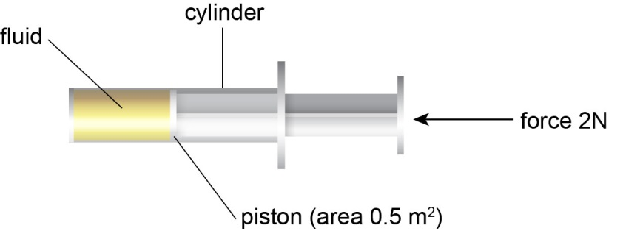
 |  | A | 4 x 10⁴ Pa
 |  | B | 1 x 10^{–4} Pa
 |  | C | 4 Pa
 |  | D | 1 Pa
 | Your answer

3 |  | An athlete runs a 100m race in 11 seconds. What is their speed?[1]
 |  | A | 9.1 m/s
 |  | B | 1100 m/s
 |  | C | 0.11 m/s
 |  | D | 89 m/s
 | Your answer

4 |  | Two forces act on an object as shown in the diagram below.  What is the resultant force acting on the object? [1]
 |  | A | 25N
 |  | B | 15N
 |  | C | 40N
 |  | D | 10N
 | Your answer

5 |  | A train accelerates from 10 m/s to 50 m/s in 20 seconds.  What is the train’s acceleration?[1]
 |  | A | 2 m/s²
 |  | B | 2.5 m/s²
 |  | C | 800 m/s²
 |  | D | 1000 m/s²
 | Your answer

6 |  | Which statement about mass and weight is true?[1]
 |  | A | Mass is a force and weight is a quantity.
 |  | B | Mass and weight are both forces.
 |  | C | Mass and weight are both quantities.
 |  | D | Mass is a quantity and weight is a force.
 | Your answer

7 |  | Which part of the velocity- time graph below shows the object moving at a constant speed?[1]
 | Your answer

8 |  | On Mars the strength of gravity is 4 m/s².  What is the weight of a 60kg astronaut on Mars? [1]
 |  | A | 60 N
 |  | B | 240 kg
 |  | C | 15 N
 |  | D | 240 N
 | Your answer

9 |  | A car is travelling at a constant velocity of 17.0 m/s. The car has a mass of 995.0 kg.  What is the momentum of the car? [1]
 |  | A | 58.5 kgm/s
 |  | B | 0.017 kgm/s
 |  | C | 16915.0 kgm/s
 |  | D | 17.0 kgm/s
 | Your answer

10 |  | A vehicle and driver with a total mass of 1000 kg is travelling at 20m/s.  The driver applies the brake and the vehicle comes to a stop in 4 seconds.  What is the mean force on the vehicle? [1]
 |  | A | 80000 N
 |  | B | 5000 N
 |  | C | 200 N
 |  | D | 20000 N
 | Your answer

