# Purposeful Practicals

# Microscopy (onion cells)

This Practical Pack is part of OCR's Purposeful Practicals. This resource can be used to contribute to PAG B1 and is referenced in the Practical Menu (B5). There are also accompanying Integrated Instructions for students to use.

## Aim

To prepare and observe an onion cell slide and produce a biological drawing of the cells observed. Students will use iodine solution to stain structures in the onion cells and use a light microscope to observe the visible structures.

Time required for activity: 60 minutes.

## Introduction

Light microscopes can be used to observe some of the cellular structures of plant cells. In this activity, students will prepare a temporary mount of a piece of onion epidermal tissue. They will use iodine solution as a stain, which will make the structures that they are observing clearer. Students will then use the light microscope to view the epidermal tissue and produce a biological drawing which will be labelled to identify the cellular structures that you can see.

## Specification theory content links

**Biology A J247**: B1.1a B1.1b

## Health and safety

| Hazards | Mitigations |
| --- | --- |
| Safety goggles iconDilute solutions of iodine will stain skin. | Use eye protection. |
| Hazard iconCuts from sharps/tweezers/mounted needle | Care should be taken when tweezers/mounted needle to transfer epidermis. |
| Hazard iconBright light source can damage eyes. | Always make sure there is a slide on the stage of a microscope before looking down the microscope. Do not look down the microscope without a slide on the stage. |
| Hazard iconCorners of slides/broken/damaged glass slides are sharp and can cut skin easily. | Corners of slides/broken/damaged glass slides are sharp and can cut skin easily. |

## Technician notes

Dilute iodine solutions below 1 M should be used. One onion per class should be sufficient.

## Equipment

* light microscope with light source
* onion
* tweezers or mounted needles (a sharp pencil could also be used)
* microscope slide
* cover slip
* dilute iodine solution (less than 1 M)



## Procedure and procedural understanding

|  |  |
| --- | --- |
| **Procedure: Preparing a slide** | **Understanding** |
| 1. Using tweezers carefully peel off a thin layer of epidermis from the onion. |  |
| 1. Using a pipette, add one drop of water to the centre of the slide. Lay the thin layer of epidermis on the microscope slide in a single flat layer. | Why is a thin layer of epidermis needed?  What would be observed if the layer was thick? |
| 1. Place 2 small drops of iodine on to the layer of epidermis. | Why is a small amount of iodine used?  What would happen if the amount of iodine used was too much or too little?  Which cell structures will the iodine stain and make visible? |
| 1. Carefully lower a cover slip on top of the layer of epidermis, taking care to make sure there are no air bubbles. | Why is a cover slip placed over the specimen and stain? |
| 1. Make sure that hands are washed with soap and water. |  |

**Fig. 1.1 A light microscope**

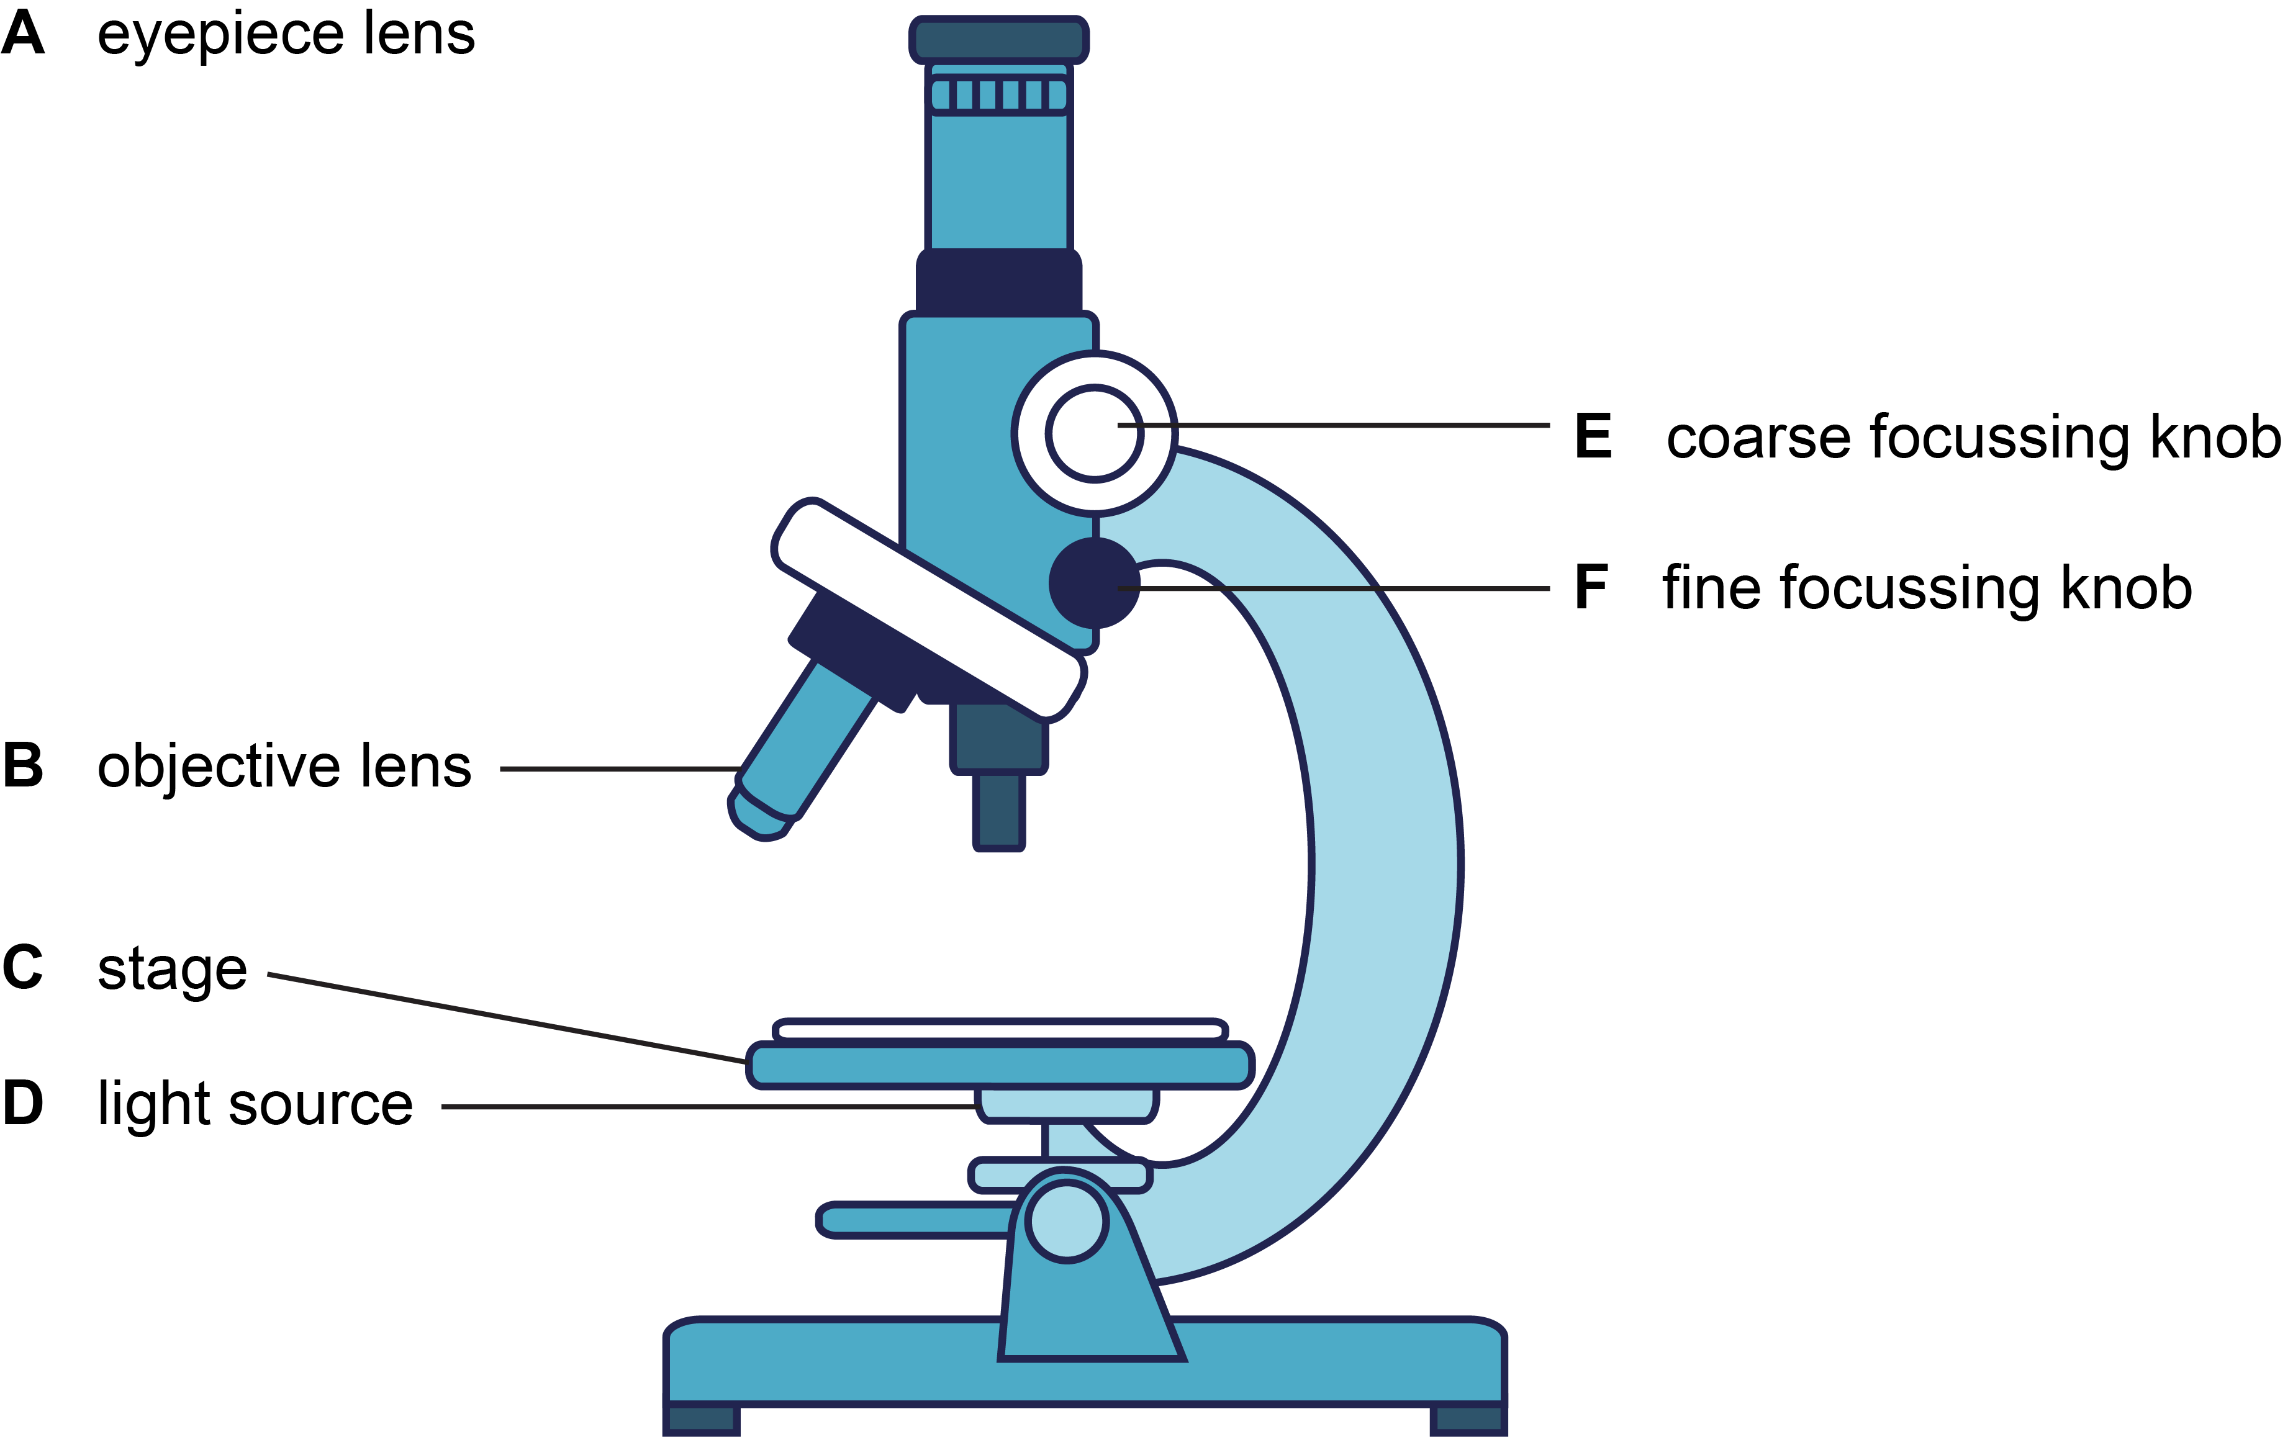

|  |  |
| --- | --- |
| **Procedure: Using a light microscope to observe cells** | **Understanding** |
| 1. Place the slide on the stage of the light microscope. |  |
| 1. Select the lowest power objective lens and make sure the specimen on the slide is directly beneath the objective lens. |  |
| 1. Looking from the side of the microscope, use the coarse focusing knob to raise the stage so the specimen and slide are just below the objective lens. Do not allow the lens to touch the slide. |  |
| 1. Look through the eye piece lens and carefully use the coarse focusing knob to focus the image. | When you turn the coarse focusing knob how does this help to focus the image? |
| 1. If further focusing is required use the fine focusing knob to make the image clearer. |  |
| 1. To see the image in more detail select a higher power objective lens and refocus using the focusing knobs if necessary (coarse then fine). | Which cell structures can you observe using the light microscope?  Why is the cell membrane not visible?  Why is the cell vacuole not visible?  Do onion epidermal cells have chloroplasts? |

|  |  |
| --- | --- |
| **Procedure: Biological drawings** | **Understanding** |
| 1. Select one cell from your field of view to draw. | What are the criteria for producing a good biological drawing? |
| 1. Produce a biological drawing of a single onion epidermal cell in the space below. 2. Label your drawing. | What are the criteria for producing a good biological drawing? |

Students can use this box for their draw their biological drawing.

## Further questions

A student placed a section of onion epidermis in a concentrated sugar solution. They left the onion tissue in the solution for several hours.

They then used a light microscope to observe the onion tissue. The image shows the cells they observed.

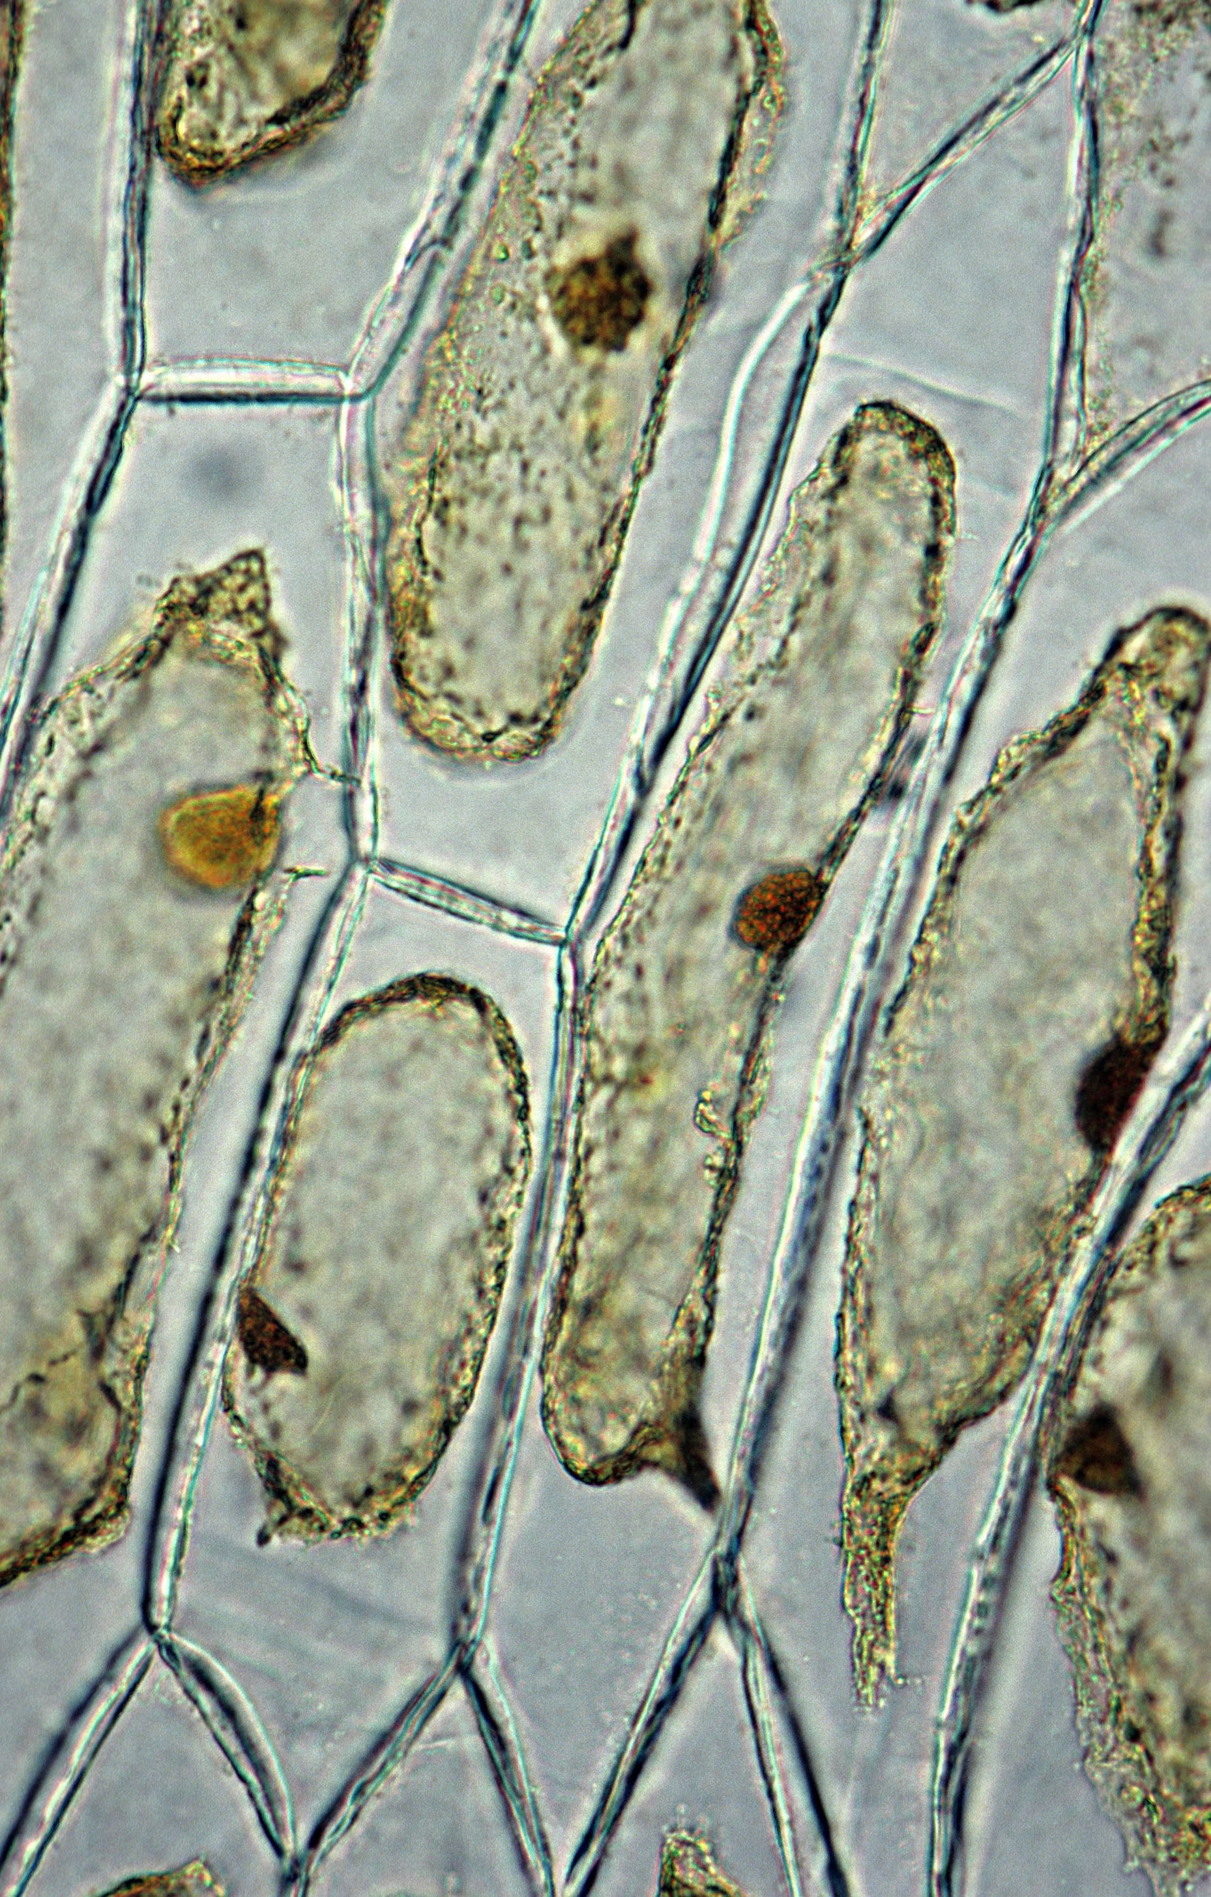

1. Describe how the onion cells look different from the onion cells you observed.
2. Which cell structure is now visible?
3. When producing a biological drawing, a total magnification factor must be included on the diagram. How is total magnification calculated?

## Answers

1. Two lines around the outside of the cell are now visible.
2. The cell membrane is now visible (water left the onion cells and this caused the cell membrane to move away from the cell wall – this is called plasmolysis)
3. Total magnification = eyepiece lens magnification × objective lens magnification.

### Practical skills, apparatus and techniques assessed

|  |  |  |
| --- | --- | --- |
| a | **Reference** | **Description of skill/technique** |
|  | 1- i | Use a **microscope** to make observations of biological specimens and produce **labelled scientific drawings**. |

## Scientific and practical understanding

### Light microscope

A type of microscope that uses light to produce an image

### Magnification

Use of a lens to make an object look larger

### Resolution

This is the ability to distinguish two parts that are close together.

### Epidermal tissue (onion)

Single layer of simple, transparent cells that provide a protective layer.

### Cell wall

Rigid outer layer that maintains the shape of the cells and provides strength and support.

### Nucleus

Large cell structure that contains the organisms genome and provides the instructions for protein synthesis

## Notes and references

Before carrying out any experiment or demonstration based on this guidance, it is the responsibility of teachers to make sure that they have undertaken a risk assessment in accordance with their employer’s requirements, making use of up-to-date information and taking account of their own particular circumstances. Any local rules or restrictions issued by the employer must always be followed. [CLEAPSS](http://science.cleapss.org.uk) resources are useful for carrying out risk-assessments. Centres should trial experiments in advance of giving them to students. Centres may choose to make adaptations to this practical activity. They should be aware that this may affect the apparatus and techniques covered by the student.

Please note – web links are correct at date of publication but other websites may change over time. If you have any problems with a link you may want to navigate to that organisation’s website for a direct search.



We’d like to know your view on the resources we produce. Click ‘[Like’](mailto:resources.feedback@ocr.org.uk?subject=I%20like%20GCSE%20(9-1)%20Biology%20A%20(Gateway%20Science)%20Purposeful%20Practicals%20Pack%20-%20Microscopy%20(onion%20cells)) or ‘[Dislike’](mailto:resources.feedback@ocr.org.uk?subject=I%20dislike%20GCSE%20(9-1)%20Biology%20A%20(Gateway%20Science)%20Purposeful%20Practicals%20Pack%20-%20Microscopy%20(onion%20cells)) to send us an auto generated email about this resource. Add comments if you want to. Let us know how we can improve this resource or what else you need. Your email will not be used or shared for any marketing purposes.

Looking for another resource? There is now a quick and easy search [tool to help find free resources](https://www.ocr.org.uk/qualifications/resource-finder/) for your qualification.

OCR is part of Cambridge University Press & Assessment, which is itself a department of the University of Cambridge.

For staff training purposes and as part of our quality assurance programme your call may be recorded or monitored. © OCR 2024 Oxford Cambridge and RSA Examinations is a Company Limited by Guarantee. Registered in England. Registered office The Triangle Building, Shaftesbury Road, Cambridge, CB2 8EA. Registered company number 3484466. OCR is an exempt charity.

OCR operates academic and vocational qualifications regulated by Ofqual, Qualifications Wales and CCEA as listed in their qualifications registers including A Levels, GCSEs, Cambridge Technicals and Cambridge Nationals.

OCR provides resources to help you deliver our qualifications. These resources do not represent any teaching method we expect you to use. We update our resources regularly and aim to make sure content is accurate but please check the OCR website so that you have the most up to date version. OCR cannot be held responsible for any errors or omissions in these resources.

Though we make every effort to check our resources, there may be contradictions between published support and the specification, so it is important that you always use information in the latest specification. We indicate any specification changes within the document itself, change the version number and provide a summary of the changes. If you do notice a discrepancy between the specification and a resource, please [contact us](mailto:resources.feedback@ocr.org.uk).

You can copy and distribute this resource in your centre, in line with any specific restrictions detailed in the resource. Resources intended for teacher use should not be shared with students. Resources should not be published on social media platforms or other websites.

OCR acknowledges the use of the following content: plasmolysis/[Ed Reschke](https://www.gettyimages.co.uk/search/photographer?photographer=Ed%20Reschke)/gettyimages.co.uk.

Whether you already offer OCR qualifications, are new to OCR or are thinking about switching, you can request more information using our [Expression of Interest form](https://www.ocr.org.uk/qualifications/expression-of-interest/).

Please [get in touch](mailto:resources.feedback@ocr.org.uk) if you want to discuss the accessibility of resources we offer to support you in delivering our qualifications.