# Purposeful Practicals

**Measuring the rate of reaction between magnesium and hydrochloric acid**

This Practical Pack is part of OCR's Purposeful Practicals. This resource can be used to contribute to PAG C8 (and Combined Science PAG C5) and is referenced in the Practical Menu (C1). There are also accompanying Integrated Instructions for students to use.

## Aim

To determine the effect of temperature on the rate of an acid-metal reaction.

Time taken: 30 — 40 minutes.

## Introduction

Measuring the rate of a chemical reaction is a key technique in chemistry and gives insights into how the reaction is occurring. Rates of reaction can be measured in a variety of ways such as the volume of gaseous products, changes in reaction masses, changes in colour and changes in pH.

In this activity, you will carry out the reaction of hydrochloric acid with magnesium metal at various temperatures to determine how temperature affects the rate of reaction. This activity gives you opportunities to refine your skills in handling experimental apparatus and in careful observation and measurement.

## Specification theory content links

**Chemistry A J248:** CM5.1i; CM5.2iv; C5.2a; C5.2b; C5.2c; C5.2d; C5.2f; C5.2h; WS1.1b; WS1.2e; WS1.3a; WS1.3b; WS1.3c; WS1.3e; WS1.3f; WS1.3g; WS1.3h; WS1.4a; WS1.4c; WS1.4f; WS2a; WS2b; WS2c

## Health and safety

| Hazards | Mitigations |
| --- | --- |
| hydrogen gas  **DANGER:** extremely flammable. | Eye protection should be worn at all times.  Make sure laboratory is well ventilated.  Make sure there are no naked flames. |

## Technician notes

Students will carry out five reactions between magnesium and hydrochloric acid at various temperatures. They should be aware from prior discussion of theory that increasing temperature can significantly raise the rate of reaction. They will need to be particularly quick in placing the bung in the conical flask and keeping a close eye on the volume of gas evolved.

## Equipment

* eye protection
* conical flask (100 cm3)
* bung and delivery tube
* measuring cylinders (25 cm3 and 50 cm3) or gas syringe
* thermometer (-10 – 100 °C)
* stand, boss and clamp
* trough/ice-cream tub or similar
* 1.00 mol / dm3 hydrochloric acid
* magnesium (4 cm strips) (danger: flammable solid)
* stop clock/timer
* access to an electric water bath/kettle and beaker (250 cm3)
* access to a waste bucket/sieve

**Figure 1: The experimental setup**

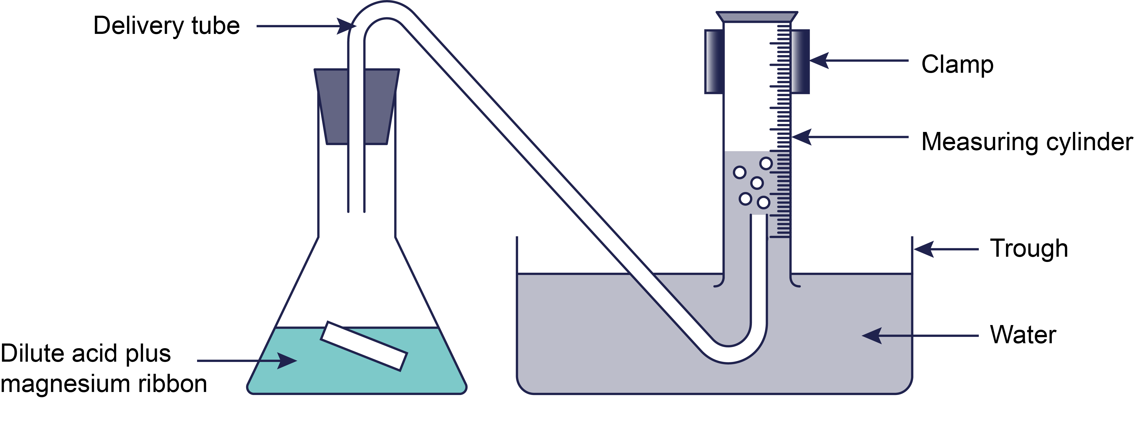

**Alternative experimental setup with gas syringe**

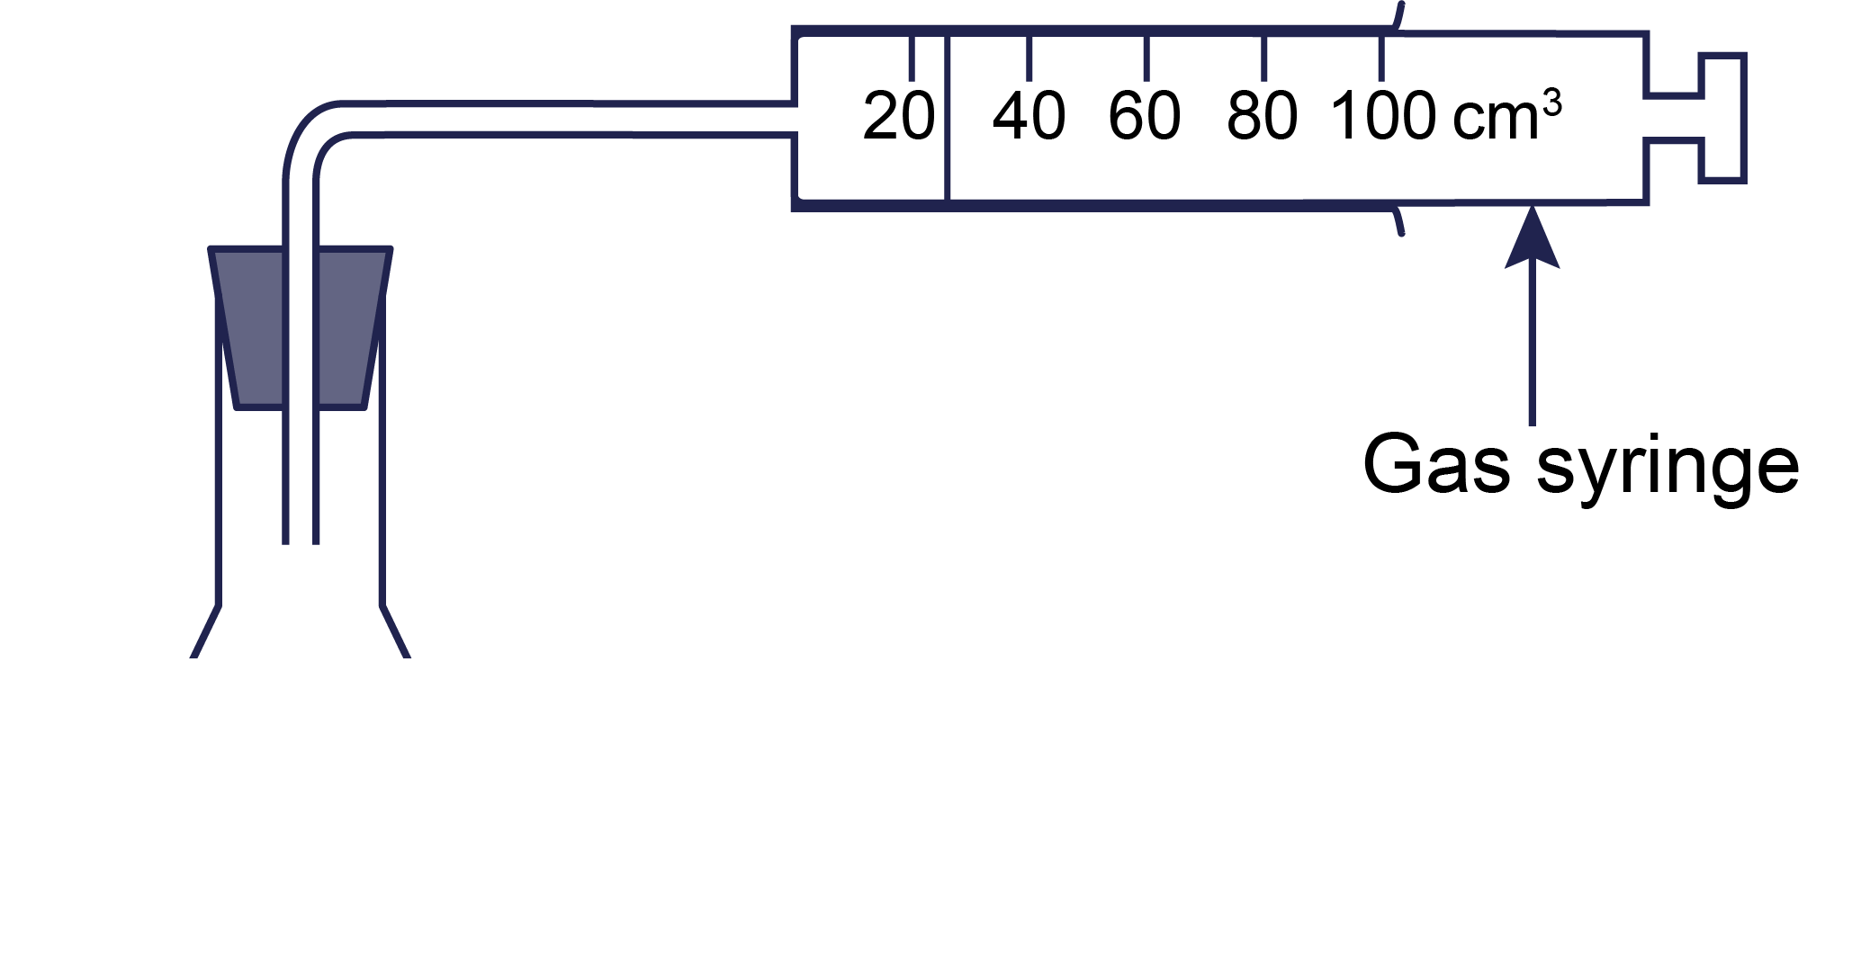

## Procedure and procedural understanding

| **Procedure** | **Understanding** |
| --- | --- |
| 1. Place bottles of hydrochloric acid (or decanted into labelled beakers) into the water baths at pre-set temperatures (**30°**C, 40**°**C, 50**°**C and 60**°**C). Leave the bottles to reach temperature. Note: for acid at ‘room temperature’ a water bath is not required. 2. Set up the apparatus as shown in **Figure 1**.   If the trough is too small to place the measuring cylinder on its side, fill the measuring cylinder to the top, hold a folded dampened piece of scrap paper over the top and invert into the filled trough. A gas syringe can be used in place of a measuring cylinder and trough of water. | How will you monitor the temperature of the acid?  What is the purpose of the scrap paper? |
| 1. Select first temperature to be tested, carefully remove from water bath and measure 50 cm3 of 1.0 mol / dm3 hydrochloric acid into a 100 cm3 conical flask. | Why is it important to use a measuring cylinder to measure instead of pouring straight into the flask?  Why is it important to return the bottle/beaker of hydrochloric acid to the correct water bath immediately after measuring out what is needed? |
| 1. Add a 4 cm3 strip of magnesium to the flask, use a pair of tweezers if necessary.   **Quickly** replace the bung and start the stop clock. | Why are the tweezers helpful in order to do this safely?  Why is it important for you to **quickly** replace the bung? |
| 1. Monitor the volume of gas produced.   Stop the stop clock when you have collected 30 cm3. | Make sure you know how to read the scale of your measuring apparatus before you begin. |
| 1. Pour the mixture into the waste bucket through a sieve and rinse out the conical flask. | What is the purpose of the sieve? |
| 1. Repeat steps 2-6 for each different temperature of acid. |  |

## Analysis of results

|  |  |  |
| --- | --- | --- |
| **Temperature of HC*l* (°C)** | **Time (t) taken to produce 30 cm3 H2 (s)** | **Rate of reaction (s–1)**  **(rate of reaction = 30/t)** |
| (room temperature) = |  |  |
| 30 |  |  |
| 40 |  |  |
| 50 |  |  |
| 60 |  |  |

## Further questions

1. Calculate the rate of reaction by dividing 30 by the time taken to produce the 30 cm3 of hydrogen gas.
2. Plot a graph of temperature of HCl (°C) against rate of reaction (s‒1).

Include a line or curve of best fit:

* Does the line pass through the origin?
* Should the graph extrapolate beyond the data points?

1. Describe the relationship between temperature of HCl and the rate of reaction with Mg.

You should refer to collision theory in your answer.

1. Describe an alternative method to do the experiment safely without a water bath.
2. Explain why using a gas syringe is a better method than collecting gas in a measuring cylinder.

### Answers

1. Correct calculations based on data collected. All values should be given to 2 significant figures.
2. x-axis – temperature of HCl (°C). y-axis rate of reaction (s‒1).
3. As the temperature of HCl increases so does the rate of reaction. It begins to increase slowly at first and then faster at higher temperatures. As the temperature increases rate of reaction increases. As the temperature increases the particles move faster causing more frequent and successful collisions as a higher proportion of collisions are equal to or higher than the activation energy.
4. Water can be heated in a beaker over a Bunsen burner, tripod and gauze. A thermometer can be used to measure the temperature. A retort stand, clamp and boss can be used to ensure the beaker does not fall.
5. Gas is produced very quickly which can make it difficult to measure whilst reading the scale upside down, it is easier to read a gas syringe. The gas syringe has more graduations giving a more precise reading. Gas syringes are also better when using water soluble gases e.g. carbon dioxide.

## Practical skills, apparatus and techniques assessed

| **Practical skills, apparatus and techniques assessed** | | |
| --- | --- | --- |
| a | **Reference** | **Description of skill/technique** |
|  | 1iii  1iv  1vii | Use of appropriate apparatus to make and record a range of measurements accurately, including:  iii) a **thermometer** for **temperature**  iv) a **measuring cylinder** for **volume of liquids**  vii) an **inverted measuring cylinder or gas syringe** for **volume of gases** |
|  | 2ii | Safe use of appropriate heating devices and techniques including use of a:  i) **water bath OR electric heater** |
|  | 3i / 8i | Use of appropriate apparatus and techniques for:  i) **conducting** and **monitoring chemical reactions** |
|  | 5ii / 10ii | Making and recording of appropriate observations during chemical reactions including:  ii) the measurement of **rates of reaction** by a variety of methods such as **production of gas**. |
|  | 6i / 11i  6ii / 11ii | Safe use and careful handling of **gases, liquids and solids**, including:  i) careful **mixing of reagents** under controlled conditions  ii) using appropriate apparatus to explore **chemical changes and/or products** |

## Scientific and practical understanding

In this activity, students will carry out the reaction between hydrochloric acid and magnesium metal at various temperatures to determine the effect of temperature on the rate of reaction. The activity requires good manual handling skills and organisation and is best carried out in pairs.

### Anomaly

A value in a set of results that is judged not to be a part of the inherent variation. Calculate the mean without the anomaly if you suspect an anomaly due to an error or due to different conditions. If you identify an anomaly during the practical then consider repeating the measurement.

### Line/curve of best fit

## A line drawn on a graph that passes as close as possible to the data points. It represents the best estimate of the underlying relationship between the variables. It can be a straight line or a curve.

## Notes and References

This resource is adapted from the [Practical Chemistry project,](https://edu.rsc.org/resources/practical) developed by the Nuffield Foundation and the Royal Society of Chemistry:

Specifically the practical ‘[The rate of reaction of magnesium with hydrochloric acid’](https://edu.rsc.org/experiments/the-rate-of-reaction-of-magnesium-with-hydrochloric-acid/1916.article).

Please note – web links are correct at date of publication but other websites may change over time. If you have any problems with a link you may want to navigate to that organisation’s website for a direct search.



We’d like to know your view on the resources we produce. Click ‘[Like’](mailto:resources.feedback@ocr.org.uk?subject=I%20like%20GCSE%20(9-1)%20Chemistry%20A%20(Gateway%20Science)%20Purposeful%20Practicals%20Pack%20-%20Measuring%20the%20rate%20of%20reaction%20between%20magnesium%20and%20hydrochloric%20acid) or ‘[Dislike’](mailto:resources.feedback@ocr.org.uk?subject=I%20dislike%20GCSE%20(9-1)%20Chemistry%20A%20(Gateway%20Science)%20Purposeful%20Practicals%20Pack%20-%20Measuring%20the%20rate%20of%20reaction%20between%20magnesium%20and%20hydrochloric%20acid) to send us an auto generated email about this resource. Add comments if you want to. Let us know how we can improve this resource or what else you need. Your email will not be used or shared for any marketing purposes.

Looking for another resource? There is now a quick and easy search [tool to help find free resources](https://www.ocr.org.uk/qualifications/resource-finder/) for your qualification.

OCR is part of Cambridge University Press & Assessment, which is itself a department of the University of Cambridge.

For staff training purposes and as part of our quality assurance programme your call may be recorded or monitored. © OCR 2024 Oxford Cambridge and RSA Examinations is a Company Limited by Guarantee. Registered in England. Registered office The Triangle Building, Shaftesbury Road, Cambridge, CB2 8EA. Registered company number 3484466. OCR is an exempt charity.

OCR operates academic and vocational qualifications regulated by Ofqual, Qualifications Wales and CCEA as listed in their qualifications registers including A Levels, GCSEs, Cambridge Technicals and Cambridge Nationals.

OCR provides resources to help you deliver our qualifications. These resources do not represent any teaching method we expect you to use. We update our resources regularly and aim to make sure content is accurate but please check the OCR website so that you have the most up to date version. OCR cannot be held responsible for any errors or omissions in these resources.

Though we make every effort to check our resources, there may be contradictions between published support and the specification, so it is important that you always use information in the latest specification. We indicate any specification changes within the document itself, change the version number and provide a summary of the changes. If you do notice a discrepancy between the specification and a resource, please [contact us](mailto:resources.feedback@ocr.org.uk).

You can copy and distribute this resource in your centre, in line with any specific restrictions detailed in the resource. Resources intended for teacher use should not be shared with students. Resources should not be published on social media platforms or other websites.

OCR acknowledges the use of the following content: N/A

Whether you already offer OCR qualifications, are new to OCR or are thinking about switching, you can request more information using our [Expression of Interest form](https://www.ocr.org.uk/qualifications/expression-of-interest/).

Please [get in touch](mailto:resources.feedback@ocr.org.uk) if you want to discuss the accessibility of resources we offer to support you in delivering our qualifications.