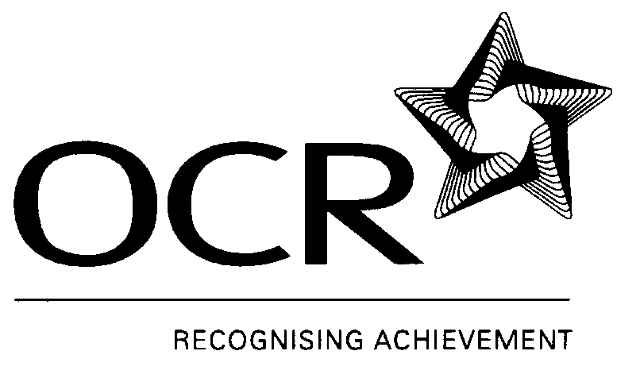
notes on RECORDING EVIDENCE
There are three forms for recording candidate evidence for this qualification. Where possible, these forms should be filled in by the candidate with the help of an assessor if necessary. The first two forms (or a suitable alternative) are mandatory.
Evidence Log
This form is used to record each piece of evidence, describe the nature of that evidence, and assign it an appropriate reference.
Evidence Record Sheet (ERS)
Each candidate requires one ERS for each unit they complete. OCR has designed an ERS specifically for each unit. The form is used to link the evidence to each of the assessment criteria, and thereby show how the candidate is able to meet all the assessment requirements. The appropriate evidence reference (from the Evidence Log) should be inserted beside each of the assessment criteria. There may be more than one piece of evidence applicable to each assessment criteria. For each piece of evidence, assessors will be advised to identify the method that has been used to assess the evidence. OCR external verifiers will look for this information when verifying the qualification.
When recording the method of assessment, the following individual codes should be used:
Method of assessment used | Code to be inserted on ERS
Observation of the candidate by the assessor | O
Examination of the evidence by the assessor
Examination of a product | EP
Examination of the witness testimony | EWT
Examination of a case history | ECH
Examination of a personal statement | EPS
Examination of written answers to questions | EWA
Questioning of the candidate or witness by the assessor
Questioning of the candidate | QC
Questioning of the witness | QW
Professional Discussion | PD
These codes are also given on the ERS itself for reference.
Record of Achievement
This form is designed to record a candidate’s progress through the qualification. It will show, at a glance, which units the assessor considers the candidate to have completed. The use of this form is optional.

