Unit R071 – How scientific ideas have an impact on our lives

Module 1 – Using energy

The activities below cover ‘Module 1 – Using energy, LO2’

Electromagnetic Spectrum
Activity 1
Radiation can be ionising or non-ionising.

Electromagnetic radiation is a non-ionising radiation. It consists of seven parts ranging in intensity from low energy to high energy. Each part has a distinctive name given to it.

Your task is to find out more about each part of the electromagnetic spectrum (EMS) by completing the attached table.

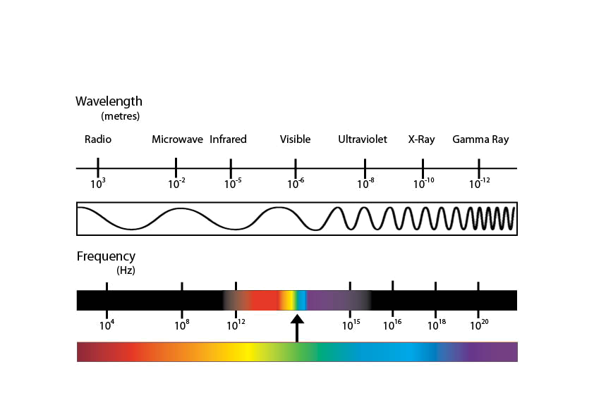
Electromagnetic Spectrum Factsheet
.

 | Radio | Microwave | Infrared | Visible | Ultraviolet | X-Ray | Gamma Ray
Write the words ‘high’ and ‘low’ at the correct ends of the arrow: | ..…………  ENERGY |  |  |  |  |  | ..…………  ENERGY
Give an example of a source of this type of radiation:
Give examples of how we use this type of radiation in everyday life:
Give examples of jobs which use this type of radiation:
How do you think we can detect this type of radiation?

