Candidate and Teacher Authentication Form
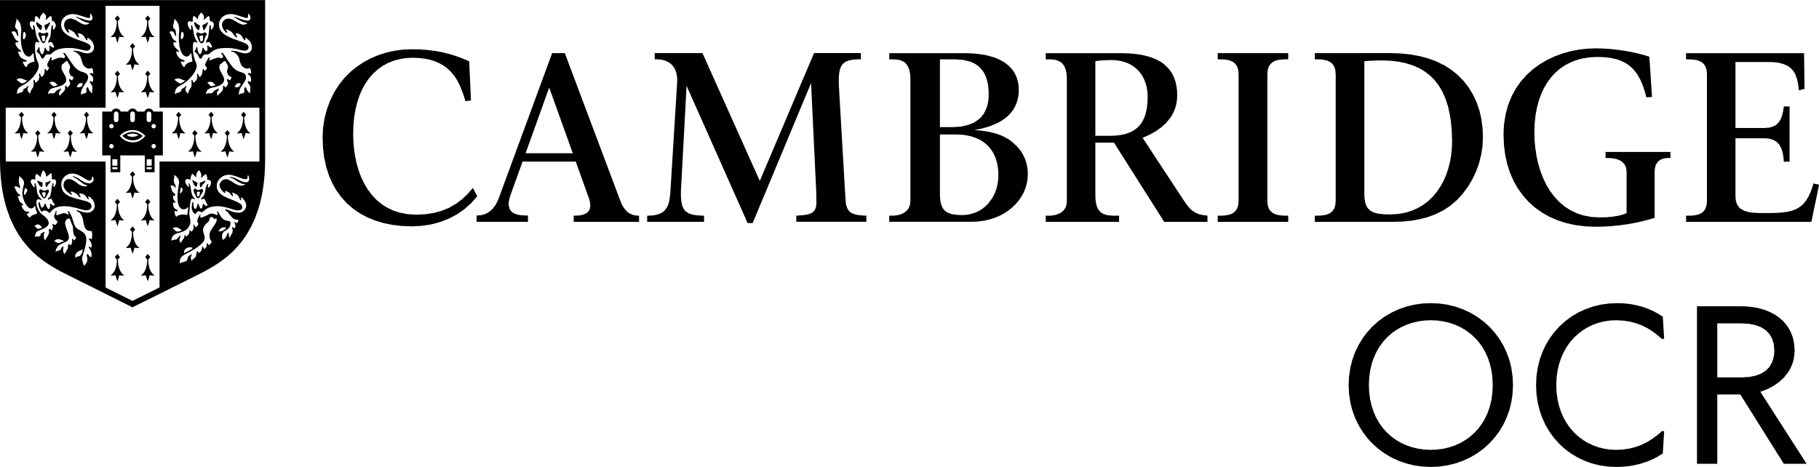
Centre name |  | Centre number
Qualification and unit/component title |  | Unit/component code
Assessment series (if relevant) |  | Year
Candidate name |  | Candidate number
Notice to Candidates
- The work you submit for assessment must be your own.
You must not plagiarise. This means you must not take someone else’s words, thoughts, ideas or outputs and try to pass them off as your own.

- You must clearly reference all your sources.
If you have used any material to create ideas for your work (like a book, journal or internet search) you must reference this, even if you haven’t used exactly the same words or phrases in your own work. You must make clear which part, element or phrase you have used and say where it came from. If you receive help and guidance from someone other than your teacher, you must tell your teacher. They will then record the assistance given to you.

- You must clearly acknowledge and reference any use of AI.
Sometimes you are allowed to use an AI tool to create your NEA/coursework. You must keep a copy of the original question(s) and any AI generated content you used, for example, a screenshot with a short explanation of how you used it. You must acknowledge the name of the AI tool used; the date the content was generated and the sources used by the AI tool in generating the content.
You need to hand this in with your final work so your teacher can check the AI content and how you used it.

- You must keep your work confidential.
You can only share the work you submit for assessment with your teacher(s). You must not share it with anyone else, and you must not post it online.

- The work you submit for assessment must be produced under the conditions set out in the specification/scheme of assessment/NEA handbook.
Each qualification has a specific set of conditions. Your teacher will have explained the level of supervision and control necessary for this assessment.

If you break the rules, you could get zero marks, be disqualified from the unit or subject, or even from all exams. Cambridge OCR will investigate and decide what happens.
If there is anything you don’t understand, please speak to your teacher before you sign the form below.
Candidate declaration
I have read and understood the Notice to Candidates above I declare that the work submitted for this assessment:
- is my own work
- has clearly referenced all sources
- has clearly acknowledged any use of AI
- has been kept confidential
- has been produced under the conditions set out in the specification/scheme of assessment/NEA handbook
I understand that if I make a false declaration this is a form of malpractice.
If there is anything you don’t understand, please speak to your teacher before you sign the form.
Name | Signature | Date

Notice to Teachers
You must keep a copy of the candidate declaration on file until the deadline for requesting a review of results has passed or until any appeal, malpractice or other results enquiry has been completed, whichever is later. This may be subject to inspection by Cambridge OCR and/or a JCQ Centre Inspector.
Before signing this declaration, please ensure you have read and understood the guidance produced by JCQ on authenticating candidates’ work, marking candidates’ work and internal standardisation. Please also ensure that you are familiar with the candidate’s general standard of work.
Teacher declaration
I confirm that:

- all reasonable steps were taken, including steps to mitigate the risk of AI misuse, to make sure the work submitted is solely that of the candidate concerned

- to the best of my knowledge, where sources have been used, they are referenced

- to the best of my knowledge, where the candidate has used AI, it has been used and acknowledged appropriately

- any help given to the candidate has been recorded

- to the best of my knowledge, the work has been kept confidential (when with the candidate) and has been securely stored by the centre (when appropriate to the assessment)

- the candidate’s work was conducted under the required conditions detailed in the specification/scheme of assessment/NEA handbook

- the marking was carried out according to the mark scheme and AI was not used as the sole form of marking; I have reviewed the work in its entirety and determined the final mark

- internal standardisation was carried out to ensure all candidates have been assessed against the same standard.

I understand that a false declaration is a form of malpractice.

Name | Signature | Date
This declaration must be completed by the person responsible for authenticating the candidate's work and confirming that the requirements set out above have been met.

