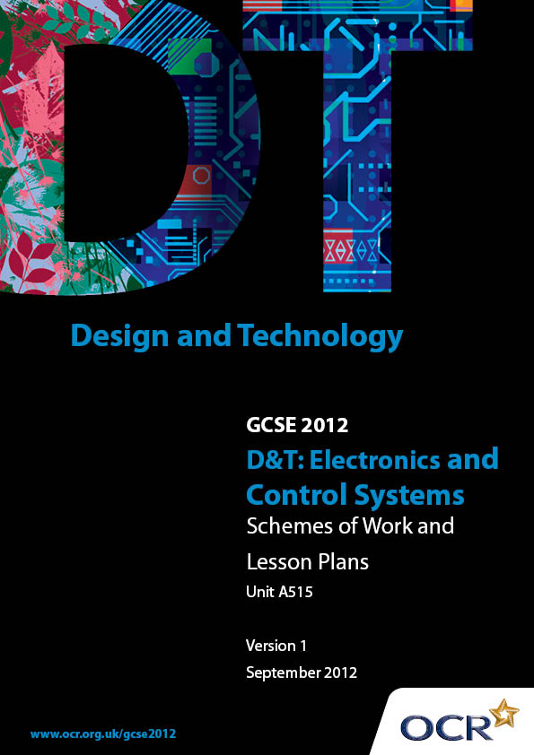

Contents
Contents 2
Introduction 3
Sample Schemes of Work: OCR GCSE D&T Electronics and Control Systems Unit A515: Sustainability and technical aspects of designing and making 5
Sample Lesson Plan: OCR GCSE D&T Electronics and Control Systems Unit A515: Sustainability and technical aspects of designing and making 22

Introduction

Background
OCR has produced a summary brochure, which summarises the changes to Design & Technology. This can be found at www.ocr.org.uk, along with the 2012 specification.
In order to help you plan effectively for the implementation of the new specification we have produced these schemes of work and sample lesson plans for Design & Technology. These support materials are designed for guidance only and play a secondary role to the specification.

Our Ethos
OCR involves teachers in the development of new support materials to capture current teaching practices tailored to our new specifications. These support materials are designed to inspire teachers and facilitate different ideas and teaching practices.
Each scheme of work and set of sample lesson plans are provided in Word format to be used as a foundation to build upon and amend the content to suit your teaching style and students’ needs.
The scheme of work and sample lesson plans provide examples of how to deliver these units and suggested teaching hours which could be applicable to your teaching.
The specification is the document on which assessment is based and specifies what content and skills need to be covered in delivering the course. At all times, therefore, this support material booklet should be read in conjunction with the specification. Any clarification should be found in the specification.

A Guided Tour through the Scheme of Work

= Innovative Teaching Idea
This icon is used to highlight exceptionally innovative ideas.

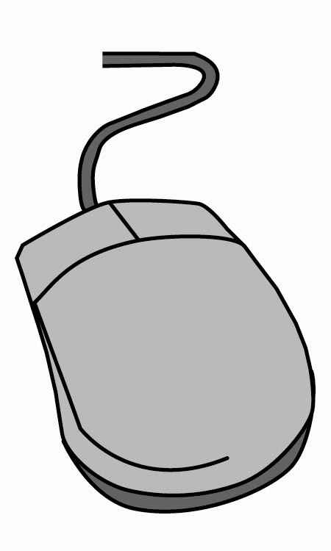
= ICT Opportunity
This icon is used to illustrate when an activity could be taught using ICT facilities.

OCR GCSE D&T Electronics and Control Systems Unit A515
Suggested teaching time | 12 hours | Topic | The 6 Rs: recycle, reuse, reduce, refuse, rethink, and repair
Topic outline |  | Suggested teaching and homework activities |  | Suggested resources | Points to note
Recycle :  - Materials that can be recycled  - Primary, secondary and tertiary recycling  - Products that use recycled materials  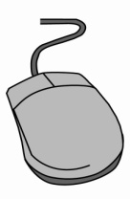    - Disassembly – reprocessing materials for use in new products |  | - Definition of ‘recycling’ – the conversion of waste products into fresh materials  - Reasons to recycle:  - Conserve earth’s resources  - Reduce landfill waste  - Primary recycling – second hand use of the product:  - Students to investigate an internet-based company which buys used mobile phones. How much are the phones bought for? What happens to the phones? Who benefits?  - Secondary recycling – reforming the material(s) into new products.  - Tertiary recycling – chemically breaking down the materials to form into new materials/products  - Students to visit wasteonline website to research and present findings on recycling of used batteries |  | - One computer per student with internet access and word processor or PowerPoint  - GCSE Electronics and Control Systems (Hodder):  - Textbook ISBN 978 0 340 98201 3  - DVD ISBN 978 0 340 99120 6  - The Sustainability Handbook for Design and Technology Teachers (Practical Action publishers) ISBN 978 1 85339 670 0  - www.wasteonline.org.uk | - This material can be covered over 2 x 1 hour lessons  - Encourage students to consider the large range of parts and materials used in a typical electronic product and the need to separate these before secondary or tertiary recycling can take place
 |  | - Homework: DVD task sheet ‘Recycle’ - recycling symbols, recyclable plastic, products made from recycled materials, products designed to be easily recyclable
Reuse:  - Products that can be reused for either the same purpose or a new purpose  - Products that can be adapted to suit an alternative use |  | - Products that are specifically designed to be reused eg milk bottles, carrier bags, printer cartridges, ‘disposable cameras’  - Students to bring in products that are normally thrown away (yoghurt pots, drinks bottles). In groups, students take a product and suggest ways of reusing it – results written on a large sheet. Pass products round – 3 mins per product. Feedback results to group  - Making reuse fashionable eg charity shops |  | - One computer per student with internet access and word processor or PowerPoint  - GCSE Electronics and Control Systems (Hodder):  - Textbook ISBN 978 0 340 98201 3  - DVD ISBN 978 0 340 99120 6  - The Sustainability Handbook for Design and Technology Teachers (Practical Action publishers) ISBN 978 1 85339 670 0 | - This material can be covered over 2 x 1 hour lessons  - Students can bring in suitable products for these exercises from home  - Encourage light-hearted responses for the reuse suggestions – some ‘silly’ suggestions can produce useful ideas!  - Some students may have visited the WEEE man
- Packaging – students to bring in a box/packaging for a product. Group work to discuss need for packaging, excessive packing and ways that packaging can be redesigned to become a useful or collectable item
- Students to research the WEEE directive and the ten categories of electrical and electronic waste
- The WEEE man sculpture
- Homework: DVD task sheet ‘Reuse’ – materials which can pollute environment, parts for reuse, packaging

OCR GCSE D&T Electronics and Control Systems Unit A515
Suggested teaching time | 12 hours | Topic | The 6 Rs: recycle, reuse, reduce, refuse, rethink, and repair
Topic outline |  | Suggested teaching and homework activities |  | Suggested resources | Points to note
Reduce:  - Life cycle of product/Eco footprint  - Built in obsolescence  - Energy and waste of production processes  - Materials - waste |  | - See Sample Lesson Plan  - Students to dismantle an unwanted electronic product (consider safety issues). Suggested activities:  - Photograph original product  - Photograph all parts dismantled  - Part count and identification  - Materials and manufacturing processes identified  - Report on energy usage during manufacture and during use  - Carry out life cycle assessment (LCA) - sourcing materials, manufacturing, transportation (materials and product), the product in use, disposal/recycling  - Produce an Eco footprint for the product, highlighting ways in which ‘Reduce’ can be applied |  | - Basic tools for dismantling products – risk assess the activity  - Digital camera and A4 printer  - Storage bags for dismantled parts  - GCSE Electronics and Control Systems (Hodder):  - Textbook ISBN 978 0 340 98201 3  - DVD ISBN 978 0 340 99120 6  - The Sustainability Handbook for Design and Technology Teachers (Practical Action publishers) ISBN 978 1 85339 670 0 | - This material may need 3 x 1 hour lessons to cover properly  - Unwanted electronic products can be brought into school for disassembly  - One product per 2/3 students may be more effective and the students could share out tasks
- Planned obsolescence – students to argue why they needed to upgrade their latest mobile phone or MP3 player
- Homework: DVD task sheet ‘Reduce’ – Eco footprints, electricity use, planned obsolescence, LCA
Refuse:  - Issues relating to sustainable design  - Materials we should refuse to use |  | - Some reasons why a consumer might refuse to buy a product:  - It may use too much material  - It may use harmful materials  - It may have been manufactured with little attention to human rights  - It may have excessive packaging  - It may have been unnecessarily transported  - It may be an unhealthy product  - It may not be easy to recycle  - The product is not really needed |  | - Teacher to source range of suitable products  - GCSE Electronics and Control Systems (Hodder):  - Textbook ISBN 978 0 340 98201 3  - DVD ISBN 978 0 340 99120 6  - The Sustainability Handbook for Design and Technology Teachers (Practical Action publishers) ISBN 978 1 85339 670 0 | - Can be covered in a single 1 hour lesson
- It may not work very well
- Teacher led activity – source 3 or 4 products which are examples of some of the above categories. Students to identify which categories for which product
- Homework: DVD task sheet ‘Refuse’ – materials, energy-hungry products, food packaging
- How it is possible to approach design problems differently |  | - The difference between products we need and products we want  - Encouraging students to think about their lifestyle and the impact it has on the world |  | - GCSE Electronics and Control Systems (Hodder):  - Textbook ISBN 978 0 340 98201 3  - DVD ISBN 978 0 340 99120 6  - The Sustainability Handbook for Design and Technology Teachers (Practical Action publishers) ISBN 978 1 85339 670 0 | - Can be covered in 2 x 1 hour lessons  - The class activities can be tailored to relevant control systems products

OCR GCSE D&T Electronics and Control Systems Unit A515
Suggested teaching time | 12 hours | Topic | The 6 Rs: recycle, reuse, reduce, refuse, rethink, and repair
Topic outline |  | Suggested teaching and homework activities |  | Suggested resources | Points to note
- An existing product that has become waste, eg Utilising materials or components for another purpose without reprocessing it |  | - Student activities: the Sustainability Handbook for D&T Teachers has numerous suggestions for class activities to encourage ‘rethink’:  - Needs and wants  - Personal audit line-up  - Energy sources  - Efficient food preparation  - Homework: DVD task sheet ‘Rethink’ – products which are not used, needs and wants, unwanted presents, electricity usage
Repair:  - Products that can or cannot be repaired  - Issues relating to repair |  | - Teacher led exercise to find out why electronic products are hardly ever repaired:  - Complexity  - Small size  - Availability of spares  - Opening the product case  - Cost of replacement is often very low |  | - One computer per student with internet access  - GCSE Electronics and Control Systems (Hodder):  - Textbook ISBN 978 0 340 98201 3  - DVD ISBN 978 0 340 99120 6  - The Sustainability Handbook for Design and Technology Teachers (Practical Action publishers) ISBN 978 1 85339 670 0 | - This material can be covered in 2 x 1 hour lessons  - The ‘torch’ product could be changed to any similar, simple product with predictable modes of failure
 |  | - Problems of growing piles of electronic and electrical waste  - Teacher led information to highlight common faults which occur in electronic products eg Battery connections, dirty switches, cracked pcb tracks etc  - Use of internet to find repair information for products eg Enter ‘how to repair …’ into search engine or visit howtomendit website  - Students to produce a fault tree analysis (FTA) for a simple product such as a torch – a simple step-by-step guide considering the range of faults which could occur  - Small groups: students to consider how to set up a viable torch repair business - advertising, repair charges, repair times, collection/delivery of product, expenses/profits etc  - Homework: DVD task sheet ‘Repair’ – modern products, design for repair, fault finding, history |  | - www.google.com  - www.howtomendit.com | - Setting up a repair business for products is a very viable proposition – consider safety issues if students actually want to carry out repairs (do NOT allow repairs to mains powered equipment)

OCR GCSE D&T Electronics and Control Systems Unit A515
Suggested teaching time | 8 hours | Topic | Product analysis and the design of products
Topic outline |  | Suggested teaching and homework activities |  | Suggested resources | Points to note
Social issues:  - Social development, through recognising the need to consider the views of others including people with disabilities when designing and discussing designed products  - Signs and symbols giving valuable information about materials, products and safety issues |  | - Social responsibility of designers – ensuring people’s quality of life is not compromised by our wants  - Use a specific product example such as an item of cheap clothing  - Split students into groups – each to spend 20 mins using the internet to research one of the following:  - Where are the materials sourced and at what cost to local people?  - Under what conditions do people work to manufacture it?  - How does the product improve the quality of life for its users?  - Does the product help social or cultural traditions (if sold overseas)  - How does it encourage social interaction?  - Does it meet our needs today without sacrificing future generations? |  | - Teacher-sourced item of cheap clothing  - One computer per student with internet access  - GCSE Electronics and Control Systems (Hodder):  - Textbook ISBN 978 0 340 98201 3  - DVD ISBN 978 0 340 99120 6  - The Sustainability Handbook for Design and Technology Teachers (Practical Action publishers) ISBN 978 1 85339 670 0 | - This material can be covered in a single 1 hour lesson  - A particularly cheap but fashionable T-shirt can be bought for less than £1
- Anthropometrics and ergonomics |  | - One from each group to report findings to whole class  - Homework: DVD task sheet ‘Social Issues’ – age discrimination, the younger market, anti-social products
Moral issues:  - Conditions of working  - Protecting the safety of users of products  - Ethical trading initiative (ETI) |  | - Definition of ‘moral’  - Group 1: students to use ETI website to research their nine point Base Code  - Group 2: students use Fairtrade website to answer specific FAQs set by teacher  - After 10 mins students compile their findings onto a single PowerPoint (or similar) which is then presented to whole class  - Homework: DVD task sheet ‘Moral Issues’ – moral arguments, safety issues, advertising |  | - One computer per student with internet access and word processor  - Projector for presentation to class  - GCSE Electronics and Control Systems (Hodder):  - Textbook ISBN 978 0 340 98201 3  - DVD ISBN 978 0 340 99120 6  - The Sustainability Handbook for Design and Technology Teachers (Practical Action publishers) ISBN 978 1 85339 670 0  - www.ethicaltrade.org  - www.fairtrade.org.uk | - This material can be covered in a single 1 hour lesson  - Students need to be given a copy of the completed compilation for their own reference

OCR GCSE D&T Electronics and Control Systems Unit A515
Suggested teaching time | 8 hours | Topic | Product analysis and the design of products
Topic outline |  | Suggested teaching and homework activities |  | Suggested resources | Points to note
Cultural issues:  - Looking at, responding to and valuing the responses of others to design solutions  - The impact of different cultures on modern products |  | - Definition of ‘culture’ as related to product designers  - Each student to bring in a product (or a photo of the product) with a clear cultural identity eg traditional clothing, food, toy, or item made by traditional methods - present to the class with information about the product  - Teacher to photo each product and produce compilation for students’ reference  - Homework: DVD task sheet ‘Cultural Issues’ – cultural products, fusion of cultures, cultural traditions and beliefs |  | - GCSE Electronics and Control Systems (Hodder):  - Textbook ISBN 978 0 340 98201 3  - DVD ISBN 978 0 340 99120 6 | - This material can be covered in a single 1 hour lesson  - This could be an entertaining and enlightening lesson  - The compilation of photos will be a useful memory-jogger for students

OCR GCSE D&T Electronics and Control Systems Unit A515
Suggested teaching time | 8 hours | Topic | Product analysis and the design of products
Topic outline |  | Suggested teaching and homework activities |  | Suggested resources | Points to note
Environmental Issues:  - Understanding and being able to select materials, including ‘smart’ and ‘modern’ materials that are both suitable and sustainable  - The reduction in the common use of chemicals and materials dangerous to the environment, ie bleaches, CFCs, toxic materials |  | - Definitions of environmental responsibility and sustainability – facts and figures  - Students to use internet to identify:  - one manufacturing process where bleach is used  - what CFCs are and where they are/were used  - the chemicals used in batteries and their dangers  - The effects of CO₂ emissions on the environment and climate change  - Definition of carbon footprint  - Pupils to calculate their own carbon footprint using footprint.wwf calculator (or similar). Discuss the results and the consequences  - Carry out the mobile phone columbite-tantalite activity from The Sustainability Handbook for D&T Teachers |  | - One computer per student with internet access and word processor  - GCSE Electronics and Control Systems (Hodder):  - Textbook ISBN 978 0 340 98201 3  - DVD ISBN 978 0 340 99120 6  - The Sustainability Handbook for Design and Technology Teachers (Practical Action publishers) ISBN 978 1 85339 670 0  - www.footprint.wwf.org.uk | - This material can be covered in 2 x 1 hour lessons  - The results of the personal carbon footprint calculator should give lots of opportunity for students to think about ways of reducing their footprint – personal targets, posters etc

OCR GCSE D&T Electronics and Control Systems Unit A515
Suggested teaching time | 8 hours | Topic | Product analysis and the design of products
Topic outline |  | Suggested teaching and homework activities |  | Suggested resources | Points to note
- Carbon footprint – transportation of materials and goods, energy usage in manufacture  - Carbon offsetting  - The need to dispose of redundant products and their packaging in a safe and environmentally friendly way |  | - Homework: DVD task sheet ‘Environmental Issues’ – environmental responsibility, carbon footprint, sustainability, hazardous chemicals

OCR GCSE D&T Electronics and Control Systems Unit A515
Suggested teaching time | 8 hours | Topic | Product analysis and the design of products
Topic outline |  | Suggested teaching and homework activities |  | Suggested resources | Points to note
Design Issues:  - Identifying how good design and product choice improves the quality of life  - Examining the way that designers respond to changing styles, taste, technological advances and environmental pressures  - Eco-design – the whole system of looking at a product from design to finished article, its use of materials and energy |  | - In groups, students to indentify products which they believe are well-designed, and those that are not – justify each selection  - The idea of ‘iconic products’ with photo examples – students to contribute their own choice of iconic product from the present and from their parents’ childhood (short internet exercise)  - Eco-design and the European Ecolabel  - Eco-design Web exercise from The Sustainability Handbook for D&T Teachers – applied to any designing and making activity they have been involved in, possibly unit A511  - Homework: DVD task sheet ‘Design Issues’ – product design, iconic products, Ecolabel, globalisation  - Students to monitor their personal energy usage for 1 week (see The Sustainability Handbook for D&T Teachers) |  | - One computer per student with internet access  - GCSE Electronics and Control Systems (Hodder):  - Textbook ISBN 978 0 340 98201 3  - DVD ISBN 978 0 340 99120 6  - The Sustainability Handbook for Design and Technology Teachers (Practical Action publishers) ISBN 978 1 85339 670 0  - Teacher-prepared photos of iconic products  - Teacher-prepared examples of products (or photos of products) with a variety of power sources | - This material can be covered in 3 x 1 hour lessons
- The globalisation of products |  | - Consider a range of products with different power sources: mains, rechargeable battery, disposable battery, solar power, wind-power, wind-up power. Students to consider environmental and user advantages and disadvantages of each source  - Energy efficiency and product power ratings  - Homework: DVD task sheet ‘Energy Efficiency’ – batteries, product ratings, self-powered products, product design

OCR GCSE D&T Electronics and Control Systems Unit A515
Suggested teaching time | 3 hours | Topic | Test Preparation
Topic outline |  | Suggested teaching and homework activities |  | Suggested resources | Points to note
Test Structure  Sample Questions  Sample Papers |  | - Explain structure of test  - Students to tackle individual short questions – group discussion of answers  - Set individual longer questions – teacher feedback  - Individual and group work to cover revision material – variety of approaches – paper-based, computer and discussion.  - Set whole paper under timed conditions |  | - www.ocr.org.uk/qualifications/gcsefor2009/ .dt_electronics/documents.html for a link to the assessment materials  - Teacher-prepared revision materials | - Individual Centres and teachers will formulate the best revision and preparation approach for their students

OCR GCSE D&T Electronics and Control Systems Unit A515

Electronic product analysis linked to the ‘reduce’ element of the 6 Rs.
OCR recognises that the teaching of this qualification above will vary greatly from school to school and from teacher to teacher. With that in mind this lesson plan is offered as a possible approach but will be subject to modifications by the individual teacher.
Lesson length is assumed to be one hour.

Learning Objectives for the Lesson
Objective 1 | To introduce to students the concept of ‘reduce’.
Objective 2 | Students to be able to suggest ways of applying ‘reduce’ to systems product design.
Objective 3 | Students to have dismantled an unwanted electronic product and analysed the parts.
Objective 4 | Students to be able to identify the problems associated with recycling electronic products, namely the large amount of parts and materials used.

Recap of Previous Experience and Prior Knowledge
- Recap on the importance of the 6R’s and what they stand for: Recycle, Reuse, Reduce, Refuse, Rethink and Repair.
- Note that this lesson is the first of a group of three on the ‘reduce’ topic.

Content
Time | Content
5 minutes | Brief recap of the 6 Rs.  Develop the idea of ‘reduce’ – to minimise the amount of material and energy used during the whole of a product’s life cycle.  Ascertain the unwanted products that students have brought in.  Introduce the class to the objective of the product analysis:  - To investigate the components and materials used in electronic products  - To investigate methods of manufacture, fixings, PCB mounts, battery connectors etc  - To consider the problems of separating all the materials before the product can be recycled  - To think about ways that manufacturers could reduce the number of parts in a product and the amount of materials used.
Time | Content
5 minutes | Suggest one unwanted product between 2/3 students.  Safety instructions to students for dismantling the products:  - Cut off any mains plugs and dispose of them (teacher does this)  - Dismantle the product, don’t force it open  - Use the correct tools  - Don’t try to open any batteries  - Ask if you are unsure.  Issue basic tools – large selection of screwdrivers, pliers etc. It helps if there is a kit of ‘security screwdrivers’ available – many modern products use security screws – encourage students to ask why.
30 minutes | Students to begin dismantling products. Encourage students to delegate jobs within their small group:  - dismantle main product  - dismantle sub-parts  - lay out parts in order on backing sheet  - identify parts and perform component count.

Consolidation
Time | Content
15 minutes | Take photo of dismantled parts laid out on a plain A3 backing sheet.  Print out A4 photos – one per student.  During this process, students share information within their small group ready for the homework task – identifying the parts, materials and manufacturing processes used, component count, eg number of screws, number of resistors/capacitors etc on PCB.  Keep all dismantled parts in bags for use next lesson.
5 minutes | Homework:  - Take home the photo of the dismantled parts and annotate to show:  - Part identification and approximate component count  - Materials used  - Likely method of manufacture.  - Write a paragraph to explain the problems of separating all these parts for recycling  - Write a paragraph to suggest ways that the manufacturer might be able to reduce the number of separate parts used in this product.  [After two further 1-hour lessons on this topic, set homework task sheet ‘Reduce’ from Electronics and Control Systems DVD  ISBN 978 0 340 99120 6  (Hodder)]

