
Functional Skills
Maths
Functional Skills qualification in Maths at Entry 1, Entry 2, Entry 3
Scheme code: 09862, 09863, 09864

Assessment Templates – Set C

These templates have been created as a guide to centres to give an example of an approach to gathering evidence for the Functional Skills Maths Entry Level assessment.

These templates may be used in the form they are presented in, however Centres may amend these to add in their own wording, pictures, resources, contexts in conjunction with the Entry Level marking guidance to ensure that the criteria for the assessment are still met.

Centres are reminded that any changes they make to the assessment must still enable learners to produce evidence as required by the mark scheme in order to pass the assessment.

Functional Skills Maths: Entry Level 1 Name

Assessment Task: Bake or Buy?

For full marks in this assessment you will need to:

- Show all the calculations you need to do

- Show how you have checked your calculations

- If you make a choice, say why you have made that choice

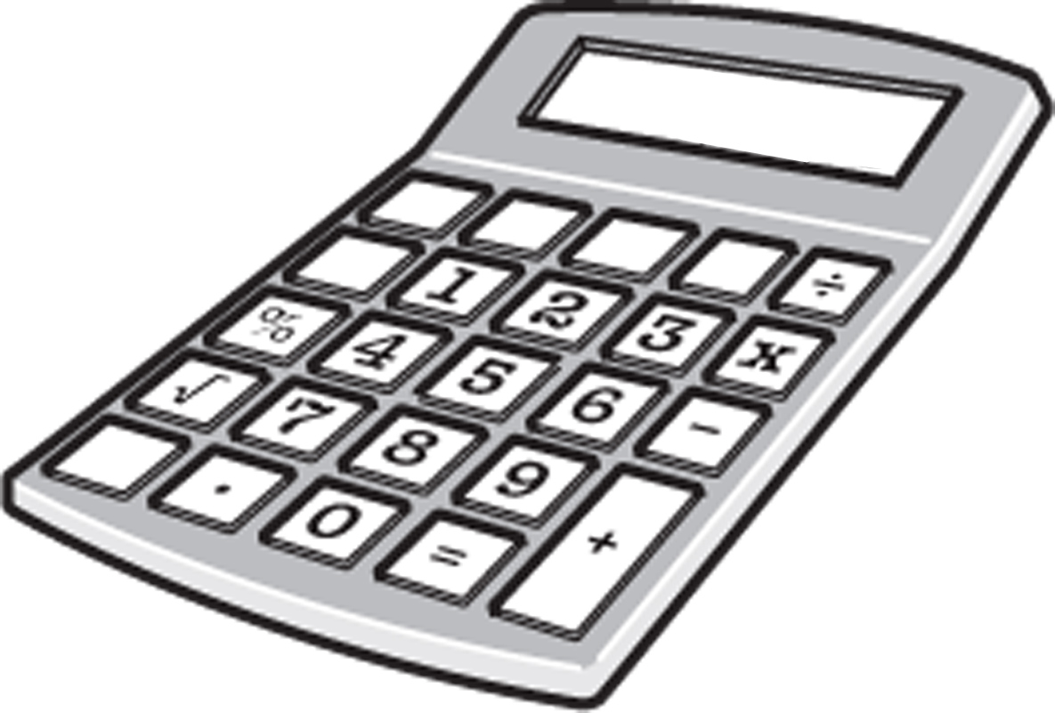
In this assessment you can use a calculator
Functional Skills Maths: Entry Level 1 Name

Assessment Task: Bake or Buy?

Decide on type of cake to make:

Type of cake

Make a list of the ingredients and amount:

Ingredient | Amount

R1 Make a list of the ingredients and amount (3 marks)
How many ingredients are needed?

A1 Count how many ingredients are needed (3 marks)

How much does each ingredient cost?

Ingredient | Cost

R1 List the cost of the ingredients (3 marks)
Decide how many people the cake could be for:

A2 Decide how many people it will be for (3 marks)

Which is the heaviest ingredient?

A1 Identify the heaviest ingredient (3 marks)

If you were making two cakes, how much of the heaviest ingredient would you need?

R1 Calculate how much of one of the ingredients are needed for two cakes (3 marks)

What three shapes could you make the cake in?

I1 Identify the different shapes it could be made in (3 marks)

How long it will take to prepare the cake?

How long it will take to cook the cake?

Which is the longest? Preparing the cake or cooking the cake?

I1 Work out the time to prepare and the time to cook and identify the longest (3 marks)

What is the cost of buying the cake?

What is the cost of making the cake? (Your tutor may add up the cost of the ingredients for you).

Which has the highest cost?

Would you bake a cake or buy a cake?

I1 Compare the cost of making and buying a cake and decide which to do (3 marks)
Functional Skills Maths: Entry Level 2 Name

Assessment Task: Let’s celebrate with a bang!

For full marks in this assessment you will need to:

- Show all the calculations you need to do

- Show how you have checked your calculations

- If you make a choice, say why you have made that choice

In this assessment you can use a calculator

Functional Skills Maths: Entry Level 2 Name

Assessment Task: Let’s celebrate with a bang!

Choose some fireworks to buy. You need to choose between five and ten:

R1 List the fireworks they wish to purchase (2 marks)
Find the price of these fireworks from two different shops:

Type of firework: | Shop 1: | Shop 2:
 | £ | £

R1 Find the price for all fireworks from 2 different outlets (3 marks)

On your list of fireworks, circle the lowest price for each firework.

Which shop has the most fireworks at the lower price?

I1 compare the cost of each firework from the list (3 marks)

How long does each firework burn for?

Firework: Time to burn:

R1 Find the price for all fireworks from 2 different outlets (3 marks)

What is the total cost of the fireworks from each shop?

Shop 1

Shop 2

R2 Calculate the total cost of the fireworks from each outlet (2 marks)

Which shop is the lowest price to buy them all from?

I1 Compare the total cost of the fireworks from each outlet (2 marks)

What shapes are the fireworks made up from?

Firework Shape

I1 Describe the shapes of the fireworks (2 marks)
You may have spent too much!

Your tutor will tell you what your spending limit is. a

Decide which firework to leave out so that you don’t go over your limit.

Firework to leave out

Cost of firework

I have left this one out because

A1 Remove one firework to come within spending limit (3 marks)

How much will it cost for the fireworks now?

A2 Calculate the revised cost of all the fireworks (2 marks)
Your friend is going to pay half the total cost.

How much will each of you have to pay for the fireworks?

Show your working and show how you could check your answer.

A3 Work out the cost when halved and check calculation (3 marks)

How long will the whole display of fireworks last?

A2 Calculate how long the display will last (2 marks)

Your friend is going to order the fireworks.

Make a list of which fireworks you are going to buy from which shop.

Say why you have decided to get them from this or these shops.

I1 Make a final decision as to which they are buying from where (3 marks)
Functional Skills Maths: Entry Level 3 Name

Assessment Task: Set up a gym

For full marks in this assessment you will need to:

- Show all the calculations you need to do

- Show how you have checked your calculations

- If you make a choice, say why you have made that choice

In this assessment you can use a calculator

Functional Skills Maths: Entry Level 3 Name

Assessment Task: Set up a gym

Choose a room which you think may be suitable to use as a gym.

What are the measurements of the room?

I have chosen

The measurements are

R1 Obtain dimensions of a suitable room to be used as a home gym (3 marks)

Choose between three and five pieces of equipment to use and find the prices from at least two different suppliers:

Equipment | Costs from: | Costs from:

R2 Choose and obtain prices for equipment from different suppliers (4 marks)

From the list above, decide which equipment to buy from which supplier.

Give a reason for your decisions.

Equipment | From | Reason

I1 Compare prices and decide what to buy and from where (3 marks)

Find the dimensions of the equipment you have chosen.

Equipment | Measurements

R1 Investigate the dimensions of each piece of equipment (2 marks)

Find out the monthly costs of joining two local gyms.

Choose the one you would prefer to join and state why.

R3 Investigate the costs of joining two separate gyms (2 marks)

Work out the total cost of the gym equipment you decided to buy.

Total cost

A1 Calculate the total cost of the items from the chosen supplier(s) (3 marks)

Calculate the monthly payment for all the equipment if you had to pay it over one year.

A1 Calculate the monthly payment for the equipment over 12 months (3 marks)

If you were paying the gym membership fee, how long would it be before you had paid enough to cover the cost of the equipment?

A2 Calculate the time taken in gym fees to reach equipment costs (3 marks)
Draw a plan of the room you have chosen and show how the equipment could fit.

You may use squared paper for this.

Scale =

I1 Draw a plan of the room showing all equipment (5 marks)

From the information you have found out about the gym equipment and local gyms, would you choose to join a local gym or set one up for yourself?

Make sure you explain your decision referring to the information you have found.

I1 Make a decision on a home gym or a local gym membership (3 marks)

