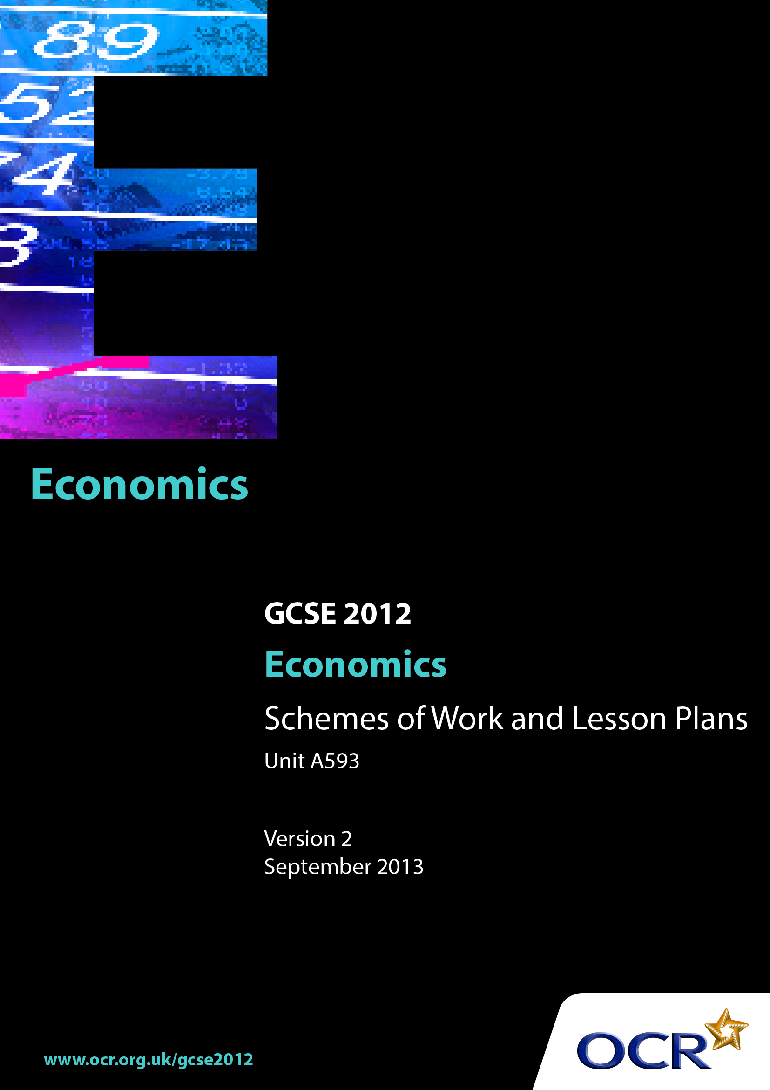

Contents
Contents 2
Introduction 3
Sample Scheme of Work: GCSE Economics Unit A593 The UK Economy and Globalisation 5
Sample Lesson Plan: GCSE Economics A593 The UK Economy and Globalisation 21

Introduction

Background
Following a review of 14 – 19 education and the Secondary Curriculum Review, the Qualifications and Curriculum Authority (QCA) has revised the subject criteria for GCSEs, for first teaching in September 2009. This applies to all awarding bodies.
The new GCSEs have more up-to-date content and encourage the development of personal, learning and thinking skills in your students.
We’ve taken this opportunity to redevelop all our GCSEs, to ensure they meet your requirements. These changes will give you greater control of assessment activities and make the assessment process more manageable for you and your students. Controlled assessment will be introduced for most subjects.
From September 2012 assessment tasks may be undertaken at any point between release of the task and the examination series for which the task must be submitted. Centres must ensure that candidates undertake a task that is valid for submission in the year in which the candidate intends to submit it.
OCR has produced a summary brochure, which summarises the changes to Economics. This can be found at www.ocr.org.uk, along with the new specification.
In order to help you plan effectively for the implementation of the new specification we have produced these Schemes of Work and Sample Lesson Plans for Economics. These Support Materials are designed for guidance only and play a secondary role to the Specification.

Our Ethos
OCR involves teachers in the development of new support materials to capture current teaching practices tailored to our new specifications. These support materials are designed to inspire teachers and facilitate different ideas and teaching practices.
Each Scheme of Work and set of sample Lesson Plans is provided in Word format – so that you can use it as a foundation to build upon and amend the content to suit your teaching style and students’ needs.
The Scheme of Work and sample Lesson plans provide examples of how to teach this unit and the teaching hours are suggestions only. Some or all of it may be applicable to your teaching.
The Specification is the document on which assessment is based and specifies what content and skills need to be covered in delivering the course. At all times, therefore, this Support Material booklet should be read in conjunction with the Specification. If clarification on a particular point is sought then that clarification should be found in the Specification itself.

A Guided Tour through the Scheme of Work

= Innovative Teaching Idea
This icon is used to highlight exceptionally innovative ideas.


= ICT Opportunity
This icon is used to illustrate when an activity could be taught using ICT facilities.

GCSE Economics Unit A593 The UK Economy and Globalisation
Suggested teaching time | 12hours | Topic | Why do countries trade?
Topic outline |  | Suggested teaching and homework activities |  | Suggested resources | Points to note
  What is globalisation? Candidates should be able to:  - Explain what is meant by globalisation  - Evaluate the factors that have contributed to the growth of globalisation, including the impact of new technology  - Give examples of, and explain what is meant by a multinational company  - Evaluate the role of multinational companies in globalisation |  | - Use the internet to find definitions of globalisation – students to share findings and to agree on a class definition  - Given a list of the causes of globalisation e.g. improvements in transport, internet, financial markets, world media, growth of multinationals etc search daily newspapers to find evidence/examples of globalisation  - Find examples of multinational companies listing their products  - Produce a montage of multinational company logos, brand names etc  - Plot on a world map where these companies have interests/factories – what goods/services do the students’ families buy from these companies |  | - OCR GCSE Economics Heinemann text  - www.tutor2u.net  - www.bized.co.uk  - www.nationmaster.com  - National Newspapers  - ‘Word Search’ to embed key terms  - Outline world map | - All suggested teaching/homework activities should be supported with a clear set of notes  - Try to place the students at the centre of ‘globalisation’ clearly showing how it impacts on their daily lives
  What is meant by international specialisation and trade?  Candidates should be able to:  - Understand the meaning of specialisation  - Understand and apply the principles of absolute advantage  - Appreciate the advantages of trade and the consequences of global interdependence  - Explain the possible negative externalities associated with trade e.g. increased pollution |  | - Working in small groups research three countries each and list the main products that they are ‘famous’ for - suggest reason why these countries ‘specialise’ in these products – share ideas with the rest of the class  - Look at a country like Ireland – look at the resources it has – land, labour, capital and enterprise – what does it specialise in and why? Why does Sweden not specialise in similar goods?  - Visit a supermarket and list five goods that come from abroad only, five goods that are imported but we also produce (choice), and five goods that are imported because they are cheaper than we could produce them  - Take three goods and identify where they come from – calculate the distance from the UK – how are they transported? Identify the negative externalities involved with this trade |  | - OCR GCSE Economics Heinemann text  - www.tutor2u.net  - www.bized.co.uk  - www.nationmaster.com  - ‘Word Search’ to embed key terms | - Revisit the ‘Economic Problem’ with particular reference to specialisation and the costs and benefits of specialisation  - This is a good opportunity to revisit ‘Factors of Production’  - Linked to the advantages of trade revisit the ‘Growth of Firms’ , economies of scale and productivity...it is from the concept of specialisation that interdependence becomes clearer  - Revisit negative and positive externalities – correcting market failure
The World Trade Organisation  Candidates should be able to:  - Explain what is meant by free trade  - Evaluate the arguments for free trade  - Understand the role of the World Trade Organisation in promoting free trade |  | - Visit the WTO website – log on to their FAQ video – working in pairs look at a section each – prepare a PowerPoint on the key points to deliver to the rest of the class |  | - OCR GCSE Economics Heinemann text  - www.tutor2u.net  - www.bized.co.uk  - www.wto.org | - The WTO website is excellent and has a wealth of resources
Patterns of trade  Candidates should be able to:  - Explain what is meant by an export and an import  - Identify the UK’s main imports and exports with the EU and the rest of the world  - Evaluate the impact of changes in trading patterns on the UK and the EU  - Evaluate the potential impact of China and India on patterns of world trade |  | - List the top five goods that the UK exports to (a) the EU and (b) the rest of the world  - List the top five goods that the UK imports from (a) the EU and (b) the rest of the world  - Repeat the two exercises above for the 1950s or 1960s  - Find out how much we trade as a percentage of UK GDP  - Visit ‘nationmaster’ and create a ‘fact sheet’ for China and India e.g. size of country, population, age distribution, economic growth income distribution, GDP per Capita, imports and exports, main trading partners etc – split class into three – one group argues the advantages of the impact of China/India on the UK economy and one group the disadvantages – the third group evaluates the arguments |  | - OCR GCSE Economics Heinemann text  - www.tutor2u.net  - www.bized.co.uk  - www.statistics.gov.uk  - www.ec.europa.eu/eurostat  - www.nationmaster.com  - ‘Word Search’ to embed key terms | - A good opportunity to revisit GDP  - Good ICT opportunity for students to display imports and exports and changing patterns in an original way  - Revisit economic growth and relate to China and India
Protectionism  Candidates should be able to:  - Understand the reasons for protection  - Identify the methods of protection, such as tariffs and quotas  - Evaluate the methods of protection |  | - Students need to explore the impact of a tariff and a quota on price and quantity  - Students should draw up a list of reasons for protection to include – protect infant industries, protect jobs, to prevent dumping, to protect against unfair competition e.g. cheap labour, to help rectify a balance of payments problem, to protect essential industries e.g. defence, energy supplies, food etc…these reasons should then be evaluated in the light of the benefits of ‘tree trade’ and interdependence |  | - OCR GCSE Economics Heinemann text  - www.tutor2u.net  - www.bized.co.uk  - www.statistics.gov.uk  - www.ec.europa.eu/eurostat  - www.nationmaster.com | - Revisit ‘demand and supply in order that students can illustrate the impact of a tariff

GCSE Economics Unit A593 The UK Economy and Globalisation
Suggested teaching time | 6 hours | Topic | Why is the UK in the European Union?
Topic outline |  | Suggested teaching and homework activities |  | Suggested resources | Points to note
Membership of the EU  Candidates should be able to:  - Identify the member countries of the EU and the Euro-Zone (Euro-Area)  - Explain and evaluate the advantages and disadvantages of the single market  - Explain and evaluate the advantages and disadvantages of the single currency |  | - Identify the members of the EU on a map of Europe and identify on the map those currently in the Euro-Area  - Download fact sheets on the advantages and disadvantages of membership of the EU – prepare a PowerPoint presentation exploring things in favour and things against and come to a reasoned  - Conclusion about the UK’s membership  - Identify the notes and coins of the EU – display giving the approximate conversion rates in pounds and pence  - Watch presentation on the EU making brief notes on slide handout – class then have a referendum on whether the UK should adopt the Euro – students are asked to justify how they vote |  | - OCR GCSE Economics Heinemann text  - www.tutor2u.net  - www.bized.co.uk  - www.civitas.org.uk  - www.ec.europa.eu/eurostat  - Outline map of Europe  - ‘Word Search’ to embed key terms  - PowerPoint – the advantages and disadvantage of the EU | - A range of information including maps and fact sheets can be downloaded from the ‘civitas’ website

GCSE Economics Unit A593 The UK Economy and Globalisation
Suggested teaching time | 6 hours | Topic | How is the UK’S international trade recorded?
Topic outline |  | Suggested teaching and homework activities |  | Suggested resources | Points to note
Balance of payments  Candidates should be able to:  - Identify the components of the current account  - Calculate the balance of trade in goods, the balance of trade in services and the current account balance |  | - Economic transactions include:  - exports and imports of goods such as oil, agricultural products, other raw materials, machinery and transport equipment, computers, white goods and clothing;  - exports and imports of services such as international transport, travel, financial and business services;  - Students to visit  www.statistics.gov.uk and obtain supporting evidence to show that trade in goods is usually in deficit and trade in services is often in surplus  - Cut and paste a simple copy of the Balance of Payments on Current Account – students design their own guide to explain imports, exports, goods, services and how the current account balance is calculated |  | - OCR GCSE Economics Heinemann text  - www.tutor2u.net  - www.bized.co.uk  - www.statistics.gov.uk  - ‘Word Search’ to embed key terms  - Example of simple Balance of Payments on Current Account
Balance of Payments deficit  Candidates should be able to:  - Explain what is meant by a balance of payments deficit and surplus  - Understand the reasons for a balance of payments deficit  - Evaluate the methods of rectifying a balance of payments deficit |  | - Using the data above students construct a bar chart to show the difference between imports and exports of goods and services and the overall balance on the current account - they explain the meaning of deficit and reproduce the bar chart to illustrate a surplus  - Students select a card – read it out to the group and have to explain how it might impact on the Balance of Payments e.g. ‘imports of foreign cars are reduced due to economic recession in the UK’.....answer less imports may help to reduce deficit on BoP |  | - OCR GCSE Economics Heinemann text  - www.tutor2u.net  - www.bized.co.uk  - www.statistics.gov.uk  - ‘Word Search’ to embed key terms  - Example of simple Balance of Payments on Current Account  - ‘Key idea’ cards on BoP

GCSE Economics Unit A593 The UK Economy and Globalisation
Suggested teaching time | 5 hours | Topic | How important is the value of a currency?
Topic outline |  | Suggested teaching and homework activities |  | Suggested resources | Points to note
Exchange rates  Candidates should be able to:  - Explain what is meant by an exchange rate  - Understand and illustrate how exchange rates are determined through the interaction of demand and supply  - Understand how exchange rates may be influenced by interest rates  - Explain and evaluate the impact of changes in exchange rates on trade and international competitiveness |  | - Students to obtain data of current exchange rates from a Daily newspaper – Compare Euro to £...list five thing you may buy on holiday in the Euro Area e.g. car hire, meal for 4, price of excursion, day at pleasure park etc ...convert the estimated cost from Euros to £s ..alter the value of the £ by +/-25%...look at the new costs of a holiday. Draw conclusions.  - Repeat the above but for a UK company that trades within the Euro Area or the US...relate changes in the exchange rate to the price of imported raw materials and the price of the finished exported good  - Illustrate on a demand and supply diagram the impact of increase in demand e.g. during the holiday period for the Euro – show and comment on the new equilibrium price – say how it may impact on importers and exporters – relate to the idea of international competitiveness  - Utilise ‘Key Ideas’ cards to explore class understanding e.g. given scenario about exchange rates and impact on tourism, importers, exporters, BoP, competition etc |  | - OCR GCSE Economics Heinemann text  - www.tutor2u.net  - www.bized.co.uk  - www.DailyFx.com  - Daily Newspaper  - Access to ‘currency converter’  - ‘Word Search’ to embed key terms  - ‘Key Ideas’ cards of exchange rates | - ICT opportunity to construct spreadsheet to convert currency from £ to $ or Euros  - Revisit demand and supply applying to exchange rates...for more able students the impact of changes in the exchange rate may be linked to elasticity of demand for the final product  - Revisit ‘balance of payments deficit’...explore the implications of changes in the exchange rate on trade

GCSE Economics Unit A593 The UK Economy and Globalisation
Suggested teaching time | 6 hours | Topic | How does a country become more competitive?
Topic outline |  | Suggested teaching and homework activities |  | Suggested resources | Points to note
Factors influencing competitiveness  Candidates should be able to:  - Appreciate the importance of wages and relative unit labour costs  - Understand the importance of the exchange rate  - Understand the importance of productivity  - Understand the importance of other costs |  | - Students to produce their own PowerPoint on international competitiveness – relate back to fact sheets on India and China...compare with UK |  | - OCR GCSE Economics Heinemann text  - www.tutor2u.net  - www.bized.co.uk  - www.ec.europa.eu/eurostat  - ‘Word Search’ to embed key terms  - PowerPoint – international competitiveness  - ‘Key Ideas’ cards on international competitiveness | - Revisit competition and relate to international competitiveness
Government policy and international competitiveness  Candidates should be able to:  - Understand the importance of low inflation  - Understand the importance of sustainable economic growth  - Understand the importance of incentives for investment  - Evaluate the importance of investment in education and training  - Discuss and evaluate government policies aimed at improving UK international competitiveness |  | - Students to compile their own crossword concentrating on how the government can make the UK more competitive with respect to international trade  - Cut and paste articles from the internet (National Daily Papers) relating to macro-economic situations e.g. rise in inflation – say how each may impact on the UK’s international competitiveness |  | - OCR GCSE Economics Heinemann text  - www.tutor2u.net  - www.bized.co.uk  - PowerPoint – Government Policy and International Competitiveness  - ‘Word Search’ to embed and revise key terms  - Access to online ‘crossword maker’ | - Revisit – ‘How the economy works’ with particular reference to inflation, economic growth, investment and education and training
The UK and globalisation  Candidates should be able to:  - Evaluate the extent to which globalisation has benefited the UK |  | - Students given a list of all the benefits of globalisation...and then place them in rank order for the UK – they should justify their rankings |  | - OCR GCSE Economics Heinemann text  - www.tutor2u.net  - www.bized.co.uk

GCSE Economics Unit A593 The UK Economy and Globalisation
Suggested teaching time | 5 hours | Topic | Why do some less developed countries struggle to achieve growth and benefit from international trade?
Topic outline |  | Suggested teaching and homework activities |  | Suggested resources | Points to note
Poverty  Candidates should be able to:  - Explain the difference between absolute and relative poverty  - Discuss and evaluate the impact of policies aimed at reducing poverty |  | - Students should illustrate absolute and relative poverty with reference to incomes per capita in a range of countries including USA, EU, and LDCs e.g. countries in Africa, South America and Asia – access to the ‘Human Development Index’ could extend this exercise |  | - OCR GCSE Economics Heinemann text  - www.tutor2u.net  - www.bized.co.uk  - www.ec.europa.eu/eurostat  - www.waronwant.org  - ‘Word Search’ to embed key terms  - Access to a measure such as the ‘Human Development Index’
Limits to benefiting from globalisation  Candidates should be able to:  - Evaluate factors such as poor infrastructure, poor education and training, health and population problems, debt, weak government and corruption, low inward investment, lack of foreign currency etc |  | - Students list the basics that their families have and expect in life. They should then take a LDC and complete the same for a family in this country – a PowerPoint may be produced to present to the rest of the class |  | - OCR GCSE Economics Heinemann text  - www.tutor2u.net  - www.bized.co.uk  - www.oxfam.org  - www.waronwant.org  - www.oxfam.org  - ‘Crossword’ to embed key terms

GCSE Economics Unit A593 The UK Economy and Globalisation
Suggested teaching time | 5 hours | Topic | What measures may be used to support growth for less developed countries?
Topic outline |  | Suggested teaching and homework activities |  | Suggested resources | Points to note
Ways of supporting growth  Candidates should be able to evaluate factors such as :  - Aid  - Trade  - Debt relief  - Investment  - Help with investment in human capital  - Fair trade schemes  - Non-governmental organisations |  | - Students need to evaluate ‘ways of supporting growth’ by evaluating how effective each area of support might be in helping ‘poor’ countries to compete in international trade ……  - The problems faced by LDCs include high birth and death rates, poor investment, low productivity, subsistence based economies, poor infrastructure, lack of finance, poor education, poor transport, corrupt governments, war, famine etc |  | - OCR GCSE Economics Heinemann text  - www.tutor2u.net  - www.bized.co.uk  - www.oxfam.org  - www.waronant.org  - ‘Word Search’ to embed key terms | - Students need to gain a clear understanding of the possible impact of ‘trade’ as opposed to ‘aid’

GCSE Economics Unit A593 The UK Economy and Globalisation
Suggested teaching time | 20 hours* | Topic | Case Study
Topic outline |  | Suggested teaching and homework activities |  | Suggested resources | Points to note
The Case Study is available from 1 September in the academic year of the examination  Candidates should be able to:  - Understand the data given in the Case Study  - Apply economic concepts to the data  - Analyse and evaluate the data |  | - The Case Study should be seen as a vehicle for revision and students should be given the opportunity to apply the knowledge and skills they have gained studying ‘The UK Economy and Globalisation’ |  |  | - Students receive a clean Case Study in the examination with the question paper  - A specimen ‘Case Study’ with questions and mark scheme is provided by OCR on their website
* PLEASE NOTE THAT THE 20 HOURS SUGGESTED FOR THE CASE STUDY INCLUDES THE REVISION OF CONCEPTS PREVIOUSLY ENCOUNTERED IN ALL T UNITS OF THE COURSE AS WELL AS THEIR APPLICATION TO THE CASE STUDY.

GCSE Economics A593 The UK Economy and Globalisation

Investigating reasons for the growth of globalisation
OCR recognises that the teaching of this qualification above will vary greatly from school to school and from teacher to teacher. With that in mind this lesson plan is offered as a possible approach but will be subject to modifications by the individual teacher.
Lesson length is assumed to be one hour.

Learning Objectives for the Lesson
Objective 1 | Students should be able to explain what is meant by globalisation
Objective 2 | Students should be able to identify and analyse the factors that contribute to the growth of globalisation
Objective 3 | Students should be able to evaluate the factors that have contributed to the growth of globalisation

Recap of Previous Experience and Prior Knowledge
Extension work – in order that students appreciate that ‘globalisation’ is not just a recent event they could they could chart the causes starting back in the 1870s e.g. improvements in transport

Content
Time | Content
5 minutes | Recap over previous lesson – ‘definitions of globalisation’ – from a brief discussion students appreciate why they chose a particular definition of ‘globalisation’  Students are shown a graph showing the growth of world trade – source IMF -to illustrate just how much trade has grown since the 1970s
20 minutes | Working in small groups – each group selects a card giving a reason for the growth of globalisation e.g. improvements in transport, rising real living standards, internet, growth of world media, improvement in financial markets, growth of large companies etc  Each group then finds an image that represents that reason for growth – this is imported into a PowerPoint slide and the group write a brief explanation of the reason at the side of the image – the slide is emailed to the teacher
15 minutes | Groups show their slide to the rest of the class and briefly explain why they chose that image and the significance of their given reason
10 minutes | Teacher collects the PowerPoint slides together in one presentation and displays them in ‘slide sorter’ – students vote on the ‘importance’ of each factor in the growth of globalisation – the slides are sorted in order of importance to form a presentation

Consolidation
Time | Content
10 minutes | Teacher takes the group through the presentation leading the discussion on the order and significance of each slide. Through careful questioning the main points are highlighted

