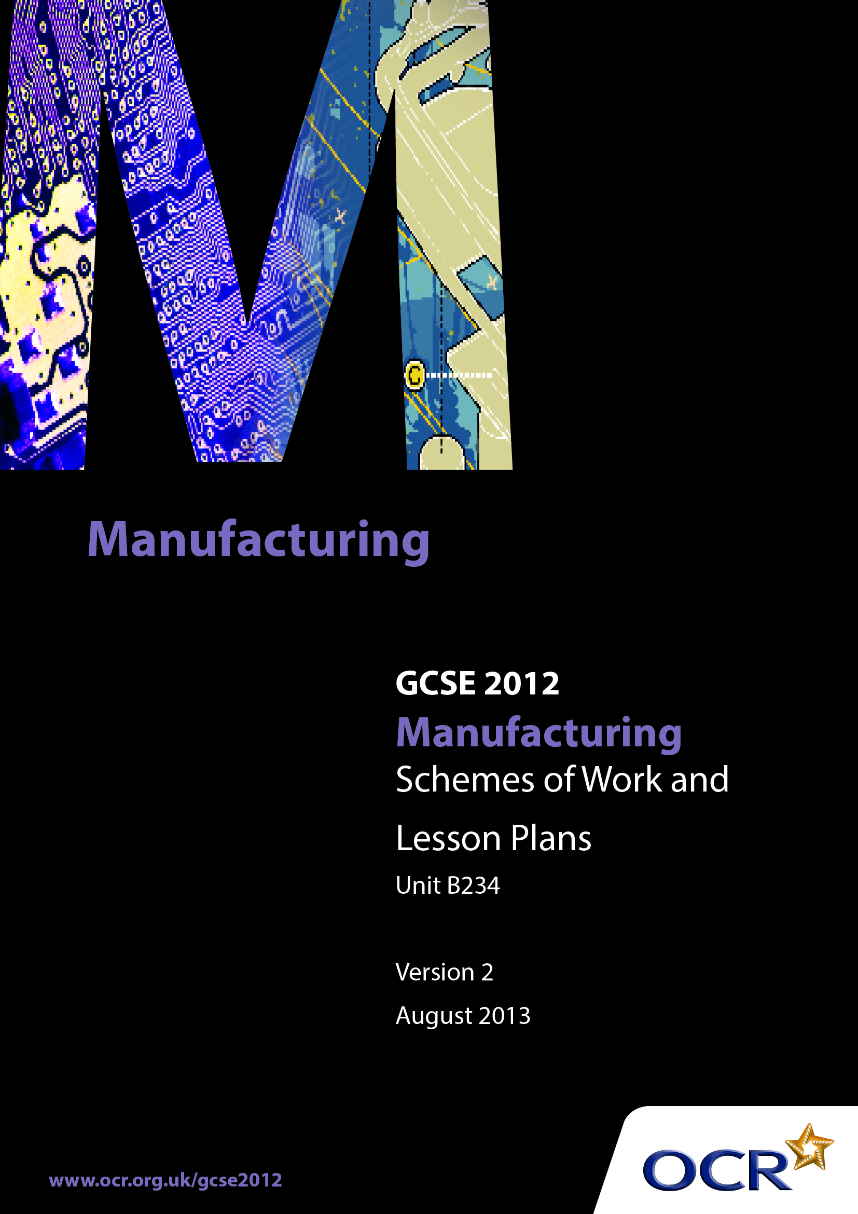

Contents
Introduction 3
Sample Scheme of Work: OCR GCSE Manufacturing J510 Unit B234: Impact of Modern Technologies on Manufacturing 5
Sample Lesson Plan: OCR GCSE Manufacturing J510 Unit B234: Impact of Modern Technologies on Manufacturing 14

Introduction

Background
OCR has produced a summary brochure, which summarises the changes to Manufacturing. This can be found at www.ocr.org.uk, along with the 2012 specification.
In order to help you plan effectively for the implementation of the new specification we have produced these schemes of work and sample lesson plans for Manufacturing. These support materials are designed for guidance only and play a secondary role to the specification.

Our Ethos
OCR involves teachers in the development of new support materials to capture current teaching practices tailored to our new specifications. These support materials are designed to inspire teachers and facilitate different ideas and teaching practices.
Each scheme of work and set of sample lesson plans are provided in Word format to be used as a foundation to build upon and amend the content to suit your teaching style and students’ needs.
The scheme of work and sample lesson plans provide examples of how to deliver these units and suggested teaching hours which could be applicable to your teaching.
The specification is the document on which assessment is based and specifies what content and skills need to be covered in delivering the course. At all times, therefore, this support material booklet should be read in conjunction with the specification. Any clarification should be found in the specification.

A Guided Tour through the Scheme of Work

= Innovative Teaching Idea
This icon is used to highlight exceptionally innovative ideas.


= ICT Opportunity
This icon is used to illustrate when an activity could be taught using ICT facilities.

OCR GCSE Manufacturing J510 Unit B234: Impact of Modern Technologies on Manufacturing
Suggested Teaching Time | 40 Hours | Topic | Impact of Modern Technologies on Manufacturing
Topic Outline |  | Suggested Teaching and Homework Activities | Suggested Resources | Points To Note
Unit Overview: This unit will be assessed by a one-hour written examination. Questions will be a mix of short answer and free response styles, and will require candidates to demonstrate practical application of knowledge related to products and manufacturing environments they have studied.
Where possible, links should be made with a manufacturing company to allow candidates access to real-life manufacturing practice. They should study a range of products from at least two manufacturing sectors.
In this unit, for two selected manufacturing sectors, candidates will consider:
- Sustainability: lean manufacture – to reduce waste in the manufacturing system
- Sustainability: environmental considerations within manufacturing
- Design for manufacturing assembly (dfma)
- Production methods and constraints
- Materials, components and/or ingredients available and their constraints
- Environmental benefits of modern technology used in and by the manufacturing industries
- The impact that the use of modern technology has had upon society
- Research and analysis of existing products, the use of materials, manufacturing processes used and market needs, considering issues of sustainability and the needs of manufacturers and the manufacturing sectors with knowledge and understanding being gained in a variety of ways during the course and also from final examination preparation.
Candidates will demonstrate broad knowledge and understanding of manufacturing related to:  Sustainability: lean manufacture.  To reduce waste in the manufacturing system by looking at:  - Over-processing  - Scrap  - Waiting  - Inventory  - Movement (people)  - Transport (materials and products)  - Over-production.  Sustainability: environmental considerations:  - Waste management  - Safe disposal  - Concepts of reduce, reuse, recycle  - End of life disposal  Design for manufacturing assembly (DFMA):  - Common fixing strategy  - Standardised components  - Complexity reduction  - Make versus buy  - Handling.  Materials, components and/or ingredients available and their constraints through:  - Their availability, form and supply  - Ethical and fair-trade issues  - Material properties, characteristics and performance  - Their cost, both monetary and environmental  - Health, safety and hygiene requirements  - Handling, storage, disposal.  Modern technology used in and by the manufacturing industries  - Environmental impact of the use of modern technology  - Information, communications and digital technologies  Impact of these technologies on manufacture and design of products, such as global trading, remote manufacture  - ‘Green’ energy supplies.  Students will research and analyse existing products, the use of materials, manufacturing processes used and market needs, considering issues of sustainability and the needs of manufacturers and the manufacturing sectors  Product design:  - Analysing client design briefs for manufactured products  - Producing, using and modifying design specifications for manufactured products  - Considering material details, sustainability, environmental impact and constraints  - Considering production details and constraints  - Applying quality standards  - Developing sustainable design ideas  - Presenting a design solution for sustainable manufactured products  - Modifying design solutions.  Product manufacture:  - Making a prototype from a design solution  - Selecting and using:  – A range of appropriate materials, parts and components  – Appropriate processes  – Appropriate tools and equipment  – Applying health and safety procedures and quality control techniques; and  – Producing a batch of a product from a design solution as a member of a team.  - Analysing and evaluating the product in terms of the manufacturing processes used and detailing how these would be modified in real-world manufacturing. The environmental impact of the product and any issues of sustainability linked to its manufacture. |  | - A key point to note about this unit is the fact that candidates should study a range of products from at least two Manufacturing sectors. This is a requirement of the specification and so will enable them to more readily respond to the written questions in this externally assessed unit.  - It is expected that the SOW for this unit will have two parts.  Part A: the topic content is fully interwoven with that of units B232 and B231 parts A and B, plus B233 parts A and B  Part B: will consist of the “top up” topic content which, for each centre, has not been covered in their individual Part A.  - So a centre based structured plan, building on students existing experience gained at KS3 should be prepared by each centre. This should be alongside a mapping exercise of the topic contents against the products from two different Manufacturing sectors in preparation for the teaching.  - It is suggested that students study, with the support of structured teaching, a number of products.  - These sectors will differ dependent on the teacher(s) delivering the specification, centre resources and arrangements (e.g. links with other establishments) and the centres actual timetables and teacher contact times.  - It is anticipated that rather than “theory” dealing with each of the topics in turn many will naturally link together to gradually complete a matrix of taught content..  - Areas where knowledge is new (i.e. has not been covered during previous teaching or candidates controlled assessment activities (B231 parts A & B and B233 Parts A & B), demonstrations, media support – CD-ROMs, Videos, industrial visits – should be re-enforced by practical or visual duplication of information.  - There is topic overlap with unit B232 and this unit, B234, but centres can expect different questions in both the January and June sittings for any overlap content. i.e. the questions will not be the same for the Single Award B232 paper and the Double Award B234 paper for any common content.  - Centres should note that there are also some common products from some of the Manufacturing Sectors between Single Award content (B232) and Double Award content (B234).  Centres are strongly advised to ensure students study entirely different products in preparation for B234 and B232 to ensure full specification coverage  - Ideally the majority of the topics will be addressed at least once during the “controlled assessment” activities and activities which precede the controlled assessment.   - Support can be gained by linking directly with activities in Unit B231, A Study of a Manufactured Product where the work students are engaged in has this unit in mind.   - Support can be gained by linking directly with activities undertaken in Unit B231 B Manufacturing a Product: Acquisition of practical skills  with teachers naturally extending their teaching input to encompass the topics needing to be covered by this unit.  - It is therefore suggested that centres produce some form of mapping, possibly a spreadsheet, with sector specific “topic content” cross referenced to:  - the practical pre-“controlled assessment” activities students will undertake  - KS3 experiences  - The two “controlled assessment” activities B231 and B233  - This will then reveal topic areas which have not naturally been covered which will then need “theory” inputs for final examination preparation.  - Sample Assessment materials should be used initially and then past papers as they become available following each examination sitting as a template for centres generating their own worksheets and homework sheets for fortnightly exposure to all students.  - The structure of the questions should be copied and should remain unchanged, a range of different mark responses should be incorporated to give all students regular experience of what the papers will look and feel like and the types of things they will be asked to respond to.  - If centres generate sector specific questions for preparation of this unit they should be given the style and feel of the sample assessment materials and past papers which is an important “familiarisation” exercise and one which should not be underestimated as a student support mechanism.  - Where these work sheets and homework sheets are used there should be comprehensive group and/or individual feedback on the responses made by students to identify:  - Common misunderstandings  - Gaps in the teaching groups knowledge  - Types of questions which students respond to poorly  - Use of the “non-rewardable” generic responses `  - Examination techniques e.g. marks allocations in brackets [4]   - Time management  - Reading the whole question paper through before starting to answer  - Legibility  - Use of technical terms  - Quality of written communication  - Understanding and use of the Computer based software  - Remedial input for any of the areas identified should then be incorporated into the SOW and form part of the preparatory content for any subsequent SOW | - http://www.ocr.org.uk/Data/publications/  assessment_materials  /GCSE_Manufacturing_SAM_Unit_B234.pdf  - http://www.ocr.org.uk/Data/publications/  assessment_materials/  GCSE_Manufacturing_  SAM_Unit_J510.pdf will also be useful.  - OCR Manufacturing for GCSE. John Hill ISBN 9780340985090 | - It is expected that preparation for this unit will be an on-going activity and not just a final “theory” input immediately prior to the examination.  - Where possible, links should be made with a Manufacturing company to allow candidates access to ‘real-life’ Manufacturing practice. They should study a range of products from at least two Manufacturing sectors.  Chemical and pharmaceutical  - Petroleum jelly  - Lipstick  - Penetrating oil  Clothing and textiles  - Soft furnishings  - Outdoor sportswear  - Sails (eg marine, hang gliding).  Electrical  - Wind turbine  - Vacuum cleaner  - Electric fire.  Food and drink:  - Celebration cake  - Pro-biotic yogurt  - Gluten-free ready meal.  Furniture:  - Outdoor dining (eg pavement café)  - Home entertainment unit (eg gaming, DVD)  - Child’s cot.  Machinery and equipment:  - Pressure washer  - Lift (eg dumb waiter)  - Conveyor belt.  Packaging for:  - Glassware  - Perishable goods (eg sandwiches, baby food)  - Drinks  Electronic and communication  - Touch screen  - Domestic wifi  - Navigation systems (eg GPS).  Motor manufacturing  - Seat belts  - Trailers  - Glazing.  Paper and print  - Newspapers  - Promotional material  - Wallpaper.  -  Where the topic does not directly apply one sector, the selection of the alternative sector and product will almost certainly provide appropriate and necessary coverage of the specification and unit content.  -  Failure to study different products and Manufacturing sectors will limit students‘ ability to respond flexibly and appropriately to examination questions.  - Similar SOW content to that of B232, the Points to note column should be employed whilst preparing students for this examination.  -  In written examinations candidates should be advised to avoid responses such as:  Cheap / very cheap / cheaper, strong / stronger / very strong, light / very light / lighter, tough / very tough / tougher, unless they are qualified in some way.  -  Guidance should be given as to the length and breadth of responses expected in an examination question. For example if a question has three marks [3] there is an expectation of three “bits” to their response. This might be two different points with some extension of a point or one point with several points of extension / explanation.

OCR GCSE Manufacturing J510 Unit B234: Impact of Modern Technologies on Manufacturing

Material, Components and/or Ingredients and their Constraints
OCR recognises that the teaching of this qualification above will vary greatly from school to school and from teacher to teacher. With that in mind this lesson plan is offered as a possible approach but will be subject to modifications by the individual teacher.
Lesson length is assumed to be one hour.
Analysis by the teacher of an advertisement for a mobility mechanical “reacher” will provide a range of teaching opportunities related to the topics for Unit B234 for the Machinery and Equipment Sector.
Text from an advertisement such as “Made from lightweight aluminium, this “reacher” is designed for people with limited reach and/or mobility. The jaw opening is highly visible and features a slip resistant surface for a secure hold on the object.
Constructed with a cord running through the tube, which operates the plastic jaw. This cord style allows the “reacher” to be folded in the centre for ease of storage and transportation.
Include a magnet tip, a hook for dressing, a rubber lined jaw and a device that allows the “reacher” to be clipped to a stick or walker.”
Although this example focuses on a specific part of the specification, the frameworks is capable of being adapted to many different scenarios.

Learning Objectives for the Lesson
Objective 1 | Students to understand that both ferrous and composite materials can be magnetised
Objective 2 | Students to understand the appropriate assembly methods for magnets to aluminium
Objective 3 | Students to suggest alternative methods of assembly with advantages and disadvantages

Recap of Previous Experience and Prior Knowledge
Metals: Knowledge of Ferrous and composite materials
Knowledge of the property of magnetism
Restrictions of “reach” for certain people:

Materials and Equipment required for demonstration: | Method 1: White board, OHP, chalk board or equivalent  Method 2: Laptop with LCD projection  Images of “reacher” and disabled person
Materials and Equipment required for student practical: | An existing “reacher” probably borrowed from the caretaker.

Content
Time | Content
5 minutes | Introduction.  Class view an advertisement for a mobility mechanical “reacher”.  OR  Request volunteer student to “do a little job”. Student is asked to get something from a shelf or something which is out of reach.  The concept of an “extension” to reach for getting jars, keys etc. from higher or further away places introduced.  
10 minutes | Student Activity: Students, in controlled, measured fashion undertake product Analysis (reverse Manufacturing) on an image of a “reacher” in use presented for them.  The use of the product should be considered in addition to the materials, possible construction.

15 minutes | Summative collation of student findings written up on whiteboard / media projection.  Contrived situation of dropping a safety pin on floor and asking a student to pick it up. Brief discussion as to associated problems i.e. not being able to see the pin, feel the pin, grab the pin. Introduction of magnet on the end of the “reacher”.  Question to students: What might be the problems of fixing a 10mm square of ferrous magnet to the end of a “reacher”?  Responses obtained or supplied by teacher: Brittle so if dropped might break, difficulty in “drilling” a hole through and fixing to “reacher” (they are normally pop riveted), general restriction of having a standard component, costs associated with purchase of limited numbers of ferrous units.  A modern alternative is required – enter the plastic magnet.  Details of magnetic attachment given:  Recap on understood facts that ferrous materials can be magnetised but exciting introduction of “plastic” magnetic materials introduced. (The chemical content is not required at this level of study). The range of available plastic magnets is unveiled.

15 minutes | Student Activity 1: Working in pairs students sample the plastic magnet issued for handling testing. Testing such as cutting, drilling, stickling / bonding, punching, flame / heat /burn test, water testing and other testing as appropriate  Student Activity 2: Working in pairs students:  1] analyse / discuss the Manufacturing possibilities of the attachment of this material to the “reacher”  2] discuss the Manufacturing possibilities of this modern material  3] discuss the possible limitations of this modern material
10 minutes | Clear away and re-form group ensuring they have written “notes” of the previous 2 x 15 minute slots of activity. Student Activity: Consolidate and begin preparations for an individual 3 - 4 minute presentation on the properties of the modern material, its advantages and uses and its direct relationship to the “reacher”.  ICT and ITI Opportunities. The presentation can be in any of the following formats:  - OHP presentation  - PowerPoint presentation  - Handouts  - Worksheet with answers  - Quiz with answers

Consolidation
Time | Content
5 minutes | Recap with set questions pre-written on cards which are numbered.  Each student asks for a number and has that question asked to them.  If they get it right appropriate praise given  If incorrect or partially correct the correct answer is 1] sought from the group or 2] clarified by the teacher.  Home work: To complete the presentations for possible delivery to the group next lesson.  All work would be collected in and checked / marked and returned.  A small selection which uses different methods of presentation will be delivered by the students at the start of the next lesson.  This will serve several purposes one of which will be to expose students to alternative presentation methods for their own work so possibly taking them out of their comfort zones.

