Unit 2 – Anatomy and physiology for sport

Where are the bones?

‘Where are the bones?’ is a range of tasks that allows learners to identify a variety bones on a skeleton, describe the types of joints and the joints’ structures.

This resource compromises of three tasks.

Task 1 – Identify the bones

Your teacher will give you a picture of skeleton. Working in pairs (or groups), place the name of the bones on the correct location on the skeleton.

(If asked by your teacher, print the names of the bones on one A4 sheet and cut along the dotted lines for one set of bone names. You need one set per pair, or group, of learners.)

Names of bones

Carpals | Radius
Clavicle | Ribs
Femur | Scapula
Fibula | Skull (Cranium)
Humerus | Spine (Vertebral Column)
Metacarpals | Sternum
Metatarsals | Tarsals
Pelvis | Tibia
Phalanges | Ulna
Phalanges

Task 2 – Types of joints

There are three different types of joints in the human body, What is the name of each of the following types of joint? Write your answer in the table below.

Name of joint | Type of joint
Elbow

Foot

Hip

Knee

Shoulder

Wrist

Task 3 – Structures of joints

Complete the paragraph by selecting/writing the missing words from the table below.

A ________ joint is the area where two or more ________ meet. The ends of the bones are covered with ________ which absorbs ________ and reduces ________. The joint is made flexible by synovial ________ which is produced by the synovial ________. The joint also consists of ________ which connect bone to bone and stabilises the joint, and ________ which connect muscle to bone and enables the movement at the joint.

bones | friction | shock
cartilage | ligaments | synovial
fluid | membrane | tendons

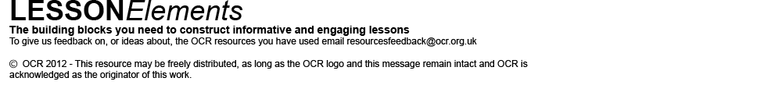
These activities offer an opportunity for English skills development.

