Unit 1 – Principles of anatomy and physiology in sport

The Heart, Lungs and Oxygen

‘The Heart, Lungs and Oxygen’ is a range of tasks that allows learners to identify parts of the heart and lung and answer some questions about oxygen.

This resource compromises of three tasks.

Task 1 – The Heart

Your teacher will give you a picture of a heart. Working in pairs (or groups), place the name of the parts of the heart on the correct location.

(If asked by your teacher, print the names of the parts of the heart on one A4 sheet and cut along the dotted lines for one set of parts of the heart. You need one set per pair, or group, of learners.)

Parts of the heart

Aorta | Pulmonary semilunar valve
Aortic semilunar valve | Pulmonary trunk
Cardiac muscle | Right atrium
Inferior vena cava | Right ventricle
Left ventricle | Superior vena cava
Left atrium | Tricuspid valve
Mitral / bicuspid

Task 2 – The Lungs

Your teacher will give you a picture of a lung. Working in pairs (or groups), place the name of the parts of the lung on the correct location.

(If asked by your teacher, print the names of the parts of the lung on one A4 sheet and cut along the dotted lines for one set of parts of the lung. You need one set per pair, or group, of learners.)

Parts of the lung

Alveoli | Larynx
Bronchioles | Nasal cavity
Bronchus | Pharynx
Epiglottis | Trachea

Task 3 – About Oxygen

Complete the crossword below.

 |  | ¹ |  |  | ² |  |  |  | ³ | ⁴
 | ⁵
 | ⁶
 | ⁷
 | ⁸ |  |  |  |  |  | ⁹
¹⁰

Crossword questions.

Across:
3 |  | The MAXIMUM amount of oxygen the body is able to use in one minute.
5 |  | The type of ‘exchange’ which takes place when blood moves between the lungs and the blood vessels.
6 |  | Technical word for ‘Breathing In’
7 |  | The total amount of air the lungs can hold
8 |  | Technical word for ‘Breathing Out’
10 |  | Haemaglobin carries oxygen - these contain haemaglobin

Down:
1 | Breathed out in quantities of approximately 4%
2 | The volume of OXYGEN the body actually uses in one minute (not just how much air is breathed in)
4 | Breathed in quantities of about 21% and breathed out in quantities of 16% - more of this is needed by the muscles when exercising.
9 | The VOLUME of air breathed in and out in one breathing cycle

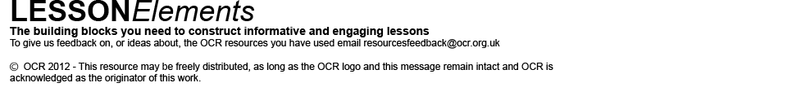
These activities offer an opportunity for English skills development.

