Unit 5 – Anatomy and physiology for health and social care

Pulse and Breathing

Task 1

1 Investigate and outline below, the importance of monitoring an individual’s pulse rate.

Task 2

2 Investigate and outline below, the importance of monitoring an individual’s breathing (respiratory) rate.

Task 3

3 Working in groups, follow the instructions below to measure the breathing rate of at least three other people (volunteers) in your group.

You will need a stop-watch or a watch that can act like a stop-watch.

- Tell the volunteers that you are going to count the number of times they breathe on six different occasions as outlined in the table below
- Tell them that you will say 'GO' when test starts.
- At the same time you say 'GO' start the stop-watch. Count the number of times they breathe in.
- Say 'STOP' after the period outlined in the table below.
- This will be their breathing rate.
- Record your findings in the table below.

http://wiki.answers.com/Q/How_do_you_measure_your_breathing_rate#ixzz1jF1k4wMK

 | Person 1 | Person 2 | Person 3
Breathing rate while resting for one minute
Breathing rate after one minute of exercise
Breathing rate after 2 minutes of exercise
Breathing rate after 3 minutes of exercise
Breathing rate 2 minutes after exercise
Breathing rate 5 minutes after exercise

4 Plot the data you have recorded in the table above, into a graph. Use a different colour for each person.

5 Write a report in which you explain any differences between the three people’s breathing rates.

Task 4

6 Taking a pulse

Many illnesses can make a person's heart rate increase. A pulse can be taken on your wrist, neck or upper arm. Working in groups, follow the instructions below to measure the pulse rate of at least three other people (volunteers) in your group.

- Your volunteer should sit still and rest quietly for five to 10 minutes.
- Place two fingers gently against their wrist below the palm of their hand. If a pulse is hard to feel in their wrist, find their carotid artery in the neck, which is located to either side of the windpipe. Press gently.
- Count the beats for 30 seconds and then double it to determine beats per minute.

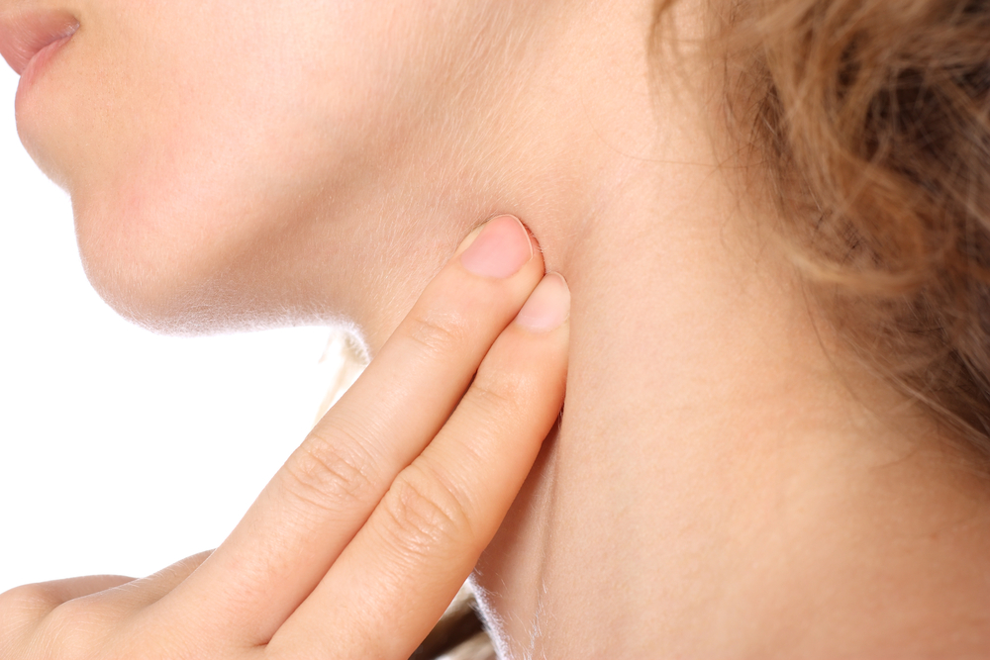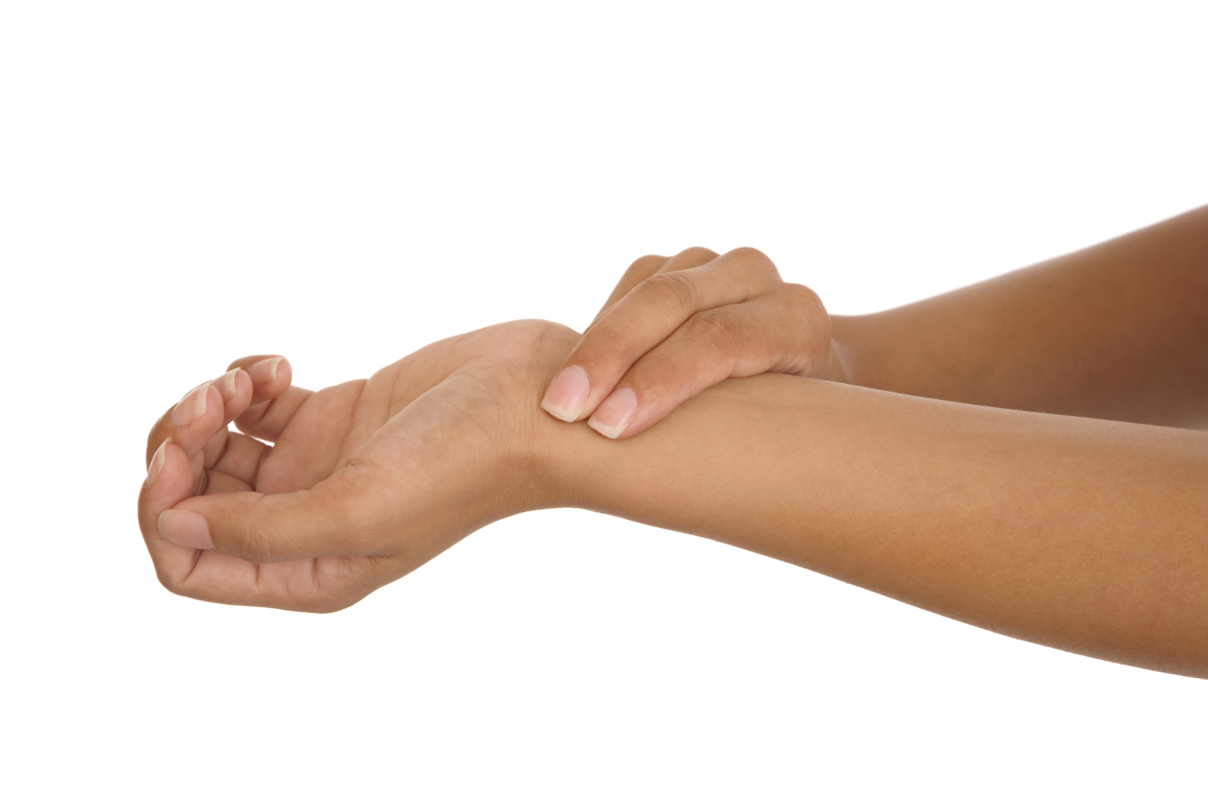

A normal resting pulse for:
- Infant to one year old is 100 to 160 BPM.
- One to six year olds is 65 to 140 BPM.
- Seven to 10 years old is 60 to 110 BPM.
- Eleven to adult age is 50 and 100 BPM.

http://www.ehow.com/how_5049189_persons-pulse.html#ixzz1jF46Ijh9

 | Person 1 | Person 2 | Person 3
Pulse rate while resting
Pulse rate after 1 minute of exercise
Pulse rate after 2 minutes of exercise
Pulse rate after 3 minutes of exercise
Pulse rate 2 minutes after exercise
Pulse rate 5 minutes after exercise

7 Plot the data you have recorded in the table above, into a graph. Use a different colour for each person.

8 Write a report in which you explain any differences between the three people’s pulse rates.

 These activities offer an opportunity for English and Maths skills development.



